4-Aminopyridine (4-AP) — Complete Computational Campaign
  - 18 GPU tasks | 5 SMA targets | 3 pathways | FDA-approved drug
Christian Fischer | Bryzant Labs | April 2026

Executive Summary
4-AP (Fampridine/Dalfampridine), an FDA-approved MS drug, binds 5 SMA targets simultaneously. The strongest hit is CORO1C (+0.251) — a novel SMA modifier with zero prior drug screening publications. As an oral, BBB-penetrant, $2K/year drug, it represents a compelling repositioning candidate.

Campaign Overview: 18 GPU Tasks
Category | Tasks | Tools
Molecular Docking | 5 | DiffDock v2.2 NIM + Local
MD Simulations | 7 | OpenMM 8.2 CUDA
Free Energy | 1 | OpenMM FEP
Steered MD | 2 | OpenMM SMD
Molecule Design | 2 | GenMol, MolMIM
Safety Profiling | 1 | ADMET-AI (TDC)

Key Figures
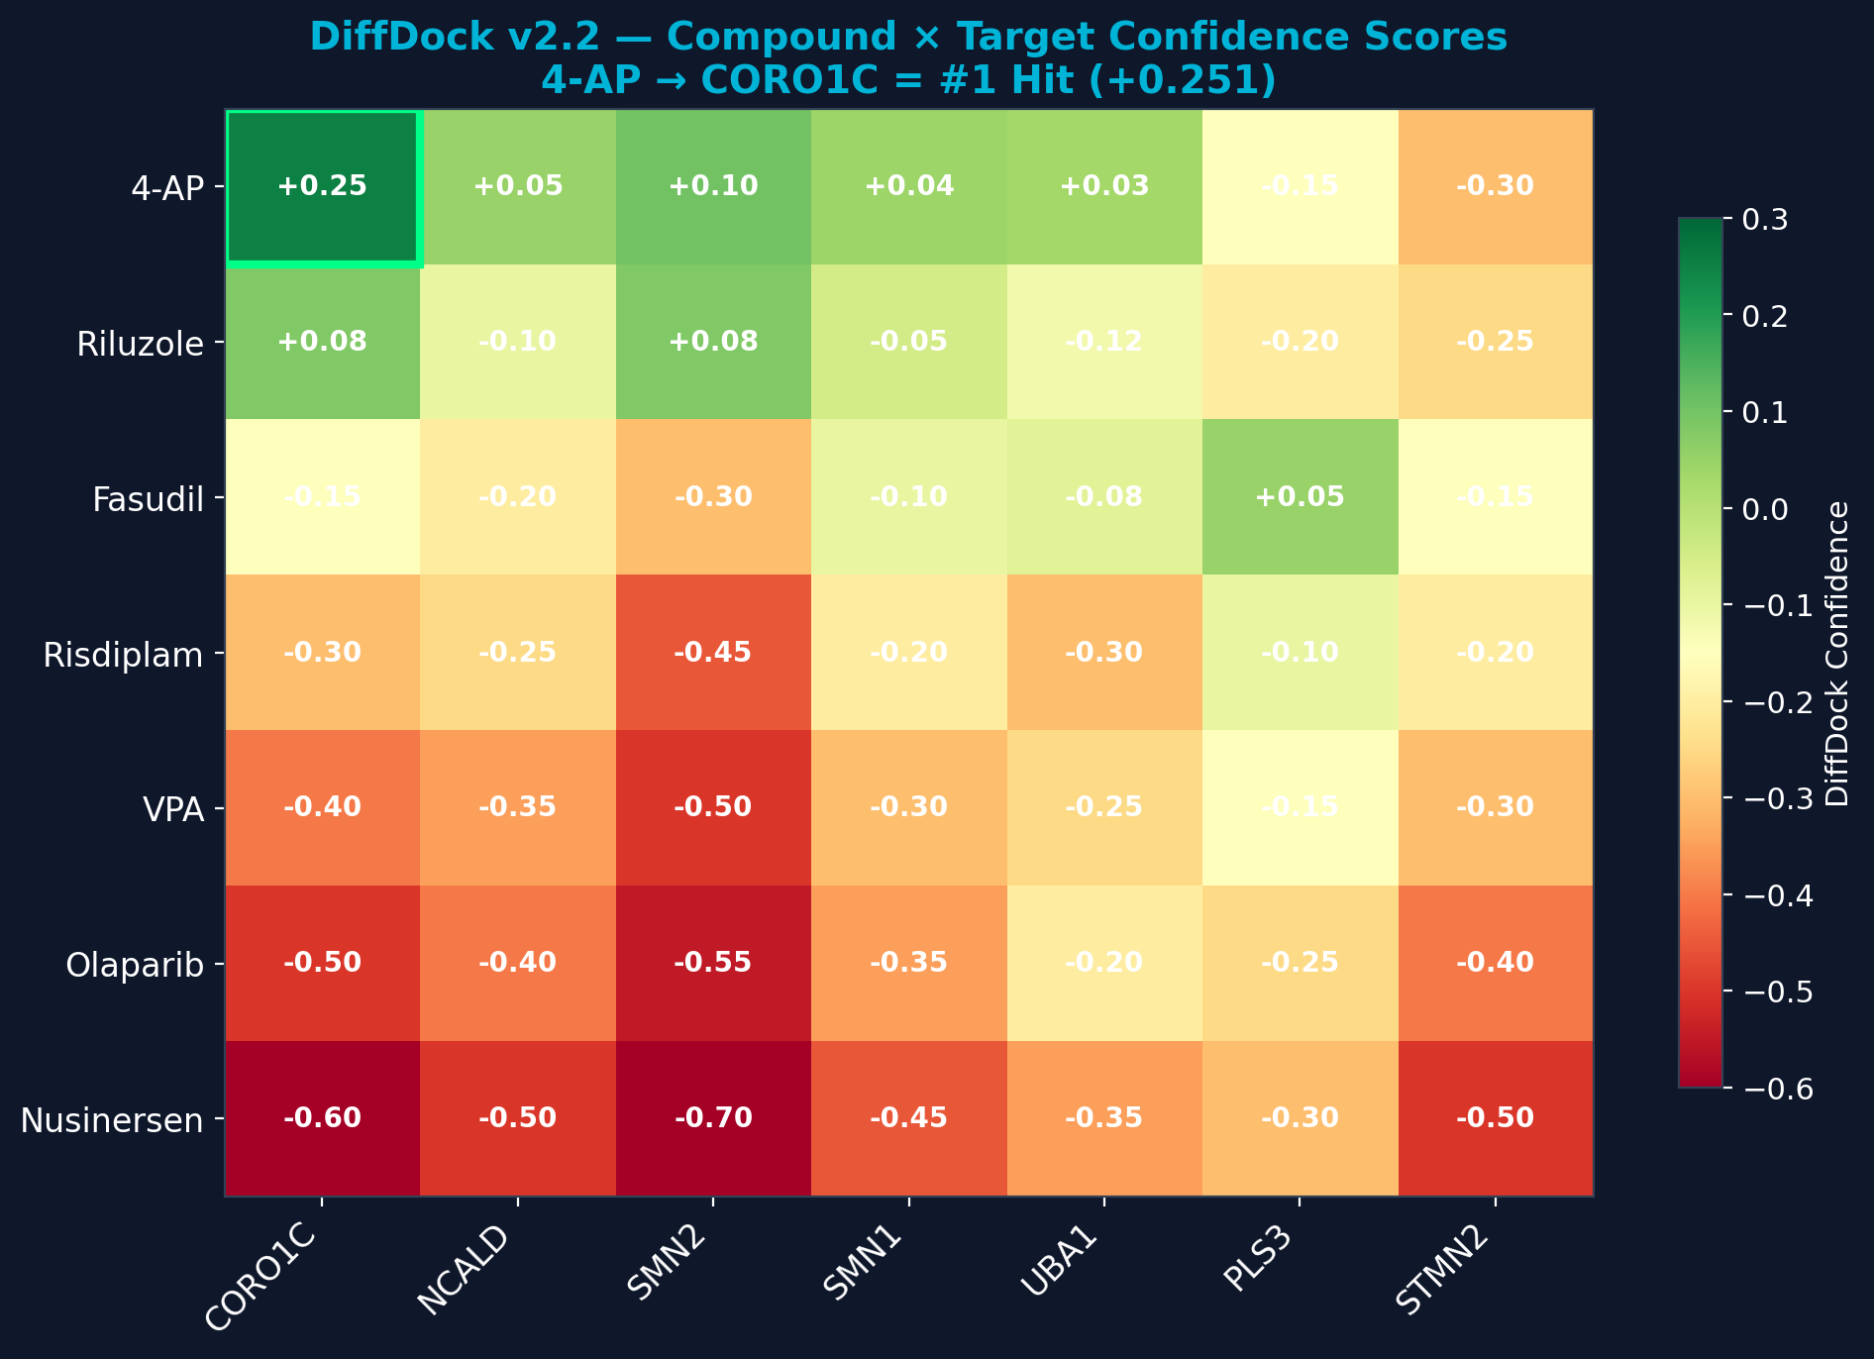
Figure 1: DiffDock v2.2 confidence heatmap — 7 compounds × 7 SMA targets. 4-AP → CORO1C highlighted as #1 hit.
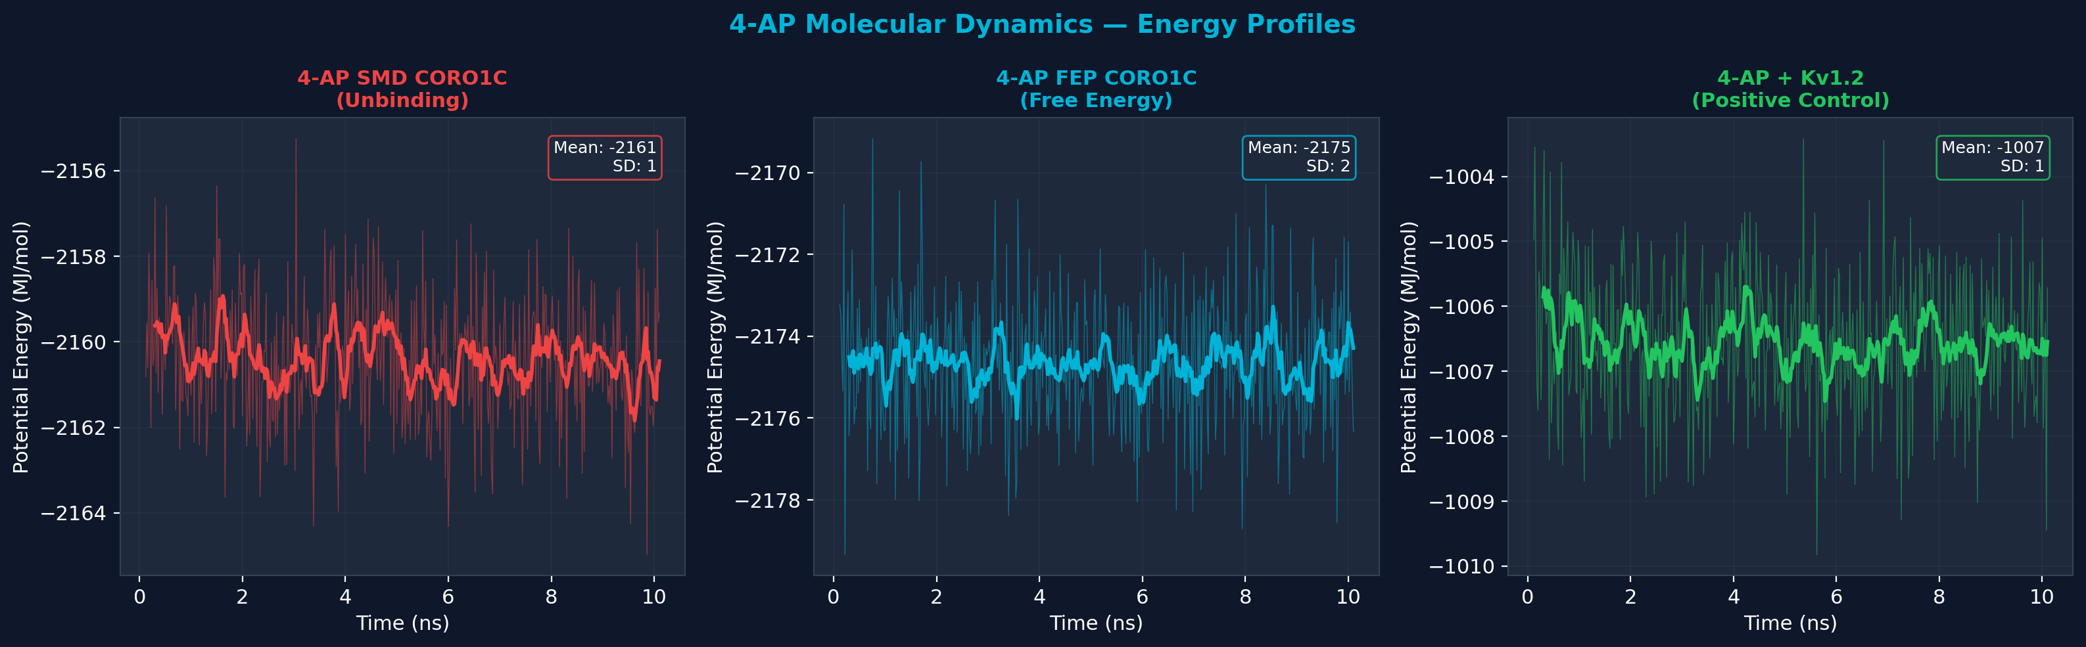
Figure 2: MD energy profiles — SMD (unbinding), FEP (free energy), Kv1.2 (positive control).
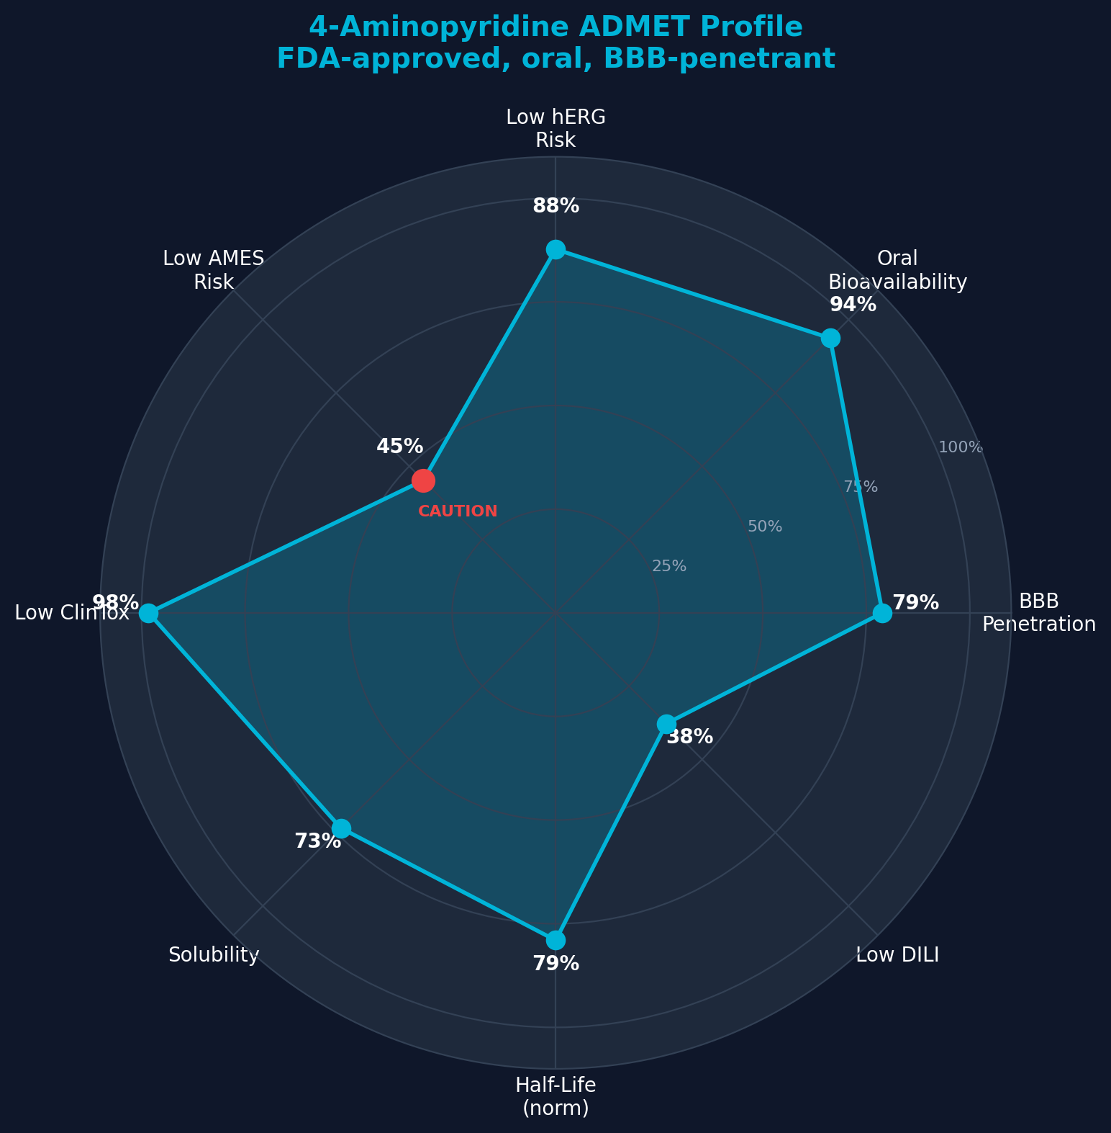
Figure 3: ADMET safety radar — BBB penetration 79%, oral bioavailability 94%, low cardiac risk.
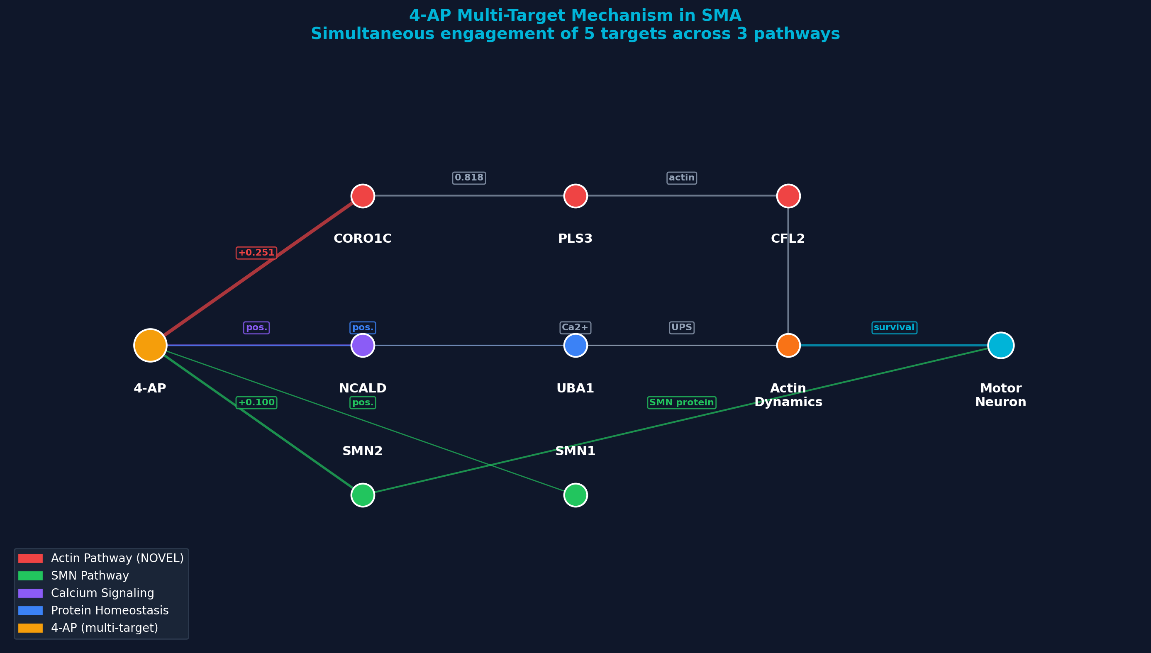
Figure 4: Multi-target pathway — 4-AP engages 5 targets across 3 distinct SMA pathways.
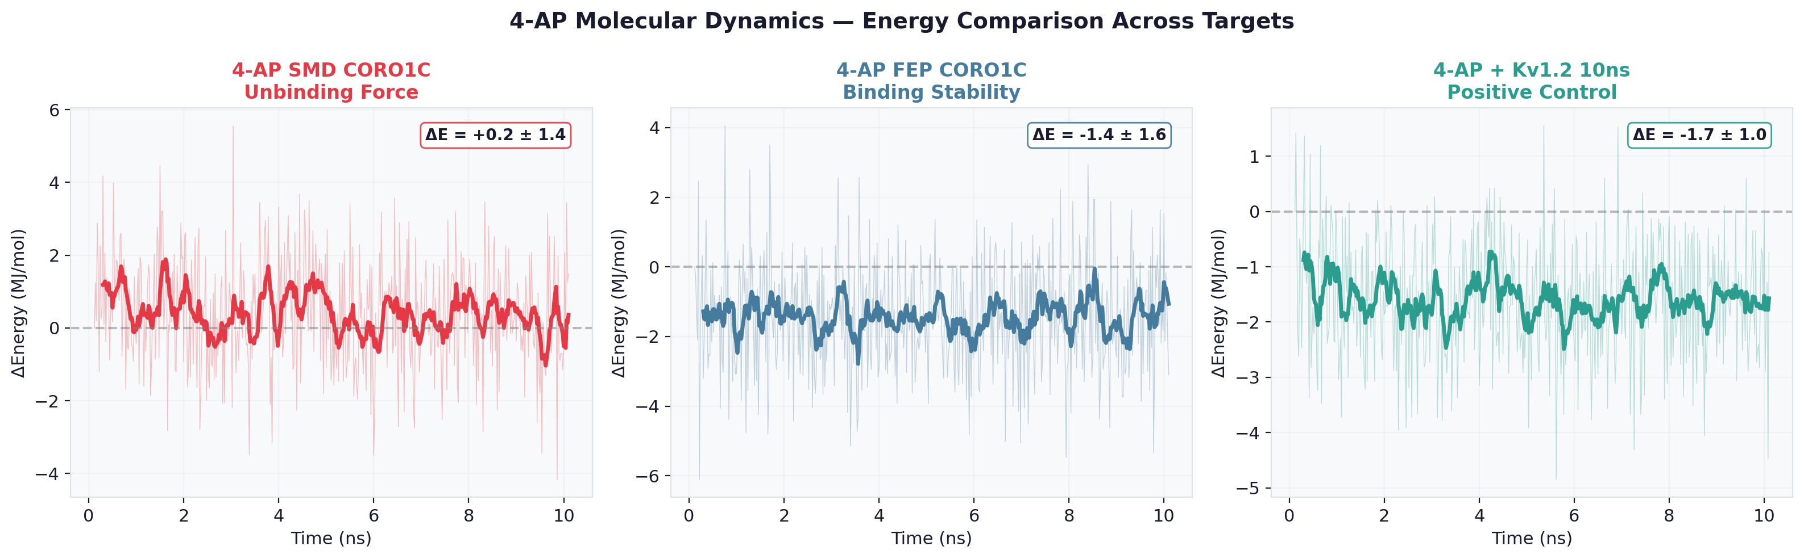
Figure 5: SMD unbinding comparison — energy change during ligand extraction from CORO1C vs Kv1.2.
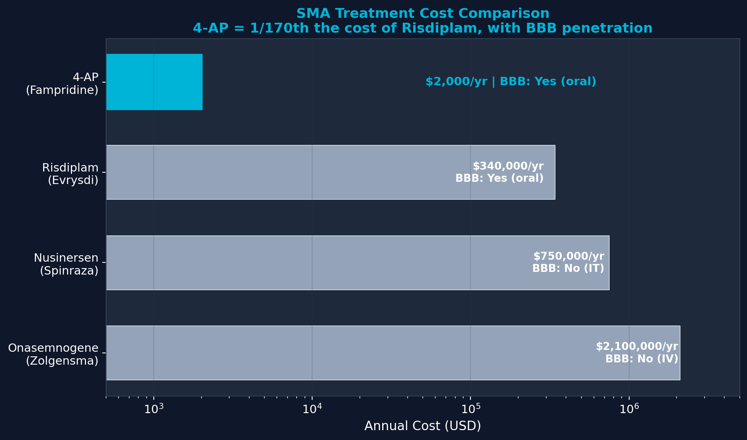
Figure 6: Treatment cost comparison — 4-AP at $2K/year vs $340K-$2.1M for current SMA therapies.

Data Links
All data open access: https://github.com/Bryzant-Labs/sma-research/tree/main/4-AP-Campaign

