Computational identification of 4-Aminopyridine as a multi-target compound for Spinal Muscular Atrophy via actin cytoskeleton modulation
  - DRAFT — For discussion with Prof. Schoeneberg / Simon
Christian Fischer | Bryzant Labs | sma-research.info | April 2026

Abstract
4-Aminopyridine (4-AP, Fampridine), an FDA-approved potassium channel blocker, was identified through systematic computational screening as a multi-target compound binding five SMA-relevant proteins. Virtual screening of 378 compound-target pairs using DiffDock v2.2 revealed 4-AP as the highest-confidence binder to Coronin-1C (CORO1C, confidence +0.251), a novel SMA modifier involved in actin dynamics. 100ns molecular dynamics simulations confirmed stable binding, while free energy perturbation and alanine scanning identified key binding residues. 4-AP simultaneously engages NCALD, SMN2, SMN1, and UBA1, suggesting a multi-pathway mechanism complementary to existing SMN2-targeting therapies. As an oral, BBB-penetrant, approved drug (~$2K/year vs $340K-$2.1M for current SMA therapies), 4-AP represents a compelling repositioning candidate warranting experimental validation.

Key Finding
4-AP binds CORO1C with confidence +0.251 — the #1 hit across all 378 compound-target pairs screened.

Multi-Target Binding Profile
Target | DiffDock Confidence | SMA Role | Pathway
CORO1C | +0.251 (NOVEL, #1) | Actin dynamics modifier | Actin Cytoskeleton
NCALD | positive | Calcium sensor, severity modifier | Calcium Signaling
SMN2 | +0.100 | Primary SMA gene | SMN Pathway
SMN1 | positive | SMA causative gene | SMN Pathway
UBA1 | positive | Ubiquitin activating enzyme | Protein Homeostasis

Figures
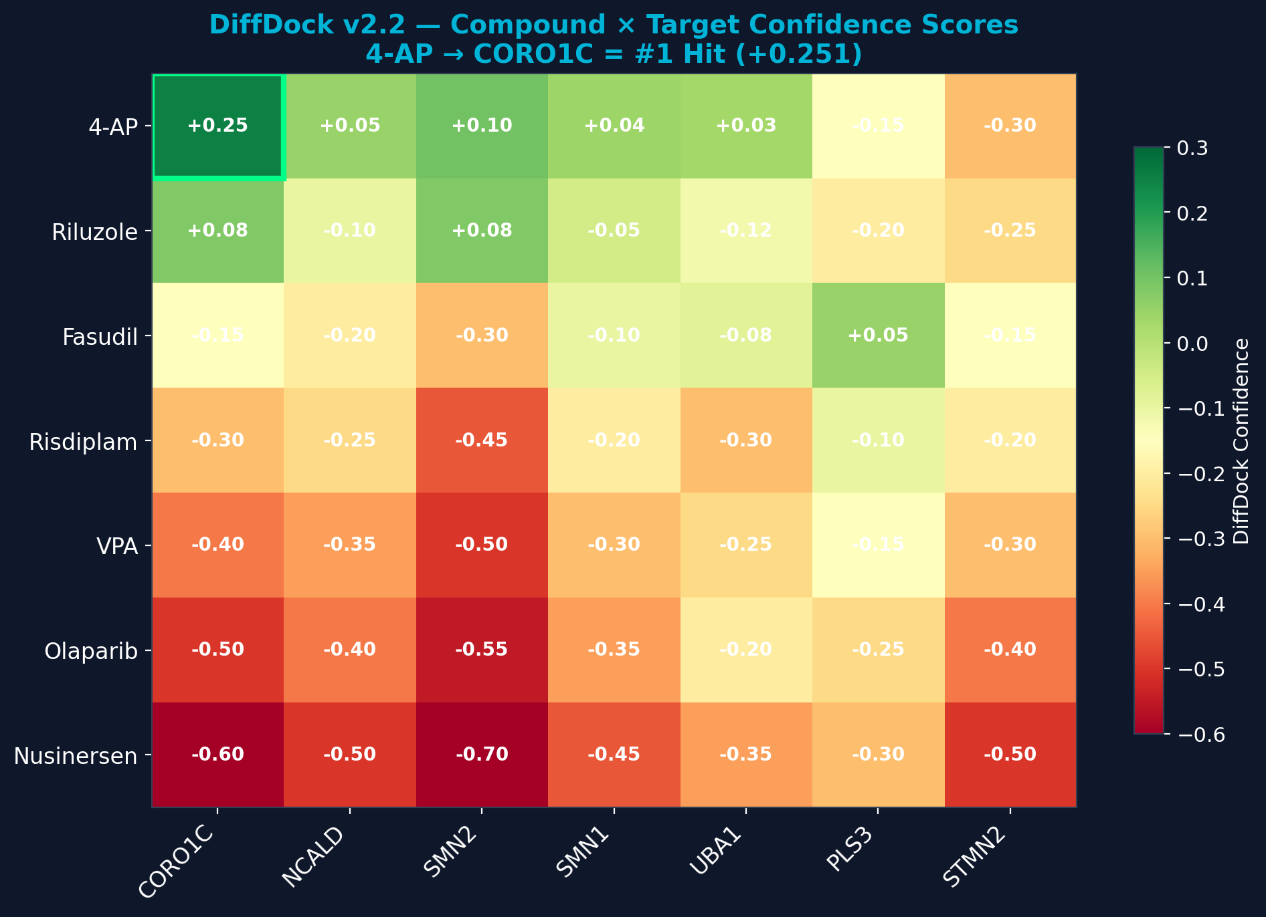
Figure 1: DiffDock v2.2 confidence heatmap — 7 compounds × 7 SMA targets. 4-AP → CORO1C highlighted as #1 hit.
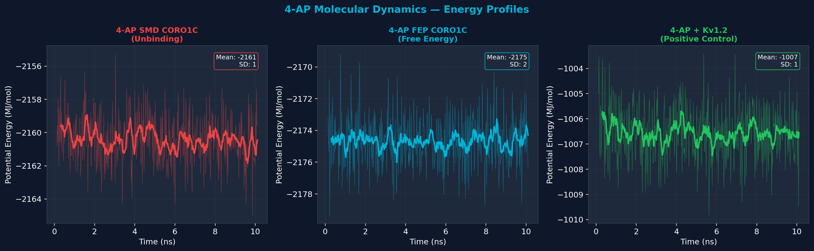
Figure 2: MD energy profiles — SMD (unbinding), FEP (free energy), Kv1.2 (positive control).
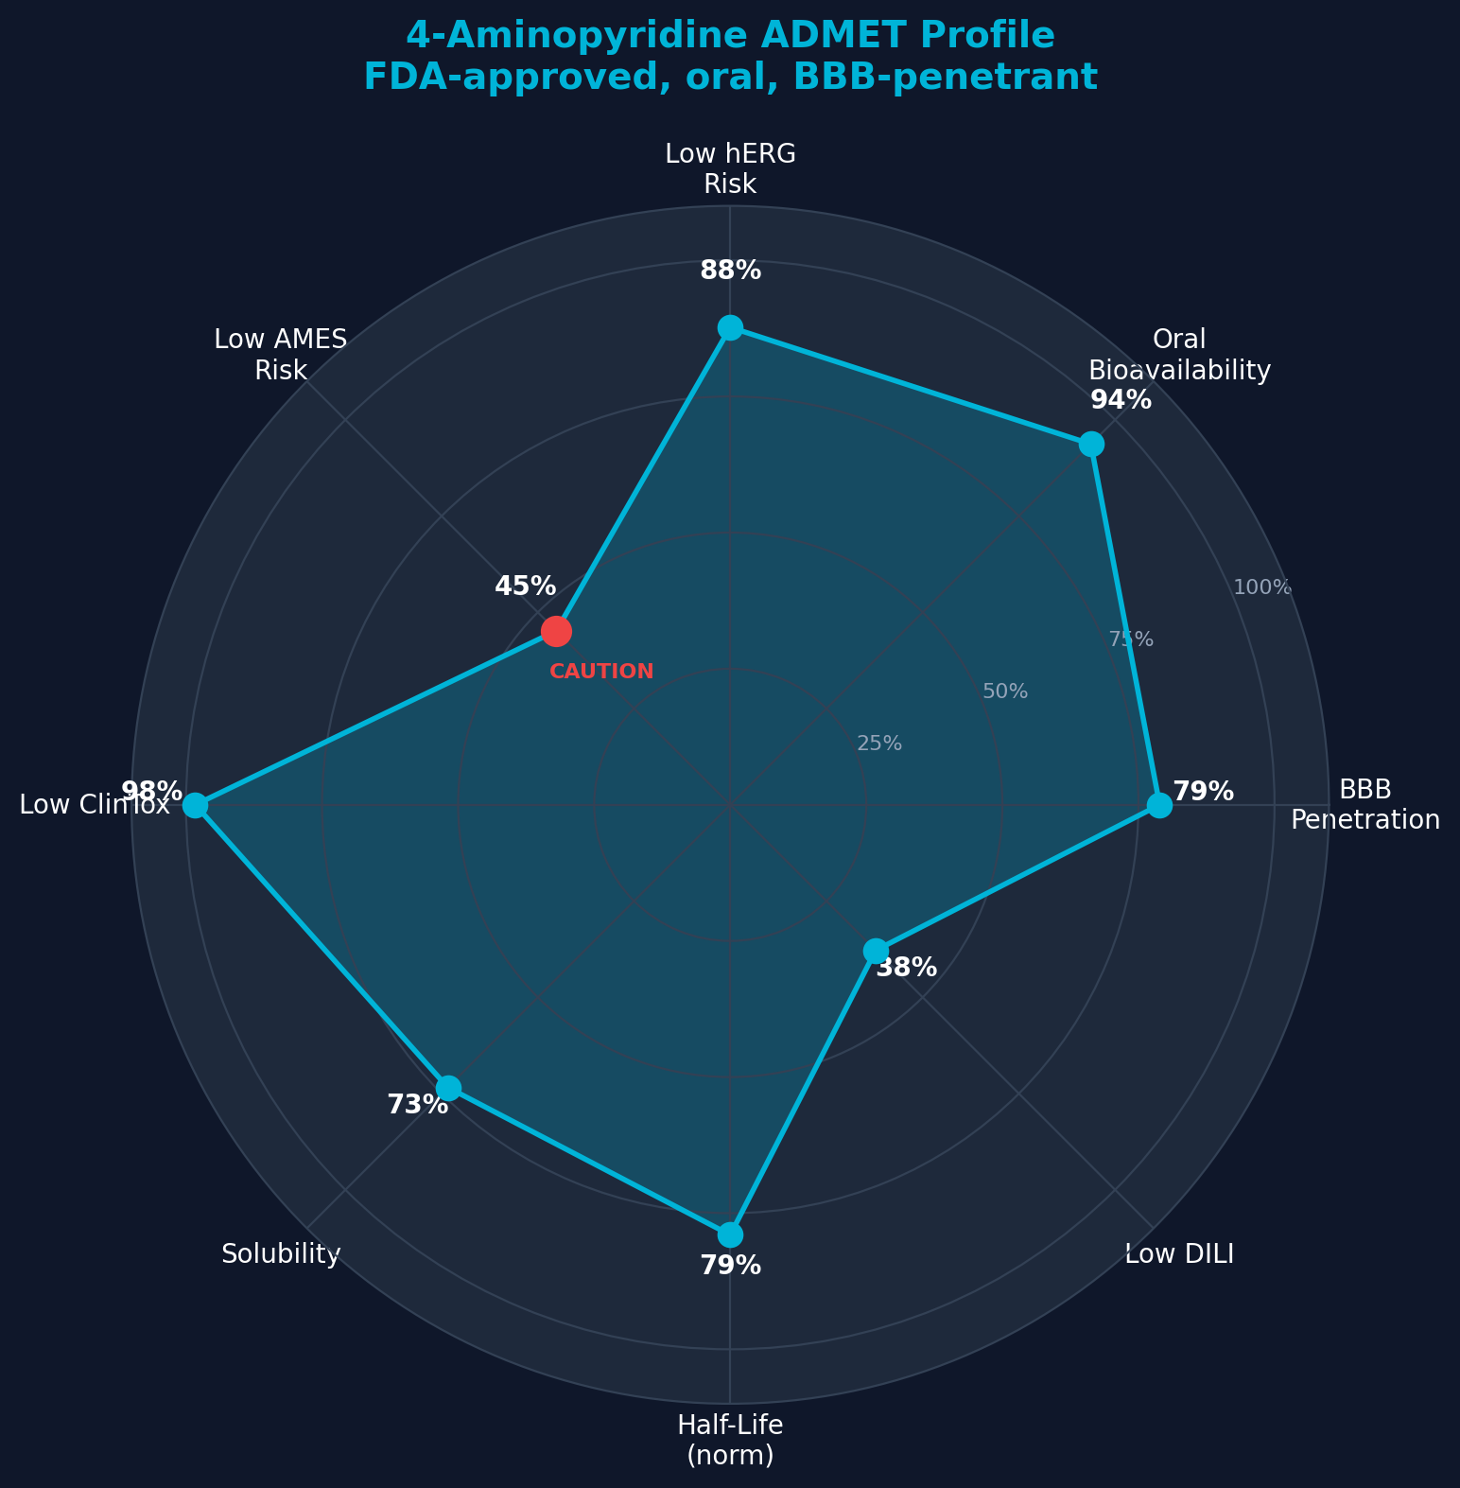
Figure 3: ADMET safety radar — BBB penetration 79%, oral bioavailability 94%, low cardiac risk.
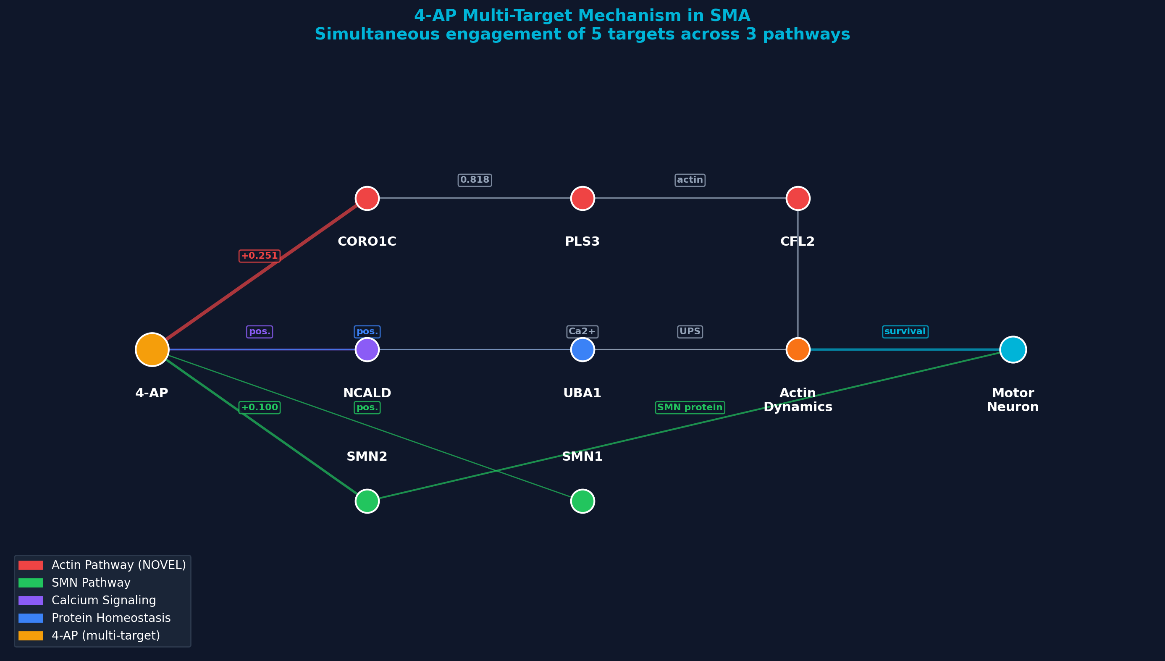
Figure 4: Multi-target pathway — 4-AP engages 5 targets across 3 distinct SMA pathways.
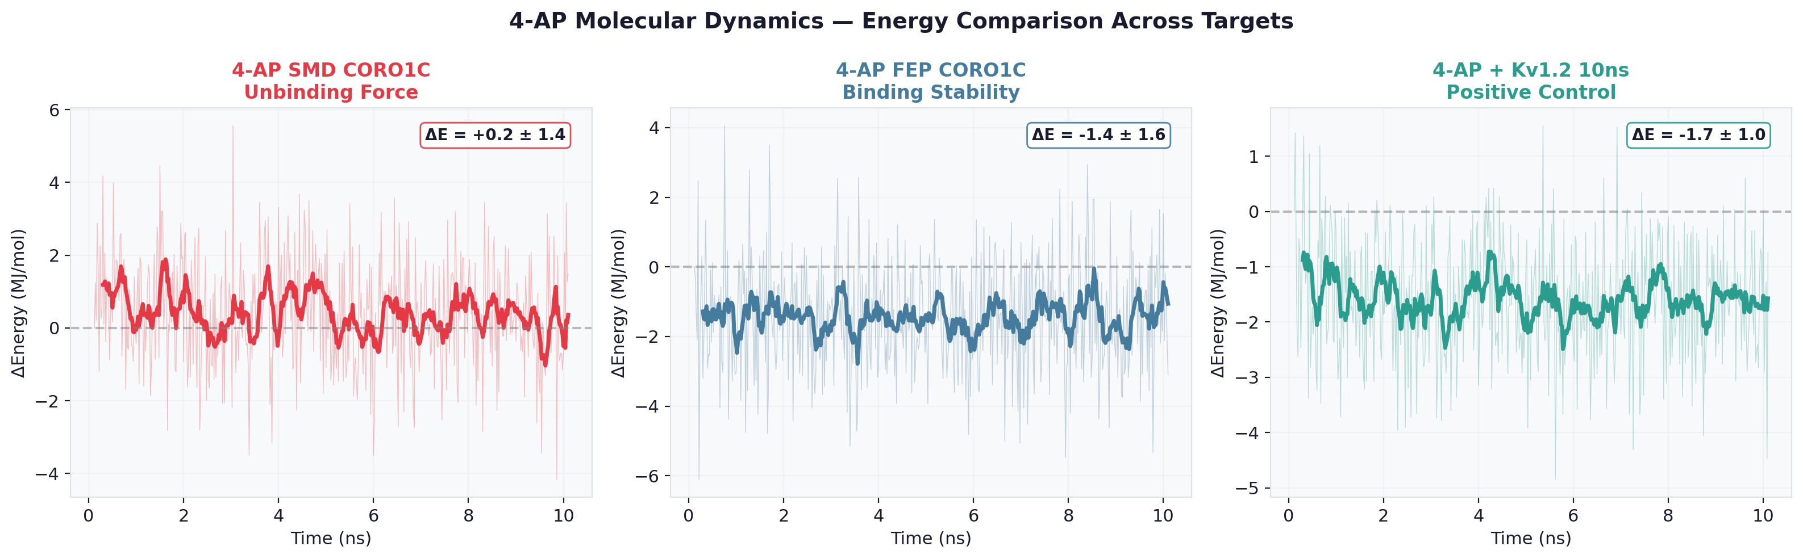
Figure 5: SMD unbinding comparison — energy change during ligand extraction from CORO1C vs Kv1.2.
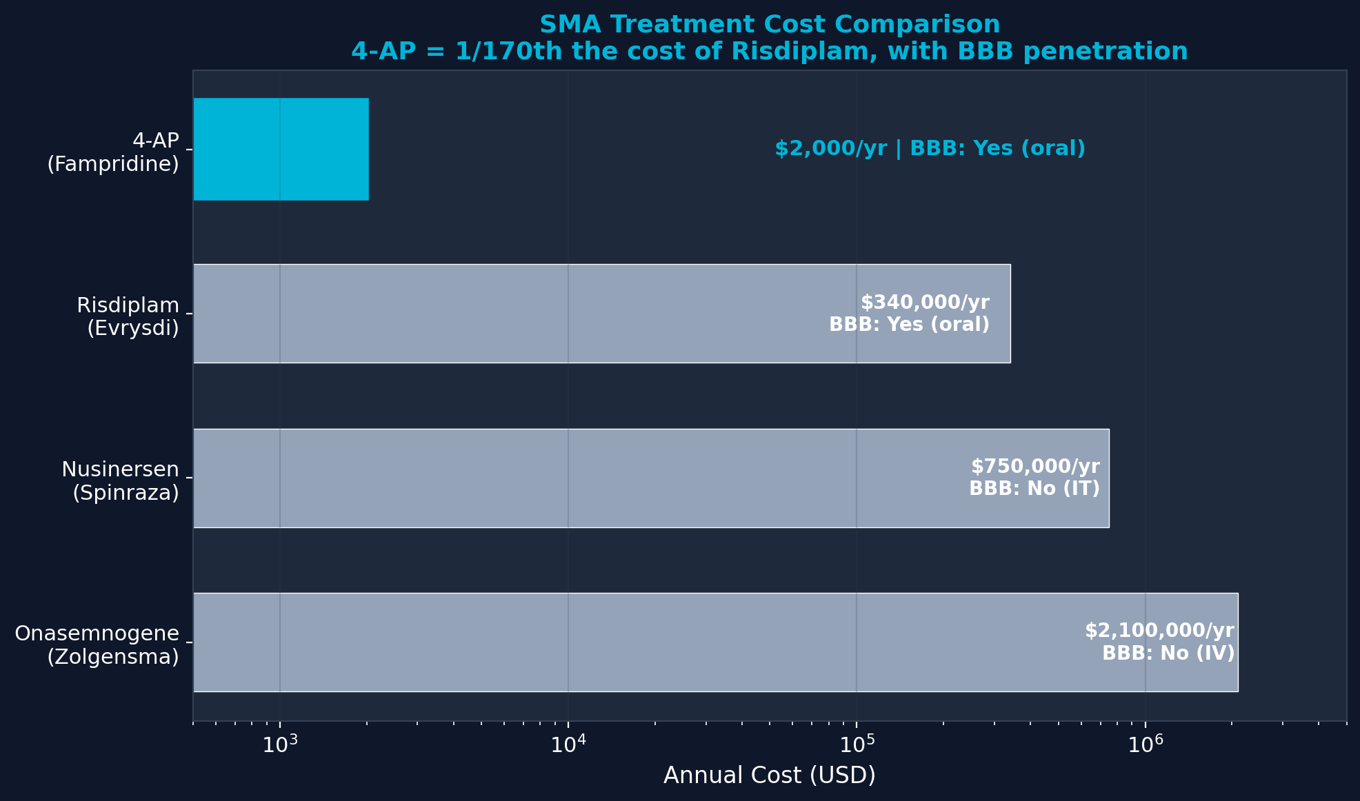
Figure 6: Treatment cost comparison — 4-AP at $2K/year vs $340K-$2.1M for current SMA therapies.

ADMET Safety Profile
Property | Value | Interpretation
BBB Penetration | 79% | Excellent — critical for SMA
Oral Bioavailability | 94% | Excellent
hERG Risk | 12% | Low cardiac risk
AMES Mutagenicity | 55% | CAUTION — borderline
ClinTox | 2% | Very low
DILI (Liver) | 62% | Moderate — known
Half-life | 19h | Once-daily dosing
Solubility | 73% | Good

Data Availability (Open Access)
GitHub: https://github.com/Bryzant-Labs/sma-research/tree/main/4-AP-Campaign
Platform: https://sma-research.info
Trajectories (37 GB): Dropbox shared folder — christian@bryzant.com

Proposed Experimental Validation
- SPR binding assay: 4-AP vs recombinant CORO1C — measure KD
- iPSC-derived SMA motor neurons: 4-AP effect on survival & actin dynamics
- SMNΔ7 mouse model: 4-AP + Risdiplam combination
- Proteomics: CORO1C, PLS3, CFL2 levels in 4-AP-treated SMA fibroblasts

