1. **Show demo of simple CRUD in MVC concept.**

**Models/Employee.cs**

using System.ComponentModel.DataAnnotations;

using System.Collections.Generic;

namespace EmployeeManagement.Models{

public class Employee{

public int Id { get;set;}

[Required(ErrorMessage= "First Name is required")]

public string FirstName { get;set;}

[Required(ErrorMessage="Last Name is required")]

public string LastName { get; set;}

public string Address { get; set;}

public byte? Age { get; set;}

public float? Salary { get; set;}

}

}

**Controllers/EmployeeController.cs**

using System;

using System.Collections.Generic;

using Microsoft.AspNetCore.Mvc;

using System.Linq;

using EmployeeManagement.Models;

using EmployeeManagement.Data;

namespace EmployeeManagement.Controllers{

public class EmployeeController : Controller

{

private readonly EMSContext db;

public EmployeeController(EMSContext _db)

{

db = _db;

}

public IActionResult Index()

{

var employees = db.Employees.ToList();

return View(employees);

// return View();

}

public IActionResult Detail(int id){

var employee = db.Employees.Find(id);

return View(employee);

}

public IActionResult Add(){

return View();

}

[HttpPost]

public ActionResult Add(Employee employee){

db.Employees.Add(employee);

db.SaveChanges();

return RedirectToAction("Index");

}

[HttpGet]

public ActionResult Edit(int id)

{

var employee = db.Employees.Find(id);

return View(employee);

}

[HttpPost]

public ActionResult Edit( Employee employee)

{

db.Employees.Attach(employee);

db.Employees.Update(employee);

db.SaveChanges();

return RedirectToAction("Index");

}

public ActionResult Delete(int id)

{

var employee = db.Employees.Find(id);

return View(employee);

}

[HttpPost]

public ActionResult Delete(Employee employee)

{

db.Employees.Attach(employee);

db.Employees.Remove(employee);

db.SaveChanges();

return RedirectToAction(nameof(Index));

}

}

}

**Views/Employee/Add.cshtml**

@model Employee

<form asp-controller="Employee" asp-action="Add" method="POST">

<div class="form-group">

<span asp-validation-for="FirstName" class="text-danger"></span>

<input type="text" class="form-control" asp-for="FirstName" placeholder=" First Name" >

</div>

<div class="form-group">

<span asp-validation-for="LastName" class="text-danger"></span>

<input type="text" class="form-control" asp-for="LastName" placeholder=" Last Name" >

</div>

<div class="form-group">

<textarea class="form-control" asp-for="Address" rows="3" placeholder=" Address" ></textarea>

</div>

<div class="form-group">

<input type="number" class="form-control" asp-for="Age" placeholder=" Age" >

</div>

<div class="form-group">

<input type="number" class="form-control" asp-for="Salary" placeholder=" Salary" >

</div>

<div class="form-check">

<input type="checkbox" class="form-check-input" id="exampleCheck1">

</div>

<button type="submit" class="btn btn-primary">Submit</button>

</form>

**Output:**

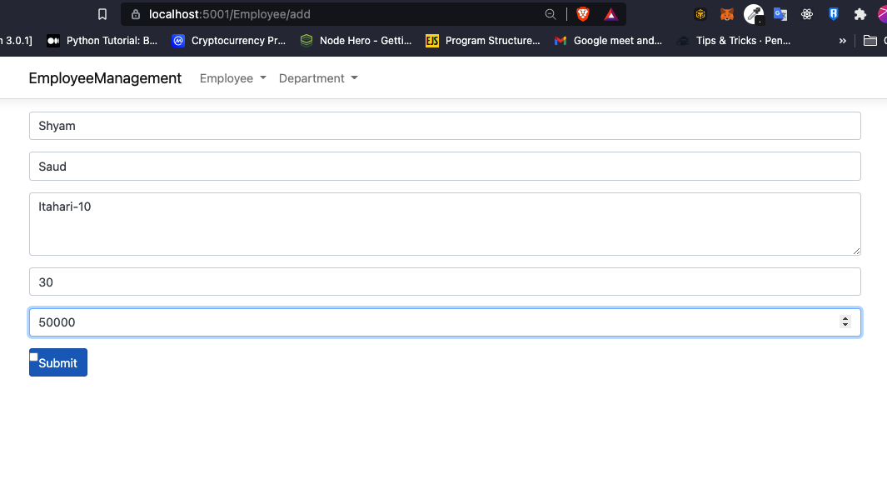

**Views/Employee/index.cshtml**

@model List<Employee>;

@{

ViewData["title"]= "Employee";

}

<h1>List of Employeess

</h1>

<button> <a href="/Employee/add">Add Employee</a> </button>

<table class="table table-striped">

<thead>

<tr>

<th scope="col">Id</th>

<th scope="col">First Name</th>

<th scope="col">Last Name</th>

<th scope="col">Address</th>

<th scope="col">Age</th>

<th scope="col">Salary</th>

</tr>

</thead>

@foreach (var item in Model)

{

<tbody>

<tr>

<th scope="row">@item.Id</th>

<td>

<a href = "/Employee/detail?id=@item.Id">@item.FirstName</a> </td>

<td>@item.LastName</td>

<td>@item.Address</td>

<td>@item.Age</td>

<td>@item.Salary</td>

<td> <a href="/Employee/edit?id=@item.Id"><button class="btn btn-primary">Edit</button></a> <a href="/Employee/delete?id=@item.Id"> <button class="btn btn-danger">Delete</button></a></td>

</tr>

</tbody>

}

</table>

**Output:**

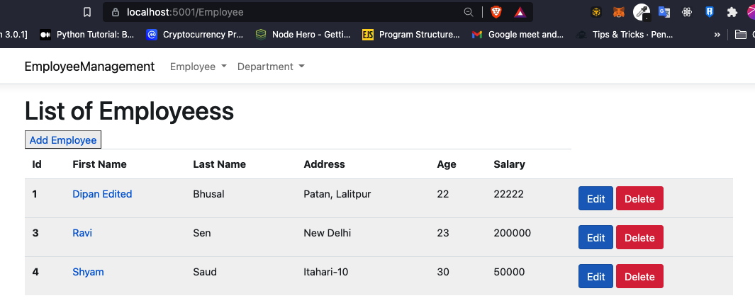

**Views/Detail.cshtml**

@model Employee

@{

ViewData["title"] = Model.FirstName;

}

<h4>@Model.FirstName

<a href="/Employee" class="btn btn-secondary">Back To Home</a>

</h4>

<ul class="list-group">

<li class="list-group-item"><label>First Name:</label>@Model.FirstName</li>

<li class="list-group-item"><label>Last Name:</label>@Model.LastName</li>

<li class="list-group-item"><label> Salary:</label>@Model.Salary</li>

<li class="list-group-item"><label> Address:</label>@Model.Address</li>

<li class="list-group-item"><label> Age:</label>@Model.Age</li>

</ul>

**Output:**

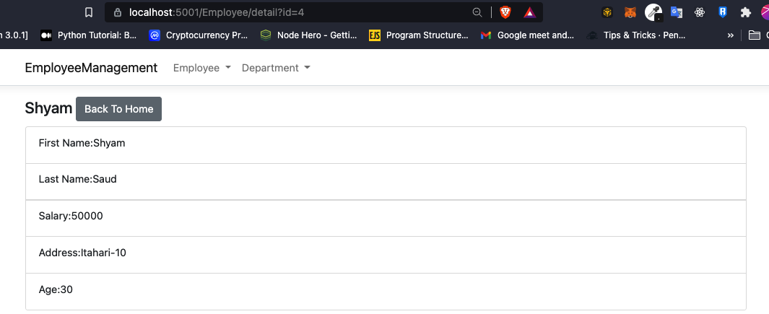

**Views/Employee/Delete.cshtml**

@model Employee

@{

ViewData["title"] = "Delete";

}

<h2>Are you sure you want to delete employee @Model.FirstName @Model.LastName's data? </h2>

<form asp-controller="Employee" asp-action="Delete" method="POST">

<input type="hidden" asp-for="Id" />

<button type="submit" class="btn btn-danger">Delete Anyway</button>

</form>

<a href="/Employee/detail?id=@Model.Id"><button class="btn btn-primary">Go back to employee</button></a>

Output:

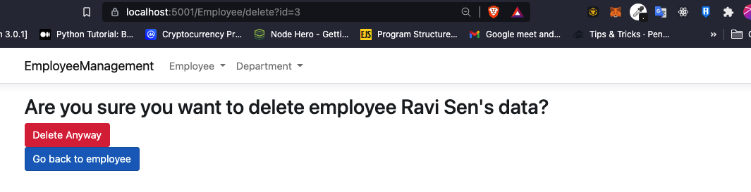

**Views/Employee/Edit.cshtml**

@model Employee

@{

ViewData["title"] = "Edit Employee";

}

<form asp-controller="Employee" asp-action="Edit" method="POST">

<input type="hidden" asp-for="Id" />

<div class="form-group">

<span asp-validation-for="FirstName" class="text-danger"></span>

<input type="text" class="form-control" asp-for="FirstName" placeholder="First Name">

</div>

<div class="form-group">

<span asp-validation-for="LastName" class="text-danger"></span>

<input type="text" class="form-control" asp-for="LastName" placeholder=" Last Name" >

</div>

<div class="form-group">

<textarea class="form-control" asp-for="Address" rows="3" placeholder=" Address" ></textarea>

</div>

<div class="form-group">

<input type="number" class="form-control" asp-for="Age" placeholder=" Age" >

</div>

<div class="form-group">

<input type="number" class="form-control" asp-for="Salary" placeholder=" Salary" >

</div>

<button type="submit" class="btn btn-primary">Update</button>

</form>

Output:

