**MVC pattern**

**Department Controller**

using System;

using System.Collections.Generic;

using System.Diagnostics;

using System.Linq;

using System.Threading.Tasks;

using Microsoft.AspNetCore.Mvc;

using Microsoft.Extensions.Logging;

using EmployeeManagement.Models;

namespace EmployeeManagement.Controllers

{

public class DepartmentController : Controller

{

public IActionResult Index()

{

var department = Department.GetDepartments();

return View(department);

}

public ActionResult Detail(int id)

{

var departments = Department.GetDepartments();

var emp = departments.FirstOrDefault(x => x.Id == id);

return View(emp);

}

public ActionResult Add()

{

return View();

}

[HttpPost]

public string Add(Department department)

{

return "Record Saved";

}

}

}

**Department Model**

using System.ComponentModel.DataAnnotations;

using System.Collections.Generic;

namespace EmployeeManagement.Models

{

public class Department

{

public int Id {get; set;}

[Required(ErrorMessage="Department name Required!!")]

public string DepartmentName {get; set;}

public int DepartmentNo {get; set;}

public string Floor {get; set;}

public float Salary { get; set;}

public static List<Department> GetDepartments()

{Department department1 = new Department()

{

Id = 103,

DepartmentName = "Finance",

DepartmentNo = 770,

Floor = "3rd",

Salary = 3000000

};

Department department2 = new Department()

{

Id = 104,

DepartmentName = "HR",

DepartmentNo = 800,

Floor = "1st",

Salary = 8900000

};

Department department3 = new Department()

{

Id = 105,

DepartmentName = "Marketing",

DepartmentNo = 900,

Floor = "2nd",

Salary = 8500000

};

List<Department> departments = new List<Department>() {department1, department2,department3};

return departments;

}

}

}

**Department View**

**Add.cshtml**

@model Department

@{

ViewData["t"] = "Add Department";

}

<form asp-controller="Department" asp-action="Add" method="POST">

<div class="form-group">

<label asp-for="DepartmentName">DepartmentName</label>

<span asp-validation-for="DepartmentName" class="text-danger"></span>

<input type="text" class="form-control" asp-for="DepartmentName" placeholder="Enter Department name">

</div>

<div class="form-group">

<label asp-for="DepartmentNo">DepartmentNo</label>

<input type="number" class="form-control" asp-for="DepartmentNo" placeholder="Enter Department No">

</div>

<div class="form-group">

<label asp-for="Floor">Floor</label>

<input type="number" class="form-control" asp-for="Floor" placeholder="Enter Floor Number">

</div>

<div class="form-group">

<label asp-for="Salary">Salary</label>

<input type="number" class="form-control" asp-for="Salary" placeholder="Enter Salary">

</div>

<button type="submit" class="btn btn-primary">Add Department</button>

</form>

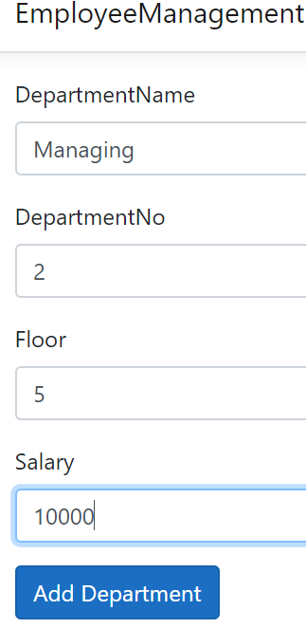

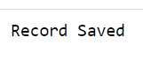

**Detail.cshtml**

@model Department

<h2>@Model.DepartmentName Detail<a class="btn btn-primary" href="/Department/Index">Back to Department List</a>

</h2>

<ul class="list-group list-group-flush">

<li class="list-group-item"></b>DepartmentName: @Model.DepartmentName</li>

<li class="list-group-item"></b>DepartmentNo: @Model.DepartmentNo</li>

<li class="list-group-item"></b>Floor: @Model.Floor</li>

<li class="list-group-item"></b>Salary: @Model.Salary</li>

</ul>

