**E-commerce**

E-commerce, or electronic commerce, refers to transactions conducted via the internet. Every time individuals and companies are buying or selling products and services online they’re engaging in e-commerce. The term e-commerce also encompasses other activities including online auctions, internet banking, payment gateways, and online ticketing.

**History of E-commerce**

The first e-commerce transaction was made in 1994. A guy named Phil Brandenberger used his MasterCard to buy Sting’s Ten Summoner’s Tales via the internet for $12.48. This particular transaction made history and signaled to the world that the “internet is open” for e-commerce transactions. Needless to say, e-commerce has grown by leaps and bounds ever since. [The rise of ecommerce giants like Amazon and Alibaba in the mid -1990s](https://www.bigcommerce.com/blog/ecommerce/" \l "the-impact-of-ecommerce) changed the face of the retail industry. They largely capitalized on the global internet penetration and digitalization of the financial system which [contributed to the decline in sales](https://www.floship.com/amazon-killing-traditional-retail/) for many brick-and-mortar businesses. The growth of ecommerce has also shifted the retail workforce. The US Bureau of Labour Statistics (BLS) has revealed that from 1997 to 2016, e[mployment in the ecommerce sector](https://www.bls.gov/careeroutlook/2018/article/e-commerce-growth.htm?view_full) increased by 80%. BLS is also predicting that the number of ecommerce jobs will keep on growing and reach 450,000 in the US by 2026.

**Business model of the ShoppMe E-commerce website**

A business model is a framework for how a company will create value. Ultimately, it distills the potential of a business down to its essence. A business model answers fundamental questions about the problem you are going to solve, how you will solve it, and the growth opportunity within a given market.

The business model we have chosen for our website is Business-to-consumer model. Under this model, we directly sell our products to the consumers without presence of any intermediary. Consumers will be able to browse the products listed on the website and choose and buy according to their choice. The use of e-payment will ensure they can pay digitally and the product will be delivered to their destination within certain time period.

The value of our business comes from the transaction of the user. So the main focus is to drive up the website traffic and bring up as many user as the servers can handle. The website traffic can be improved by SEO optimization, influence marketing where a well know personality is asked to promote our website or use a product form our website, social media marketing where we optimize our social media page and advertise our product to large volume of social media users. Social media marketing can only be impactful if we have large social media presence.

**Case Study Of Payment System(E-Sewa)**

# **Introduction:**

It is a form of direct payments and banking without physical appearance at the MDA(Maximum Distributable Amount) or Bank through the means of electronic, interactive communication channels and other technology infrastructure. Simply, it is easier and safer way of electronic transfer of money from one account to another account with both customer and merchant benefited.

Online payment refers to money that is exchanged electronically. Typically, this involves use of computer networks, the internet and digital stored value systems. When you collect a payment over the internet, you are accepting an online payment. Online payment usually is the transaction that results in transfer of monetary funds from the customer bank or credit card account to your bank account. The online payment can be done from a credit card, checking account or other clearing house like PayPal for example.

In Nepal there has been increasing demand for electronic payment in recent years mainly in the urban areas. Due to rapid demand and keen interest in the newer technology there have been positive impacts as it has ease our daily life.

In our case study we are concerned about electronic payment provided by e-sewa.

# **Background:**

Recharge cards were the only way to recharge multiple platforms for a long time. You have to physically travel to the shop that sell the recharge card for your designed platform, which were easy for telecoms but extremely difficult for cable TV networks because they were only available in specific stores. e-Sewa’s online top-up system has made recharging accessible to everyone. A simple top-up has the same functionality as recharge cards with almost negligible efforts when compared to recharge cards. e-Sewa is operation since 2009 and has recently been licensed by Nepal Rastra Bank as Payment Service Provider .

**Problem definition:**

The customers throughout the country were complaining of the recharge card problem and it was a havoc for taking longer time to resolve. One of the main reasons for replacement of recharge card is that there was saying and belief that while scratching the recharge card we may suffer from cancer. So, to minimize the problem faced by customer and to save time of buying recharge card e-Sewa top-up was introduced.

**Objectives:**

The objectives of the case study are:

• To find the changes occurred after introducing e-Sewa top-up.

• To find the range of people using e-Sewa top-up service.

• To know the benefits of e-Sewa top-up over recharge card.

• To know the help provided by e-Sewa in E-Commerce business.

**Methodology:**

Google search engine is one of the best ways to collect information. The installation of eSewa app has also been one of the methods to know how to use e-Sewa i.e. know about the login process. The login is done by phone number or email and we get the authentication code to be registered in e-Sewa networks. After login we can know the various services included in e-Sewa top-up.

# **Overview of e-sewa:**

Esewa is Nepal-based company mainly focused on electronic payment system It is one of the major service provided by f1soft.com which is the well known name for safer and easier way to pay online. It offers a state-of-art payment gateway solution that incorporates some of the latest integrated techniques developing a secured, fast, and real-time gateway. . It has been growing as trusted company because of its quality service to its customers.

Though there are others payment gateways e-sewa has become the first choice due to its goodwill. More than twenty five thousand of customers with sixty five percent of active customers have been benefited by its services and the number of users is increasing day by day.

Services provided by e-sewa:

1. Send and Receive Money
2. eSewa in Mobile
3. Pay Utility Bills
4. Buy Air Tickets
5. Buy Recharge Cards
6. Pay School, College Bills
7. Pay Internet Bills
8. Subscribe Newspapers, Magazine
9. Pay Credit Card Bills

e-sewa recharge cards can be purchased from theirs partner banks counters. E-Sewa recharge cards are available in two face values. Rs. 2000 and Rs. 5000. Scratch the shaded area behind the recharge card to reveal the 16 digit pin code. Once we enter the pin code our account is funded with amount equivalent to the face value of the card. Can also recharge from Through Internet Banking of Partner Banks and Counter Deposit in Partner Banks. Such as:

1. Laxmi Bank
2. Kumari Bank
3. NCC Bank
4. NIC Bank
5. Global Bank
6. Sanima Bank
7. ACE
8. Bank of Asia
9. Bank of Kathmandu
10. KIST Bank
11. Commerz and Trust Bank

**Services:**

The services provided by e-Sewa top-up are:

• NTC (Prepaid, Postpaid, CDMA, ADSL, Landline).

• NCELL (Prepaid, Postpaid).

• SMART CELL.

# **Security via e-sewa:**

eSewa is the safer, easier way to pay. We can use our credit card/Bank account with eSewa, and get all the benefits - without exposing our bank account/card number. Customer's financial security is highest priority of e-sewa. eSewa uses SSL technology to keep information safe. In addition, when customer sends payment using eSewa, the recipient won't receive sensitive financial information like your credit card or bank account number.

# **Challenges:**

Challenges that esewa must deal are mainly government regulations and limited use of electronic payment in Nepal. In Nepal credit card payment has not yet emerged. Although, few banks provide credit card facility, people do not use credit card. It may be because credit card cannot be used for international purchase due to government policies. Since, Nepal is receiving only country it has been difficuilt for esewa to establish itself internationally. On the other side, people prefer hand cash than the digital cash.

# **Conclusion:**

E-Sewa has evolved as a dynamic and interactive platform for electronic payment. It has changed the way of payment, gradually replacing the traditional way of payment. Its success has been remarkably acknowledged by more people in urban areas where there is a good infrastructure for internet and network services. It is expected that the way e-sewa is emerging will definitely serve the people ensuring more security, reliability and efficiency in the coming days.

**Homepage of website**

A company's homepage is its face to the world and the starting point for most user visits. Homepages are the most valuable real estate in the world. Each year, companies and individuals funnel millions of dollars through a space that's not even a square foot in size. For good reason. A homepage's impact on a company's bottom line is far greater than simple measures of e-commerce revenues: The homepage is a company's face to the world. Increasingly, potential customers will look at a company's online presence before doing business. The homepage is the most important page on most websites, and gets more page views than any other page. Of course, users don't always enter a website from the homepage. A website is like a house in which every window is also a door: People can follow links from search engines and other websites that reach deep inside your site. However, one of the first things these users do after arriving at a new site is go to the homepage,

Thus, keeping the importance of homepage in mind, we decided to display all the categories of our products that we offer in home page. The homepage also contains the header with login info and the cart. All this helps the user to navigate through the products section as well as the login/profile section. The design of the homepage captures the company’s brand eloquently where each graphics try to capture the product.

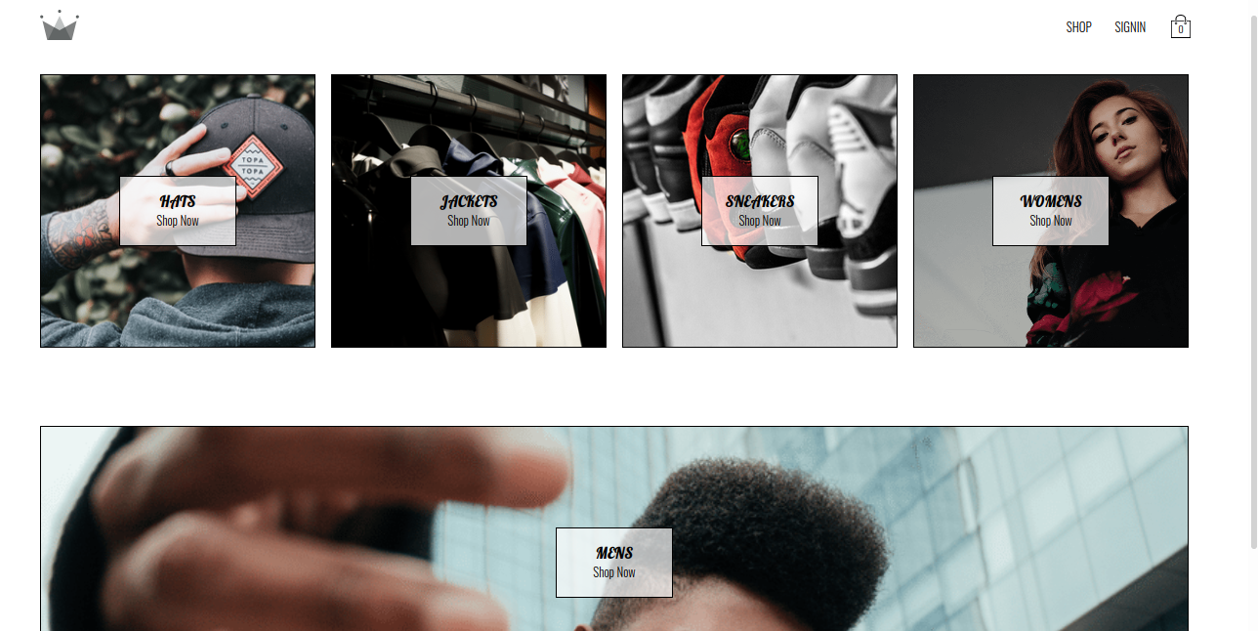

**Catalog of the website**

An e-commerce catalog is commonly defined as any online catalog that showcases the products or services of a company that operates primarily online, or in e-[commerce](https://www.wisegeek.com/what-is-commerce.htm). This catalog represents part of a general shift in the way the world's consumer base does business. A large amount of what used to take place in physical stores now happens online. Just as physical or brick and mortar stores have migrated to the internet, many of their catalogs have moved from print to online formats.

The catalog of our website is based on the simplicity. The products are organized under a category in a grid system. Each product is displayed with its image alongside the name of the product and its price. As the product increases, it can increase the page length and fit in it. The screenshot of the proposed catalog is displayed below.

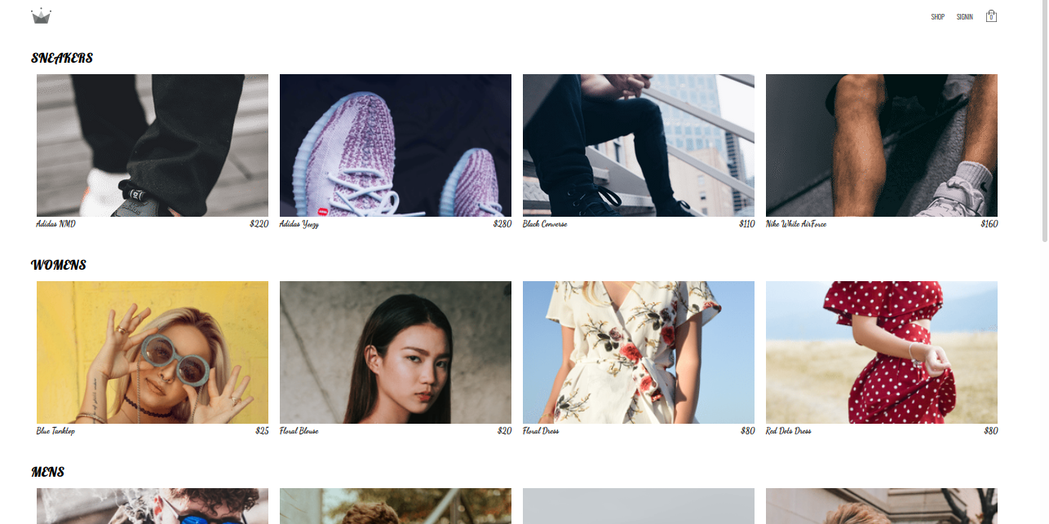

**Form validation technique**

Form validation is a technical process where a [web-form checks](https://designmodo.com/ux-form-validation/) if the information provided by a user is correct. The form will either alert the user that they messed up and need to fix something to proceed, or the form will be validated and the user will be able to continue with their registration process. There are two types of form validation:

**Client side validation:**

In client side validation techniques, we determine if the format of entered input is correct or not. We check if the user entered email, date, number etc format matches the standard format of the input. The comparison check is also performed here. The common comparison is done to password where user has to enter the password and confirm password. The form advances only when the two field matches.

**Server side validation:**

The server side validation performs all the validation of client side again, plus it checks the length of the input. It checks the length of the input with the description of model, and either grants access or rejects the request.

**Access control mechanism**

Access control is a method of restricting access to sensitive data. Only those that have had their identity verified can access company data through an access control gateway. Like most websites, the main access control mechanism applied is login system. When the user is registered, an email and password is set along side recovering methods. So, the next time the user needs access of the privilege section in website, user needs to enter the login credentials that has been registered.

**Session management**

Session management is the rule set that governs interactions between a web-based application and users. Browsers and websites use HTTP to communicate, and a web session is a series of HTTP requests and response transactions created by the same user. Since HTTP is a stateless protocol, where each request and response pair is independent of other web interactions, each command runs independently without knowing previous commands. In order to introduce the concept of a session, it is necessary to implement session management capabilities that link both the authentication and access control (or authorization) modules commonly available in web applications.

In this website we have used cookie-based session management. A cookie is a small piece of data sent by a server to a browser and stored on the user’s computer while the user is browsing. Cookies are produced and shared between the browser and the server using the HTTP Header.

It Allows server store and retrieves data from the client, It Stored in a file on the client side and maximum size of cookie that can be stored is limited up to 4K in any web browser. Cookies have a short time period because they have expiry date and time as soon as the browser closed.

**Cart**

A shopping cart on an online retailer's site is a piece of software that facilitates the purchase of a product or service. It accepts the customer's payment and organizes the distribution of that information to the merchant, [payment processor](https://www.bigcommerce.com/payments/) and other parties. Shopping carts bridge the gap between shopping and buying, so having the [best shopping cart software](https://www.bigcommerce.com/shopping-cart/) is extremely important on a website.

We have used a cart icon on the header of the website that shows a drop-down of product selected. The no of items can be reduced or increased according to the desire of the user. It contains checkout option which takes the user to checkout page where payment can be done.

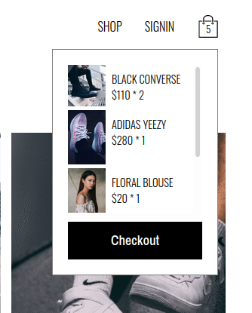

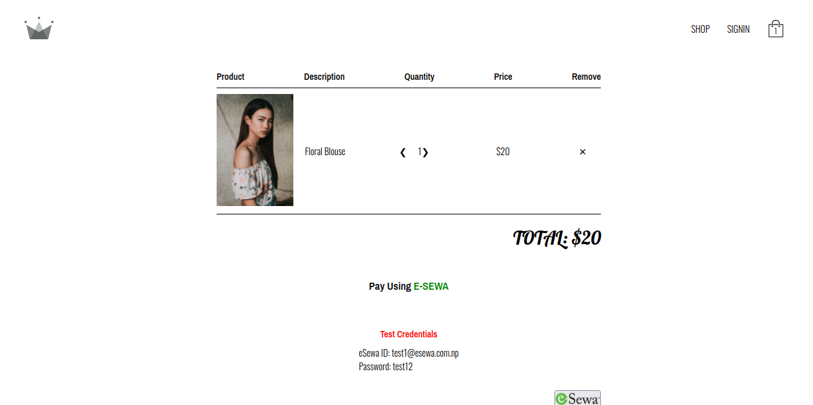

**Facebook**

Facebook is an American online social media and social networking service based in Menlo Park, California, and a flagship service of the namesake company Facebook, Inc. It was founded by [Mark Zuckerberg](https://en.wikipedia.org/wiki/Mark_Zuckerberg), along with fellow [Harvard College](https://en.wikipedia.org/wiki/Harvard_College) students and roommates [Eduardo Saverin](https://en.wikipedia.org/wiki/Eduardo_Saverin), [Andrew McCollum](https://en.wikipedia.org/wiki/Andrew_McCollum), [Dustin Moskovitz](https://en.wikipedia.org/wiki/Dustin_Moskovitz), and [Chris Hughes](https://en.wikipedia.org/wiki/Chris_Hughes).

The founders of Facebook initially limited membership to Harvard students. Membership was expanded to [Columbia](https://en.wikipedia.org/wiki/Columbia_University), [Stanford](https://en.wikipedia.org/wiki/Stanford_University), and [Yale](https://en.wikipedia.org/wiki/Yale_University) before being expanded to the rest of the [Ivy League](https://en.wikipedia.org/wiki/Ivy_League), [MIT](https://en.wikipedia.org/wiki/Massachusetts_Institute_of_Technology), and [higher education institutions in the Boston area](https://en.wikipedia.org/wiki/List_of_colleges_and_universities_in_metropolitan_Boston), then various other universities, and lastly high school students. Since 2006, anyone who claims to be at least 13 years old has been allowed to become a registered user of Facebook, though this may vary depending on local laws. The name comes from the [face book](https://en.wikipedia.org/wiki/Face_book) directories often given to American university students.

**Facebook Analytics**

Facebook Analytics is a robust tool that lets marketers explore users’ interactions with advanced goal paths and sales funnels for Facebook ads.

Overall, [the Facebook Analytics update](https://developers.facebook.com/blog/post/2017/04/18/facebook-analytics-new-features-f8/) added these [features](https://developers.facebook.com/docs/analytics):

1. Advanced machine learning/AI capabilities to display important insights, such as which audiences are most often engaging with or converting from your content
2. Omni-channel analytics so you can view users who hopped from the Facebook app to your app to your website back to Facebook on desktop before converting
3. Custom dashboards so you can see important data at a glance
4. The ability to build custom audiences based on omni-channel insights
5. The ability to create [event source groups](https://www.facebook.com/help/analytics/1387547017939527) from the dashboard, allowing you to segment and retarget people who followed a specific event path on your page.

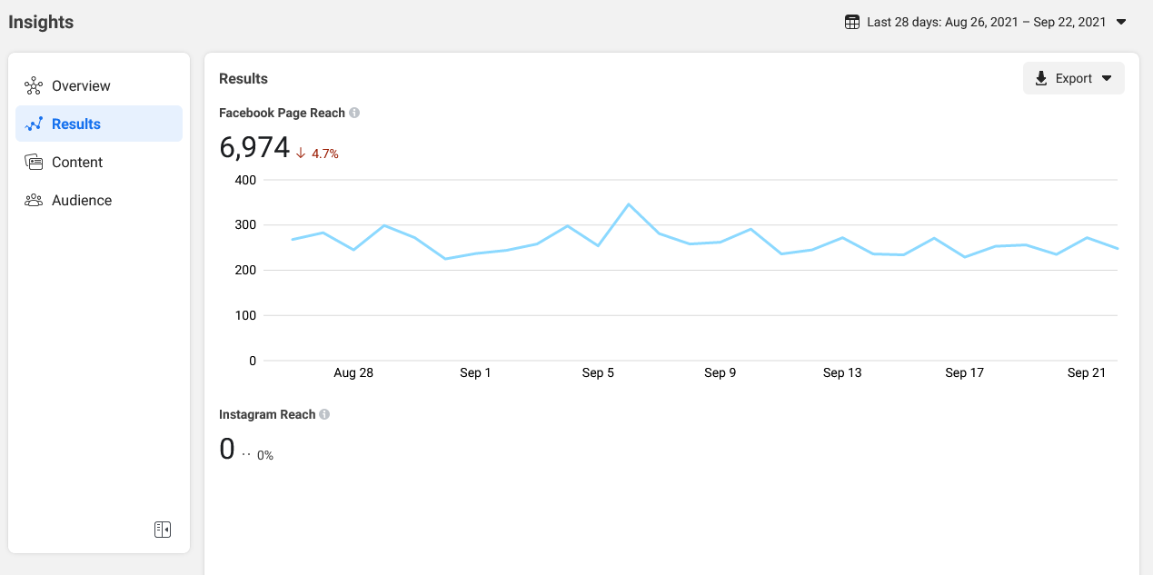

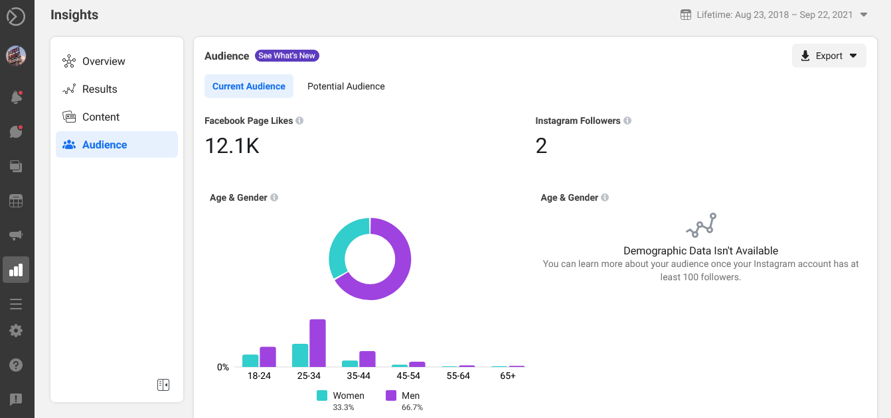

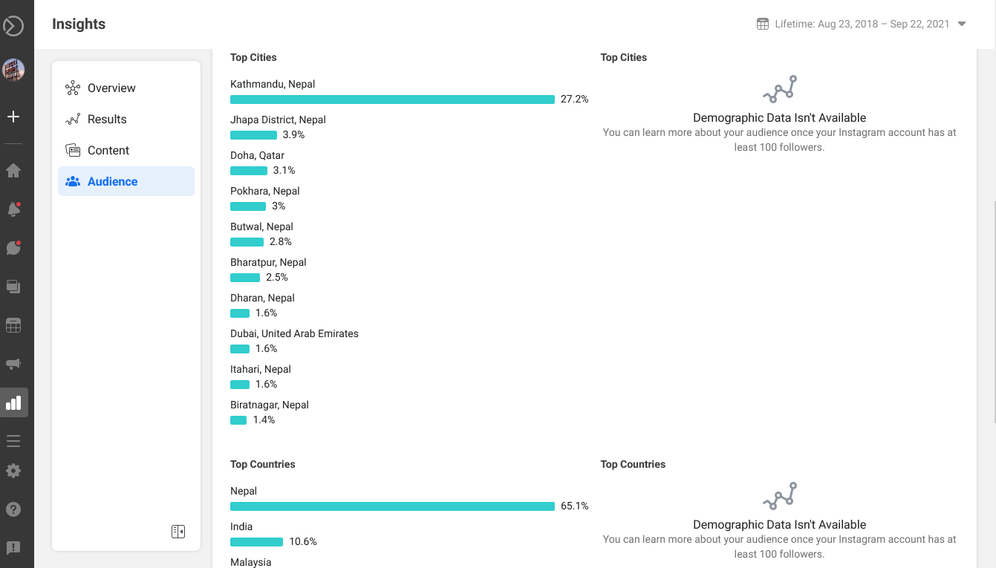

The real value of Facebook Analytics is how you use the data to make informed decisions for your business. It’s important to understand that even if a [Facebook ad campaign](https://www.socialmediaexaminer.com/how-to-set-up-an-effective-facebook-ad-campaign/) isn’t converting well, it may still be having a positive effect on your bottom line. These insights can help you see that.

For instance, suppose that one of your campaigns gets people to click but not convert. From there, people may interact with another retargeting campaign that’s converting well. Remember that without the initial campaign, you wouldn’t get the first touch point that arguably led to the final conversion.

So how do you use this data to your advantage? One way is to **see which funnels are converting best** and then **push to get more people through those funnels.**

For example, if you notice that most people convert after messaging you on Facebook, you can [use Messenger chatbots](https://www.socialmediaexaminer.com/how-to-create-facebook-messenger-chatbot/) to automatically engage with anyone who likes your page. Or if you notice people convert better after commenting, do more to [encourage comments](https://www.socialmediaexaminer.com/10-ways-to-increase-your-facebook-engagement/) such as posting questions for your audience to answer.

**Twitter**

Twitter, a social networking site launched in 2006, is undoubtedly one of the most popular social media platforms available today, with [100 million daily active users](https://www.omnicoreagency.com/twitter-statistics/) and [500 million tweets](https://www.omnicoreagency.com/twitter-statistics/) sent daily.

Twitter can be used to receive news, follow high-profile celebrities, or stay in-touch with old high school friends.

But its popularity can be intimidating -- if you don't know how to use Twitter in 2019, should you even bother trying to join the masses who've acquired years of experience on the site?

Fortunately, Twitter is incredibly easy to use. Here, we'll cover what Twitter is, who uses Twitter, and how you can get started on the site, today.

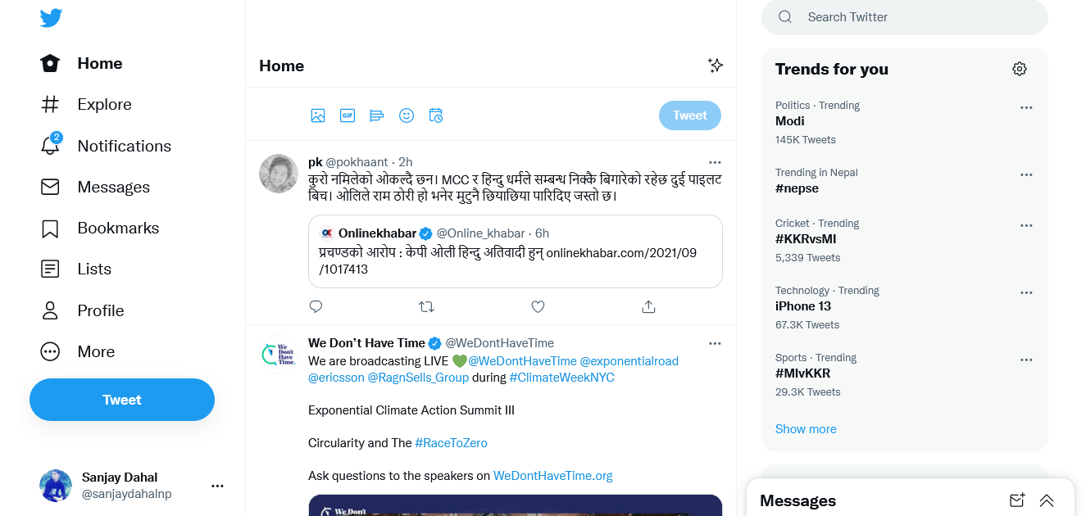

In 2006, Jack Dorsey, co-founder of Twitter, had an idea -- he would create a SMS-based communications platform in which friends could keep tabs on each other by updating statuses. In the beginning, Twitter was an idea all-too-similar to texting.

The idea evolved, in large part due to brainstorming sessions with Dorsey's co-founder, Evan Williams.

On March 21, 2006, Jack sent the first tweet, which read -- "just setting up my twttr."

Twitter saw [explosive growth at the 2007 South By Southwest Interactive conference](https://techcrunch.com/2011/01/04/twitter-foursquare-sxsw/), during which more than 60,000 tweets were sent. The Twitter team took advantage of the conference to begin growing their user base.

Twitter began as an SMS-based platform, so the 140 character limit was initially simply a necessity -- mobile carriers imposed the limit, not Twitter.

However, as Twitter grew to become a web platform, they kept the limit simply because it aligned with Twitter's brand -- Twitter is a platform that aims to create highly skimmable content for our tech-heavy, attention-deficit modern world.

Twitter has grown exponentially over the past 10+ years. Its purpose is ultimately to spread information fast -- while that information is not always serious (Kim Kardashian's thoughts on makeup, for instance), it sometimes is (like when [Iranian protesters used Twitter](https://abcnews.go.com/Technology/story?id=7979891&page=1) to assemble marches).

**Twitter Analytics**

Twitter analytics and knowing how to use them can change your social media game.

Whether it’s identifying which messages resonate, determining successful campaigns, or spotting holes in your customer service, the data at your fingertips can turn seemingly random social interactions into strategy-changing insights.

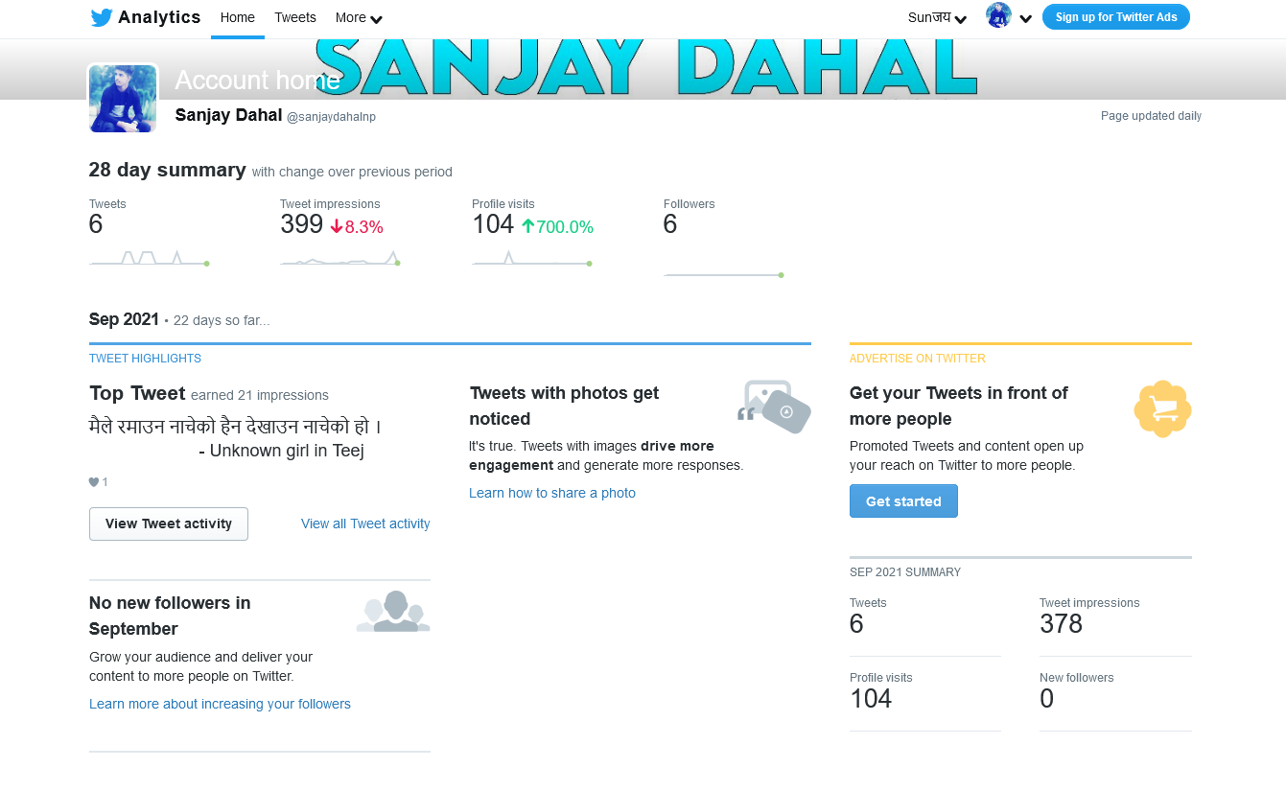

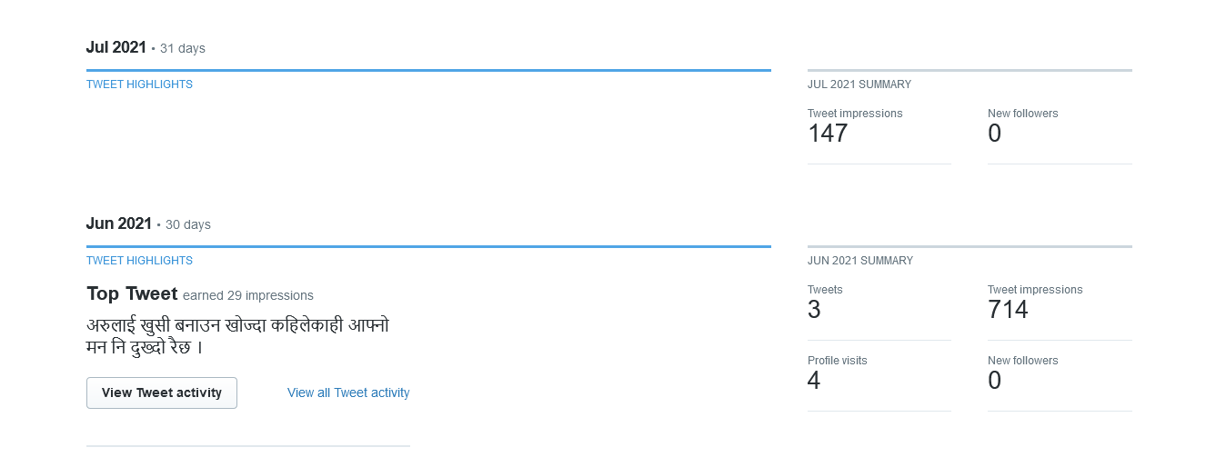

Any data you glean from Twitter analytics — or any analytics tool for that matter — will only give you clues about your organization’s performance. The next step after collecting data is to read between the lines and search for the real answers. Without the metrics, however, it’s nearly impossible to get this process underway.

**Google Analytics**

Google Analytics is a web analytics service that provides statistics and basic analytical tools for search engine optimization (SEO) and marketing purposes. The service is part of the Google Marketing Platform and is available for free to anyone with a Google account.

Google Analytics is used to track website performance and collect visitor insights. It can help organizations determine top sources of user traffic, gauge the success of their marketing activities and campaigns, track goal completions (such as purchases, adding products to carts), discover patterns and trends in user engagement and obtain other visitor information such as demographics. Small and medium-sized retail websites often use Google Analytics to obtain and analyze various [customer behavior analytics](https://searchcustomerexperience.techtarget.com/news/252441433/Customer-behavior-analytics-brings-marketing-analytics-together), which can be used to improve marketing campaigns, drive website traffic and better retain visitors.

### How does Google Analytics work?

Google Analytics acquires user data from each website visitor through the use of page tags. A [JavaScript](https://www.theserverside.com/definition/JavaScript) page [tag](https://whatis.techtarget.com/definition/tag) is inserted into the code of each page. This tag runs in the web browser of each visitor, collecting data and sending it to one of Google's data collection servers. Google Analytics can then generate customizable reports to track and [visualize](https://searchbusinessanalytics.techtarget.com/definition/data-visualization) data such as the number of users, bounce rates, average session durations, sessions by channel, page views, goal completions and more.

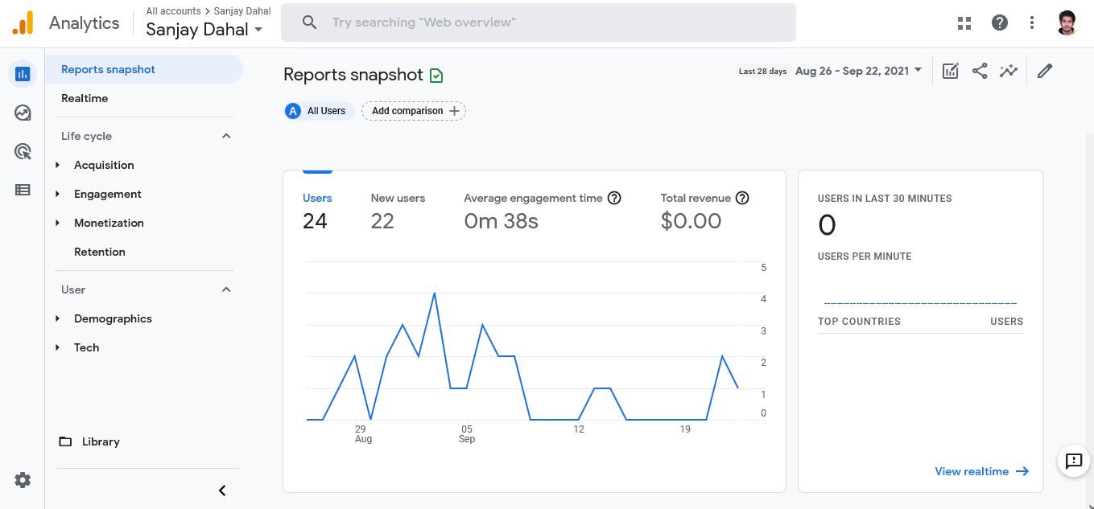

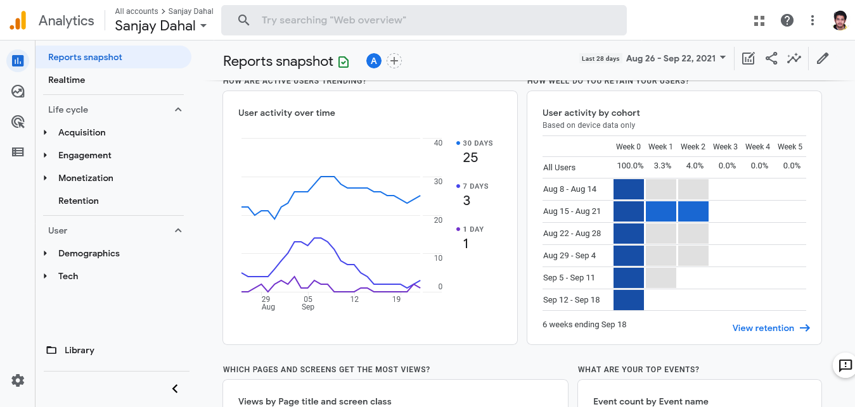

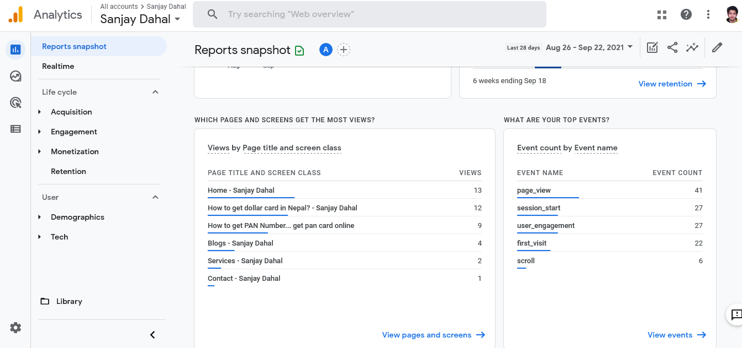

Google Analytics includes features that can help users identify trends and patterns in how visitors engage with their websites. Features enable data collection, analysis, monitoring, visualization, reporting and integration with other applications. These features include:

* data visualization and monitoring tools, including dashboards, [scorecards](https://searchbusinessanalytics.techtarget.com/definition/performance-scorecard) and motion charts that display changes in data over time;
* data filtering, manipulation and funnel analysis;
* data collection application program interfaces ([API](https://searchapparchitecture.techtarget.com/definition/application-program-interface-API)s);
* [predictive analytics](https://searchbusinessanalytics.techtarget.com/definition/predictive-analytics), intelligence and anomaly detection;
* segmentation for analysis of subsets, such as [conversions](https://whatis.techtarget.com/definition/conversion-rate-optimization);
* custom reports for advertising, acquisition, audience behavior and conversion;
* email-based sharing and communication; and
* integration with other products, including Google Ads, Google Data Studio, Salesforce Marketing Cloud, Google AdSense, Google Optimize 360, Google Search Ads 360, Google Display & Video 360, Google Ad Manager and Google Search Console.