USECASE

* Number of users: 10
* Loop count :5
* Ramp up period(seconds):10

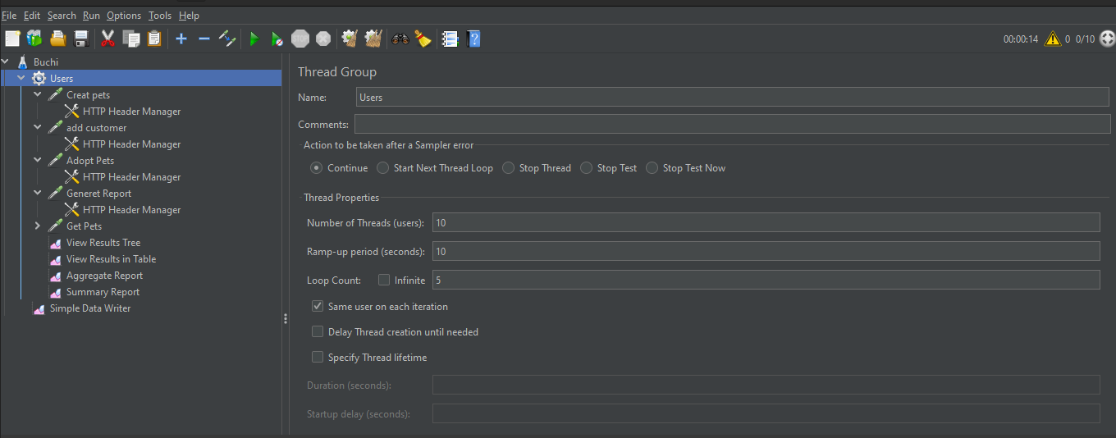

**View Results in Table**

Test result summery using view results in table:

* **Latency:** is a difference between time when request was sent and time when response has started to be received

**Response time** (Sample time/Load time/Elapsed time) is a difference between time when request was sent and time when response has been fully received So Response time always >= latency

* **Bytes:** represents the quantity of data in the sample response returned from the server
* **Latest sample :** last sampler’s Sample Time (ms)
* **Deviation:** standard deviation of Sample Time (ms)
* **No of Samples :** Total number of requests

