## **Activity Diagram**

Activity diagram is another important behavioral diagram in UML diagram to describe dynamic aspects of the system. Activity diagram is essentially an advanced version of flow chart that modeling the flow from one activity to another activity.

### **Justification**

Various reasons are there to design Activity diagram. Some of them are listed below:

* Helps to understand the workflow of the activity of the system.
* Helps to describe the complicated sequential algorithm.
* Helps to deal with multithreaded application.
* Helps to analyze use cases of the system.

### **Notation used**

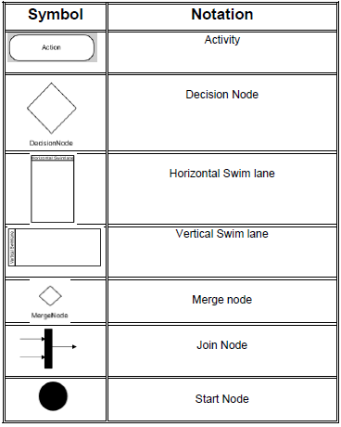

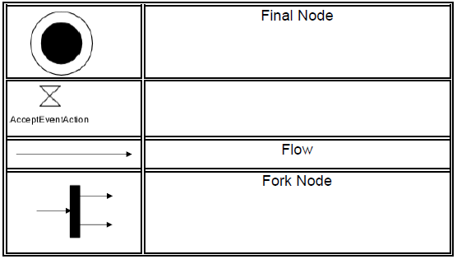

### **Actual Activity Diagram :**

The Activity Diagram for the Mark Sheet Generator is shown below:

