Two- Tier Architecture

**Client Application**

Database User

Database Application

**Server**

Database System

The two- tier architecture is simple type of architecture where the system is actually divided into two layers. One layer is called Client layer and another is Database layer.

Client layer consist of client or user application i.e. application that user will be using.

Database layer mean database of the system where data is being store.

In this architecture, Client action is taken in action after firing database query into the database through application connection interface like JDBC, ODBC, etc.

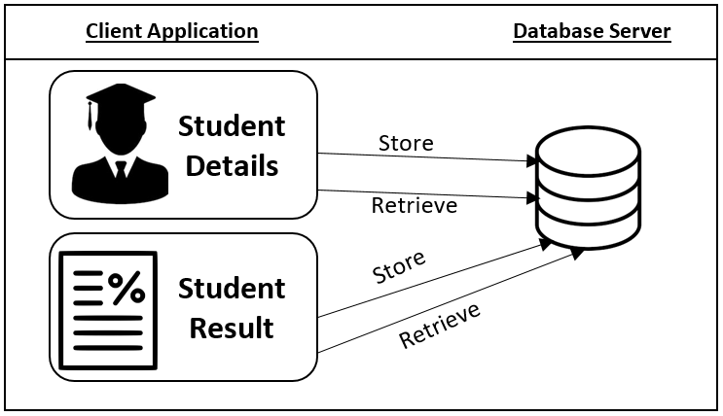  
For instance, in this system Mark Sheet Generator, when user enters the student information which is to be stored in database, it is stored in database by insert query at the back end of the program. Similarly, when the information is to be retrieve, select query is being trigger. In this way, other functionality of this system works on using two- tier architecture.