## **ER Diagram**

ER Diagram is the diagram that represents the logical structure of database. It shows all the possible relationship between the entities. It consists of entities and attributes of entities in the relationships.

### **Justification**

Various reasons are there to design ER diagram. Some of them are listed below:

* In order to determine the requirements of the system, ER model is designed in physical data modelling phase.
* Troubleshooting of the logical problems are easy while designing the ER model.
* ER model can be the base to create database of the system and conserve the time in designing of the databases.
* ER model can help in analyzing about data.

### **Notation used**

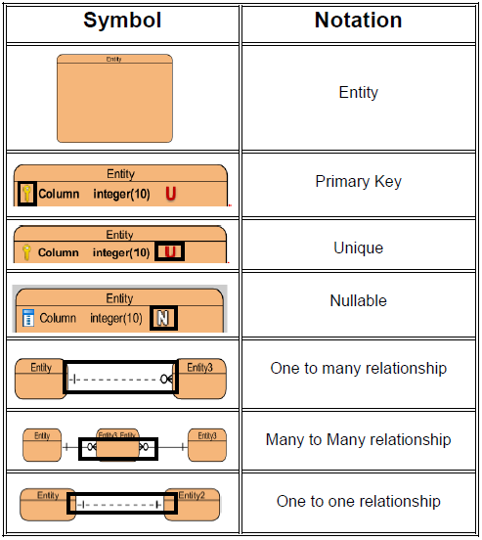

### **Actual ER Diagram:**

The ER model for the Mark Sheet Generator is shown below:

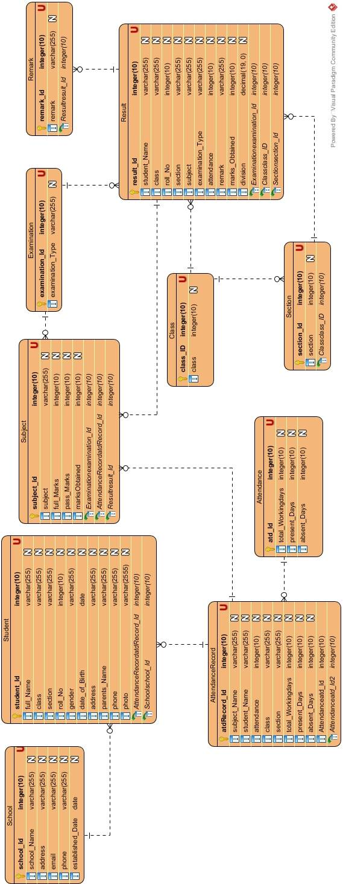

In the ER model above, I have created entities like School, Student, Subject, Examination, Remark, Result, Class, Section, Attendance and Attendance record.   
Here, one school consist of many students so school is represented as one to many relationship student. One class can have many sections, so it is thereby shown as one to many relationship. Under one examination there are several subjects so this is one to many relationship.

We needed to make attendance base upon the subjects i.e. subject wise attendance is to be performed. And based upon this issue, on the one attendance record there are multiple subjects. This mean subject have many to one relationship with attendance record entity.

Result table consist of all the students name, class, section, examination type, marks obtained on different subjects and so on. One result can have multiple subjects (one to many), one examination can have multiple results (one to many) and multiple remarks can be in one result (one to many).

Establishing all the possible relationship with entities can be fruitful to make database of the system.