## **Flow Chart**

### Flow chart is a graphical representation of a computer program in relation to its sequence of functions (as distinct from the data it processes).

### **Justification**

It shows how a process is performed from start to finish, typically in sequential order Troubleshooting of the logical problems are easy while designing the ER model. It helps to identify how long it takes to complete each task in a specific process. It is difficult to fix bugs and problems in workflow, if you do not know what went wrong and at which stage in the process it went wrong.

### **Notation used**

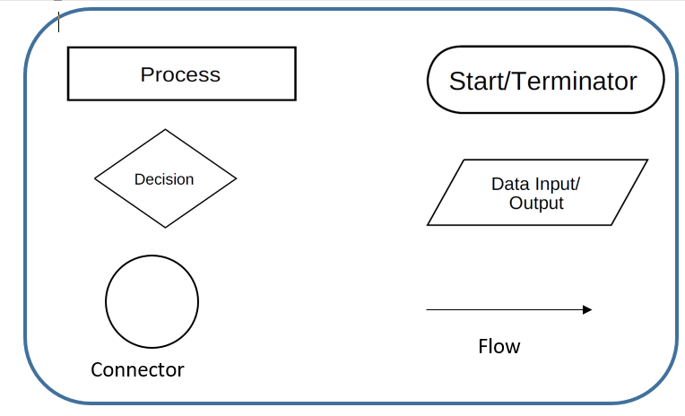

### **Actual Flow Chart**

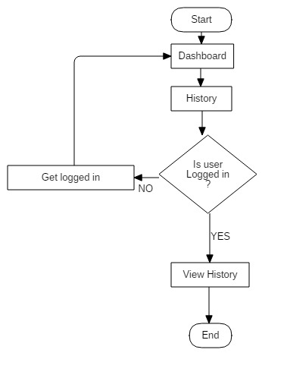

Here the flow of activity to view history is shown in aside flowchart. To view history user need to login.

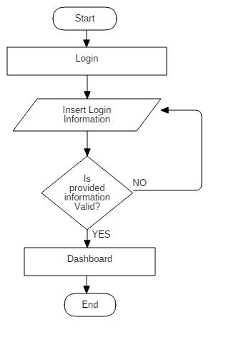

Here the flow of activity to login is shown in aside flowchart. All the valid information is to be entered to login.

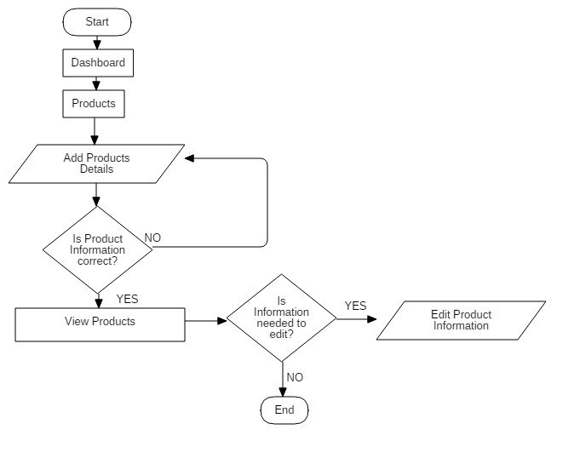

Here the flow of activity to add product details is shown in aside flowchart. Any changes that are to be made can be done.

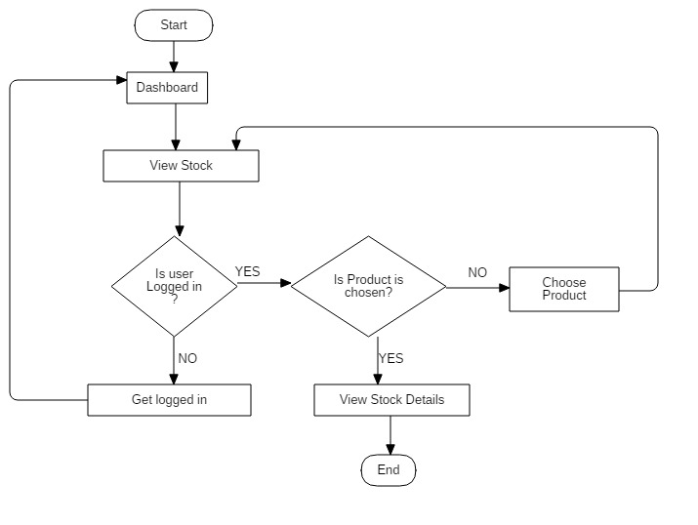

Here the flow of activity to view stock is shown in aside flowchart. User must done login to view stock. Items are to be selected to view stock information

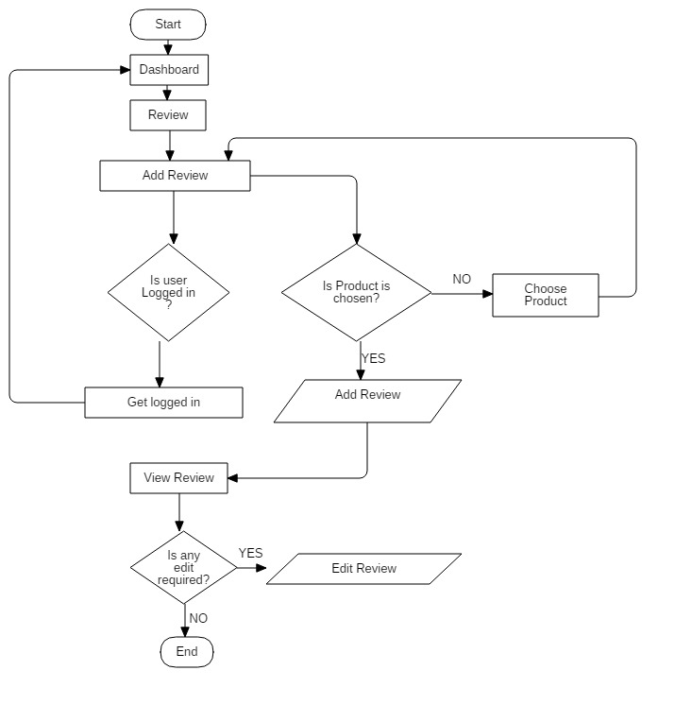

Here the flow of activity of review is shown in aside flowchart. User must be logged in to add and edit the reviews of products they wished. Just to view reviews login is not compulsory.

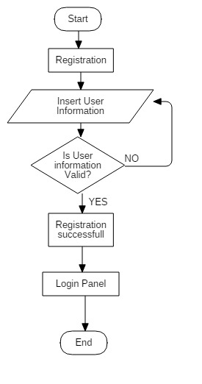

Here the flow of activity to register is shown in aside flowchart. All the valid information is to be entered to register.