## **Sequence Diagram**

Sequence Diagram is the behavioral diagram which prime motive is to represent the message flow between the objects of the system. It shows different types of message flow and lifelines of the messages and objects in the system.

### **Justification**

Reasons of creating sequence diagram are:

* Sequence Diagram is drawn to show the behavior of objects contained by a single use case.
* It is good at showing the association among the objects.
* It is drawn to get to know about the thorough functionality of systems.
* In order to visualize the logic behind function sequence diagram is drawn.

### **Notation**

### **Actual Sequence Diagram**

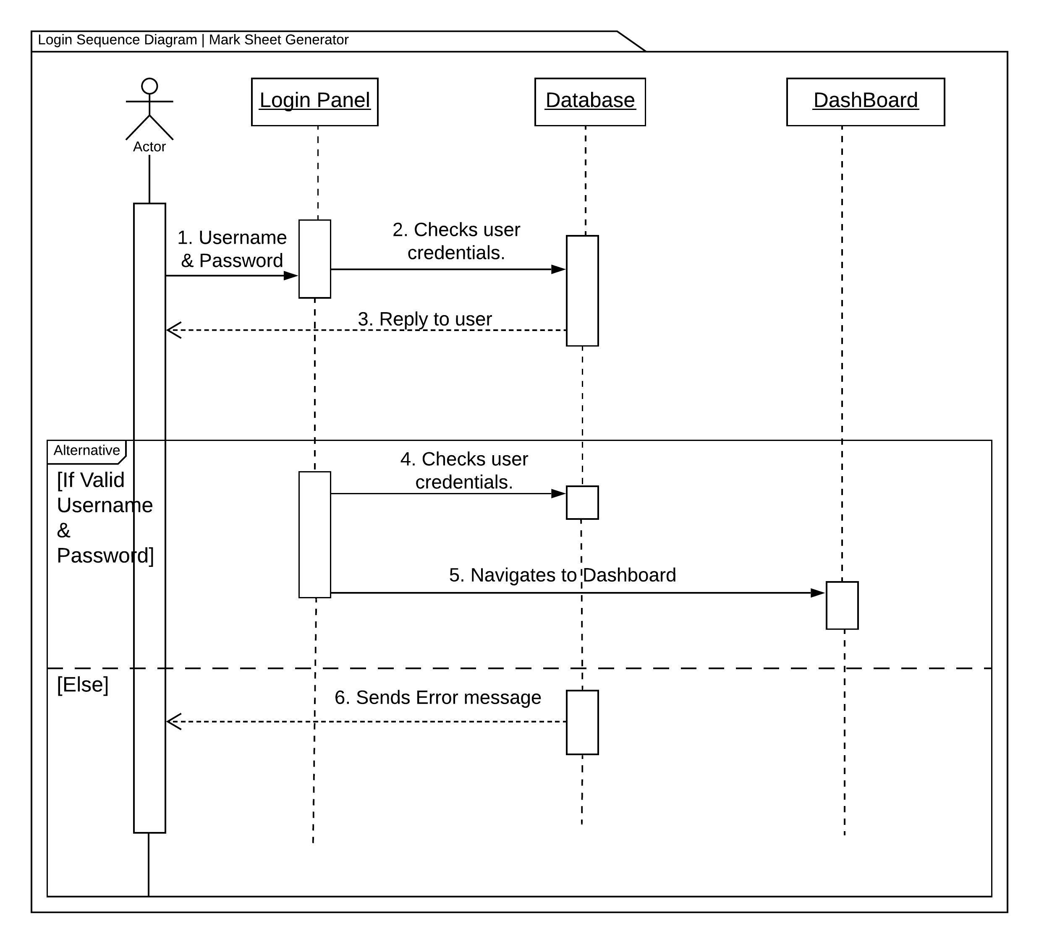

The above sequence diagram is the sequence diagram for login. Here the message flow from login panel to the database system is shown. The alternative is used to show the flow of message when the credentials are true and not true.

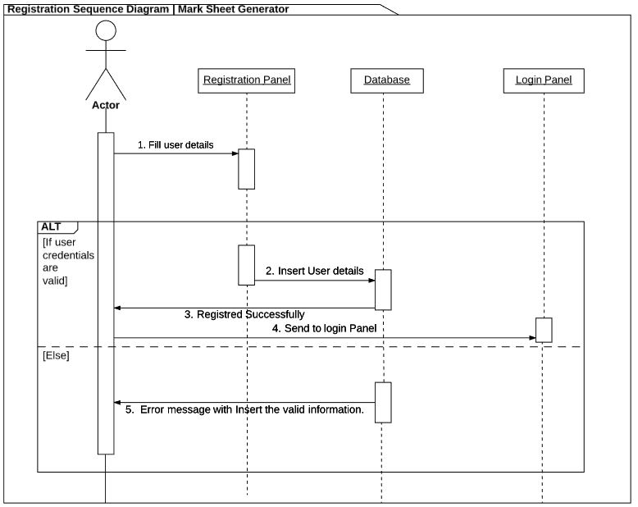

Above is the sequence diagram of the registration. Here user message flow of registration credentials with database system is illustrated. The flow of message is shown in alternative sequence diagram. If the user provides valid information (appropriate data with the correct or assigned datatype) then message is let to flow to login panel for user to be logged in to the system. If any criteria does not meet up then error message is being forwarded.

The following sequence diagram is showing the sequence of the message flowing while school details are inserting into the database.

Here I have integrated alternative and parallel sequence. In Parallel case there are inserting and retrieval school information into the database. While in alternative if all the compulsion fields are entered then the entire parallel are allowed else it will send error message.

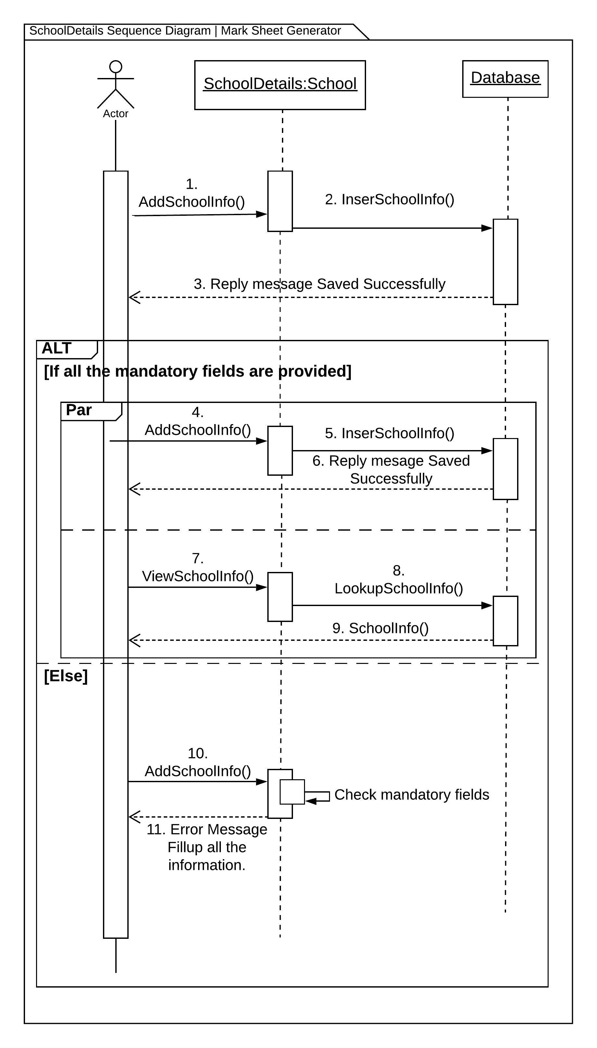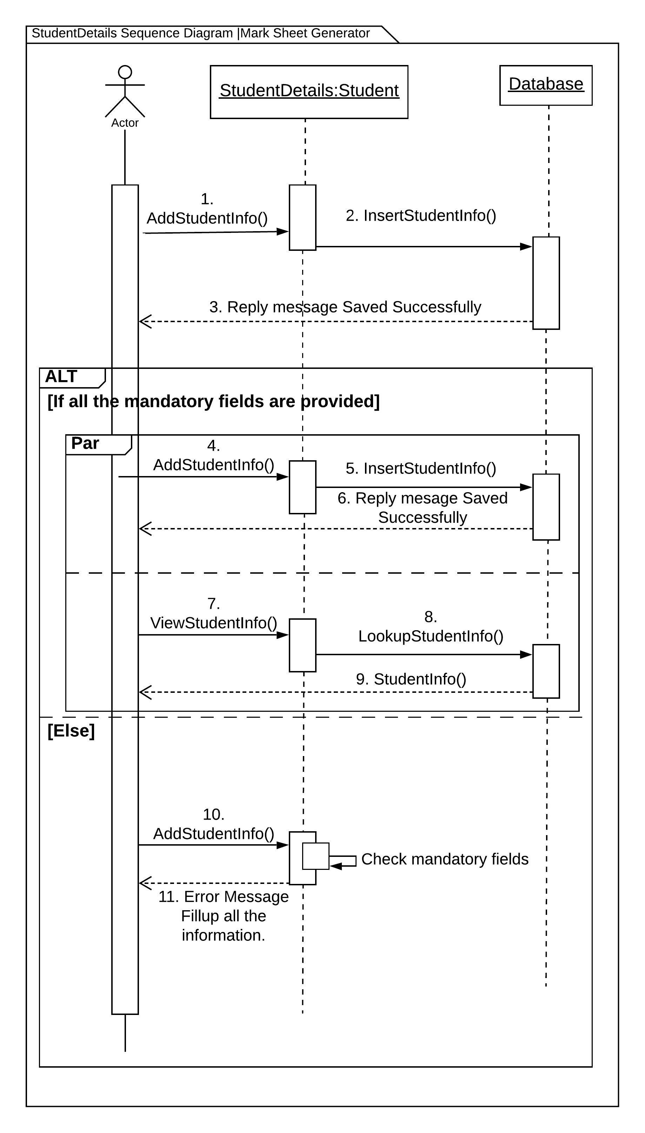

The following sequence diagram is showing the sequence of the message flowing while student details are inserting into the database.

Here the integration of alternative and parallel sequence. In Parallel case there are inserting and retrieval students information into the database. While in alternative if all the compulsion fields are entered then the entire parallel are allowed else it will send error message.

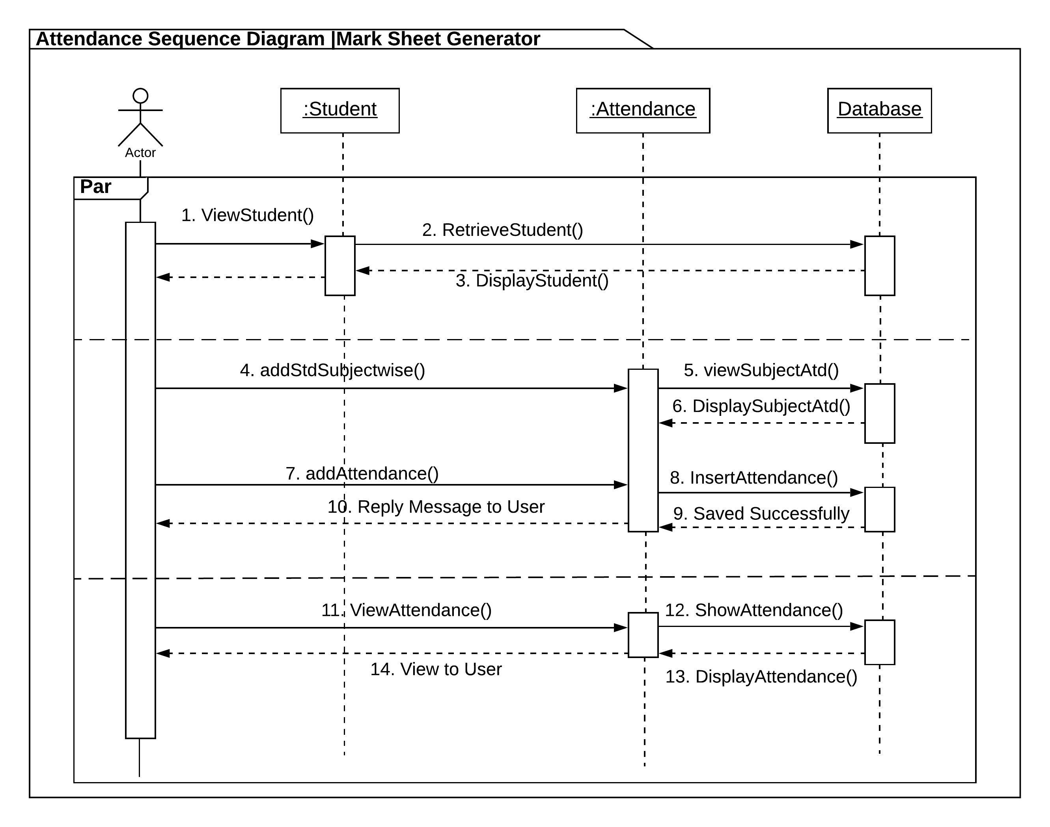

Attendance sequence is in parallel sequence. The message flow between different objects, classes and database are shown in the sequence diagram.

Obtained Marks sequence is in parallel sequence. The message flow between different objects, classes and database are shown in the sequence diagram.

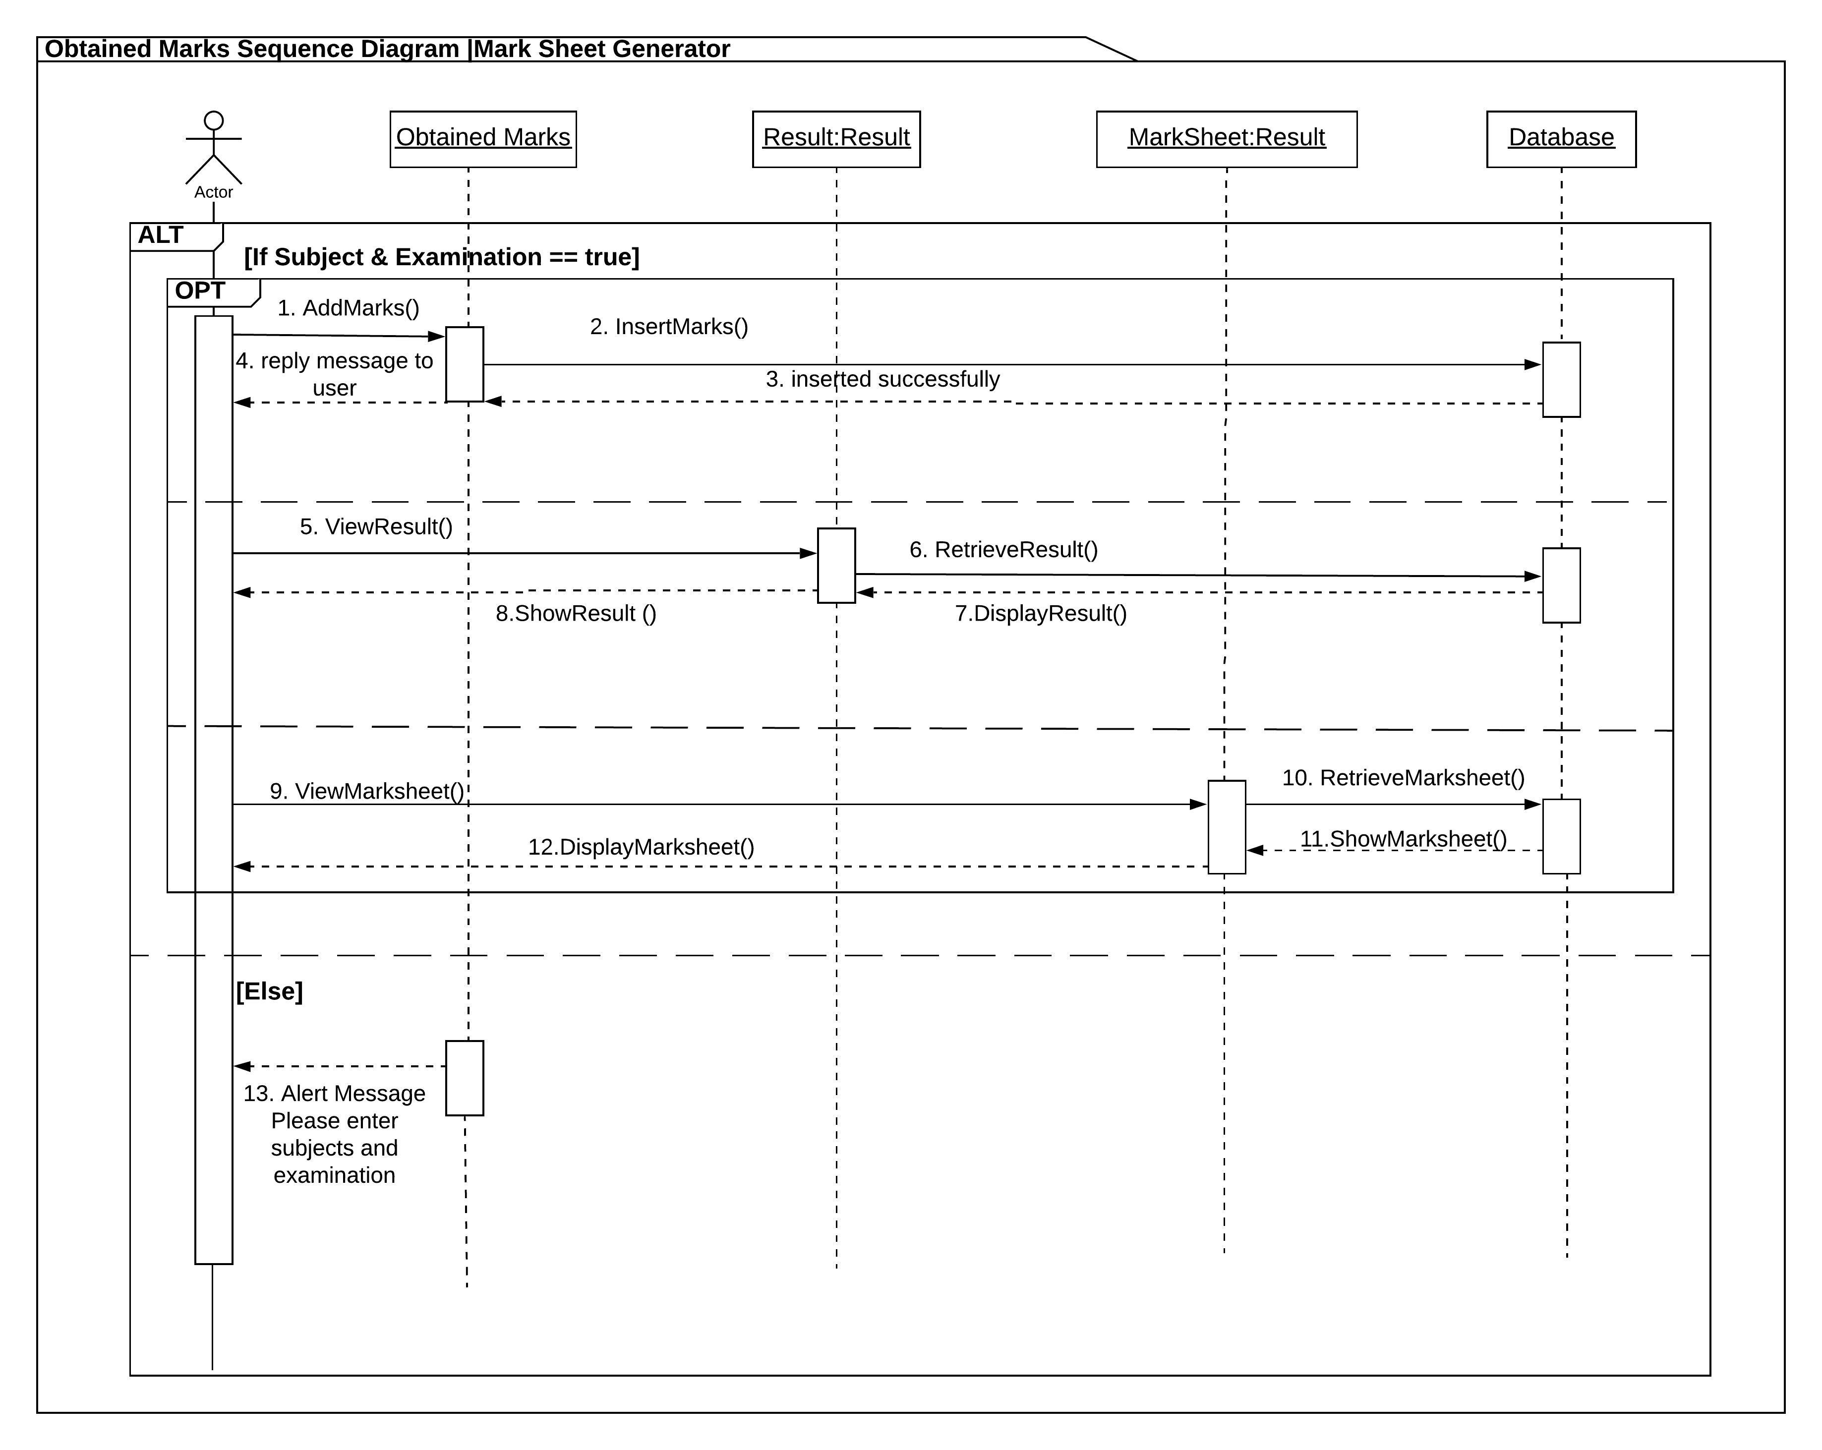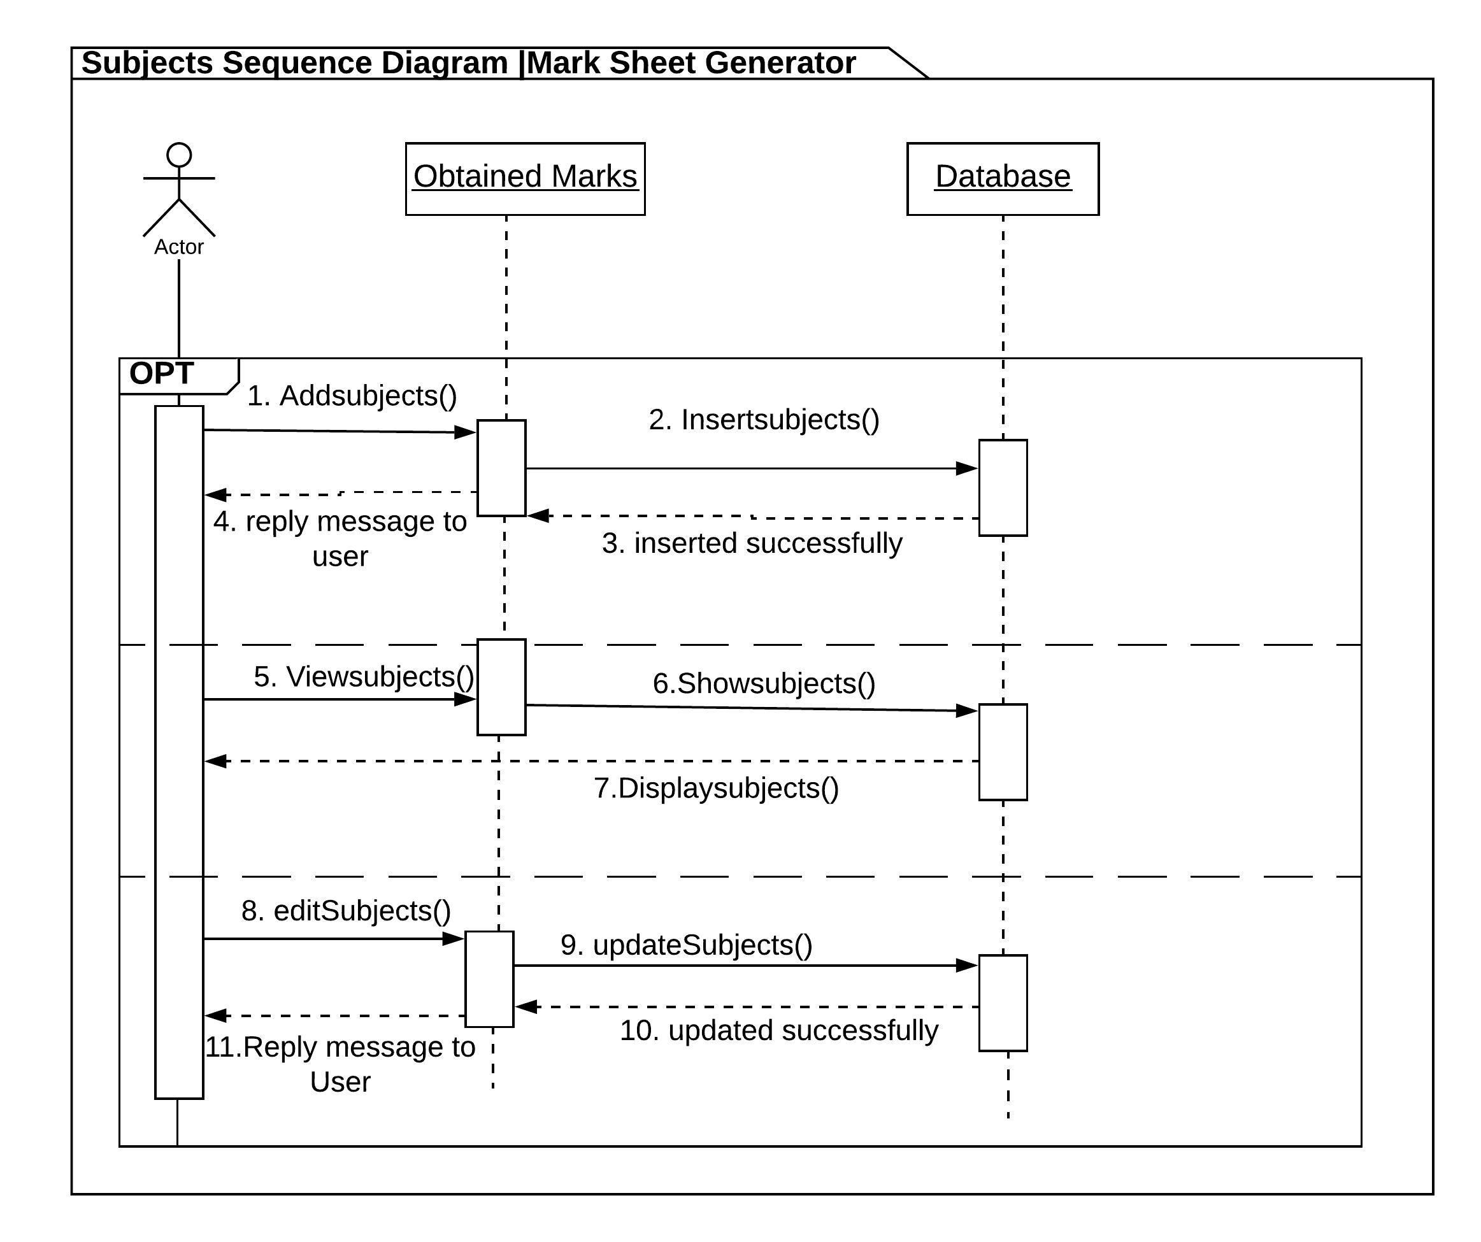

The Subject sequence diagram is shown in optional sequence. Here message flow between objects obtained marks and database are shown.

The remarks sequence diagram is shown in optional sequence. Here message flow between objects remarks and database are shown.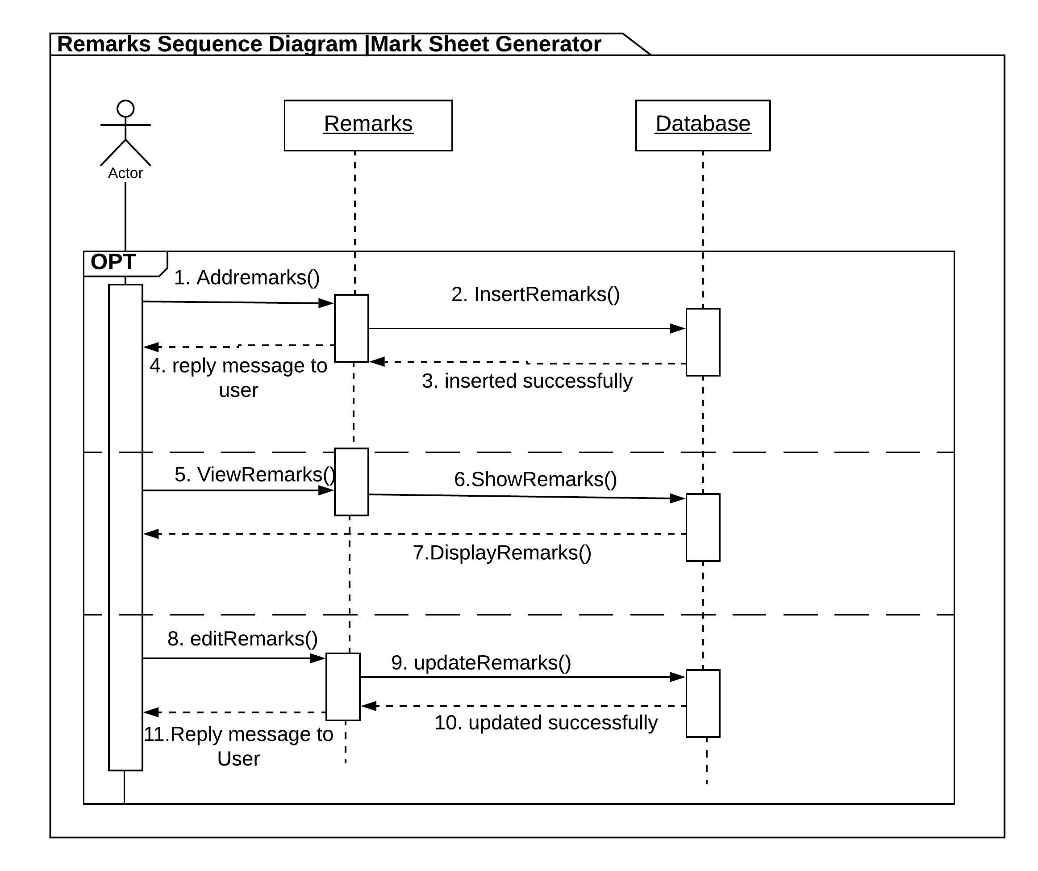

The examination sequence diagram is shown in optional sequence. Here message flow between examination and database are shown.

