# **Chapter 6: Other Project Issues**

## **Limitations of the Project**

Mark Sheet Generator have some limitations, which it cannot perform. It cannot be operate online as its desktop application. Similarly, user cannot use it in their mobile phones.

## **Future Work**

Presently, this system is released with most of the functionality as it was proposed. Some functionality are still left to customize in the system. Functionality that will be integrating in the future time are:

* Importing the excel data
* Search student by name, class and roll number
* More user friendly user platform

## **6.3 Risk Management**

Risk management is the process that involves the steps where all the possible problems are identified and the adaptation either of the all the possible steps to minimize or to eradicate those risks. All the possible risks are managed properly and protected this project from risks.

**The steps of risk management are**   
1. Identification- What can go wrong?   
2. Analysis- How will it affect us?   
3. Control- What should we do?  
4. Treatment- If something does happen, how will you manage it?

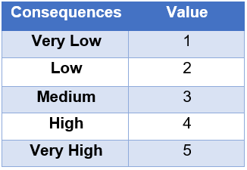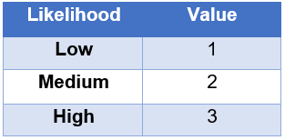**Likelihood Consequences**

Taking reference from the above Likelihood and Consequences table, we calculate the impact.

**Impact = Likelihood * Consequences**

In the table below, we identify some possible non-technical and technical risk that might occur during our project accomplishment.

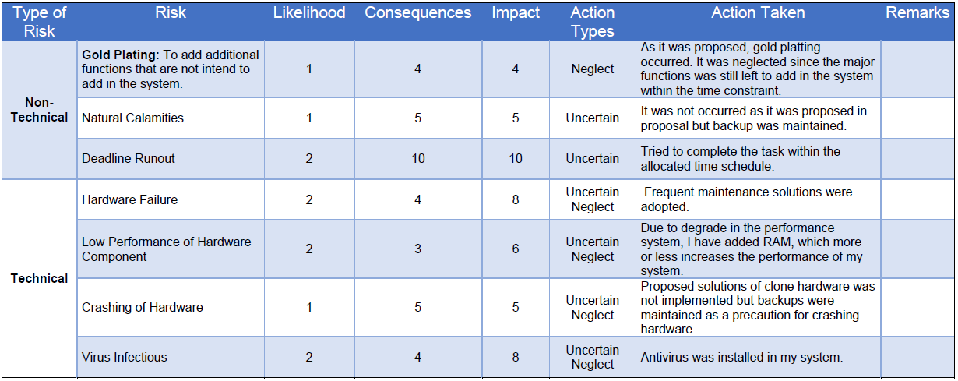

## **6.4 Configuration Management**

As proposed, the project is resided on two locations. One in local computer directory and another in Git repository (<https://github.com/BsalHada>) inside the main folder named CPproposal_Bishal Hada. Both were synchronized using GitHub Desktop application. The repository link of the GitHub is <https://github.com/BsalHada/CP_Project_Proposal>.   
  
The directory was propose to be on major phases of System Development Life cycle (SDLC). As per proposed the folders were maintained on phases of SDLC. Each phase have a folder and all documents, code base, and modelling diagrams reside in respective folders. In addition, backups are maintain in local drives as well.

## **6.5 User Manual**

The guidance about the system navigation is included in the system. This can help user whenever they require help. User Manual screenshots are:

