**Table of Contents**

**Table of Picture** 3

**Table of Tables** 3

**Key Words** 4

**Chapter 1: Introduction** 5

**1.1** **Project Introduction** 5

**1.2** **Justification of the Project** 5

**1.2.1** **Background of Project** 5

**1.2.2** **Problem Statement** 5

**1.3** **Description of the Project** 5

**1.3.1** **Features** 5

**1.3.2** **Overview of the Project** 6

**Chapter 2: Introduction** 7

**2.1 Scope** 7

**2.2 Limitation** 7

**2.3** **Aim** 7

**2.4** **Objectives** 7

**2.5** **Overview of the Scope** 7

**Chapter 3: Development Methodology** 8

**3.1 Description of the Methodology** 8

**Waterfall Model:** 8

**Advantages of Waterfall Model:** 9

**Disadvantages of Waterfall Model:** 9

**3.2 Design Pattern** 9

**Advantages of MVC pattern:** 10

**Disadvantages of MVC pattern:** 10

**3.3 Architecture** 10

**Chapter 4: Project Planning** 11

**4.1 Work Breakdown Structure (WBS)** 11

**4.2 Milestone** 13

**Time Estimation** 15

**4.3 Gantt Chart** 16

**Chapter 5: Risk Management** 18

**Chapter 6: Configuration Management** 20

**Chapter 7: Conclusion** 21

**References** 22

# **Table of Picture**

Picture 1 Waterfall Model Diagram | Mark Sheet Generator 8

Picture 2 Model View Controller (MVC) design Pattern | Mark Sheet Generator 9

Picture 3 Two- Tier Architechture | Mark Sheet Generator 10

Picture 4 Milestone | Mark Sheet Marker 13

Picture 5Scheduling| Mark Sheet Generator 16

Picture 6Gantt Chart | Mark sheet Generator 17

Picture 7Tree Structure of folders | Mark Sheet Generator 20

# **Table of Tables**

Table 1 Work Break Down Structure (WBS)| Mark Sheet Generator 12

Table 2 Time Estimation | Mark Sheet Generator 14

Table 3 Likelihood Table | Mark Sheet Generator 18

Table 4 Consequences Table| Mark Sheet Generator 18

Table 5 Risk Management Table | Mark Sheet Generator 19

# **Key Words**

* Mark Sheet Generator (MSG)
* System Development Life Cycle (SDLC)
* Water Fall Model
* Model View Controller
* Work Breakdown Structure (WBS)

# **Chapter 1: Introduction**

## **Project Introduction**

The Project, **Mark Sheet Generator**  is design for simplification in mark sheet creation. In this project, the system will be designed that can easily provide examination reports. Students grades, score, percentages and so on will be in the records. This system will increase the efficiency and availability of report cards.

## **Justification of the Project**

**Mark Sheet Generator** is the desktop application. This software is especially can be implemented in the educational institute.

### **Background of Project**

In any educational institute, there is provision to take examination to check the ability of the students. After taking examination, there is always a challenge to prepare the examination report. There are several issues, which we can here from the students that results are most of the time published lately. One of the prime reasons for the delay of the result is that there is lack of system, which can give results of the students in no time.  
**Mark Sheet Generator** is mainly designed by focusing on such problem.

### **Problem Statement**

The major issues in most of the educational institute after taking examinations is to prepare the reports. Its time consuming and not so efficient by going through each student marks obtained in all of the subjects and calculating the percentage, divisions, grades, etc.   
In Mark Sheet Generator, we need to make such system, which can sort out with such (time taking) problems. Mark Sheet Generator will be the system to optimize the time taken in result making. Not only that, data of each students will be recorded so that if results are mishandled or misplaced, there will be no problem to reprint the mark sheets.

## **Description of the Project**

Mark Sheet Generator is the project for desktop use. For this C# programming language will be use. As, it is easy and useful for desktop applications. Likewise, MSSQL server will be use as database storage.   
  
Mark Sheet Generator will be the system with various convenient features. Those features are listed in the following section.

### **Features**

The main features that specializes this **Mark Sheet Generator** is:

* **Import and export the students records in excel sheet:**   
  Students database will be import from excel sheet and be export in excel sheet for backup purposes.
* **Could be saved in PDF file formatting:**

Mark Sheets created will be save in pdf formats for easy access.

* **Easily printable:**   
  Mark Sheets created will be print in hard copy with local or networked printers available.
* **Mark Ledger view:**   
  User will be able to view the marks in ledger format. This can help to see all the marks of students in specific subjects in one place.
* **User level access:**  
  There will be admin privilege, which will be given access to authorized people. In addition, there will be normal user login, which will be for staff who will be dealing with examinations and results of the institution.
* **Easy Create/Update Student profiles:**Student profiles can easily be maintained. Any changes that are needed to be make are possible.
* **Picture uploads:**Students profile will be maintained where students’ pictures will be able to upload able.
* **Mark Sheet for different types of examination can be prepare:**  
  These days there is practice of taking several examinations. User will be able to entry types of examination title.

### **Overview of the Project**

**Mark Sheet Generator** will be the system that will increase the performance of educational institute in result making. This will certainly increase the efficiency and will put positive impact of institution. This system with its silent features will make easier in use to user.

# **Chapter 2: Introduction**

## **2.1 Scope**

Educational institutions are growing day by day. Such institutions is mostly concerned about improving and serving the education in the best ways. Therefore, the **Mark Sheet Generator** will be one the factors that can contribute to enhance the features of any educational institutions.

Generally, this project have very limited scope but can act as important aspects in those existing areas. The areas where this system will be fruitful are:

* **Schools:** In schools, this system can be in use to prepare the examination reports and keep the students details.
* **Colleges:** To provide the examination accounts of the students, this system can be implemented in the colleges.
* **Tuition Centers:** Tuition centers can also use this system to keep records of their students. Also to track their students’ progress report.
* **Language Institutions:** Languages Institutions can prepare the testimony of their students by using this system.

## **2.2 Limitation**

Every successful system has limitation either it is numerous or least. The **Mark Sheet Generator** do have some limitations. Limitation of the system Mark Sheet Generator is:

* It is not accessible in the web.
* It is not compatible in mobile phones.

## **Aims** The aims of the Mark Sheet Generator are:

* Provide reports in minimum time
* Prepare error less mark sheet
* Maintain the student database

## **Objectives**

The Objectives of the project , Mark Sheet Generator are mentioned below:

* To record the students details in managed way.
* To make the students’ mark sheet.
* To trace the students’ academic progress.
* To show the students’ progress in grades and percentage.
* To make the user-friendly environment set- up.

## **Overview of the Scope**

Overall, the scope of the Mark Sheet Generator is mainly focused on education institutions. With all the aims and objectives, all the scope areas will be satisfied to accomplish the required students database management and result making.

# **Chapter 3: Development Methodology**

## **3.1 Description of the Methodology**

Over various methodologies, this project will be develop under Waterfall Model design methodology. It is suitable for using in small projects like Mark Sheet Generator. It is feasible and appropriate to use to develop our system. In addition, due to its advantages I will be using this methodology.

### **Waterfall Model:**

A model where linear and sequential approaches are under taken for system development is a waterfall model. The system is develop systematically from one-step to another in downward manner without iteration to previous steps. This means every phase has to be completed before proceeding to the following one. This is the reason to term this methodology of system development as waterfall model.

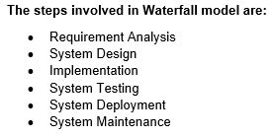

***(waterfall-model, 2019)***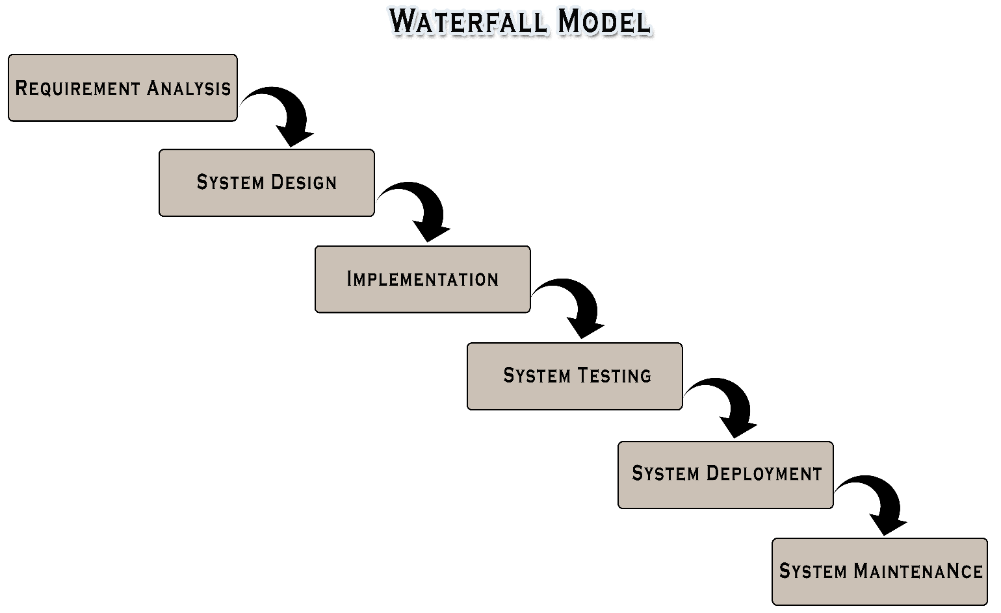

Picture 1 Waterfall Model Diagram | Mark Sheet Generator

## **Advantages of Waterfall Model:**

* Waterfall model is easy to use, simple and understandable.
* It is easy to maintain because each phase has specific outputs and review process.
* It is appropriate for small projects.
* Procedure of testing is easier and more transparent.

## **Disadvantages of Waterfall Model:**

* Requirements are not completely mention.
* Time-consuming methodology.
* Lack of flexibility in the system.
* Risk and uncertainty are high.

## **3.2 Design Pattern**

Over different design patterns, this project I will be using Model View Controller (MVC)design pattern. All the parts is being divided in different groups, which makes easy in dealing with the problems that might arise in future. Also for developers reusability of codes will exists that increases the efficiency of the system. All the parts can easily be seen as it is classified into different groups. For this reason I will be using MVC design pattern.

* **Model:**The Model , is where we place, the module that handles the data of the program. For instance, a module where it interacts with a database.
* **View:**The View, where the module whose work is to display data to the user. The View behaves as an interface between the display (which can be a physical display or e.g. a document format) and the rest of the program, and doesn't have any functionality related to anything else than displaying the data. Here, we keep front end view i.e. user interfaces.
* **Controller:**

The Controller consist of part that makes all the decisions. It has all the applicable functionality of the program and interacts with the Model and the View, allowing them and transient data between them as needed.

***(mvc_framework, 2018)***

Picture 2 Model View Controller (MVC) design Pattern | Mark Sheet Generator

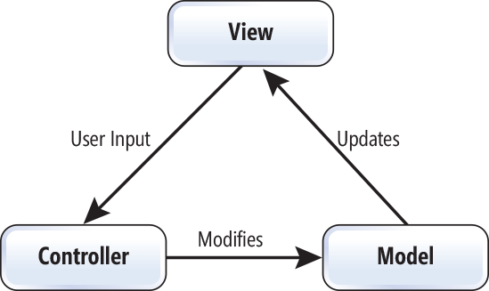

### **Advantages of MVC pattern:**

* MVC pattern helps in attaining easy maintenance, applying loose coupling, and reducing complexity.
* MVC allows independent changes on the frontend without any, or very few, changes on the backend logic, and so the development efforts can still run independently.
* Model or business logic can be changed without any changes in the view.
* Helping the developers for developing system that loads very fast as it supports asynchronous technique.

### **Disadvantages of MVC pattern:**

* Due to three layers, it can increase the complexity.
* There is deficiency of efficiency of data access in view layer.

## **3.3 Architecture**

This system will be using two- tier architecture. As it helps to run the system faster. This helps to increase in efficiency of the system. Therefore, I will using **The Two- Tier architecture.**

**Two- Tier architecture:**

The two- tier architecture is based on Client Server architecture. It is like client server application. The direct communication takes places between client and server application. Due to tight coupling, a two-tiered application will run faster.

**The Two-tier architecture is divided into two parts:**

1. Client Application (Client Tier)

2. Database (Data Tier)

Client system handles both Presentation and Application layers and Server system handles Database layer. It is also known as client server application. The communication takes place between the Client and the Server. Client system sends the request to the Server system and the Server system processes the request and sends back the data to the Client System

***(two-tier-architecture, 2018)***

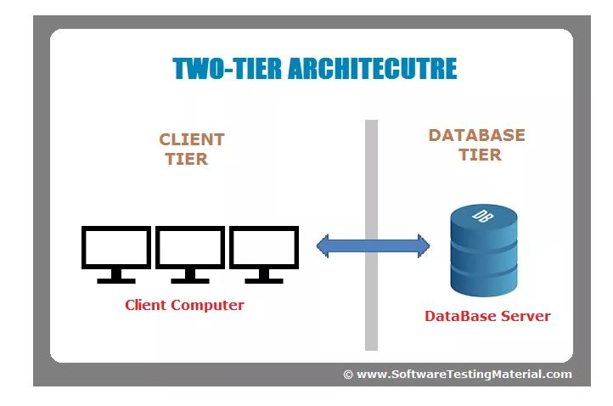

### 

### 

Picture 3 Two- Tier Architechture | Mark Sheet Generator

# **Chapter 4: Project Planning**

## **4.1 Work Breakdown Structure (WBS)**

WBS is a process that helps in breaking down of complex step into multiple steps. WBS splits and achieve large projects so we can get things done faster and more efficiently. WBS is a hierarchical tree structure that outlines our project and breaks it down into smaller, more manageable portions. The main goal of a WBS is to make a large project more manageable. Breaking it down into smaller portions means work can be done instantaneously by different team members, leading to better team productivity and easier project management overall.

The broke down of the project Mark Sheet Generator is:

**Project Management:**   
Project Management is the application of knowledge, skills, tools and techniques to project activities to meet the project requirements. Here we make feasible study, planning, monitoring and controlling aspects of the project.

**Analysis:**In the analysis model, information, functions and the behavior of the system is defined and these are translated into the architecture, interface and component level design in the 'design modeling'.

**Design:**In design we will be preparing structural model, behavior model and UI designs.   
 **Implementation:**Here, we will be making database and coding will be done.

**Testing:**Black box and white box testing will be performed in this part.

**Documentation:**In this portion, user guide and final report will be prepare.

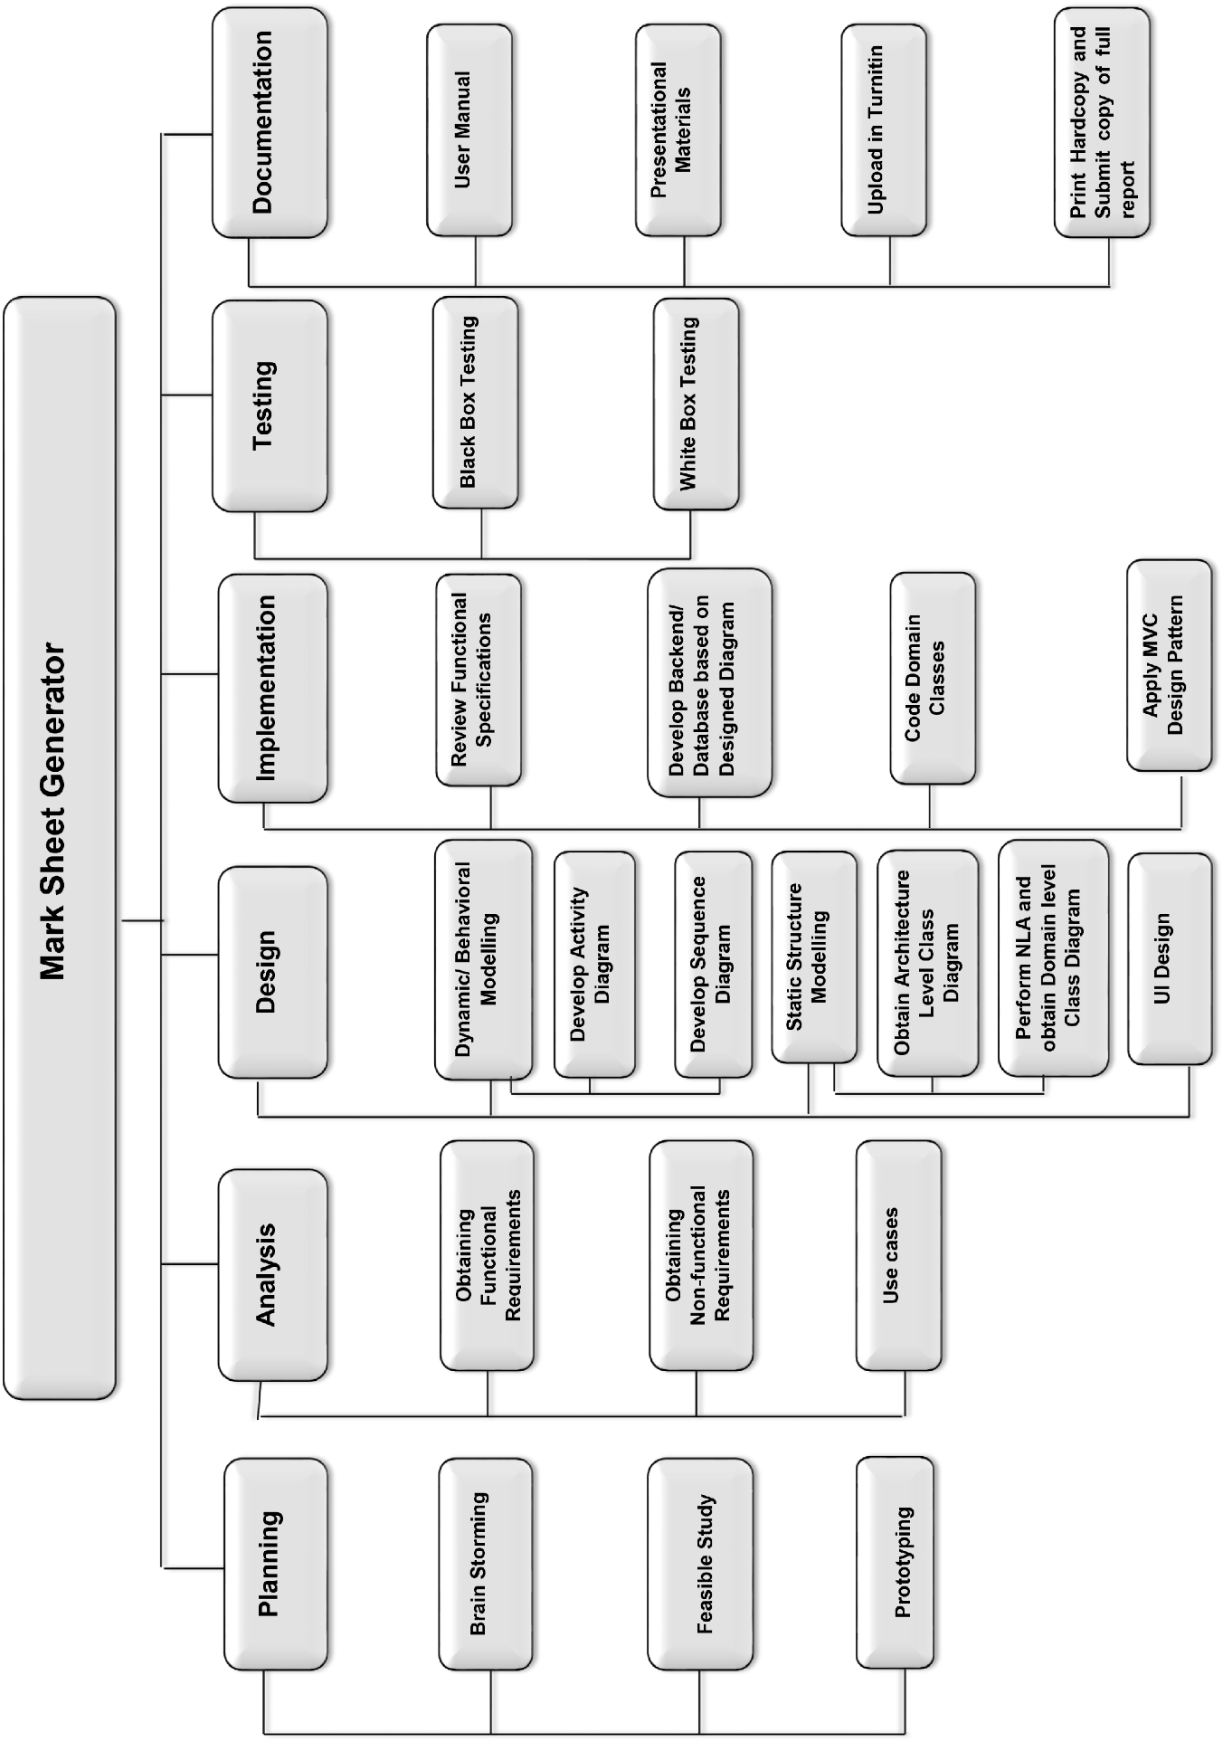

Table 1 Work Break Down Structure (WBS)| Mark Sheet Generator

## **4.2 Milestone**

A task of zero time that expresses an important attainment in a project. The milestones denote a clear series of events, which gradually build up until the project, is complete. The milestones in the project is one of the ways of knowing the project progressing. They have zero period as they represent an achievement, or a point of time in a project. Task collaboration is a key feature of a milestone as milestone has start and end date depends on a task’s start and end date. So milestone is prepared for **Mark Sheet Marker**.

***(what-are-project-milestones, 2018)***

The milestone for this project, **Mark Sheet Marker** is shown in the following:

Picture 4 Milestone | Mark Sheet Marker

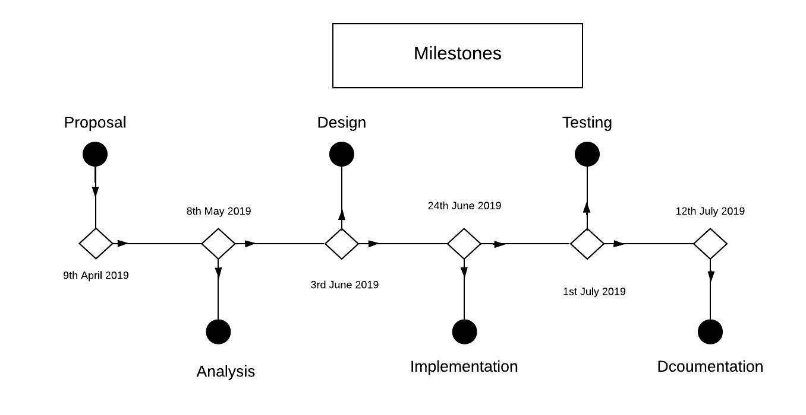

Table 2 Time Estimation | Mark Sheet Generator

|  |  |  |  |  |
| --- | --- | --- | --- | --- |
| **S.No.** | **Topic** | **Start Date** | **End Date** | **No. Of days** |
| **1.** | **Proposal** | 3/26/2019 | 4/9/2019 | 15 days |
| **2.** | **Analysis** | 4/10/2019 | 5/8/2019 | 29 days |
| **2.1** | Obtaining Functional Requirements | 4/10/2019 | 4/24/2019 | 15 days |
| **2.2** | Obtaining Non-functional Requirements | 4/25/2019 | 5/3/2019 | 9 days |
| **2.3** | Use Cases | 5/4/2019 | 5/8/2019 | 5 days |
| **3** | **Design** | 5/9/2019 | 6/3/2019 | 26 days |
| **3.1** | Dynamic/ Behavioral Modelling | 5/9/2019 | 5/10/2019 | 2 days |
| **3.2** | Activity Diagram | 5/23/2019 | 5/24/2019 | 2 days |
| **3.3** | Sequence Diagram | 5/25/2019 | 5/26/2019 | 2 days |
| **3.4** | Static Structure Modeling | 5/27/2019 | 5/28/2019 | 2 days |
| **3.5** | Architecture Level Class Diagram | 5/29/2019 | 5/30/2019 | 2 days |
| **3.6** | Domain level Class Diagram by NLA | 5/31/2019 | 6/1/2019 | 2 days |
| **3.7** | UI Design | 6/2/2019 | 6/3/2019 | 2 days |
| **4** | **Implementation** | 6/4/2019 | 6/24/2019 | 21 days |
| **4.1** | Review functional Specifications | 6/4/2019 | 6/5/2019 | 2 days |
| **4.2** | Backend/ Database design based on diagram design | 6/6/2019 | 6/13/2019 | 8 days |
| **4.3** | Code Domain Classes | 6/14/2019 | 6/21/2019 | 8 days |
| **4.4** | MVC Pattern implementation | 6/22/2019 | 6/24/2019 | 3 days |
| **5** | **Testing** | 6/25/2019 | 7/1/2019 | 7 days |
| **5.1** | Black Box Testing | 6/25/2019 | 6/26/2019 | 2 days |
| **5.2** | White Box Testing (Unit Testing) | 6/27/2019 | 7/1/2019 | 5 days |
| **6** | **Documentation** | 7/2/2019 | 7/11/2019 | 10 days |
| **6.1** | User Manual | 7/2/2019 | 7/3/2019 | 2 days |
| **6.2** | Presentation Materials | 7/4/2019 | 7/5/2019 | 2 days |
| **6.3** | Final documentation | 7/6/2019 | 7/12/2019 | 7 days |

# **Time Estimation**

1. **Proposal**For proposal we allocate 15 days as there are several things. Introducing about project, about its aim, objectives, feature, limitations, etc. are need to be insert so allocated time is required.   
   **2. Analysis**Total 29 days is given for analysis where**:  
   2.1 Obtaining Functional Requirements:** As functional aspects of the system is vital so for this 15 days is provided. **2.2 Obtaining Non- functional Requirements:** For this 9 days is given as it is also vital aspects but less important than functional requirements. .  
   **2.3 Use cases:**For this remaining 5 days is provided. **3. Design**Design is given 26 days, in this also different aspects is divided with different time constraint.  
   **3.1 Dynamic/ Behavioral Modeling:** It is given 2days within which we have to design behavioral diagram of the system.

**3.2 Activity Diagram:** It is provided with 2 days time Within this time period we have to draw activity diagram.

**3.3 Sequence Diagram:** It is provided with 2 days time Within this time period we have to draw sequence diagram that shows the sequence flow of the system.

**3.4 Static Structure Modeling:** It is expected to complete in 2 days. **3.5 Architecture Level Class Diagram:** For this 2 days will be sufficient. **3.6 Domain Level Class Diagram:** Class diagram will be made with in 2 days as it will be enough as we will have already done NLA.

**3.7 UI Design:** Front end design will be design within the 2 days.  
 **4 Implementation:**

Implementation portion will be allocate 21 days. Main backend back will be in this part so about 21 days will be required to complete this task.

**4.1 Review functional Specifications:** This will be given only 2 days as already functional requirements will be identified in above portion**.  
4.2 Backend/ Database design based on diagram design:** It is important aspect of the system so 8 days will be allocated. **4.3 Code Domain Classes*:*** As it behave as back bone of the system so 8 days will be separated for this.  
**4.4 MVC Pattern Implementation:** For this 3 days will be sufficient.  
**5 Testing:** For testing the system we will be allocating 7 days. **5.1 Black box:** Black box testing will be given 2 days.

**5.2 White Box:** White box testing will be provided remaining 5 days as its quiet time taking tasks.  
**6 Documentation**: Documentation will be consuming 10 days.   
**6.1 User Manual:** It will be prepare with in 2 days.  
**6.2 Presentation Materials:** It will be prepare in 2 days.

**6.3 Final Documentation:** Final documentation will be taking bit more time as all aspects of the system should be included. So 7 days will be allocating for this.

## **4.3 Gantt Chart**

A project management tool that helps in assisting of the plans and scheduling of projects is a Gantt chart. In Gantt chart, project management timelines and tasks are used for conversion of a horizontal bar chart, illustrating start and end dates dependencies, scheduling and deadlines. This is beneficial to keep tasks on track.   
***(gantt-chart, 2018)***

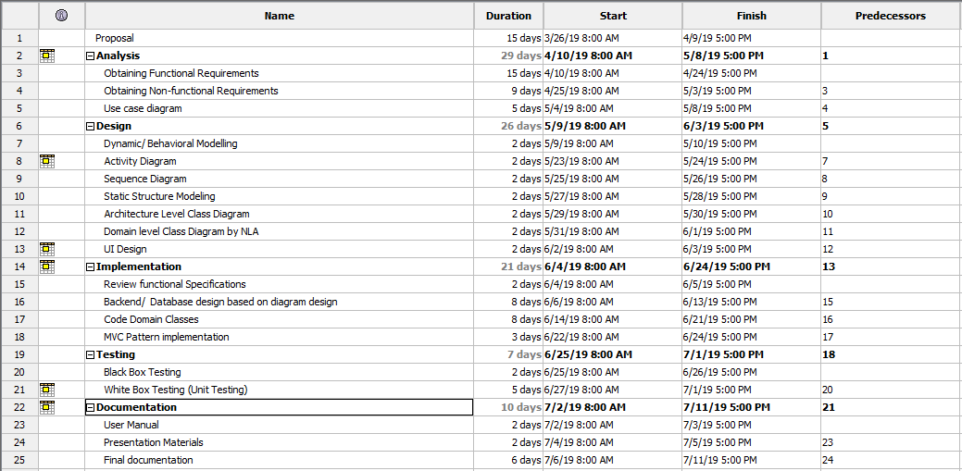The Gantt chart of **Mark Sheet Generator** is :

Picture 5Scheduling| Mark Sheet Generator

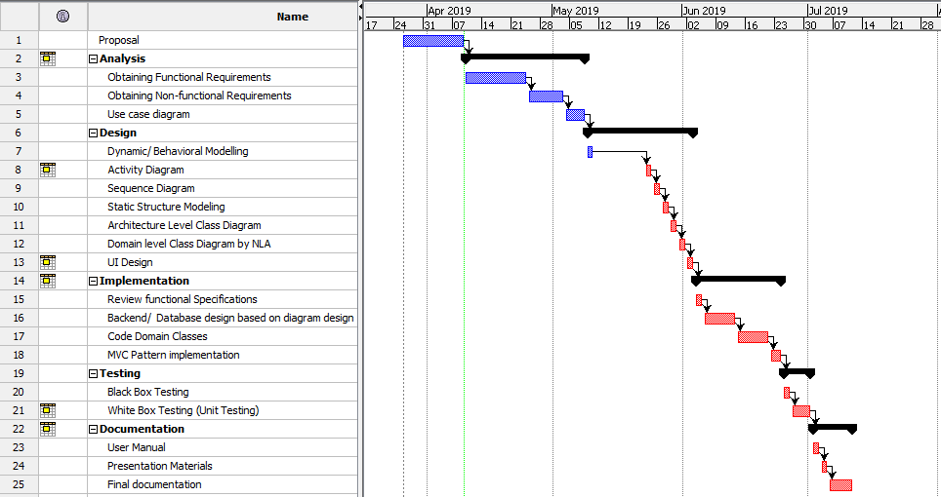

Picture 6Gantt Chart | Mark sheet Generator

# **Chapter 5: Risk Management**

Risk Management is process of identifying, analyzing, controlling, and avoiding, minimizing, or eliminating of intolerable risks. In any project risk assumption, risk avoidance, risk retention, risk transfer, or any other strategy (or combination of strategies) should be adopted for proper management of system success. Therefore, risk management is to be performed.

***(what is risk management , 2018)***

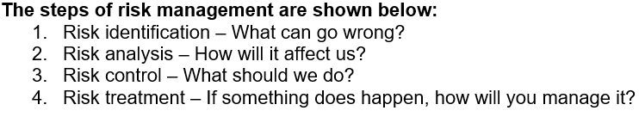

**Likelihood**

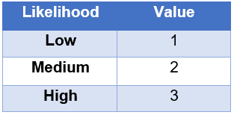

Table 3 Likelihood Table | Mark Sheet Generator

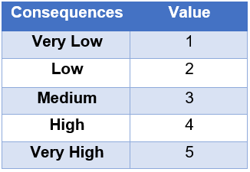**Consequences**

Table 4 Consequences Table| Mark Sheet Generator

Taking reference from the above Likelihood and Consequences table, we calculate the impact.

**Impact = Likelihood * Consequences**

In the table below, we identify some possible non-technical and technical risk that might occur during our project accomplishment.

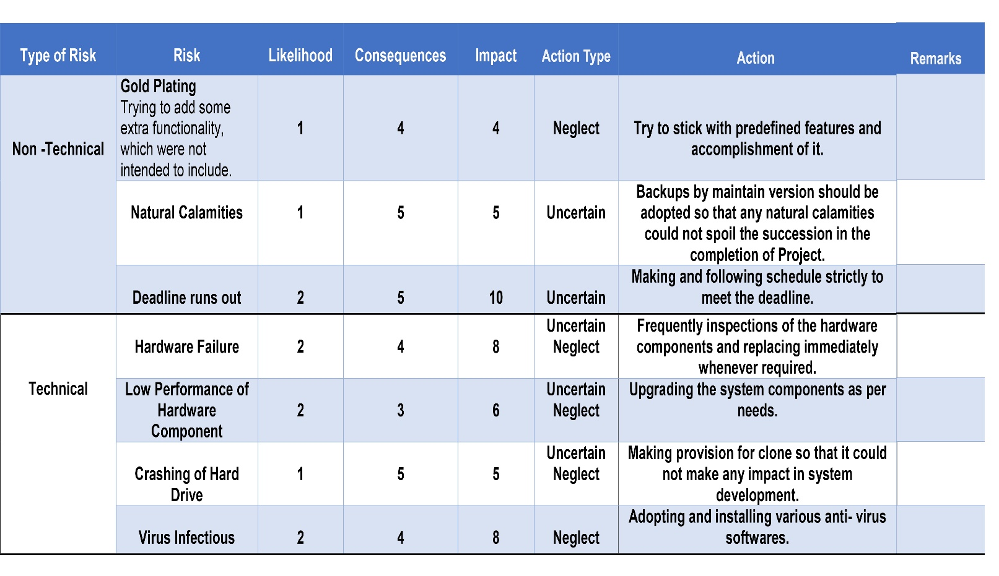

Table 5 Risk Management Table | Mark Sheet Generator

# **Chapter 6: Configuration Management**

Mark Sheet Generator is reside on two location. One on local computer directory and another is on Git repository (<https://github.com/BsalHada>) inside the main folder named CPproposal_Bishal Hada. Both are synchronize using GitHub Desktop application.  
The repository link of the GitHub is <https://github.com/BsalHada/CP_Project_Proposal>.

The directory is based on major phases of System Development Life cycle (SDLC). Each phase has a folder and all documents, code base, and modelling diagrams reside in respective folders.

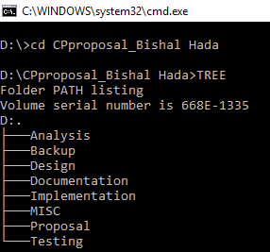

Picture 7Tree Structure of folders | Mark Sheet Generator

# **Chapter 7: Conclusion**

This proposal is prepared to clarify the purpose, aim, scope and how will the project, Mark Sheet Generator will be develop within the time frame. Initially, I set- up some background of the system. Likewise, what sorts of development methodology will be in use for development is mentioned and briefly explained. Here, I made a choice of using waterfall model. Then, moving to the project planning, for easiness I have broken down the works using WBS(Work Break Down Structure). The time estimation is illustrated in milestone table and represented graphically in Gantt Chart. All the possible risks are listed and impacts are calculated using likelihood and consequences. At last the folder and file configuration in the local directories and GitHub is managed. This is how the project, Mark Sheet Generator is expected to be completed within the time frame.

# **References**

* *gantt-chart*. (2018). Retrieved from www.investopedia.com: https://www.investopedia.com/terms/g/gantt-chart.asp
* *mvc_framework*. (2018). Retrieved from www.tutorialspoint.com: https://www.tutorialspoint.com/mvc_framework/mvc_framework_introduction.htm
* *two-tier-architecture*. (2018). Retrieved from www.techopedia.com: https://www.techopedia.com/definition/467/two-tier-architecture
* *waterfall-model*. (2019). Retrieved from www.toolsqa.com: https://www.toolsqa.com/software-testing/waterfall-model/
* *what is risk management* . (2018). Retrieved from www.businessdictionary.com: http://www.businessdictionary.com/definition/risk-management.html
* *what-are-project-milestones*. (2018). Retrieved from www.clarizen.com: https://www.clarizen.com/what-are-project-milestones/