Introduction to brushless blasters
By Thor Hansen, Ben Sanford & a lot of friends.

Foreword
This document is ment as abit of theory behind brushless blasters and is not the step-by-step guide to assemble the Mjölnier blaster – Look for step 1- X for assembly-guide.
When Ben and I first started talking about this project, we wanted to make something which was for everybody and we wanted to make it brushless and controllable. We both felt inspired by the PewPew from Pewtech and wanted to make something similar, so that was what we based our blaster on.
Niether of us have any professionel electronic experience, so this information is all gathered on a hobby level will have been proof-read by people with experience.
Since this project isnt something, which is easily optained, we had alot of help from friends and other modders in the nerf community and this blaster is the end-result of that. By the time you read this, we will have released the files for both the firmware(Based on Airzone's brilliant code), the .step files, the wire schematics, BOM and guides to assemble.
We hope you will enjoy, improve and make it your own blaster – You are free to do whatever you like with the design.

What is a "brushless blaster"?
A brushless blaster refers to the main mode of launching darts. In traditional blasters, you'll either have spring based platform or a motor based platform. The motor based platform utilizes two flywheels to compress and fire foam darts. The motors is usually brushed direct current(DC) motors, which you know from standardized RC cars etc. These motors are running off a direct current making two magnetic fields and rotating the shaft. The brushes of a DC motor is a component which provides a conducting path and is an item which will be worn down by time.
In brushless motors, you'll have several magnetic fields activating on different times to rotate the shaft. These motors conducting paths dont touch the rotating parts.

Brushless motors is more commonly known as drone-motors, because it is the same motors, which is used in high-end drones.

Brushless motors comes in two variants:
In-runner variant: The rotating bit is inside a shell and the only rotating thing sticking out is the shaft.
Out-runner variant: The entire outer shell is rotating with the shaft aswell! This is great for us, because it allows us to disperse heat faster. We will focusing on brushless outrunner motors.
This also complicates things abit, because you need something to control when the fields activate, which leads me to the first schematic:
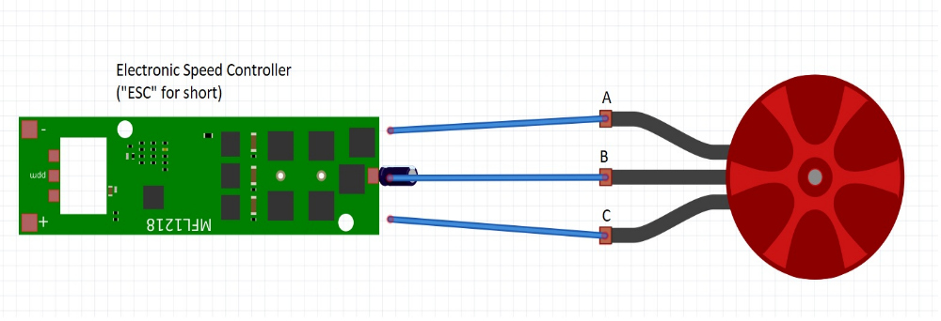
If we start on the righthand side, thats the motor. It has 3 wires comming out and none of them is going to power like a normal DC motor. For simplicity's sake, Ive called them A, B and C. It doesn't matter which end you'll start naming them, as long as the middle one is called B (I'll get back to that in a second). The wires are going directly to the Electronic Speed Controller(ESC).
The electronic speed controller is what controls which magnetic fields actives at what time and makes the brushless motor work.

Brushless motors does not work without an electronic speed controller and you need one ESC per motor.

So, back to the wires. So you've got 3 copper pads at one end of the ESC, which is ment for the motor wires. The middle one always belongs to the middle brushless wire.
For the sake of the example, we'll attach wire A to pad A, wire B to pad B and wire C to pad C. If you had a motor rotating in the wrong direction, you'd have two options to fix that.

A) You can digitally tell the ESC to change the direction of the motor (See preperation guide).
B) You can change direction of the motor spin by switch the A and C wires on the pads, so instead of A-A and C-C, it would be A-C and C-A.

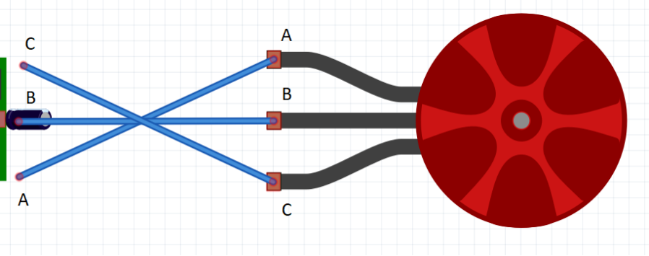
At the other end of the ESC, there will be two pads and 2 wires. The two pads is for plus and minus(ground,gnd) off the battery and will have to be the same as your lipo battery (11,1v or so).
The two other wires is for the control of the electronic speed controller(!). There should be a signal wire, usually white or named something like PMW and a black one called gnd. These should go to the micro control unit – In our case, an Arduino Nano 3.0.

Coffee break and look at next schematic

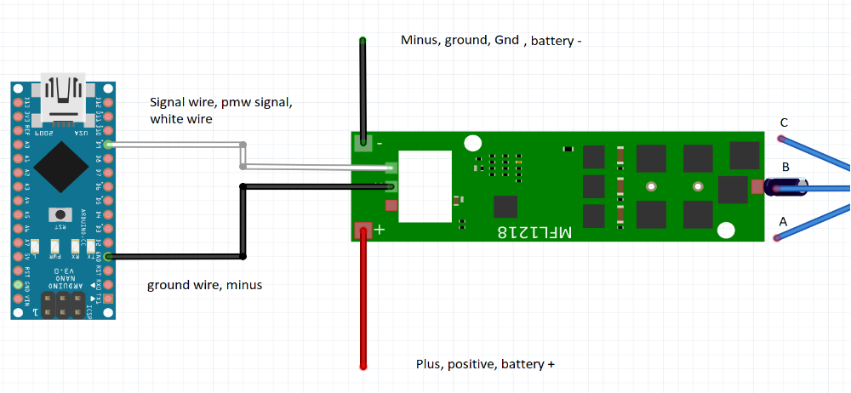
The arduino is basicly the brains of the operation. It's where we have the code for what happens when, you push X button and what the blaster should do if the battery gets low etc.
So in schematic, the arduino sends a signal to the ESC, which tells it to make to motor go.
That signal is called a PWM signal, which is short for pulse width modulator. To simplify it, it's a matter of how many small spikes per second it sends and for us, the range is 1040 to 1960 hertz (hz, spikes per second). So if our pmw signal is 1040, the motors would be spinning slowly and 1960 they would be spinning a maximum of speed.

Now, all we have to do is to program the arduino to send these signals when we push the trigger, but dont worry – We've had help to do that for us.

So now you know how a brushless motor works. Well done. I've made a picture dictionary, so you can look at the wire diagram to see what the different items means and what they do.

Components/Dictionary of the Mjölnier brushless blaster:

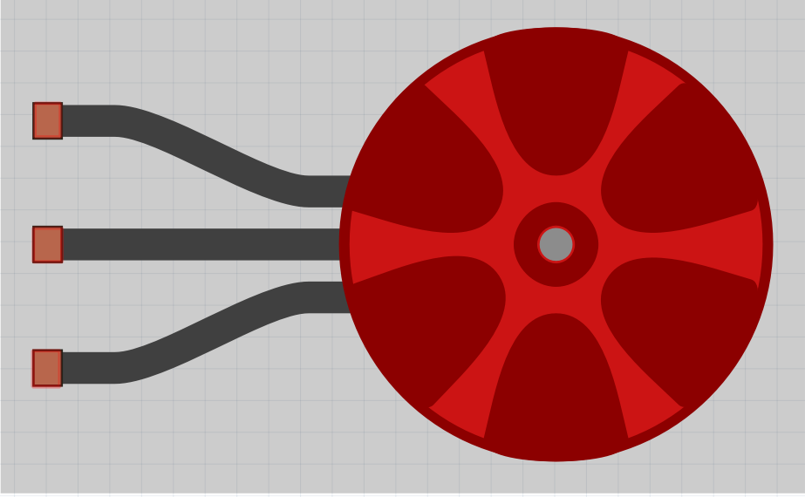
Brushless motor:
Powerhouse of the blaster. We used Xing2 1404 4600kV motors. 14 refers to the stator diameter in milimeters. The 4600kV is the motor contant and this number multiplied by the voltage will give you the rounds per minut of a brushless motor. (Lipo 3s 11,1V x 4600kV = 51,060 RPM)

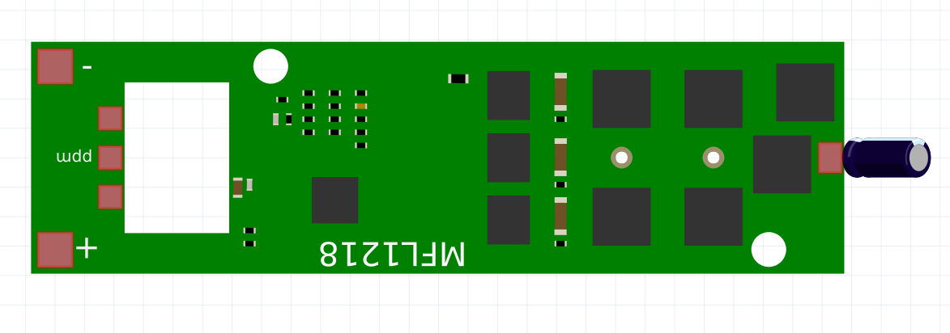
Electronic speed controller:
Used to control a brushless motor. Recieves signal from the arduino, which in turn controls its output signal. The usual ESCs has blheli S or blheli_32 firmware. Blheli_32 being the newest generation and the one with lowest latency.
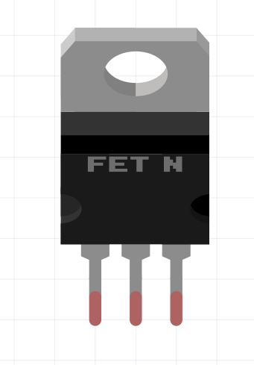
Mosfet:
A digital button. Used to let the arduino control high voltage, even though it can only survive low voltage. Arduino send signal to mosfet, mosfet open flood gates. Comes with 3 pins in this order: Gate-Drain-Source.

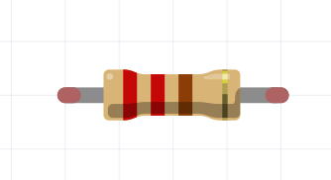
Resistor:
Adds resistence to a circuit. Used by us to limit amount of current going into our arduino. Unit is ohm.
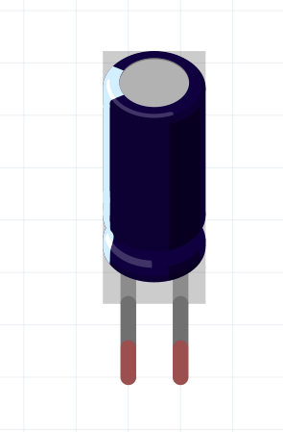
Capacitor:
Used to stabalize a power current. If the power is suddenly dropped for a mili-second, this will allow a unit to keep functioning for a short while. This could be when the motors rev up or likewise. We use them to keep the arduino and the ESC's alive while solenoid and motors and fireing.

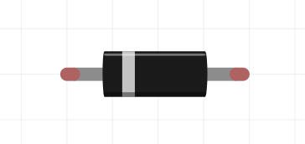
Diode:
Used to make sure a current only moves in one direction or to make sure that if a current exceeds a certain point, that it will be moved away from fragile components – Which is also why we use it.
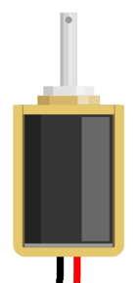
Solenoid:
An electro-magnet which creates a magnetic field, which causes an iron rod to move. It has a spring in one end, which forces the iron rod back when there is no power on it. We use this to push darts into our flywheels. The current solenoid used by us is the FJ-Z05 12v, 2A.

Firmware:
Code used to control a processor. It could be firmware for the ESC's or firmware for an arduino.

Useful links:
Facebook Groups:
https://www.facebook.com/groups/nothinbutnerf
https://www.facebook.com/groups/115961665148248

Shops:
https://blastersbyairzone.com/
https://outofdarts.com/
https://www.blaster-time.eu/

Guides:
In my personal opinion, Airzone, Torukmakto4 and Ultrasonic2 is the founding fathers of brushless foam blasters. Their respective youtube/blogspots is filled with priceless information:

Torukmakto's blogspot: https://torukmakto4.blogspot.com/
Airzones youtube channel: https://www.youtube.com/@AirzonesBlasters
Ultrasonic2's youtube channel: https://www.youtube.com/@Ultrasonictwo

https://www.youtube.com/watch?v=i6lhMcQLRSU – How to add settings/Flash an ESC

