Step by step guide to assemble the Mjölnier blaster.

Stage 1 preperation:

Step 1:
Make sure you've got all the components and cross-check with the BOM.
Get the blaster printed in your perfered colours.
Additional USB cable to connect Arduino to computer is needed aswell.
Step 2: Flashing ESC Firmware. This is done BEFORE assembly.
Depending on which ESC you got:

Download Blheli S suite: https://github.com/bitdump/BLHeli
Download Blheli_32 suite: https://github.com/bitdump/BLHeli/tree/master/BLHeli_32%20ARM

(Additional information regarding the flashing of ESC's can be found here:
Blheli S: https://oscarliang.com/flash-blheli-s-esc-firmware-fc-pass-through/
Blheli_32: https://oscarliang.com/blheli-32-esc-fc-passthrough/#download)
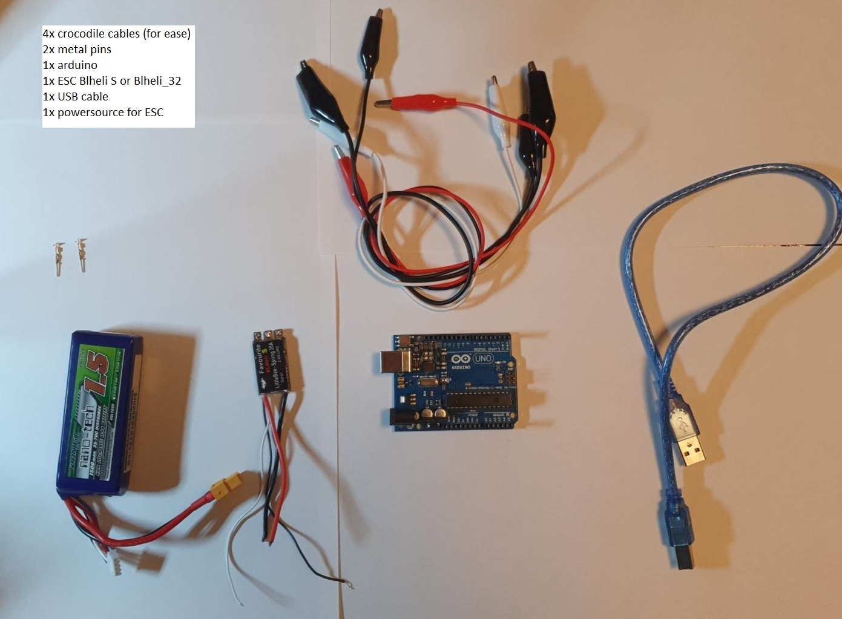
- Components I personally use to flash an ESC

- Place metal pins in D9 and gnd on arduino.
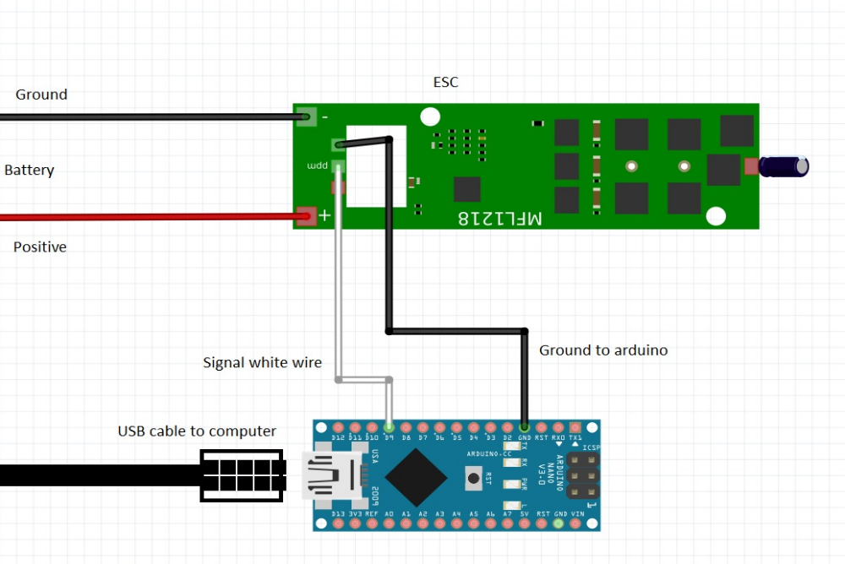Illustration 1:Wire schematic for flashing the ESC
- Use crocodile wire to connect signal wire from ESC to metal pin D9.
- Use crocodile wire to connect ground from ESC to arduino.
- Connect arduino to computer (NOTICE: No battery to ESC yet!)
- Open Blheli suite (Either the 32 or the S version, depending on your ESC)

This is how Blheli S suite looks when its just opened.
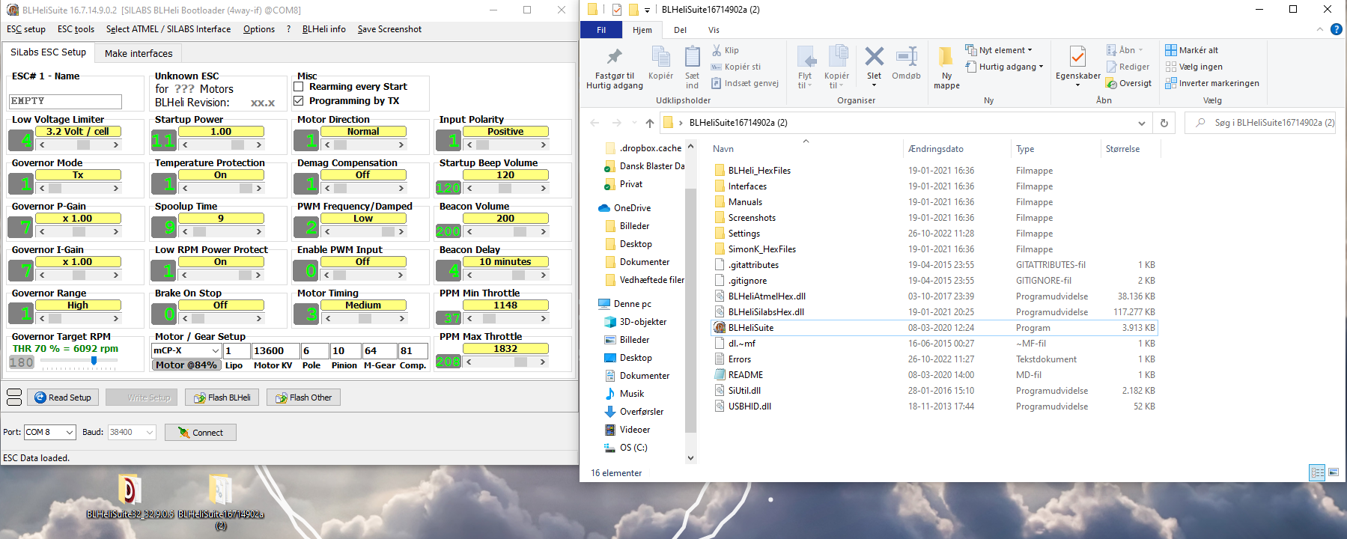Illustration 2:Blheli S suite
- Click the COMs tap at the left hand corner and choose the USB port which the arduino is plugged into
- Click "Make Interfaces"
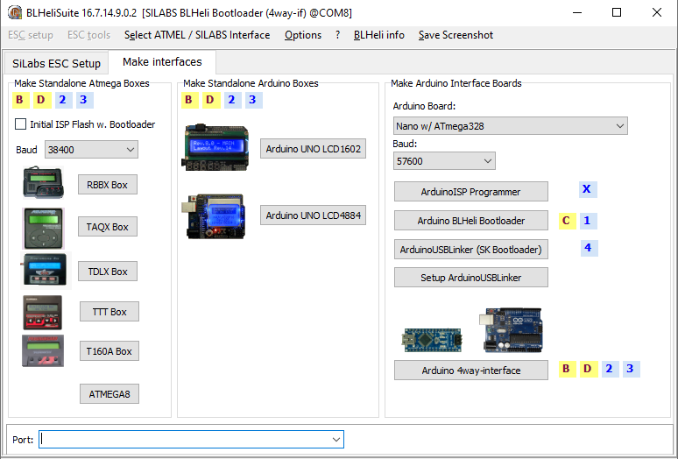Illustration 3:Make interface tap
- Choose the Arduino Board used. For the quick people, they'll notice that im using an arduino Uno instead of an arduino Nano. This makes no difference other than you have to pick the right board. I've shown the Arduino Nano board here, with the Atmega328 processor that we recommend for the Mjölnier blaster. NOTICE: I have not connected my usb correctly, so my USB port is not showing at the buttom of the program. This is a common problem with old USB ports. Doublecheck your connections.
- Press "Arduino 4way-interface"
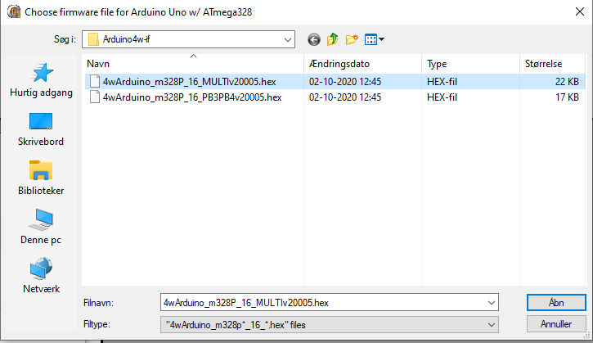
- I've picked this one multiple times with arduino uno. I havent had a chance to try this with a Nano, but I'll update as soon as I can get a chance to do so.
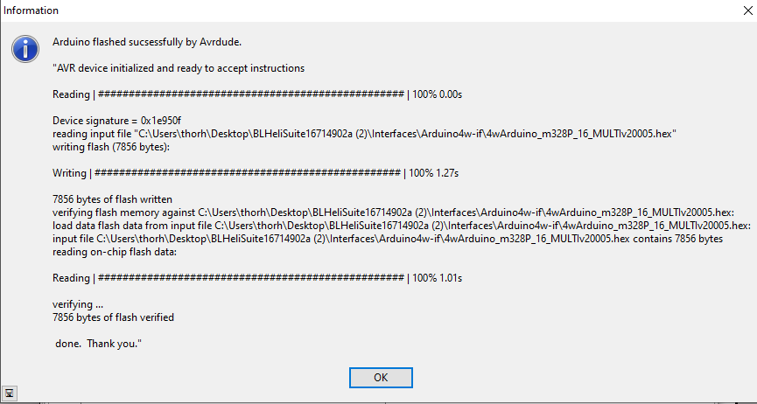
- Success!
- Move back to the ESC setup tab
- Add power to the ESC now(Woo!)
- Make sure it's still the right USB port and press Connect at the buttom of tab.
- Press "Read Setup"
- Update the data to look like your Blheli ESC (S or 32). See pictures at the buttom of this step. If you need the motor to move in another direction, this is the step where you can change that digitally.
- Press "Write Setup".
- Tadaaaa! Well done, the first ESC is flashed. Repeat for the second one.
Illustration 4:Blheli S config
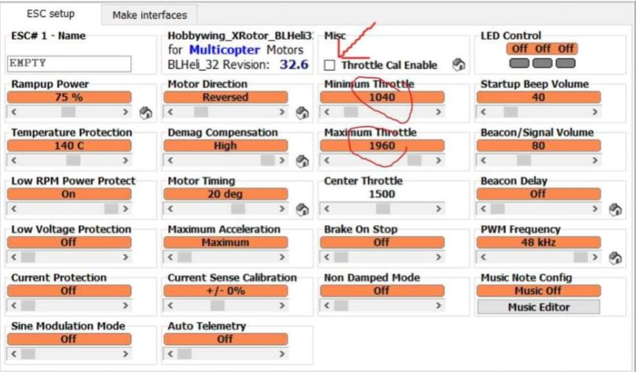Illustration 5:Blheli_32 config

Step 3 Flashing the Arduino Nano 3.0:

