**Step by step guide to assemble the Mjölnier blaster.**

**Stage 1 preparation:**

**Step 1:**

1. Make sure you've got all the components and cross-check with the BOM.
2. Get the blaster shell printed in your preferred colors.
3. Find a micro-USB cable to connect Arduino nano to your computer. Be warned that micro-USB charging cables probably won’t work for this process as they don’t have everything needed to send data.

**Step 2: Flashing ESC Firmware. This is done *BEFORE* assembly.**

Depending on which ESC you got:

**Download Blheli S suite:** <https://github.com/bitdump/BLHeli>

**Download Blheli_32 suite:** <https://github.com/bitdump/BLHeli/tree/master/BLHeli_32%20ARM>

(Additional information regarding the flashing of ESC's can be found here:  
Blheli S: https://oscarliang.com/flash-blheli-s-esc-firmware-fc-pass-through/

Blheli_32: <https://oscarliang.com/blheli-32-esc-fc-passthrough/#download>)

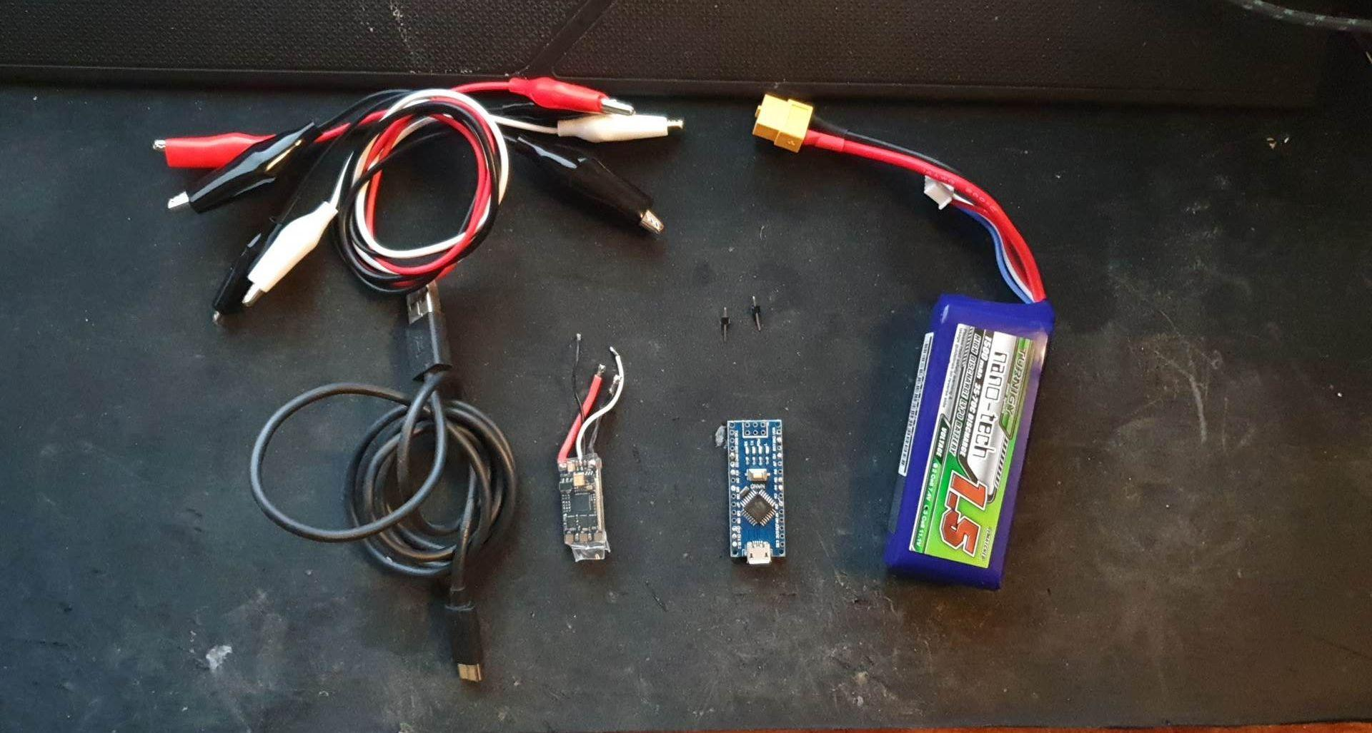

* Components I personally use to flash an ESC  
    
  4x Crocodile Cables  
  2x metal pins  
  Arduino Nano  
  ESC Blheli S or Blheli_32  
  USB cable  
  LIPO 3s for powering the ESC

1. Place metal pins in **D9** and **gnd** on arduino.
2. Use crocodile wire to connect signal wire from ESC to metal pin **D9**.
3. Use crocodile wire to connect ground from ESC to arduino **gnd**.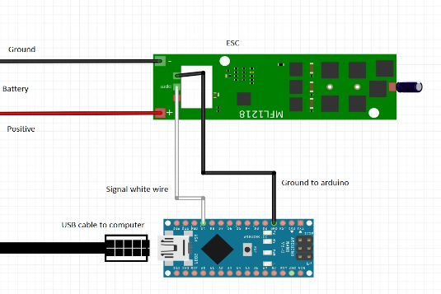
4. Connect arduino to computer (NOTICE: No battery to ESC yet!)
5. Open Blheli suite (Either the 32 or the S version, depending on your ESC.)

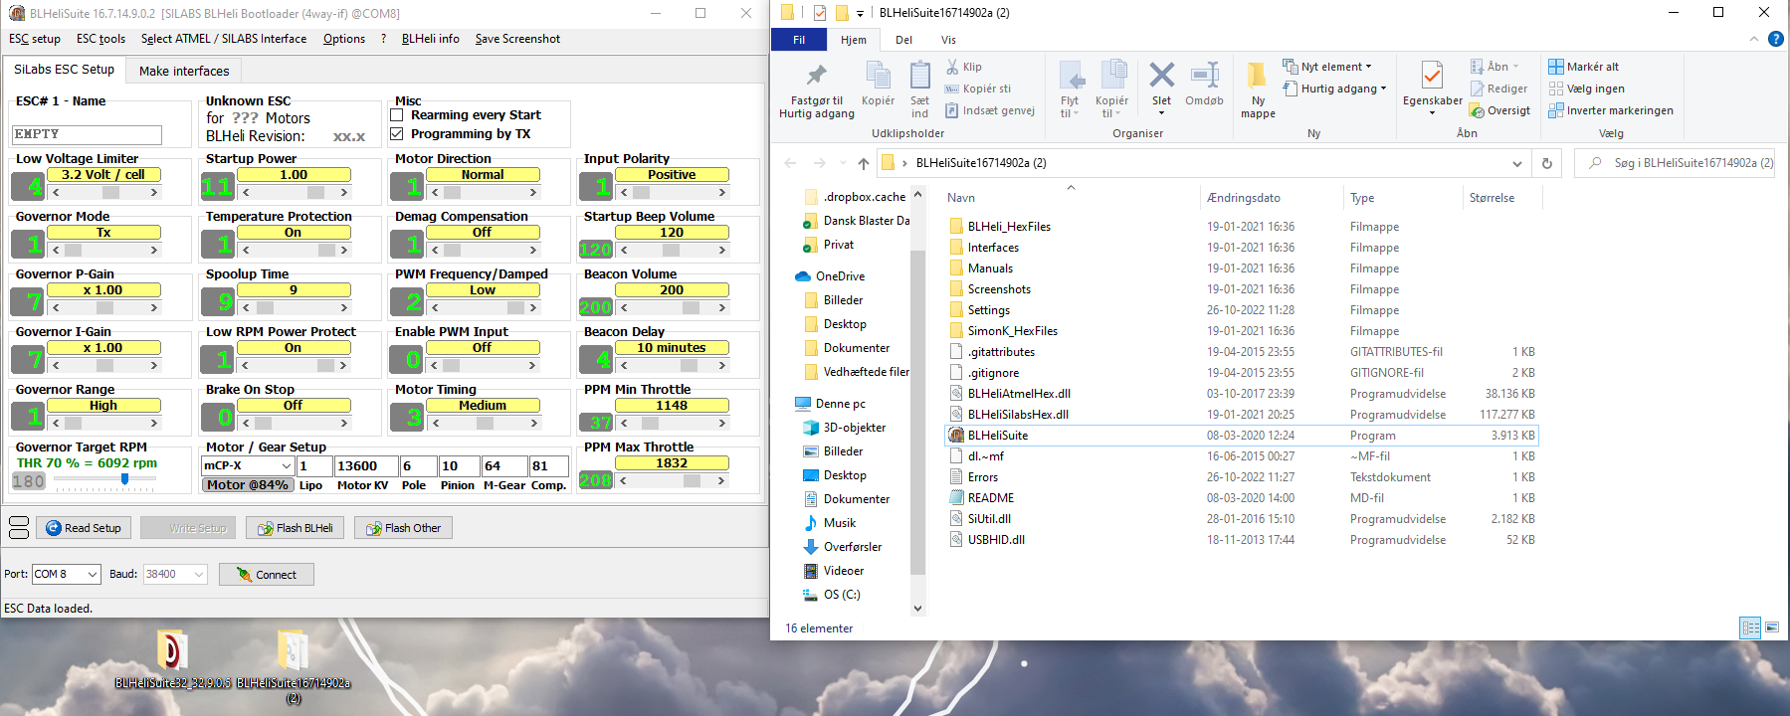

This is how Blheli_S suite looks when it's just opened.

1. Click the PORTs dropdown at the lower left hand corner and choose the USB port which the arduino is plugged into.
2. Click "Make Interfaces".

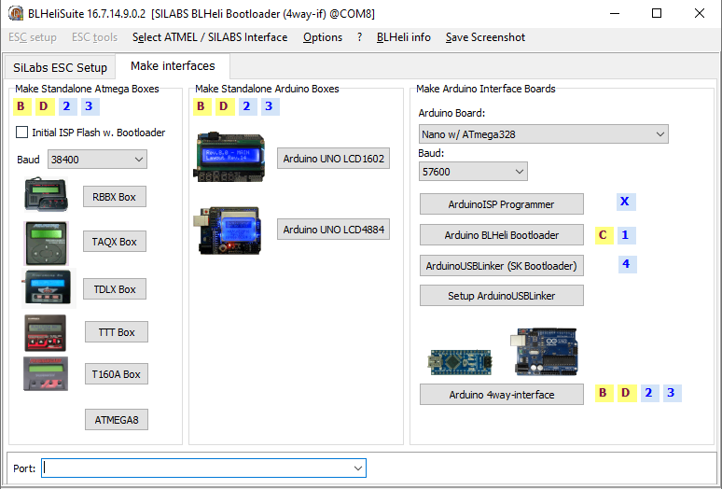

1. Choose the Arduino Board used. For the quick people, they'll notice that I'm using an arduino Uno instead of an Arduino Nano. This makes no difference other than you have to pick the right board. I've shown the Arduino Nano board here, with the Atmega328 processor that we recommend for the Mjölnier blaster. NOTICE: I have not connected my usb correctly, so my USB port is not showing at the bottom of the program. This is a common problem with old USB ports. Double check your connections.
2. Press "Arduino 4way-interface"
3. I've picked this one multiple times with arduino uno. I haven't had a chance to try this with a Nano, but I'll update as soon as I get a chance to do so. 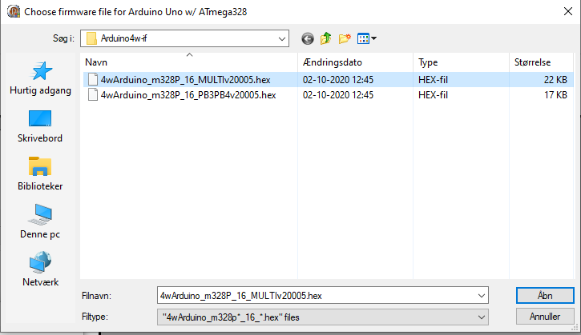
4. Success!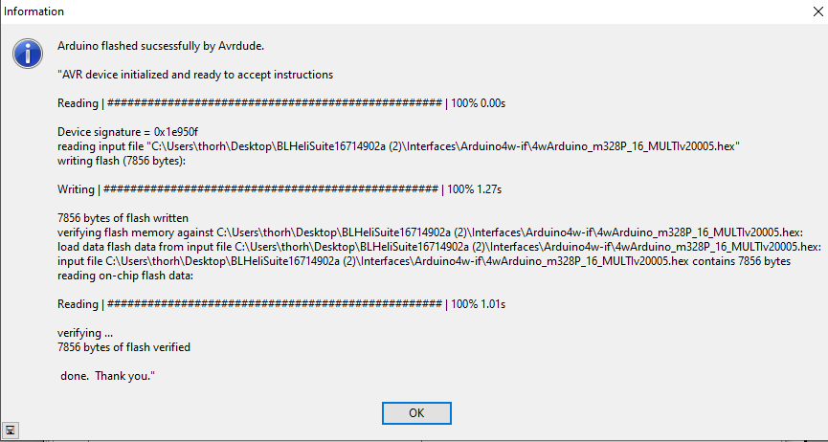
5. Move back to the ESC setup tab
6. Connect 3S Lipo or 11.1v to the ESC’s positive and ground copper pads(Woo!). The red wire from the battery is positive, the black wire is ground. **If you connect this in reverse, you will ruin your ESC**.
7. Make sure it's still the right USB port and press Connect at the bottom of the tab.
8. Press "Read Setup"
9. Update the data to look like your Blheli ESC (S or 32). See pictures at the bottom of this step.

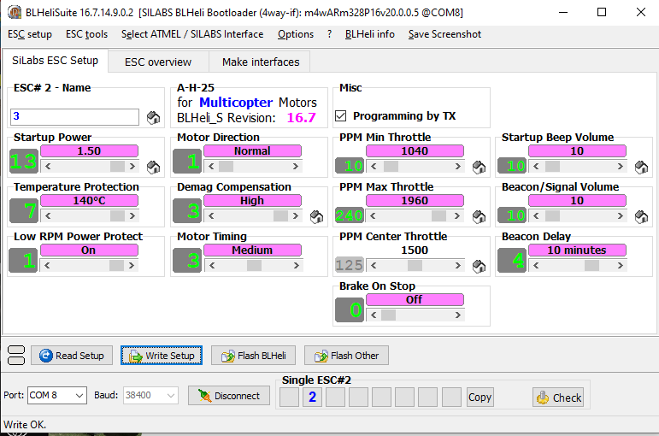

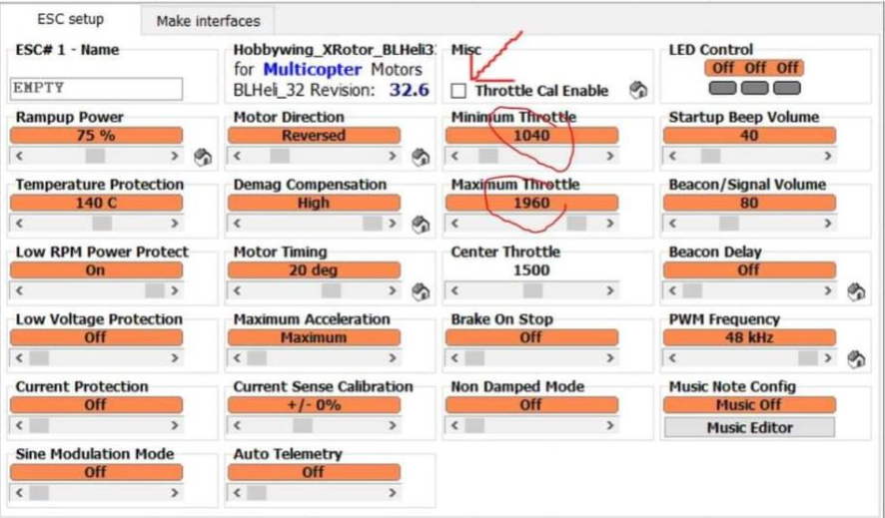

1. Press "Write Setup".
2. Tadaaaa! Well done, the first ESC is flashed.
3. Repeat for the second one with the exception of changing the “Motor Direction” setting to be a “0” so that the second motor will turn in the opposite direction..

**Step 3: Flashing the Arduino Nano 3.0:**

1. Download the Arduino IDE and install the newest version.   
    Link: <https://www.arduino.cc/en/software>
2. Download the code and open it with the arduino IDE.   
   It will look something like this: 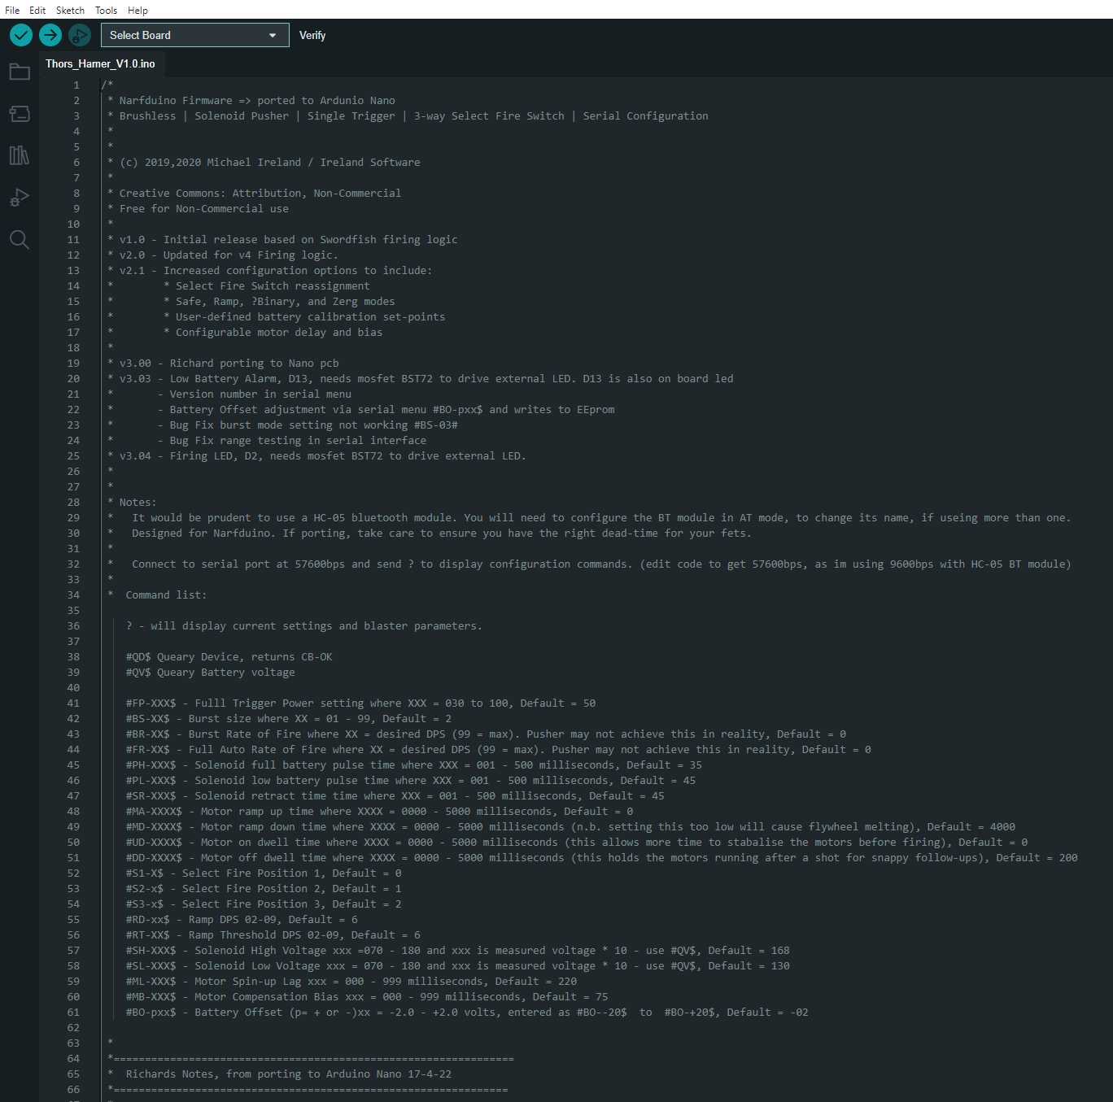
3. Plug your arduino nano 3.0 into the USB port using a USB cable.
4. Go to Tools --> Boards --> Arduino AVR Boards --> Arduino Nano  
   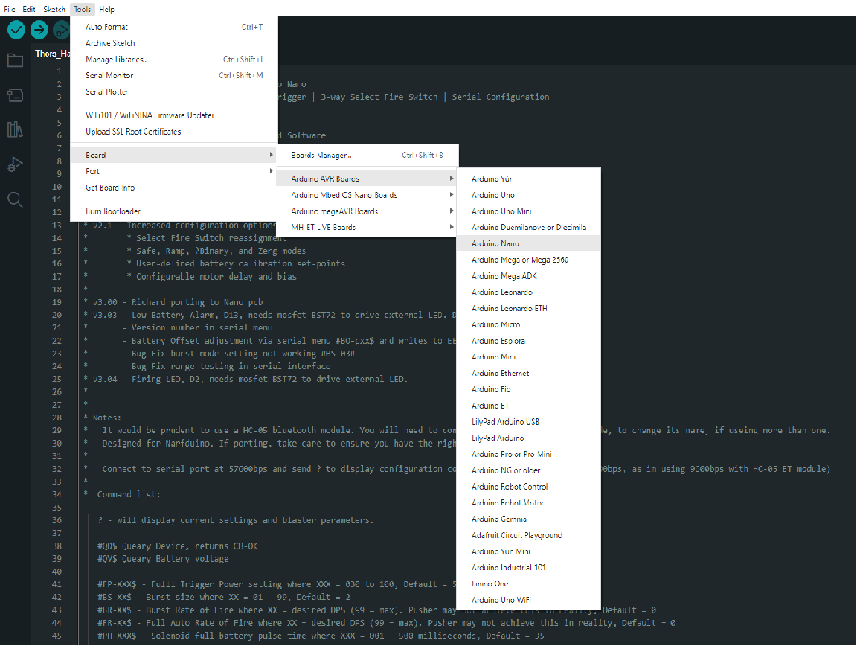
5. Go to Tools --> Port --> Pick the port which the arduino nano is connected to.
6. Press Verify (Top left corner)  
   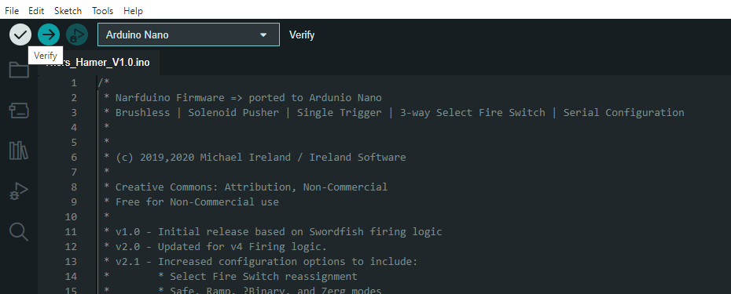
7. Press Upload (right next to it)
8. Once the loading bar in the bottom right corner finishes and it says "upload completed" or so, you're done flashing the arduino!

**Troubleshooting:**

* Try resetting the arduino by pressing the button.
* Try to use the old bootloader instead
* Download the proper drivers from the place where you bought the arduino nano (different manufacturers can make boards requiring different drivers.)
* DOUBLE CHECK YOUR CABLES. Is it a data-USB cable? Is it loose? Is the USB port working?