脳波信号パターンのパスワードアプリケーション調査と開発

◯センショ　サビノ　ブルーノ（琉球大学工学部情報工学科）、山田　孝治（琉球大学工学部情報工学科）

Test and development of a mind wave signal pattern password application

◯Senzio Savino BRUNO(University of the Ryukyus), and Koji YAMADA (University of the Ryukyus)

Abstract: This paper presents a way of developing a password application with mind wave patterns based on attention and meditation values generated by a low cost EEG interface. By generating desired peak values from the meditation readings in the time frame, a unique pattern is obtained. The pattern is compared with an expected output in order to perform specific actions.

**Key Words**: Brain wave training, EEG application, EEG adaptation, EEG pattern recognition

1. **INTRODUCTION**

As EEG and other brain non-invasive technologies have been lowering their costs and availability to the public, the number of investigations and applications on Brain-Machine Interface (BMI) has increased. While some researchers are adapting the use of physical movements for BMI[1], other investigations focus on the measurement of specific mind wave levels and brain activity locations when thinking of a specific color, object or even hand positions and actions [2].

In order to detect different mind wave values, different algorithms are needed to filter and obtain the necessary output. In this case, the use of Neurosky’s TGAM-1 module on a commercial EEG headset already provides the attention and meditation output values that were used for this research. Due to the tool’s output frequency, a set of specific mind patterns were designed and programmed to fit a time frame within a configurable threshold for peak value measurements. A small GUI application is used to compare an expected pattern with the generated one and detect whether the output signal is correct in order to perform a specific action with the corresponding result.

There are different kinds of configurable patterns; however, there must be a specific timing when generating high meditation and/or attention readings, as it requires some time for the end user to adapt to the environment and generate the desired signals. The tests were performed by selecting three basic patterns for meditation values with both trained and untrained end users to verify how easy it was to adapt to a specific mind pattern. Above 60% success rate was obtained when combining both kind of users while an 80% success rate was achieved with trained users. Some EEG adaptability tests were performed with new users in order to verify the ease of usage of an EEG device for a specific activity. It is also important to note the helmet’s measurements errors and resolutions due to the fact of being a low cost tool with simple algorithms.

Some further work for applying this technique will be implemented to achieve a specific set of mind patterns for unlocking mobile devices or applications as the one used for Brain-Mobile Phone Interface (BMPI) such as the Neurophone[3], or the use of a specific pattern customization for end users for security end applications.

The implementation of machine learning algorithms could be useful in order to adapt the mind pattern generation unique for each user. In the following paper the programmed system is described as well as the mind wave pattern technique description and achieved results.

1. **MIND PATTERNS**

There are different ways to measure brain wave signals from EEG that include both asynchronous [4] and synchronous discriminative methods in order to compare and fit a signal output to an expected result. In this case, due to the fact of the slow signal frequency output, which is one output set of attention and meditation values per second, the reduced number of EEG signal inputs from the EEG device and the ease to obtain more detailed values such as attention and meditation behaviors, the use of a synchronous signal processing method was used.

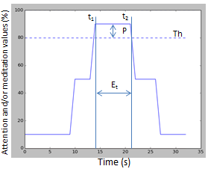

Fig. 1 Mind pattern curve parameters

The mind pattern generation method used consists of setting a specific time frame set in which a threshold value is configured depending on the attention and/or meditation percentage output from the EEG device, where 0% represents no relative signal and 100% is related to a fullattention or meditation behavior. As detailed in *Fig. 1*, the mind pattern curve is created by selecting a time frame in which the expected signal will be compared, a specific set of time in which either an attention or meditation peak value is expected such as the expected time frame **Et** between **t1** and **t2** in which peak **P** is referred to a value that exceeds a configured threshold value **Th**.

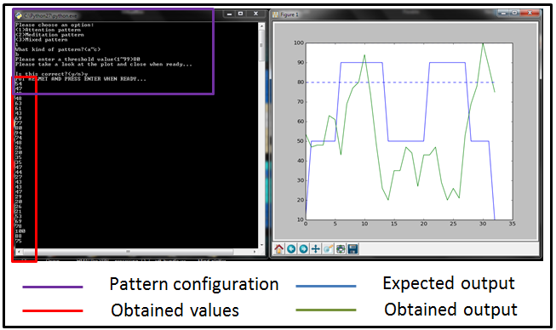As shown in *Fig. 2*, there can be different sorts of mind patterns for a time frame that can use either attention or meditation values. Combined patterns can also be created to measure two different parameters on a time frame.

Fig. 2 Different kinds of mind patterns that can measure attention or meditation values

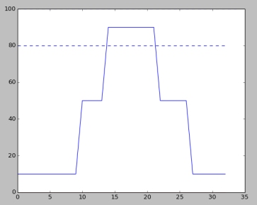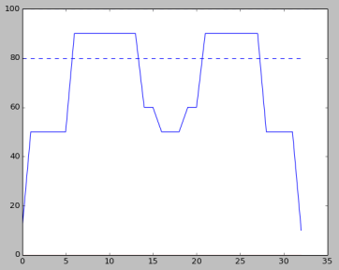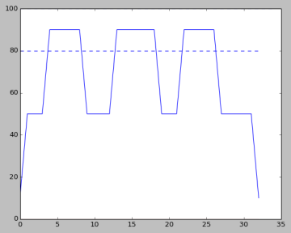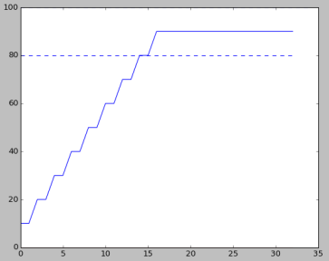

A

B

C

D

1. **SYSTEM DESCRIPTION**

The different mind wave values and outputs were generated with an EEG headset with a TGAM-1 ASIC from Neurosky Inc. The module is capable of filtering and reading mind waves at different speeds, the configuration used for testing was of 9600 bauds with Normal Output Mode [5]. In order to transmit the signal to the processing application, an RF transceiver sends the signal to a Microcontroller unit that understands the TGAM-1 coded signal packages and decrypts them to send the attention and/or meditation percentage values to a Python application via RS-232 at the same baud rate as seen on *Fig. 3*.

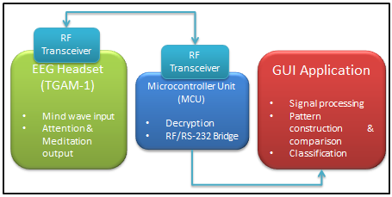Fig. 3 Mind pattern processing system description

In order to process the signal information, a filtering algorithm is used to tell whether the signal is exceeding the threshold value or not and then compared to an expected pattern using some zero-cross to check that the value peaks are generated on the expected time. The algorithm is used as a time-domain method for speech processing as well [6].

Fig. 4 Mind pattern configuration and comparison GUI (Mind tester)

The resulting Graphic User Interface (GUI), as presented in *Fig. 4* shows how a mind pattern can be selected, configured and then compared to see if the obtained output from the EEG device matches the corresponding pattern. From this, it is basically simple to develop a password application when configuring different patterns that can be reproduced in a unique way depending on each user, e.g. using patterns A, B and C in the following order C🡺B🡺A, as long as all the patterns are reproduced correctly and on time.

1. **RESULTS**

To test the mind wave matching capabilities of an end user both the attention and meditation value generation adaptability was tested in order to verify which one was simpler to recreate. For this case, meditation values resulted to a better choice. From the mind wave patterns presented on *Fig. 2*, patterns A, B and C were selected to be tested with five end users; three of them performed adaptability training tests before obtaining the corresponding data for the end results. Each pattern was to be recreated five times, each one with a corresponding threshold of 80% of meditation value on peaks. After performing A, B and C pattern tests, an end test consisted of recreating pattern B followed by pattern A in order to see if the end user was able to recreate successfully one after the other to see how easy it could be for an end user to recreate a mind password set without failing with the present EEG device. While *Table 1* shows the average obtained success rate, *Table 2* shows the specific results per user.

Table 1. Overall average success rate 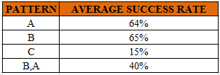

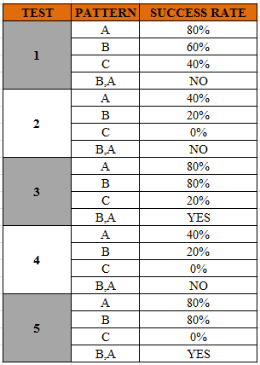Table 2. Specific user end results (gray color means the user performed adaptability training before the tests)

While the overall average success rate for patterns A and B was above 60%, pattern C was extremely difficult to recreate according to the end users, due mainly to the fact of having a small recovery time between peaks. It is important to point out the fact that the overall results include both trained and untrained end users while the specific user test results show evidence of better performance with trained users. Still, the generation of a pattern sequence such as B and A had a success rate below 50% for an overall result but a success of 66% when taking only trained users as the parameter.

1. **CONCLUSIONS**

The performance of mind pattern generation with a low cost EEG device performed successful for trained users, which implies the use of a special training routine to obtain the desired parameters. Nonetheless, it is important to understand that the adaptability of each end user depends on both human factors and the instrument’s error frame. Also, the results for trained users present a good panorama for generating mind wave patterns consisting of meditation behaviors for password applications programming.

It is interesting to verify the simplicity and versatility of recent EEG devices with the use of simple signal processing algorithms such as zero crossing comparison. The fact that pattern C could not be recreated correctly means that there must be a small space for each end user to switch between meditation/attention/normal behaviors, if the time frame is too short and the sampling rate is low it will not be possible to obtain an effective result. Although there might be users that can get easily used to recreate a specific behavior, there are some other people who would require special attention to obtain the desired result, this test might also be useful to detect people who might have concentration/meditation problems for rehabilitation purposes.

The obtained results for trained users is a good lead into developing a password application for BCPI and generate another way to generate a secure and unique password for each person in a simple and low cost way.

**REFERENCES**

1. K. Uemoto, M. Yoshioka, Y. Yoshikawa and C. Zhu. “Investigation of the Relationship between Motor Intensity and EEG by Mirror Neuron System” No. 14-2 Proceedings of the 2014 JSME Conference on Robotics and Mechatronics, Toyama, Japan. 3P1-U03(1)- 3P1-U03(2) (2014)
2. P. Ofner, G.R. Müller Putz, “Decoding of velocities and positions of 3D arm movement from EEG”, European ICT Programme Project FP7-224631, University of Technology, Krenngasse 37, 8010 Graz, Austria. p. 1-3 [Online]
3. Andrew T. Campbell, Tanzeem, Choudhury, Shaohan Hu, Hong Lu, Matthew K. Mukerjee, Mashfiqui Rabbi, and Rajeev D. S. Raizada, “NeuroPhone: Brain-Mobile Phone Interface using a Wireless EEG Headset”, MobiHeld, New Delhi, India P. 1-6 (2010) [Online]
4. Jaime F. Delgado, M¨ujdat C¸etin “Discriminative Methods for Classification of Asynchronous Imaginary Motor Tasks from EEG Data”, IEE Transactions on Neural Systems and Rehabilitation Engineering, p. 1-4 [Online]
5. TGAM-1 Spec sheet. Neurosky Inc. (2010) p.5-8 [Online]
6. L.R. Rabiner, R.W. Schafer “Digital Processing of Speech Signals”, Prentice-Hall Signal Processing Series, p.116-120 (1978)