- Explain regression -> You are a statistics tutor helping a beginner data analyst preparing for a finance internship. Explain what regression is in plain language, assuming I know basic Excel and descriptive statistics but have never studied regression. Cover what question regression answers, how it differs from classification, and what the line of best fit represents. Use one real-world finance example, such as predicting monthly sales from advertising spend. Keep it under 300 words and define any technical term the first time you use it. End with one practice question to check my understanding.
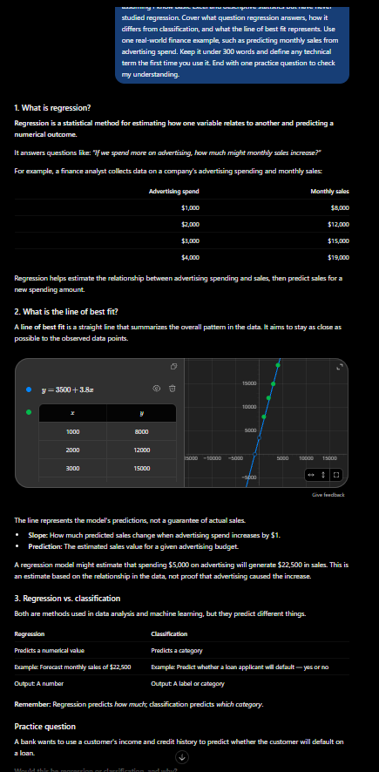
The original gave no context, so the response could have been a textbook definition or a graduate-level breakdown. Naming my skill level and adding a finance example keeps it at a level I can use, and the word limit stops it from dumping everything it knows on me.
b) Help me understand SQL -> You are a SQL instructor teaching a beginner who already knows Excel and PivotTables. Give me a learning path covering SELECT, WHERE, GROUP BY, and JOINs, in the order I should learn them. For each, include a one-sentence explanation, a short example query, and one practice problem. Use a numbered list and don’t give me the answers until I attempt them.
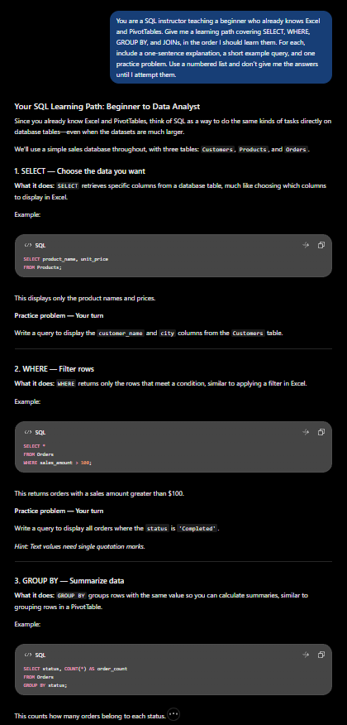 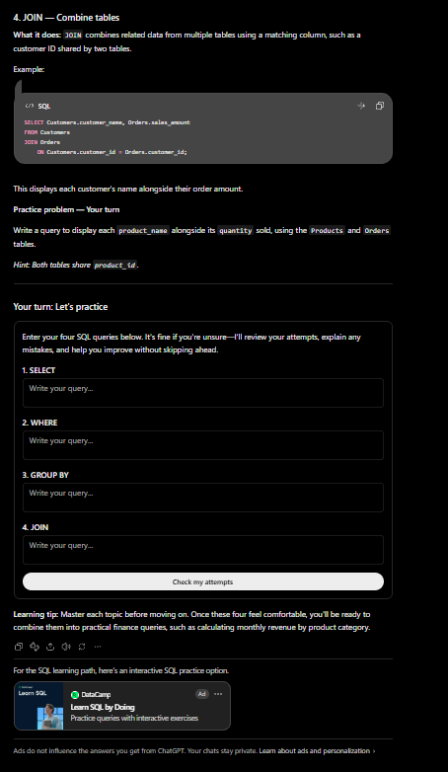
“Help me understand SQL” is too broad. Listing the specific topics and asking for them in learning order gives me a path instead of a huge wall of information, and withholding the answers forces me to actually practice.
c) Create a dataset -> Create a 15-row dataset of monthly retail sales with these columns: Month, Units Sold, Revenue, and Return Rate. Use January through March across five product categories. Units Sold should range from 100 to 900, Revenue should be realistic relative to it, and Return Rate should fall between 1% and 12%. Include one clear outlier. Format it as a table I can paste into Excel.
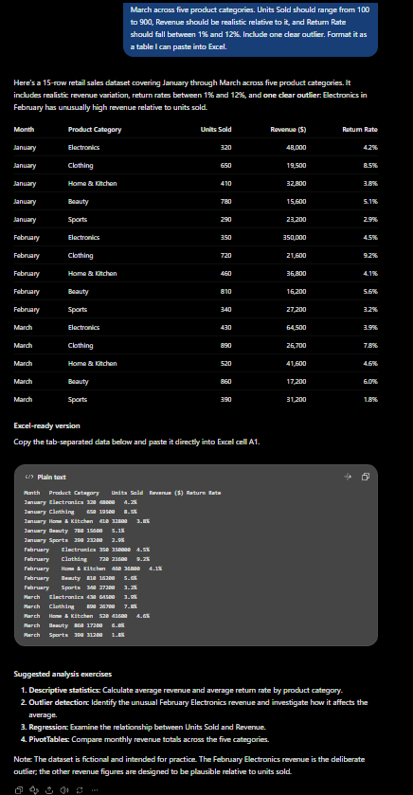
The original left every detail up to the AI, so I’d get whatever it felt like making. Specifying the columns, row count, and value ranges means I get data I can actually use, and asking for an outlier makes it useful for the kind of analysis I’m learning.

