Enterprise Hybrid Active Directory Security Architecture
A Security‑Focused Identity Infrastructure Whitepaper
Author: Benjamin Smarjesse

All infrastructure shown in this document was deployed within an isolated
virtual lab environment and does not represent a production network.

Table of Contents
Executive Summary 3
Virtual Infrastructure Platform 4
Network Architecture / Topology 4
Core Infrastructure Systems 5
Active Directory Domain Deployment 6
Organizational Unit Design 8
Role Based Access Control Architecture 9
Enterprise Printer Deployment 13
Windows LAPS Password Security 14
Enterprise Public Key Infrastructure 15
Tiered Administration Security Model 16
Privileged Access Workstation Architecture 17
Security Monitoring and Auditing 18
Credential Theft Mitigation 19
Enterprise Security Controls Implemented 19
Hybrid Identity Architecture 19
Skills Demonstrated 20
Enterprise Architecture Summary 21
Conclusion 21

Executive Summary
This whitepaper documents the design, deployment, and security hardening of a hybrid enterprise Active Directory environment implemented in a virtualized homelab. The project simulates real‑world enterprise identity infrastructure and demonstrates modern identity security practices used in production corporate environments.
The architecture includes multiple domain controllers, centralized file services, domain‑joined workstations, and a dedicated Privileged Access Workstation (PAW). Security architecture incorporates Role‑Based Access Control (RBAC), Group Policy infrastructure, Windows LAPS password rotation, Enterprise Public Key Infrastructure (PKI), and a Tiered Administration Model to protect privileged credentials.
A hybrid identity model was implemented through integration with Microsoft Entra ID using Microsoft Entra Connect. This allows synchronization between on‑premises Active Directory identities and cloud identity services.
The resulting environment demonstrates enterprise‑grade identity infrastructure design, security hardening, and operational administration workflows.

Virtual Infrastructure Platform
Hypervisor: Microsoft Hyper-V
Virtual Switch: LAB-SWITCH (Internal)
Network Range: 192.168.10.0 / 24
The network is intentionally isolated from the internet to simulate a segmented corporate infrastructure network and to prevent external exposure while allowing full domain communication.

Network Architecture / Topology
Network topology of the virtualized enterprise identity lab environment hosted on the Hyper-V platform (BLS-01). Core infrastructure includes two domain controllers (DC-01, DC-02), centralized file services (FS-01), a domain workstation (WS-01), a privileged access workstation (PAW-01), and a hybrid identity synchronization server (SYNC-01) used for Microsoft Entra ID integration.
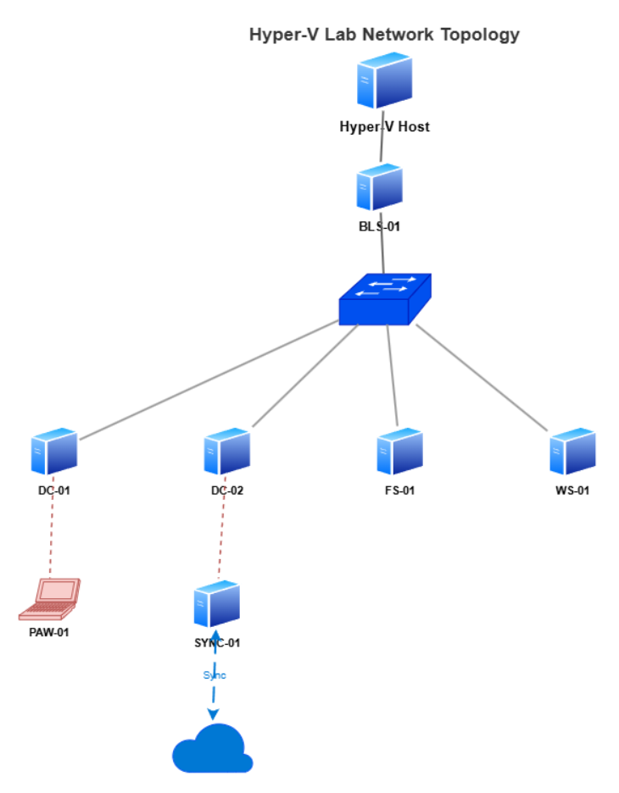
Figure 1 — Virtualized Active Directory Infrastructure Architecture

Core Infrastructure Systems
Core virtual machines supporting the Active Directory infrastructure, including domain controllers, file services, privileged administration workstation, client systems, and the hybrid identity synchronization server used for Microsoft Entra ID integration.
System | Role | Operating System
DC-01 | Primary Domain Controller / DNS | Windows Server 2022
DC-02 | Secondary Domain Controller / AD Replication | Windows Server 2022
FS-01 | File Server / Print Server | Windows Server 2022
WS-01 | Domain Workstation | Windows 11
PAW-01 | Privileged Access Workstation | Windows 11
SYNC-01 | Microsoft Entra Connect / Hybrid Identity Server | Windows Server 2022
Figure 2 — Core Infrastructure Systems of the Enterprise Identity Lab Environment

Active Directory Domain Deployment
The Active Directory domain was deployed using Windows Server 2022. DC‑01 was promoted to a domain controller with integrated DNS services.
The domain 'lab.local' was created and configured with Active Directory‑integrated DNS. Domain functionality was validated through SYSVOL and NETLOGON share verification as well as domain authentication testing.
Workstation WS‑01 was joined to the domain to validate user authentication and policy processing.
The domain controller environment was expanded through the deployment of a secondary domain controller, DC‑02. This provides redundancy, replication, and improved authentication resilience.
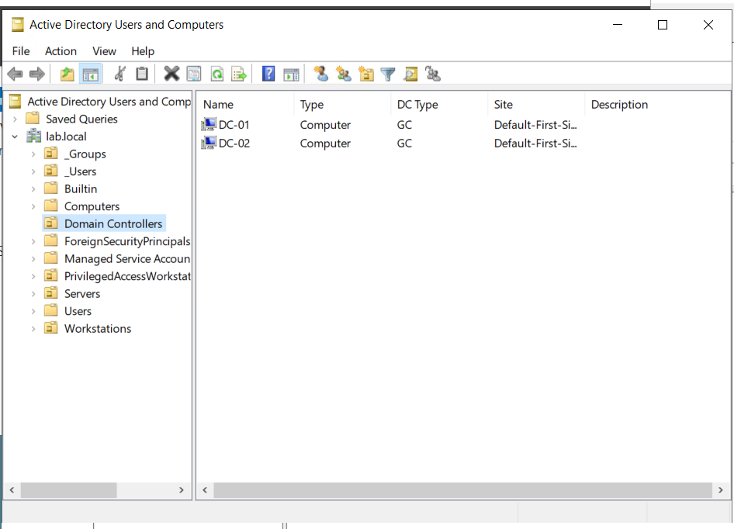
Figure 3 — Active Directory Domain Deployment and Domain Controller Infrastructure

Output from the repadmin /replsummary command confirming successful replication between domain controllers DC-01 and DC-02. The results show zero replication failures, verifying healthy directory synchronization and redundancy across the Active Directory infrastructure.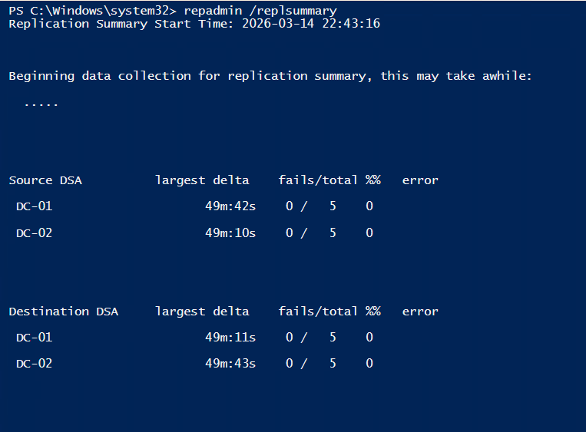
Figure 4 — Active Directory Replication Health Validation
Network configuration of domain controller DC-01 showing static IP addressing, domain DNS suffix (lab.local), and DNS servers pointing to domain controllers. This configuration ensures proper Active Directory name resolution and domain communication.
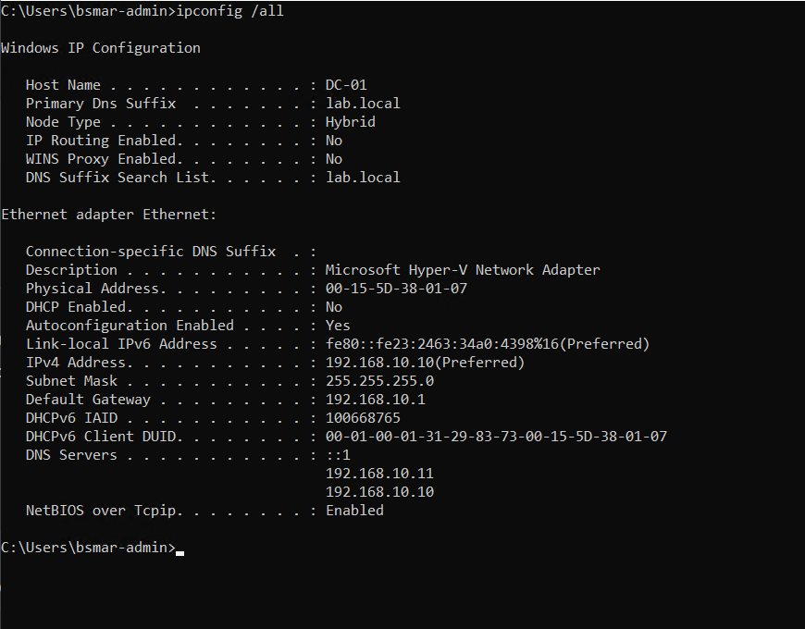
Figure 5 — Domain Network Configuration Validation

Active Directory Sites and Services configuration showing domain controllers DC-01 and DC-02 within the Default-First-Site-Name site. Both domain controllers function as Global Catalog (GC) servers, enabling directory replication, authentication redundancy, and high availability within the lab.local domain.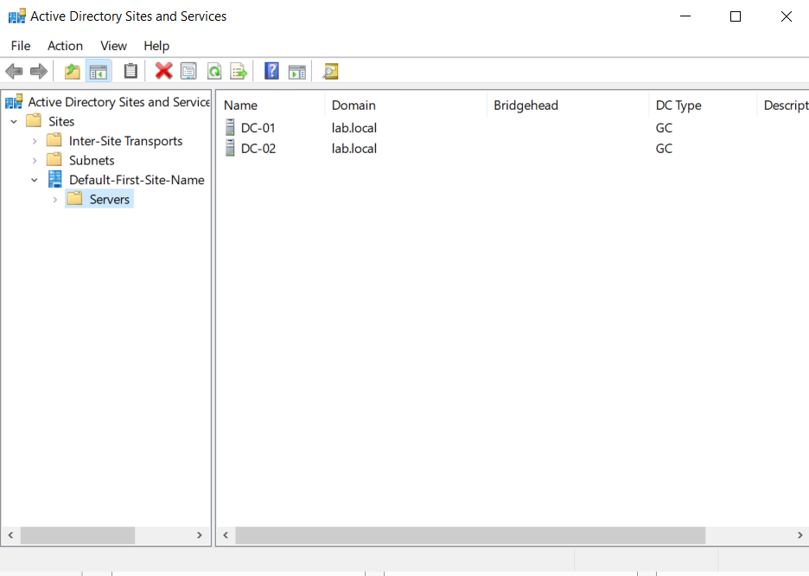
Figure 6 — Active Directory Sites and Services Replication Topology

Organizational Unit Design
A structured Organizational Unit hierarchy was implemented to support policy targeting, resource organization, and administrative delegation.
The OU structure includes:
Users – contains domain user accounts
Groups – contains security groups used for RBAC
Servers – contains server infrastructure systems
Workstations – contains client workstation systems
PrivilegedAccessWorkstations – contains hardened administrative systems
This structure allows Group Policy Objects to be applied selectively to different system types while maintaining administrative clarity.
Domain user accounts created using PowerShell automation and CSV-based bulk provisioning, enabling rapid onboarding of simulated organizational users for access control testing and RBAC validation.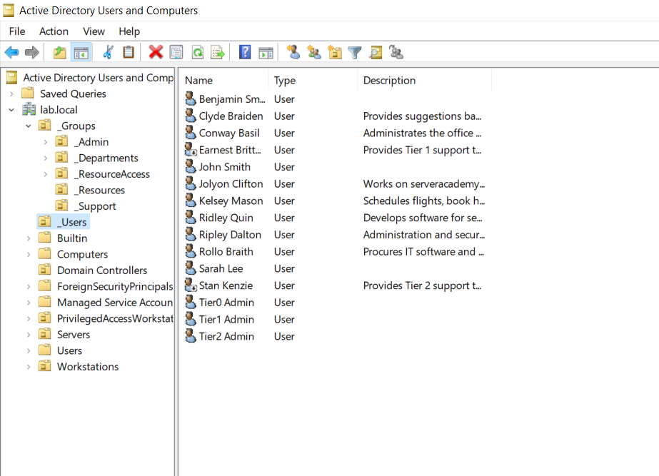
Figure 7— Active Directory User Account Provisioning

Role Based Access Control Architecture
Access to organizational resources is controlled through Role‑Based Access Control (RBAC). Security groups were created to represent organizational departments and functional roles.
Departmental security groups include:
GG_IT
GG_Support
GG_Development
GG_Executives
GG_Procurement
GG_Administration
Permissions are assigned to groups rather than directly to individual user accounts. This approach follows the AGDLP model (Accounts → Global Groups → Domain Local Groups → Permissions).
The RBAC architecture simplifies permission management while enforcing least privilege access.
Departmental security groups used to implement RBAC-based permission management for users and shared resources within the lab.local domain.
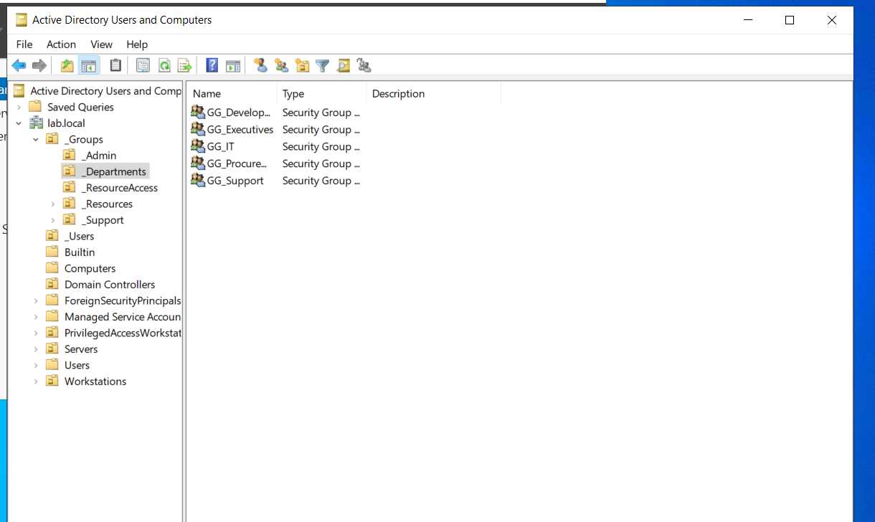
Figure 8— Department-Based Security Group Structure
PowerShell Automation
PowerShell automation was used to reduce manual administration and simulate real enterprise provisioning workflows. Automation tasks included:
- Bulk user creation from CSV
- Standardized account naming and onboarding
- Group assignment for RBAC
- Validation and troubleshooting commands
- Administrative verification of shares, connectivity, and replication
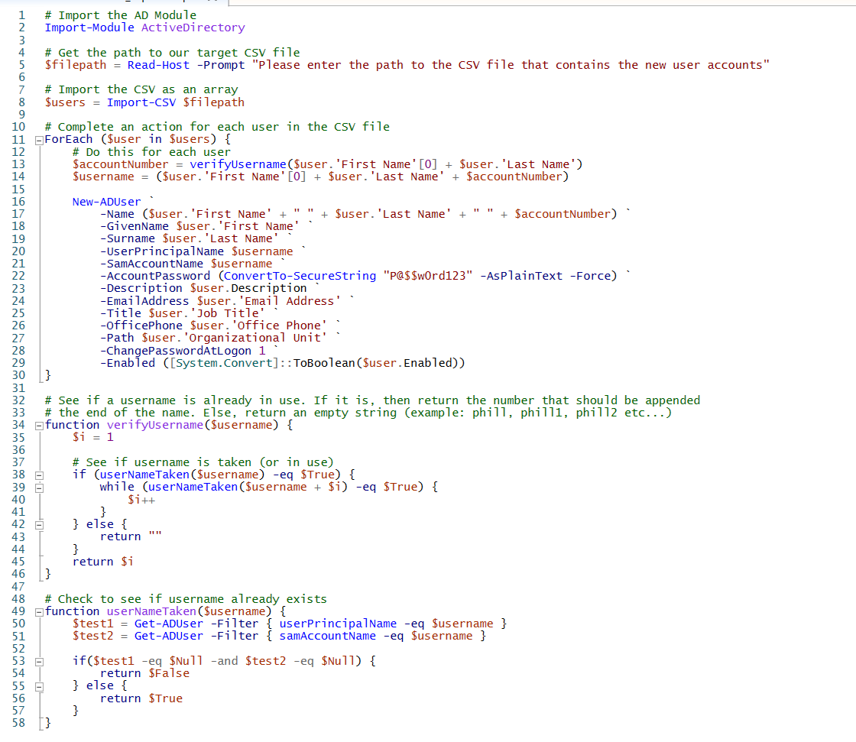
PowerShell script used to automate user provisioning within Active Directory by importing user data from a CSV file. The script creates user accounts, assigns attributes, and includes logic to prevent duplicate usernames during account creation.

Figure 9 — PowerShell Automation Script for Bulk Active Directory User Provisioning
File Server and Resource Management
FS‑01 was deployed as the centralized file server for the environment.
A shared folder structure was created to simulate departmental resources:
C:\Shares
└── IT
The folder was shared as an SMB share named \\FS‑01\IT.
Access permissions were configured using both NTFS permissions and SMB share permissions aligned with Active Directory security groups.
Computer Management displaying configured SMB shares on FS-01, including departmental shares used to simulate organizational resource access within the Active Directory environment.
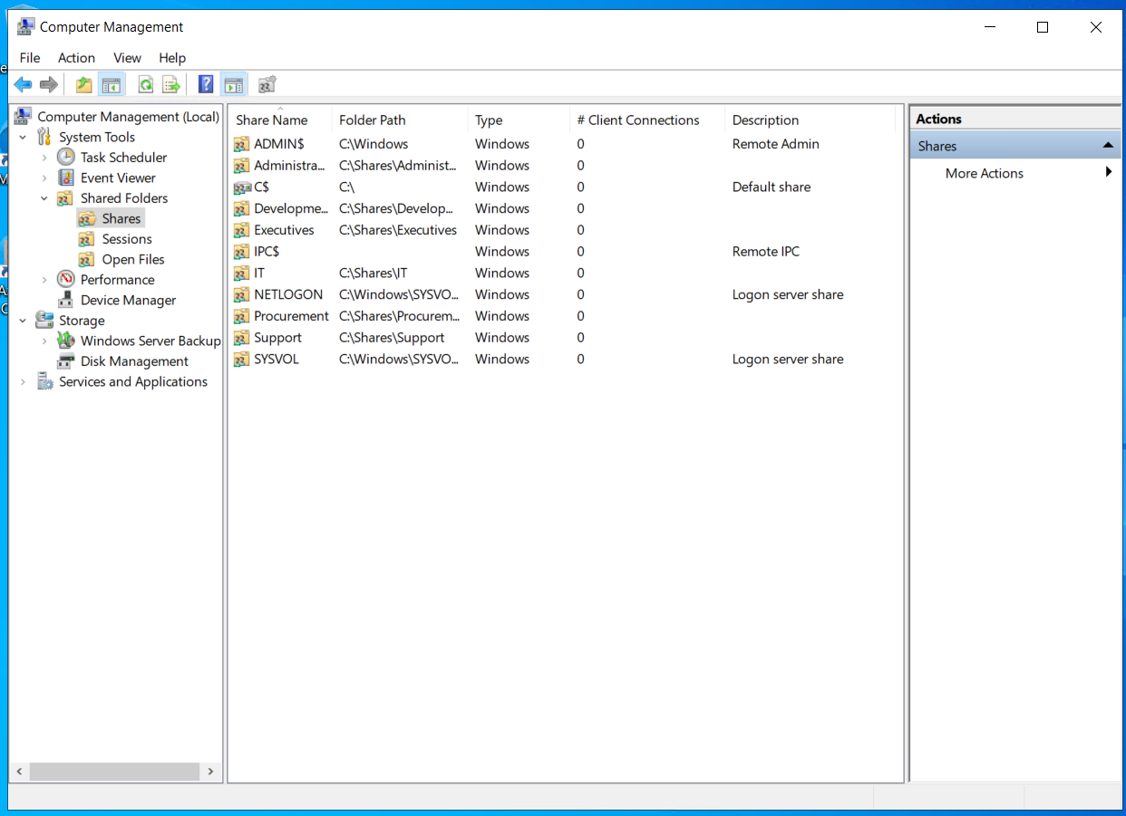

Figure 10 — File Server Shared Resources Configuration

Group Policy Infrastructure
Group Policy is used to centrally manage system configuration and resource deployment across the domain.
A Group Policy Object titled 'Drive Mapping – IT' was created to deploy a network drive to authorized users.
The drive mapping configuration includes:
Drive Letter: I:
Share Path: \\FS‑01\IT
Target Security Group: GG_IT
Item‑level targeting ensures that only members of the IT department receive the mapped drive.
Group Policy Objects configured within the lab.local domain to enforce enterprise security and operational standards. Policies include LAPS password management, Privileged Access Workstation (PAW) restrictions, Tier-0 domain controller logon protections, drive mapping, folder redirection, and printer deployment, demonstrating centralized configuration management and security hardening within the Active Directory environment.
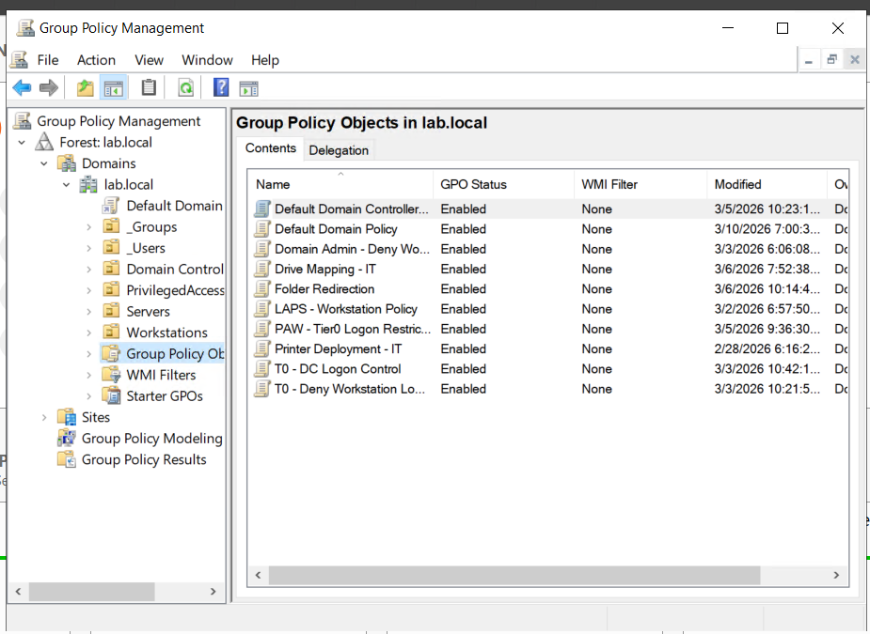
Figure 11 — Group Policy Security and Infrastructure Configuration

Enterprise Printer Deployment
The Print Services role was installed on FS‑01.
A shared printer named IT‑Printer was created and deployed using Group Policy Preferences.
Printer deployment was restricted using the security group GG_Printer_IT to ensure only authorized users receive the printer configuration.

Group Policy Objects deployed within the lab.local domain to enforce security controls, resource deployment, and administrative restrictions. Policies include drive mapping, printer deployment, Windows LAPS configuration, and privileged access restrictions.
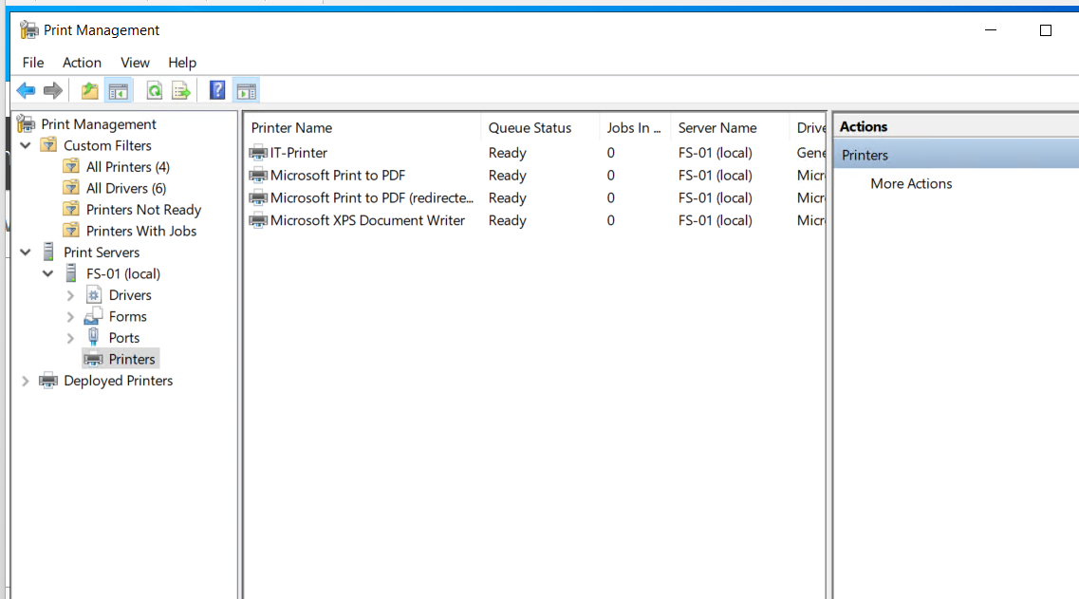

Figure 12 — Group Policy Infrastructure in the lab.local Domain

Windows LAPS Password Security
Windows Local Administrator Password Solution (LAPS) was implemented to automatically manage local administrator passwords on domain‑joined systems.
The LAPS deployment included the following steps:
Active Directory schema extension
LAPS Group Policy configuration
Delegated password read and reset permissions
Password rotation enforcement
Password data is stored securely within Active Directory and accessible only to authorized administrators.
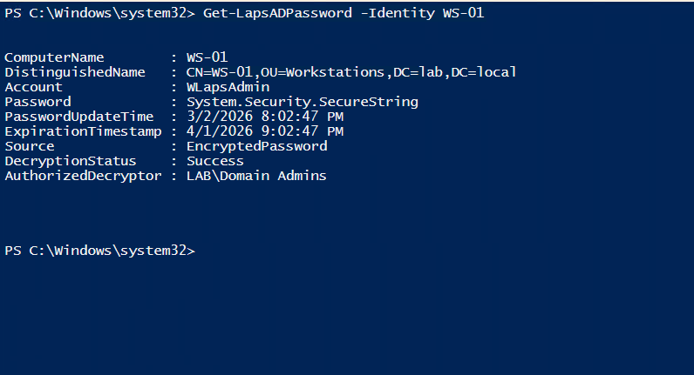
Figure 13— Retrieval of encrypted local administrator password using Windows LAPS PowerShell module.

Enterprise Public Key Infrastructure
Active Directory Certificate Services was deployed to provide certificate‑based security services.
An Enterprise Root Certificate Authority was created with the name lab‑DC‑01‑CA.
A custom computer authentication template was created and published.
Certificate auto‑enrollment was enabled via Group Policy, allowing domain‑joined computers to automatically receive machine certificates.
Active Directory Certificate Services (AD CS) configured as an Enterprise Root Certificate Authority (lab-DC-01-CA).
The certificate authority provides centralized certificate issuance for domain systems, enabling secure authentication, encryption, and trust within the Active Directory environment.
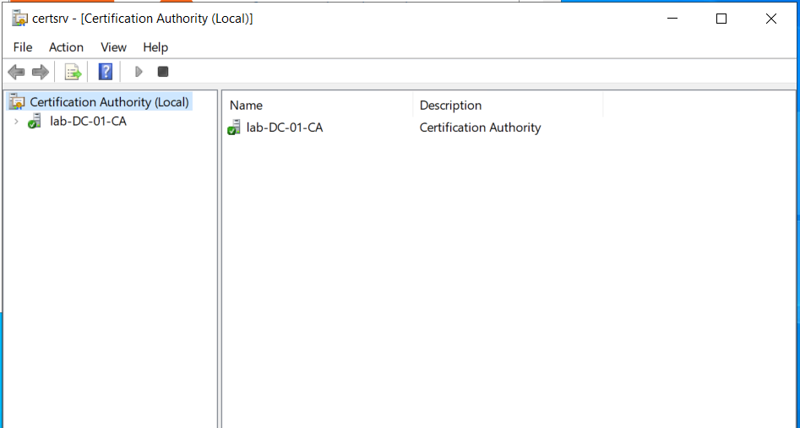
Figure 14 — Enterprise Root Certificate Authority Deployment
The Trusted Root Certification Authorities store on a domain-joined system showing the installed root certificates, including the internally deployed lab-DC-01-CA enterprise certification authority. This confirms successful deployment of the Active Directory Certificate Services (AD CS) Public Key Infrastructure, enabling certificate-based authentication, secure communications, and domain trust validation across the environment.
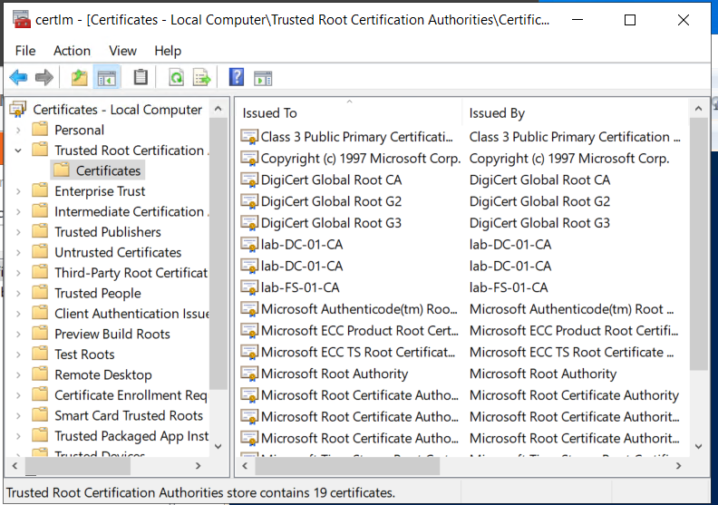
Figure 15 — Trusted Root Certificate Authorities Configuration

Tiered Administration Security Model
The environment implements a three‑tier administrative model designed to protect privileged credentials and prevent lateral movement attacks.
Tier 0 – Domain Controllers and identity infrastructure
Tier 1 – Server infrastructure
Tier 2 – Workstation systems
Dedicated administrative accounts were created for each tier.
Group Policy restrictions enforce where administrative accounts may authenticate.
The environment implements a Tier 0, Tier 1, and Tier 2 security boundary model to protect privileged credentials. Domain controllers and identity services reside in Tier 0, server infrastructure in Tier 1, and workstation systems in Tier 2. Administrative access is restricted between tiers to mitigate credential theft and privilege escalation attacks.
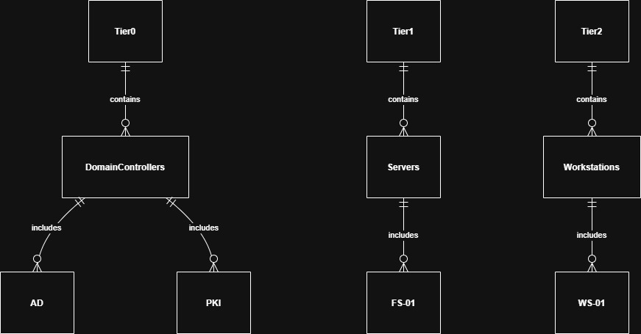
Figure 16 — Active Directory Tiered Administration Security Model

Privileged Access Workstation Architecture
A hardened administrative workstation (PAW‑01) was deployed to isolate privileged administrative activities.
The PAW is used for tasks including:
Active Directory administration
Group Policy management
DNS administration
Domain controller management
Logon restrictions ensure that only Tier‑0 administrative accounts may authenticate to the PAW.

Security Monitoring and Auditing
Advanced audit policies were configured using Group Policy to monitor authentication events and privilege changes.
Security auditing categories include:
Account Logon
Account Management
Logon / Logoff
Event ID 4728 was validated as a monitoring event to detect when users are added to security‑enabled groups.
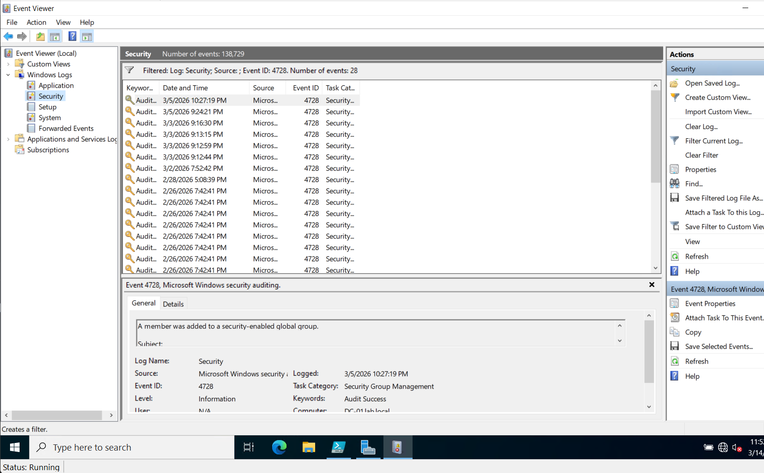
Security log entry showing Event ID 4728, generated when a member is added to a security-enabled global group. This audit event is used to detect potential privilege escalation and administrative changes within the domain.
Figure 17 — Active Directory Security Auditing Event Detection

Credential Theft Mitigation
The architecture demonstrates how enterprise organizations protect against credential theft attacks.
In many breaches attackers obtain administrative credentials from compromised workstations using credential dumping tools.
Because the Tiered Administration Model prevents Tier‑0 administrators from logging into workstation systems, privileged credentials never appear in LSASS memory on those systems.
This design significantly reduces the risk of privilege escalation and domain compromise.

Enterprise Security Controls Implemented
Least privilege access model
Credential isolation
Privileged workstation administration
Certificate based authentication
Automated password rotation
Centralized configuration management
Hybrid identity architecture
Security auditing

Hybrid Identity Architecture
The lab environment was extended to include hybrid identity integration with Microsoft Entra ID.
Microsoft Entra Connect was installed to synchronize identities between the on‑premises Active Directory domain and the cloud directory.
Synchronized objects include:
User accounts
Security groups
Directory structure
This configuration mirrors enterprise hybrid identity architectures used with Microsoft 365 and Azure services.
The Azure AD Connect Synchronization Service Manager showing successful Delta Synchronization operations between the on-premises Active Directory domain (lab.local) and Microsoft Entra ID. The synchronization status confirms that directory objects, identities, and attributes are successfully replicated to the cloud, enabling a hybrid identity architecture. 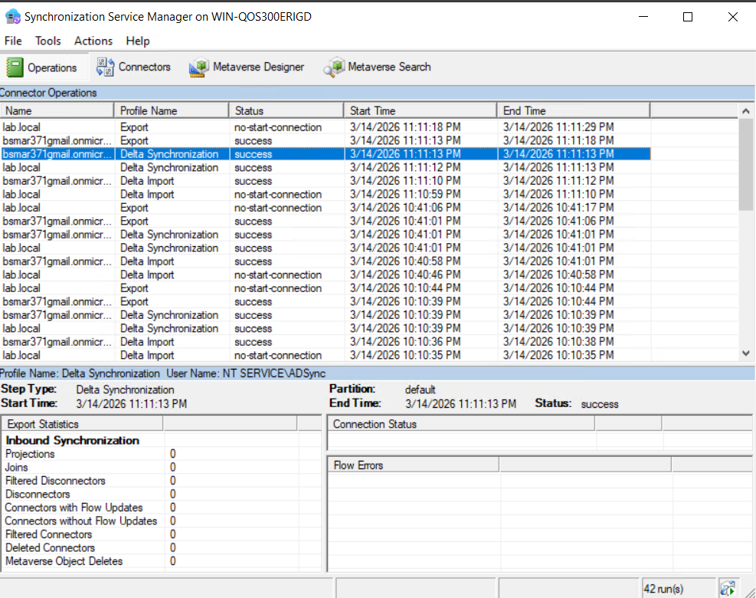
Figure 18 — Microsoft Entra ID (Azure AD) Synchronization Validation

Skills Demonstrated
Active Directory infrastructure architecture and deployment
DNS design and troubleshooting
PowerShell automation for identity provisioning
Group Policy security architecture
Enterprise RBAC access control implementation
NTFS and SMB permission design
Enterprise PKI deployment using AD CS
Windows LAPS privileged credential protection
Privileged Access Workstation (PAW) architecture
Tiered administration security model implementation
Active Directory security monitoring and auditing
Hybrid identity integration with Microsoft Entra ID
Infrastructure validation tests were performed throughout deployment to verify system functionality and security configuration.
Validation activities included domain replication health checks, DNS resolution verification, Active Directory site topology validation, Group Policy application testing, hybrid identity synchronization validation, and security auditing event monitoring

Enterprise Architecture Summary
This architecture demonstrates a layered enterprise identity infrastructure built around Active Directory, secure administrative boundaries, centralized policy management, and hybrid identity integration with Microsoft Entra ID.
Security is enforced through credential isolation, least-privilege RBAC access models, certificate-based authentication, automated password rotation, and centralized auditing.
The resulting design mirrors modern enterprise identity environments used in production corporate infrastructure.

Conclusion
This project demonstrates a secure enterprise‑style Active Directory identity infrastructure implemented in a virtualized lab environment.
The environment reflects modern enterprise security practices including credential isolation, automated password management, certificate‑based infrastructure security, and hybrid identity integration.
The lab provides a realistic platform for practicing system administration, security engineering, and enterprise identity architecture.

