## Team Roster — In-Class 1 v3

| Member | GitHub Username | Contribution |
|---|---|---|
| William Davis | @williammadisondavis | Wrote question 5-9 |
| Brian Smith | @Bsmith01cs | Wrote questions 1-4 |
1.
MaterialApp -> DefaultTabController -> Scaffold -> AppBar -> TabBar -> Tab -> TabBarView -> each tab's content. The DefaultTabController owns the number of tabs because it uses the length value. To add a fifth tab, I would change the length from 4 to 5 first.
2.
The MyApp widget is stateless because its basic structure does not change on its own. The tab portion is stateful because the selected tab can change. Making the tab widget stateless would make managing the changing tab index more complicated, while making MyApp stateful would add unneeded complexity.
3.
If _tabController.dispose() was not called, the controller could stay in memory after the widget was removed. Over time, repeated creation and removal of the widget could leave unused controllers taking up memory. A code reviewer would flag this because it can cause memory leaks.
4.
Flutter is easier to maintain because you describe what the UI should look like based on the current state, and Flutter rebuilds it. With an imperative approach, you have to manually change individual elements. In a large team, the declarative approach is less likely to get messy.
5.
The hardest part for me and Brian was making sure our branches and GitHub history were set up correctly. We had an issue with the branch histories not matching and difficult with branch creation. At a new software job, I would make sure I understood the branching workflow and how to resolve merging conflicts and other such issues before starting and communicate with my teammate about what each of us was working on.
6.
If the OS killed the app while it was in the background, the restoration layer could remember which tab the user was on. Then they returned to the app they could be brought back to that tab. Without it, the app could reopen on the default first tab which is of course not convenient.
7.
The visible tab would still change when the user tapped it because the TabController handles the tab selection. However, without setState(), the rest of the UI would not be told to rebuild when tabIndex.value changes. This shows how Flutter's declarative UI depends on rebuilding when state changes. It is a very powerful tool if used correctly, but used incorrectly it could cause loss of progress, and loss of state.
8.
I kept the for (final tab in tabs) loop pattern for both the TabBar and TabBarView. I think this is less likely to cause problems because both are using the same list, so the tabs and their content stay lined up.
9.
I used a TextField as one of the required widgets. It belongs in Layer 7 Declarative build because it is part of the UI that gets built and displayed. It does not belong in initState() because initState() is mainly for setting up state and controllers, not describing the visible UI.

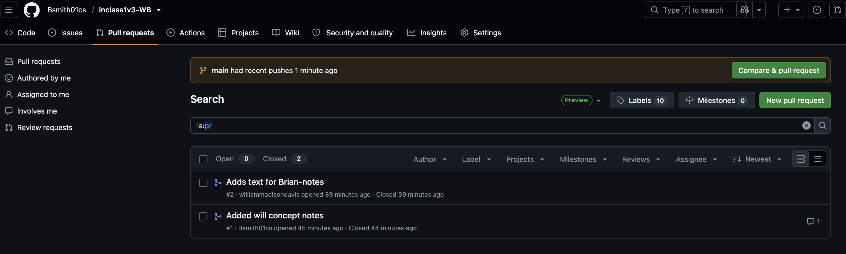
Github URL: https://github.com/Bsmith01cs/inclass1v3-WB

