**USER MANUAL**

imoody

## Social media used the right way

# Table of Contents

## 1. Introduction 3

## 2. installing our pop-up 3

## 3. Creating an account 4

## 4. Logging your mood 4

## 5. viewing your mood statistics 4

## 6. Getting activity suggestions 4

## 7. Logging out 4

# 1. Introduction

iMoody is an application developed to help combat the control that social media tends to have on user’s lives. It was designed to specifically target university students who have realized that they have an addiction to social media and want to take positive steps to change how they think about it. Our application uses elements of Cognitive Behavioural Therapy (CBT) by giving users a way to log their use of social media and how it correlates to their overall mood.

We believe that the key to creating healthy habits in our users is by teaching them how they are in control of their actions and empower them to take a step back from behaviours that aren’t healthy. This is why our suggestions section of the pop up will suggest a variety of activities and we plan to allow the option of customization in later versions.

# 2. installing our pop-up

1. Open your Chrome browser.
2. Navigate to: [Chrome Web Store - Extensions](https://chrome.google.com/webstore/category/extensions).
3. Search for iMoody or follow this link: <https://chrome.google.com/webstore/search/imoody>.
4. Click on the “Add to Chrome” button
5. A window will pop up asking “Add “iMoody”?”, click on the “Add extension” button.
6. You will now be able to view the iMoody icon in your browser, an example is show below:

Figure 1: iMoody in navigation bar

# 3. Creating an account

1. To create an iMoody account, click on the icon in your navigation bar and click on the icon that is circled in the picture below:

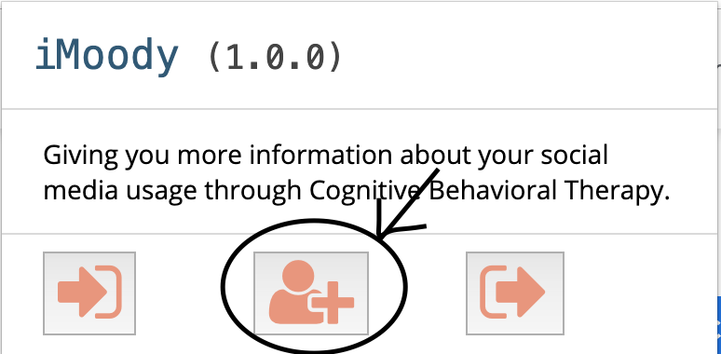

Figure 2: iMoody welcome page

1. Clicking this button will take you to this page:

Figure 3: iMoody account creation page

1. Fill in your information and click on the “Submit” button.
2. You should see the follow screen:

Figure 4: iMoody page after login

1. You now have an iMoody account!

# 4. Logging your mood

1. Click on the “Rate your mood!” button. You will see the following screen:

Figure 5: iMoody mood rating page

1. Select the emoji that best represents your mood and click “Submit”.
2. When you are ready to rate your mood again, repeat step 2.
3. You will then see a graphical representation of your mood over time and be able to re-rate your mood when you are ready.

**ADD PICTURE**

# 5. viewing your mood statistics

1. As stated in the previous section, to view your mood statistics, you must first rate your mood twice and then you will be taken to the graphical representation of your mood over time.

# 6. Getting activity suggestions

1. From the mood representation page, click the “Click for suggestions!” button.

**ADD PICTURE**

1. If you do not like any of the suggestions, click the “Get new Activities” button to get a new selection of activity suggestions.

# 7. Logging out

1. If you wish to sign out at any point when using the pop-up, simply find the symbol circled in the image below. This symbol exists on every page in the pop-up.

Figure 6: iMoody log out button