
Invoice Date: 03/08/2022
Due Date: 03/23/2022

Invoice # 7151

DURRETT Motor Company

Victoria Island, Lagos, Nigeria
BILL TO:
BSSL TECHNOLOGIES

S/N | DESCRIPTION | QTY | UNIT PRICE (N) | TOTAL (N)
1 | 2004 Toyota Corolla Sport Edition | 1 | 2,185,000.00 | 2,185,000.00
 | Chasis No.: FGT3D6XA1C7067182
 |  |  | SUB TOTAL |  | 2,185,000.00
 |  |  | TAX |  | 15,000.00
 |  |  | TOTAL |  | 2,200,000.00

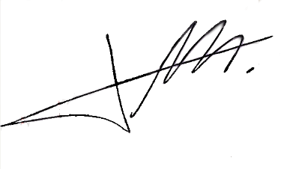
_________________________________ __________________________________
Authorised Signature Client Signature

