**CS-485: Advanced Game Development Technical Report – Asteroid Belt**

Brendan Sting

Professor Turini

Kettering University

Last Revision: 8-18-2024

(Changes to initial or past designs and versions are highlighted in blue.)

**Description To Player**

“Asteroid Belt” poses as a 3-dimensional spin-off of the classic game, “Asteroids”, which is a 1979 arcade top-down space shooter game whose objective is destroy all enemy asteroids without colliding with any of them, else you lose the game. In “Asteroid Belt”, you won’t just be playing top-down as a spaceship shooting incoming asteroids, rather, you’ll mainly play inside the cockpit of a 3D spaceship to shoot asteroids from a first-person perspective. Now, instead of just being able to control your spacecraft side to side and forward, you’ll gain full zero-gravity maneuverability to go not only forward, but roll, turn, and tilt your spaceship! With a whole new dimension added to the base “Asteroids”, you can shoot and dodge asteroid rocks with much more precision. But now, you’ll have blind-spots to worry about, which begs the question, can you survive and destroy the oncoming asteroids with your newfound controls?

**Description To Developer**

Getting into the technical side of “Asteroid Belt”, it is a 3D game that is meant to be played on a typical US keyboard layout, which means that its target platform is for PC. As previously mentioned, this game will take on the paradigm of being a first-person shooter video game, but all player movements will be restricted to vehicular movements (a.k.a., the player moves by driving the spaceship, and is confined to the spaceship). The spacecraft will be capable of 4 aircraft DOF (Degrees Of Freedom): “yaw”, “pitch”, “roll”, and “drive/throttle”. Since these DOF should have bi-directional axis values, the standard WASD keyboard controls will not work standalone and thus mouse positions will be brought in to support the extra degrees of freedom for ship controls. Firing mechanics, however, will remain relatively standard as the left-mouse button (LMB) will be the primary fire trigger button to shoot projectiles from the ship. Note that a boost button will be added in development to give the player more fast-paced control over the spacecraft; this would most likely be bound to the SHIFT key if implemented.

Moving outside the scope of the player’s ship, the outer environment of the game will of course be a chosen galaxy-themed skybox to immerse the player in a galactic setting. In turn, the theme will be reminiscent of the original Asteroids’ space shooter theme, just with more advanced graphics than plain sprite outlines. Furthermore, to add a more 3D effect to the space environment, a particle system can be used to generate “space dust” around the ship, with its quantity adjusted later on in case it obstructs field-of-view (FOV) in any way. Additionally, for terrain management, the environment will be semi open-world with the player being confined to a 3D teleportation treadmill. This will allow for a confined playable roaming space that avoids reaching a breakable transform position in the game world.

Lastly, enemies will of course be floating asteroids hurdling towards the ship at a reasonable speed that the player can dodge or shoot at and can be further improved with highlighting shaders when the player is aiming at their hitbox collider. These asteroid enemies will spawn relative to the player’s location to keep pace with their position in the playable area treadmill.

**Visuals**

To give a better visual representation of what “Asteroid Belt” will look like, here are some graphics of its concepts as well as the original base “Asteroids” game it will build off of:

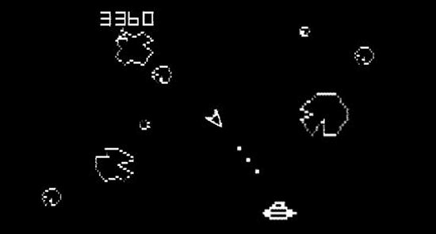

*Figure 1.* A screenshot of the original 1979 “Asteroids” arcade game, ported on the Atari.

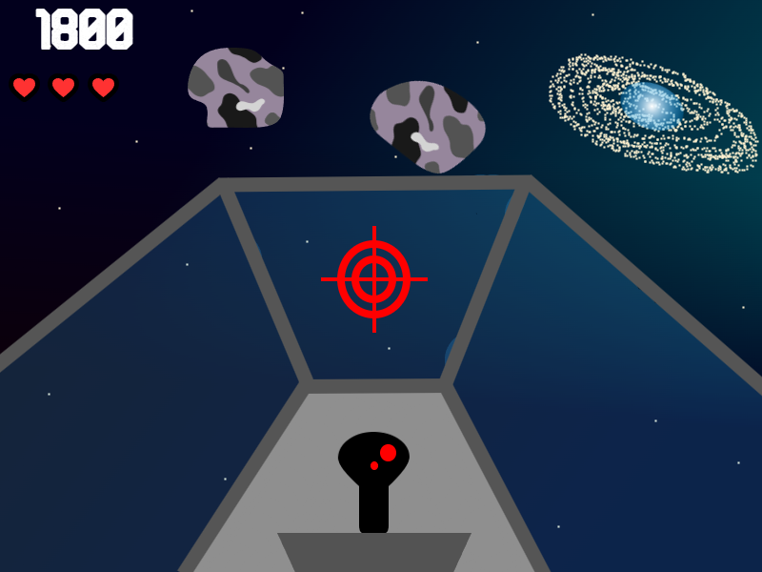

*Figure 2.* A graphic sketch of the “Asteroid Belt” spin-off game, from cockpit perspective (roof removed to show space skybox.

*Figure 3.* A graphic sketch of the UI pause screen in “Asteroid Belt”, displayed as an overlay.

*Figure 4.* A graphic sketch of the default controls schema in “Asteroid Belt” for the ship.

**Modules**

ESSENTIAL (YELLOW), NON-ESSENTIAL (REGULAR)

* Throttle Engine SFX (sound effects)
* Fire Ship Cannons SFX
* Background Music/Soundtrack (.Wav file[s])
* Player Ship Model (3D) Asset
* Asteroid Model (3D) Asset
* UFO Model (3D) Asset
  + Optional, but would be an advanced enemy unit
* Text Mesh Pro/TMP Unity Asset (UI-extension)
* Heart UI Icon (16-bit preferred)
* Emery Font Asset (.TTF or .OTF)
  + Can also interchange for another bold and/or retro font if not open-source
  + Currently using Brose (TTF) font as Emery is confirmed not open-source.
* Crosshair Icon
* Universal Render Pipeline Asset
* Particle FX (effects)
  + E.g., ship cannons/blasters, thrusters, space dust, etc.
* Galaxy Skybox(es)
* Space UI SFX (sci-fi clicking sounds for UI buttons, etc.)
* Planet Assets (static environment)
* Space Station + Satellite Asset(s) (static environment)
* Sci-fi/Space UI Icons (image assets)

**Development**

***Player Asset & Controls***

***Player Abilities***

***Environment***

***User-Interface***

***Bugs & Challenges***

***Overall Time Dedicated***

**References**