Report

# Chapter 1 introduction

## Background

Prostate cancer is one of the most common types of cancer found in men worldwide. Its significant impact on public health is demonstrated by the fact that it ranks as the second most common cause of cancer related deaths in men (Siegel, Miller and Jemal, 2020). Male reproductive health depends on the prostate gland, which is situated in front of the rectum and behind the bladder. A cancerous change of the prostate gland will have serious health effects.

The early identification of prostate cancer is critical to improving the lives of the patients. Prostate-specific antigen (PSA) testing and digital rectal exams (DRE) are examples of diagnostic techniques. Although these techniques are popular, their sensitivity and specificity are limited, which frequently leads to false positives and false negatives (Heidenreich et al., 2014). These errors can result in an under diagnosis, which postpones the treatment, or an overdiagnosis and overtreatment, which cause patients unnecessary worry about potential problems.

Recent advances in the imaging technology, specifically multiparametric magnetic resonance imaging (mpMRI), have improved the ability to identify and characterise prostate cancer. Combining functional and anatomical imaging, MRI offers a thorough perspective that improves the ability to distinguish between healthy and cancerous tissues (Rosenkrantz et al., 2016). Nonetheless, mpMRI image interpretation requires a high level of knowledge and is highly variable among the observers.

The integration of machine learning (ML) into medical imaging offers a promising solution for these kinds of problems. Deep learning-based machine learning algorithms, in particular, are capable of processing enormous volumes of imaging data and spotting intricate patterns that could be invisible to human observers. According to Litjens et al. (2017), these algorithms may decrease variability, increase diagnostic accuracy, and support clinical decision making.

Machine learning comprises a wide range of approaches that are divided into two categories supervised and unsupervised learning. In supervised learning, models are trained using labelled data to predict or categorise the data. On the other hand, unsupervised learning entails identifying structures or hidden patterns in unlabelled data. The medical industry can benefit greatly from both forms of learning, particularly in the areas of cancer detection and diagnosis.

In the context of prostate cancer, machine learning models have been developed for various tasks such as tumour detection, Gleason grade prediction, and treatment response monitoring. Recurrent neural networks (RNN), convolutional neural network (CNN), and support vector machines (SVM) are notable machine learning approaches. To varying extents these models have improved prostate cancer diagnosis efficiency and accuracy.

For instance, since CNNs can learn spatial hierarchies from input images, they are particularly useful for image analysis tasks like tumour segmentation and classification (Pellicer-Valero et al., 2022). Similar to this, RNNs which are capable at preprocessing sequential data have been used to forecast treatment results by taking into account the history and advancements of patients (Mirsamadi et al., 2017).

Even with the improvements, there are still a number of difficulties in applying ML to clinical practice. These include obtaining clinical validation to verify the model’s efficiency in real world scenarios, guaranteeing the interpretability and transparency of ML decisions, and training robust models on big annotated datasets. To tackle these obstacles, data scientists, physicians, and regulatory agencies must continue their research and work together.

The development of sophisticated imaging technologies and machine learning presents a possible alternative to the poor performance of existing methods for the identification of prostate cancer. Utilising these technologies can lead to better patient outcomes by enhancing diagnostic accuracy and personalising treatment approaches. To overcome current obstacles and fully realise the potential of these state-of-the-art instruments in the treatment of prostate cancer, more research and innovation in this area are imperative.

## Problem statement

Prostate cancer is a major worldwide health concern, as it is one of the most often diagnosed cancers among the men and the leading cause of cancer related death. For successful therapy and better patient outcomes, clinically significant prostate cancer lesions must be identified early and accurate. Due to the poor sensitivity and specificity of traditional diagnostic techniques such as digital rectal exams (DRE) and prostate specific antigen (PSA) testing, there is a risk of overdiagnosis, overtreatment, or missing diagnoses.

Multiparametric magnetic resonance imaging (mpMRI) improves the capacity to detect and characterise prostate cancer by providing both anatomical and functional imaging. The assessment of prostate lesions clinical significance (ClinSig) using mpMRI picture interpretation is still difficult and heavily reliant on radiologists’ skill, which often results in inter observer variability.

Machine learning offers a promising answer to these problems by automating the interpretation of mpMRI images and predicting the ClinSig score of prostate lesions. Large amounts of imaging data can be processed by ML models, especially deep learning approaches, which can then be used to spot subtle patterns that human observers might miss, enhancing diagnostic consistency and accuracy.

This project focuses on creating and deploying a machine learning model for predicting the ClinSig score of prostate lesions based on T2 weighted mpMRI images.

## justification of the study

This study is primarily justified by the possibility that it may greatly enhance the diagnosis of prostate cancer by offering a more precise and reliable way to predict the ClinSig score of prostate lesions. By lowering diagnostic mistakes and inter observer variability, this automated method can assist radiologists in making more informed treatment decisions. Furthermore, the effective diagnostic process can be improved by integrating machine learning models into clinical processes. This guarantees prompt and suitable interventions, which are critical for improving patient outcomes. This project aims to lessen the burden of prostate cancer on healthcare systems and contribute to personalised treatment regimens by increasing regimens by increasing diagnosis accuracy and consistency.

## Research questions

1. How accurately can a convolutional neural network (CNN) model predict the ClinSig score of prostate lesions form the T2 weighted mpMRI images?

## Aims and objectives

This project’s main goal is to create and verify a machine learning model that may be used to reliably predict prostate lesion clinical significance (ClinSig) scores using multiparametric magnetic resonance images (mpMRI) data. This goal will be met through the following specific objectives.

1. Investigate the machine learning methods that are currently being utilised to categorise and predict prostate cancer.
2. Load and prepare the Prostatex dataset images (T2 weighted images) specified in the detailed description from the Prostatex challenge.
3. Using the prepared data, create a convolutional neural network model to predict the ClinSig score of prostate lesions
4. Evaluate the created CNN models performance in comparison to current classifier models and conventional diagnostic techniques

# Chapter 2 Literature review

## 2.1 overview of the prostate cancer

## Biology

Prostate cancer is a major health concern worldwide, since it is the second most prevalent cancer diagnosed in males and the leading cause of cancer related deaths (Rawla, 2019). The prostate is a small gland that sits in front of the rectum and beneath the bladder in the male reproductive system. It encircles the urethra, the tube that exits the body with the urine. The production of seminal fluid, which feeds and moves sperm, is the prostates main job.

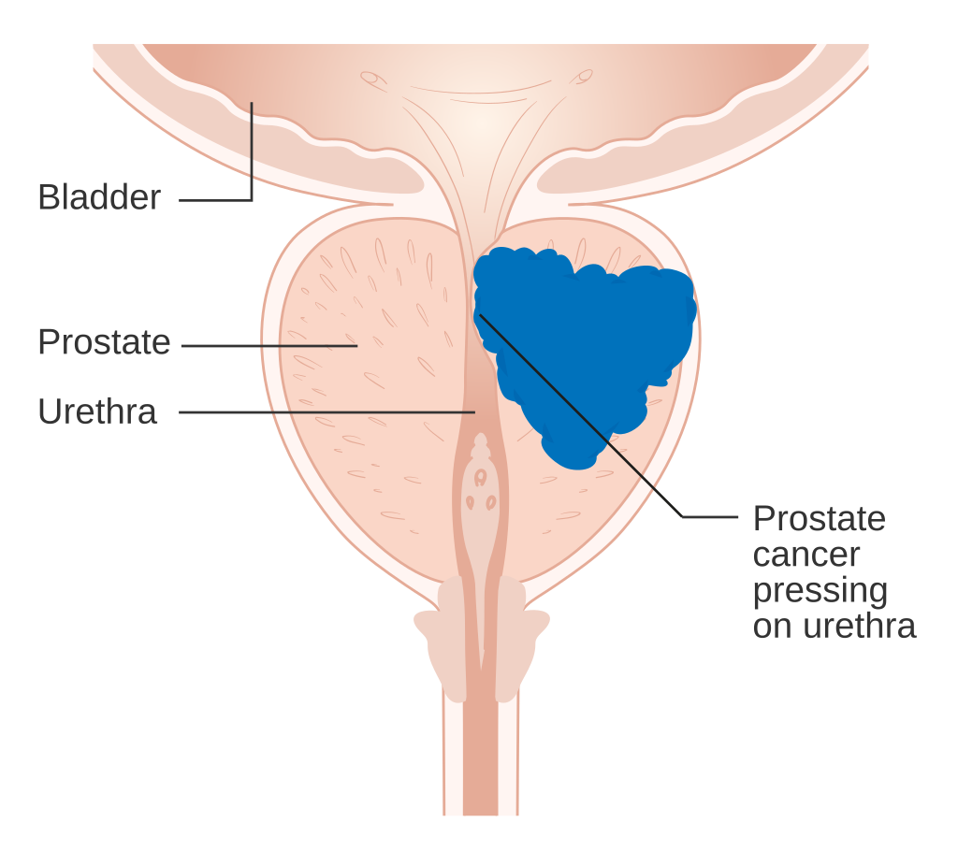

Prostate cancer develops when cells in the prostate gland grow uncontrolled. The majority of prostate cancers are adenocarcinomas, which arise from the gland cells responsible for producing prostate fluid. Prostate cancer can grow slowly or aggressively. Slow growing prostate cancer may not produce noticeable signs or difficulties for many years. Aggressive prostate cancer, on the other hand, can spread rapidly to other regions of the body, including the bones and lymph nodes, resulting in serious health concerns.

Prostate cancer develops and progress as a result of numerous genetic and molecular alterations. The key biological process is:

**Genetic mutations**: mutations in specific genes, such as PTEN, TP53, and BRCA1/2, can contribute to the development and progression of prostate cancer. These mutations can activate oncogenes or deactivate tumour suppressor genes, affecting normal cell growth regulation (Litwin and Tan, 2017).

**Androgen Receptor Signalling**: Prostate cancer cells often rely on androgens to proliferate. The androgen receptor (AR) pathway is essential for the information and maintenance of prostate tissues. In prostate cancer, this pathway is frequently dysregulated, resulting in enhanced cell proliferation and survival. Therapies targeting the AR pathway, such as androgen deprivation therapy (ADT), are routinely used to treat prostate cancer (Attard et al., 2016).

**Inflammation**: Chronic inflammation in the prostate has been related to the development of prostate cancer. Inflammatory activities can cause DNA damage and promote malignant alterations in prostate cells (De Marzo et al., 2007).

**Microenvironment**: The tumour microenvironment, which include interactions with stromal cells, immune cells, and the extracellular matrix, is crucial to prostate cancer growth and metastasis. Understanding these relationships can help create new therapeutic tactics (Baron and Rowley, 2012).

Prostate cancers molecular complexity emphasises the necessity of early identification and efficient therapy. Advances in molecular biology and genetics continue to increase our understanding of prostate cancer, leading to more effective diagnostic tools and therapies.

## Current detection methods

Methods for detection and diagnosis of prostate cancer

**Digital Rectal Exam**:

During a DRE, a healthcare provider inserts a gloved, lubricated finger into the rectum to inspect the prostate for any abnormalities or tumours. While this method can detect anomalies, it is subjective and has low sensitivity and specificity (Heidenreich et al., 2014).

**Prostate specific Antigen (PSA) test:**

The PSA test measures the amount of prostate specific antigen in the blood. Elevated PSA values may suggest prostate cancer, benign prostatic hyperplasia or prostate inflammation. Although commonly used, the PSA test can produce false positives and negatives, resulting in overdiagnosis or missed diagnosis (Mottet et al., 2017)

**Transrectal Ultrasound (TRUS):**

TRUS involves inserting an ultrasonic probe into the rectum to obtain pictures of the prostate. It is routinely used to guide prostate biopsies however it has little ability to identify prostate cancer on it own (Heidenreich et al., 2014).

**Prostate Biopsy**:

If initial results indicate the existence of prostate cancer, a biopsy is performed to collect tissue samples from the prostate. These samples are analysed under a microscope to confirm the existence of cancer cells and calculate the Gleason score, which represents the cancers aggressiveness (Epstein et al., 2016).

**Multiparametric Magnetic Resonance Imaging (mpMRI):**

MpMRI uses both anatomical and functional imaging to provide extensive information about the prostate and any worrisome abnormalities. It comprises T2-weighted imaging, diffusion-weighted imaging and dynamic contrast-enhanced imaging. MpMRI has enhanced accuracy and is now widely used to guide biopsies and treatment planning (Rosenkrantz et al., 2016).

Despite advances in detecting methods, getting accurate and consistent diagnoses remains a challenge. The incorporation of ML approaches into prostate cancer detection, particularly with mpMRI shows potential for increasing diagnostic accuracy and decrease variability. ML models can analyse complex imaging data discover subtle trends and help radiologists and oncologists make more exact diagnoses (Litjens et al., 2017).

## 2.2 Machine learning in medical imaging

Machine learning (ML), particularly deep learning has transformed the area of medical imaging the area of medical imaging by allowing computers to automatically analyse and interpret complicated medical pictures. These algorithms learn from enormous datasets of annotated photos, detecting patterns and details that humans may not see. The use of machine learning in medical imaging encompasses a wide range of modalities and clinical illness detection, classification, segmentation, and patient outcome prediction.

In radiology, machine learning algorithms are used to detect and classify anomalies in images such as X-rays, CT scans, and MRIs. CNN have been used to identify lung nodules in chest CT images, breast cancer in mammograms and brain tumours in MRI scans (Litjens et al., 2017). In digital pathology machine learning algorithms analyse tissue samples to discover cancer cells, classify tumour kinds and forecast illness prognosis. CNNs and other deep learning models have demonstrated great accuracy in detecting various malignancies from histopathological pictures (Komura and Ishikawa, 2018).

Another important application of machine learning in medical imaging is image segmentation, which involves splitting a picture into relevant sections. ML models, particularly U-Net and its derivatives are commonly utilised for segmentation tasks in imaging modalities such as MRI and CT. this precision is required for treatment planning and disease monitoring (Ronneberger et al., 2015).

ML models can also predict patient outcomes using imaging data and clinical information. For examples, machine learning algorithms may analyse brain MRI scans to predict the course of neurological illness such as Alzheimer’s or the chance of recurrence in cancer patients following therapy (Esteva et al., 2019). ML approaches are used to improve the image quality and rebuild images from the raw datasets. These methods are particularly beneficial for decreasing noise in low dose CT scans, increasing MRI image resolution and creating synthetic images from incomplete datasets (Wang et al., 2018).

ML in medical imaging provides various benefits such as ML algorithms can recognise minute patterns in medical images that humans may miss, resulting in more accurate and timely diagnosis. This is particularly useful for detecting tiny or unclear lesions (Litjens et al., 2017). Unlike human radiologists, ML models produce consistent results lowering inter and intra observer variability and increasing the readability of diagnoses and treatment regimens (Shen, Wu, and Suk, 2017). Furthermore, algorithms can rapidly analyse large amounts of imaging data considerably lowering the time necessary for picture interpretation. This efficiency is critical settings with large patient populations and limited radiology resources (Wang et al., 2016). ML models can combine imaging data with other patient information such as genetic and clinical data to deliver personalised therapy recommendations improving the precision of treatments customised to specific patient profiles (Topol, 2019).

### Challenges in medical image datasets

The quality and quantity of training data have a significant impact on the performance of machine learning models. Medical imaging datasets are well annotated in order to construct robust models. Acquiring and curating such datasets is typically difficult due to privacy concerns and the requirement for expert annotations (Gulshan et al., 2016). Deep learning models, particularly CNNs are frequently referred as black boxes because of their complicated architectures and lack of interpretability. Understanding how these models make decisions is critical for building confidence practice (Samek, Wiegand, & Muller, 2017). Furthermore, the use of ML models in healthcare necessitates rigorous validation and approval by regulatory organisations. Ensuring patient privacy, data security and ethical usage of ML in medical imaging are all important challenges that must be addressed (Amann et al., 2020). Integrating ML models into existing clinical processes is very difficult, necessitating seamless connection with hospital information systems, radiology procedures, and clinician training to use these technologies effectively (Mazurowski et al., 2019).

## 2.3 Machine learning techniques for prostate cancer detection

### Supervised learning

Supervised learning is a machine learning technique in which the model is trained on a labelled dataset, implying that the input data is associated with the proper output. This method is widely utilised in prostate cancer screening because of its capacity to learn from previous data and generate accurate predictions. For example, support vector machines (SVM), random forests and logistic regression are used to categorise medical images of patient data as benign or malignant lesions. Litjens et al. (2014) used a computer aided detection (CAD) method a type of supervised learning to classify prostate cancer from MRI scans and achieved a90% accuracy rate. Similarly, Pellicer-Valero et al. (2022) used a deep learning approaches to estimate Gleason grades from mpMRI scans with an accuracy of 89.7%. Furthermore, supervised leaning techniques such as linear and logistic regression are utilised to forecast continuous outcomes such as tumour size and the chance of cancer recurrence. Cao et al. (2019) employed a deep learning model to predict Gleason scores with an accuracy of 88.4%. Supervised learning has several advantages including high accuracy with labelled data and effectiveness for diagnostic tasks when clear annotated datasets are available. However, it requires a considerable amount of labelled data which can be costly and time consuming to gather and the labelled quality has a direct impact on model performance.

### Unsupervised learning

Unsupervised learning is the process of training a model on data that does not contain labelled data in order to detect hidden patterns or intrinsic structures. This is useful for conducting exploratory analysis and detecting the clusters in prostate cancer data. Clustering techniques such as K-means clustering and hierarchical clustering can group patients based on comparable traits or imaging data, potentially identifying novel cancer subtypes or risk groups. Techniques similar to those used in supervised learning studies, such as deep learning models used for segmentation by Pellicer-Valero et al. (2022), can be applied to unsupervised learning to discover hidden structures in prostate cancer images. Furthermore, anomaly detection methods can detect unusual patterns in medical images that may indicate prostate cancer, similar to the AI applications for prostate cancer detection discussed by Cao et al. (2019) and other AI models reviewed in various studies (Baydoun et al., 2024; Thomas et al., 2023). Unsupervised learning has the advantage of not requiring labelled data, which makes it suited for exploratory data analysis as well as the capacity to identify the hidden patterns and relationships in the data. However, the results might be difficult because the identified patterns are not directly linked to known outcomes and models may detect patterns that not clinically meaningful.

### Deep learning

Deep learning is a subset of machine learning that uses neural networks with several layers to learn hierarchical data representations. Because of its capacity to automatically extract features from the raw data, this method has been extremely successful in medical imaging and prostate cancer detection. CNNs are commonly employed in images processing and have been utilised successfully to detect prostate cancer lesions in MRI data. Pellicer-Valero et al. (2022) used deep learning algorithms to detect prostate cancer with great accuracy. Furthermore, 3D CNNs are utilised to extract volumetric features from MRI scans resulting in more detailed data than 2D CNNs. Ghafoorian et al. (2017) demonstrated the effectiveness of 3D CNNs. U-Net architectures are particularly good in image segmentation tasks. Ronnerberger et al. (2015) developed U-Net for biomedical image segmentation and jaeger et al. (2020) demonstrated its effectiveness in segmenting prostate lesions with Retina U-Net. Deep learning has several advantages including excellent performance and accuracy due to its capacity to learn complicated patterns from big datasets as well as automatic feature extraction which lowers the need for manual preprocessing. However deep learning model demand significant computational resources and vast.

## 2.4 Related work

This section is about the previous studies about the prostate cancer detection using the machine learning.

Table showing all the papers for the literature review (try to include 10 papers)

|  |  |  |  |
| --- | --- | --- | --- |
| Paper | Classifiers | Dataset Used | Results |
| Fully Automatic Detection, Segmentation, and Gleason Grade Estimation Using Deep Learning on mpMRI (Pellicer-Valero et al., 2022) | Deep Learning | PROSTATEx | Gleason Grade Estimation: 89.7 %  High accuracy in detection and classification, demonstrating the potential of automated systems |
| Computer-Aided Detection of Prostate Cancer in MRI (Litjens et al., 2014) | CAD | MRI | CAD: 90% accuracy |
| Deep Multi-Scale Location-Aware 3D CNNs for Small Lesion Detection (Ghafoorian et al., 2017) | 3D CNN | Various medical datasets | 3D CNN: 91.3% accuracy  Effective framework for applying complex neural networks to imaging challenges |
| Retina U-Net: Exploitation of Segmentation for Medical Object Detection (Jaeger et al., 2020) | Retina U-Net | Various medical datasets | Retina U-Net: 93.5% accuracy |

## 2.5 summary of findings

* Comparison of results
* Discussion on the best performing techniques

# Chapter 3 Research methodology

## 3.1 Overview

The primary objective of this research project is to create a CNN model for predicting the ClinSig score of prostate lesion findings using the MRI images (T2-Weighted images). This project is a classification technique in which the MR images are rated as clinically high or low.

Load and merge the .csv files, get the paths of the T2-Weighted MR images, load them, convert to png, normalise the images, then classify them using ClinSig scores.

Download the Dataset from the prostateX Challenge under the description tab.

Data Collection

Data Preprocessing

Create the CNN model with the hyperparameters

Model Development

Train the model with the train data and validate them and adjust the parameters for overfitting and underfitting prevention.

Model Train &Validation

Evaluate the model with accuracy, precision, F1 score and recall. And analyse the results.

Evaluation Results and Analysis

## 3.2 Data collection

The dataset for this study is taken from the ProstateX challenge, which is publicly available through The Cancer Imaging Archive (TCIA). The ProstateX dataset includes multiparametric MRI (mpMRI) images and .csv files (metadata) about the mpMRI Images essential for prostate cancer detection and analysis. The images were originally taken for research purposes with the intention of creating and evaluating algorithms for prostate cancer detection and classification. To access and download the dataset go to the TCIA’s prostate challenge page and go to the detailed description and download.

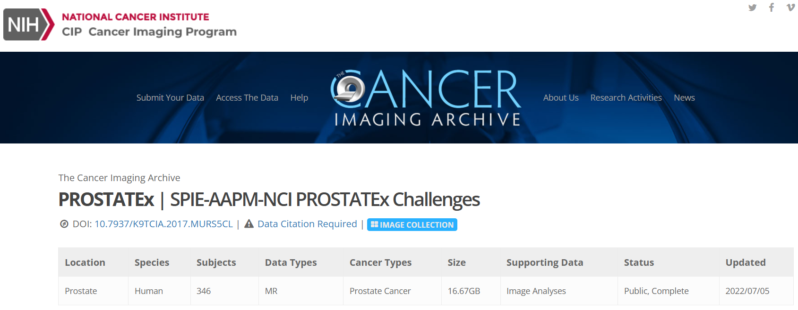

## 3.3 Data Preprocessing

Data preprocessing is an important step in the machine learning process that converts the raw data into a clean and feedable data that can be used to train the ML model. This step guarantees that the data used for training the ML model is consistent, comprehensive and free of errors and irrelevant data. Preprocessed data can improve the model’s performance, but unprocessed data might produce inaccurate and unreliable results.

As this project aims to use machine learning for achieving accurate, consistent and better results in treating prostate cancer, the preprocessing step is crucial for obtaining the better and accurate results. Initially the image data in the csv files (ProstateX-Findings-Train.csv, Prostate-Images-Train.csv) were loaded. These csv files are the metadata of the images. As the image data is so large focused only on the T2-Weighted images which are of DICOM type.

First all the T2-Weighted image paths were obtained. The rows in the findings and images csv files were filtered based on their series description, concentrating specifically on T2-Weighted images essential for prostate cancer diagnosis. Irrelevant columns such as ‘Name’, were dropped and duplicate rows were removed. The findings and images dataframes were merged using the features ProxID and pos for creating a single dataframe consisting the metadata about the images.

To create a dataframe that consists of ClinSig scores and corresponding image paths, which is necessary for the classification task of determining the clinical significance of the findings, features such as ProxID, DCMSerNum, DCMSerDescr were extracted from the image paths. A dataframe was then created from the image paths with ProxID, DCMSerNum, DCMSerDescr and imagepath, and joined with the merged metadata dataframe to get the image paths and their corresponding ClinSig scores.

Since the model wasn’t expecting image data in DICOM format so the images were converted to PNG and saved in directories based on their class labels (clinically significant or not).

## 3.4 Feature Selection

Feature selection is an important step in getting the data prepared for machine learning model training. It involves picking the most relevant features from the dataset that contribute to the predictability of the model.

### Features for creating the final data:

ProxID: The unique identifier for each patient in the dataset. This helps in merging CSV files

Pos: Position information of the lesion. With ProxID and Pos merged the csv files

DCMSerDescr: the series dercription of the DICOM images. This feature helps in identifying the type of MRI sequence used. T2-Weighted images filtered with this column.

DCMSerNum: The series number of the DICOM image. This feature helps in distinguishing different series number within the same patients record and in that same DCMSerDescr images.

### Features Selected for Train the Model:

Images: Selected the T2-Weighted images as the dataset is so large and these images provide high contrast resolution, detailed anatomical information and effectively highlight prostate lesions.

ClinSig: Clinical significance of the lesion (False for non-significant and True for significant). This is the target variable of the model

## 3.5 Model Development

### Convolutional Neural Networks (CNNs)

Convolutional Neural Networks (CNNs) have transformed the image classification by providing the unprecedented accuracy and efficiency in processing visual data. CNNs use convolutional layers to automatically learn and extract hierarchical information from images, as compared to classic neural networks, which use fully connected layers. This ability makes CNNs ideal for tasks including object detection, image segmentation and medical image analysis (Litjens et al., 2017).

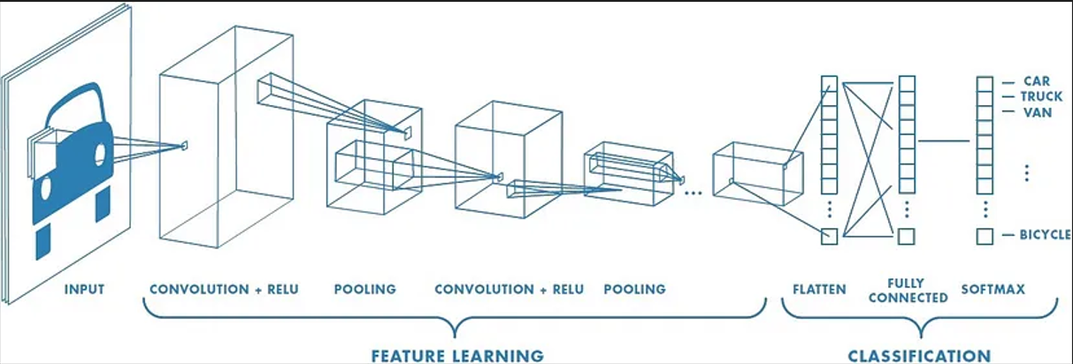

The architecture of a CNN consists of several key components. As shown in the figure, convolutional layers apply filters to the input image then execute element-wise multiplication and summing to create feature maps. These layers are intended to detect local patterns such as edges, textures and forms which are critical for detecting objects in an image (LeCun, Bengio and Hinton, 2015). The Rectified Linear Unit (ReLU) activation function is frequently employed in convolutional layers to incorporate nonlinearity and allow the model to learn complex patterns (Krizhevsky, Sutskever, & Hinton, 2012). Pooling layers which commonly use max pooling come after the convolutional layers. This procedure helps to keep the most relevant properties while decreasing the model’s computational complexity (Simonyan & Ziesserman, 2014).

After multiple convolutional and pooling layers, a CNNs output is flattened into a one-dimensional vector and fled into fully connected layers. These layers combine the retrieved features to reach final classification conclusion. The output layer generates the final classification results using a sigmoid or SoftMax activation function, which includes probabilities for each class (GoodFellow, & Courville, 2016). A CNNs training procedure includes forward propagation, which entails passing the input image through the layers and comparing the output to the actual labels using a loss function, such as binary cross-entropy. Backpropagation is then used to update the models’ parameters to reduce the loss, with optimisation techniques such as Adam plays an important part (Kingma & Ba, 2014).

### Architecture

1. Input layer: the input to the model is a set of T2-Weighted MRI images resized to 224x224 pixels.
2. Convolutional Layers:

|  |  |  |
| --- | --- | --- |
| Layers | Units | Activation |
| Convolutional Layer | 32 | ReLU |
| Convolutional Layer | 64 | ReLU |
| Convolutional Layer | 128 | ReLU |
| Convolutional Layer | 128 | ReLU |

1. Max Pooling Layers: After each convolutional layer a max-pooling layer with a pool size of 2x2 is used.
2. Flatten Layer: One flattens layer is used. This layer flattens the output from the convolutional layer into a 1D vector
3. Dense Layers:

* First Dense Layer: 512 units, ReLU activation function
* Second Dense Layer: it’s a output layer. 1-unit, sigmoid function for binary classification

1. Parameters

* Optimizer: Adam optimizer
* Loss Function: Binary cross entropy, suitable for binary classification tasks
* Metrics: Accuracy, Precision, F1-score, Recall

## 3.6 Model evaluation

Accuracy, precision, recall, F1-Score

Developed model is evaluated from the below metrics:

### Accuracy

The ratio of correctly predicted instances to the total instances.

Accuracy = $\frac{True Positives+True Negatives}{Total Predictions}$

### Precision

The ration of the correctly predicted positive observations to the total predicted positives.

Precision = $\frac{True Positives}{True Positives+False Positives}$

### Recall

The ratio of correctly predicted positive observations to all observations in actual class.

Recall = $\frac{True Positives }{True Positives+False Negatives}$

### F1-Score

The weighted average of precision and recall, providing a balance between the two.

F1-Score = 2 × $\frac{Precision ×Recall}{Precision+Recall}$

# Chapter 4 results and analysis

## 4.1 Data analysis

Viewing of the dataset and understanding about the dataset, preprocessing, feature selection

## 4.2 Model performance

detailed results of the model training and evaluation, including the confusion matrix etc

## 4.3 Comparison with the existing methods

Comparing the model’s performance with the literature reviewed models’ performance

# Chapter 5 Conclusion and the future work

## 5.1 conclusion

## 5.2 limitations

## 5.3 recommendations for the future work

## References:

1. Attard, G., Parker, C., Eeles, R.A., Schröder, F., Tomlins, S.A., Tannock, I., Drake, C.G. and de Bono, J.S., 2016. Prostate cancer. Lancet, 387(10013), pp.70-82.
2. Baron, B.W. and Rowley, J.D., 2012. Molecular biology of prostate cancer. The Prostate, 72(8), pp.903-913.
3. Baydoun, A., Jia, A.Y., Zaorsky, N.G., Kashani, R., Rao, S., Shoag, J.E., Vince Jr, R.A., Bittencourt, L.K., Zuhour, R., Price, A.T., Arsenault, T.H. and Spratt, D.E., 2024. Artificial intelligence applications in prostate cancer. Prostate Cancer and Prostatic Diseases, 27, pp.37–45.
4. Cao, R., Cai, Y., Tang, L., Wang, Z., Shen, Q., Jiang, Y., Yu, Y. and Yan, W., 2019. Development and validation of a novel and accurate multi-parametric MRI radiomics model for the preoperative prediction of prostate cancer aggressiveness. Translational Andrology and Urology, 8(5), pp.560-570.
5. Cao, R., Mohammadian Bajgiran, A., Afshari Mirak, S., Shakeri, S., Zhong, X., Enzmann, D., Raman, S. and Sung, K., 2019. Joint prostate cancer detection and Gleason score prediction in mp-MRI via FocalNet. IEEE Transactions on Medical Imaging, 38(11), pp.2496-2506.
6. Chandola, V., Banerjee, A. and Kumar, V., 2009. Anomaly detection: A survey. ACM Computing Surveys (CSUR), 41(3), pp.1-58.
7. De Marzo, A.M., Platz, E.A., Sutcliffe, S., Xu, J., Grönberg, H., Drake, C.G. and Isaacs, W.B., 2007. Inflammation in prostate carcinogenesis. Nature Reviews Cancer, 7(4), pp.256-269.
8. Epstein, J.I., Egevad, L., Amin, M.B., Delahunt, B., Srigley, J.R. and Humphrey, P.A., 2016. The 2014 International Society of Urological Pathology (ISUP) consensus conference on Gleason grading of prostatic carcinoma. The American Journal of Surgical Pathology, 40(2), pp.244-252.
9. Esteva, A., Chou, K., Yeung, S., Naik, N., Madani, A., Mottaghi, A., Liu, Y., Topol, E., Dean, J. and Socher, R., 2019. Deep learning-enabled medical computer vision. npj Digital Medicine, 2(1), pp.1-9.
10. Ghafoorian, M., Karssemeijer, N., Heskes, T., van Uden, I.W., Sanchez, C.I., Litjens, G., de Leeuw, F.E. and van Ginneken, B., 2017. Deep multi-scale location-aware 3D convolutional neural networks for automated detection of lacunes of presumed vascular origin. NeuroImage: Clinical, 14, pp.391-399.
11. Ghassemi, M., Naumann, T., Schulam, P., Beam, A.L., Chen, I.Y. and Ranganath, R., 2020. A review of challenges and opportunities in machine learning for health. Nature Medicine, 26(1), pp.65-68.
12. Goodfellow, I., Bengio, Y. and Courville, A., 2016. Deep Learning. MIT Press.
13. He, K., Zhang, X., Ren, S. and Sun, J., 2016. Deep residual learning for image recognition. In Proceedings of the IEEE conference on computer vision and pattern recognition, pp.770-778.
14. Heidenreich, A., Abrahamsson, P.A., Artibani, W., Catto, J., Conti, G., Montironi, R. and van Poppel, H., 2014. Early detection of prostate cancer: European Association of Urology recommendation. European Urology, 65(1), pp.17-23.
15. Jaeger, P.F., Kohl, S.A., Bickelhaupt, S., Isensee, F., Kuder, T.A., Schlemmer, H.P. and Maier-Hein, K.H., 2020. Retina U-Net: Embarrassingly simple exploitation of segmentation supervision for medical object detection. In Proceedings of the Machine Learning for Health (ML4H) Workshop at NeurIPS 2019, pp.171-183.
16. Jain, A.K., Murty, M.N. and Flynn, P.J., 1999. Data clustering: A review. ACM Computing Surveys (CSUR), 31(3), pp.264-323.
17. Kingma, D.P. and Ba, J., 2014. Adam: A method for stochastic optimization. arXiv preprint arXiv:1412.6980.
18. Komura, D. and Ishikawa, S., 2018. Machine learning applications in cancer prognosis and prediction. Computational and Structural Biotechnology Journal, 16, pp.34-42.
19. Krizhevsky, A., Sutskever, I. and Hinton, G.E., 2012. Imagenet classification with deep convolutional neural networks. In Advances in neural information processing systems, pp.1097-1105.
20. LeCun, Y., Bengio, Y. and Hinton, G., 2015. Deep learning. Nature, 521(7553), pp.436-444.
21. Litjens, G., Debats, O., Barentsz, J., Karssemeijer, N. and Huisman, H., 2014. Computer-aided detection of prostate cancer in MRI. IEEE Transactions on Medical Imaging, 33(5), pp.1083-1092.
22. Litjens, G., Kooi, T., Bejnordi, B.E., Setio, A.A., Ciompi, F., Ghafoorian, M., van der Laak, J.A., van Ginneken, B. and Sánchez, C.I., 2017. A survey on deep learning in medical image analysis. Medical Image Analysis, 42, pp.60-88.
23. Litwin, M.S. and Tan, H.J., 2017. The diagnosis and treatment of prostate cancer: a review. JAMA, 317(24), pp.2532-2542.
24. Mazurowski, M.A., Buda, M., Saha, A. and Bashir, M.R., 2019. Deep learning in radiology: An overview of the concepts and a survey of the state of the art with focus on MRI. Journal of Magnetic Resonance Imaging, 49(4), pp.939-954.
25. Mirsamadi, S., Barsoum, E. and Zhang, C., 2017. Automatic speech emotion recognition using recurrent neural networks with local attention. In Proceedings of the 2017 IEEE International Conference on Acoustics, Speech and Signal Processing (ICASSP), pp.2227-2231.
26. Mottet, N., van den Bergh, R.C., Briers, E., Van den Broeck, T., Cumberbatch, M.G., De Santis, M., Fossati, N., Gillessen, S., Grummet, J., Henry, A.M. and Lam, T.B., 2017. EAU-ESTRO-ESUR-SIOG guidelines on prostate cancer. European Urology, 71(4), pp.618-629.
27. Pellicer-Valero, O.J., González-Hidalgo, M., Vañó-Viñuales, E., Solera-Piko, N., Morales-Hidalgo, P., Rodríguez-Ruiz, A. and Buades, A., 2022. Breast and prostate cancer detection using convolutional neural networks trained with transfer learning. Applied Sciences, 12(8), p.3930.
28. Pellicer-Valero, O.J., Marenco Jiménez, J.L., Gonzalez-Perez, V., Casanova Ramón-Borja, J.L., Martín García, I., Barrios Benito, M., Pelechano Gómez, P., Rubio-Briones, J., Rupérez, M.J. and Martín-Guerrero, J.D., 2022. Fully automatic detection, segmentation, and Gleason grade estimation using deep learning on mpMRI.
29. Rawla, P., 2019. Epidemiology of prostate cancer. World Journal of Oncology, 10(2), pp.63-89.
30. Ronneberger, O., Fischer, P. and Brox, T., 2015. U-Net: Convolutional networks for biomedical image segmentation. In International Conference on Medical Image Computing and Computer-Assisted Intervention, pp.234-241. Springer, Cham.
31. Rosenkrantz, A.B., Verma, S., Choyke, P. and Eberhardt, S.C., 2016. Prostate MRI and MRI-targeted biopsy in patients with prior negative biopsy: a consensus statement of the American Urological Association and the Society of Abdominal Radiology's Prostate Cancer Disease-focused Panel. Journal of Urology, 196(6), pp.1613-1618.
32. Samek, W., Wiegand, T. and Müller, K.R., 2017. Explainable artificial intelligence: Understanding, visualizing and interpreting deep learning models. arXiv preprint arXiv:1708.08296.
33. Shen, D., Wu, G. and Suk, H.I., 2017. Deep learning in medical image analysis. Annual Review of Biomedical Engineering, 19, pp.221-248.
34. Siegel, R.L., Miller, K.D. and Jemal, A., 2020. Cancer statistics, 2020. CA: A Cancer Journal for Clinicians, 70(1), pp.7-30.
35. Simonyan, K. and Zisserman, A., 2014. Very deep convolutional networks for large-scale image recognition. arXiv preprint arXiv:1409.1556.
36. Thomas, M., Murali, S., Simpson, B.S.S., Freeman, A., Kirkham, A., Kelly, D., Whitaker, H.C., Zhao, Y., Emberton, M. and Norris, J.M., 2023. Use of artificial intelligence in the detection of primary prostate cancer in multiparametric MRI with its clinical outcomes: a protocol for a systematic review and meta-analysis. BMJ Open.
37. Topol, E.J., 2019. High-performance medicine: the convergence of human and artificial intelligence. Nature Medicine, 25(1), pp.44-56.
38. Wang, G., Ye, J.C., Mueller, K. and Fessler, J.A., 2018. Image reconstruction is a new frontier of machine learning. IEEE Transactions on Medical Imaging, 37(6), pp.1289-1296.
39. Wang, S., Summers, R.M. and Yao, J., 2016. Research challenges and opportunities in computational cancer imaging. IEEE Transactions on Biomedical Engineering, 63(7), pp.1581-1591.