**BRIANDT TAKOETA**

**PROFESSOR AHMED TAREK**

**CMSC 203 || PROJECT VI**

**MOVIE TICKET || WRITEUP**

**Sample Screenshots**

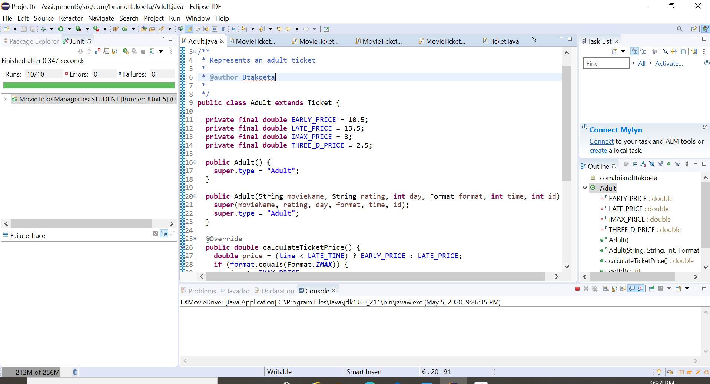

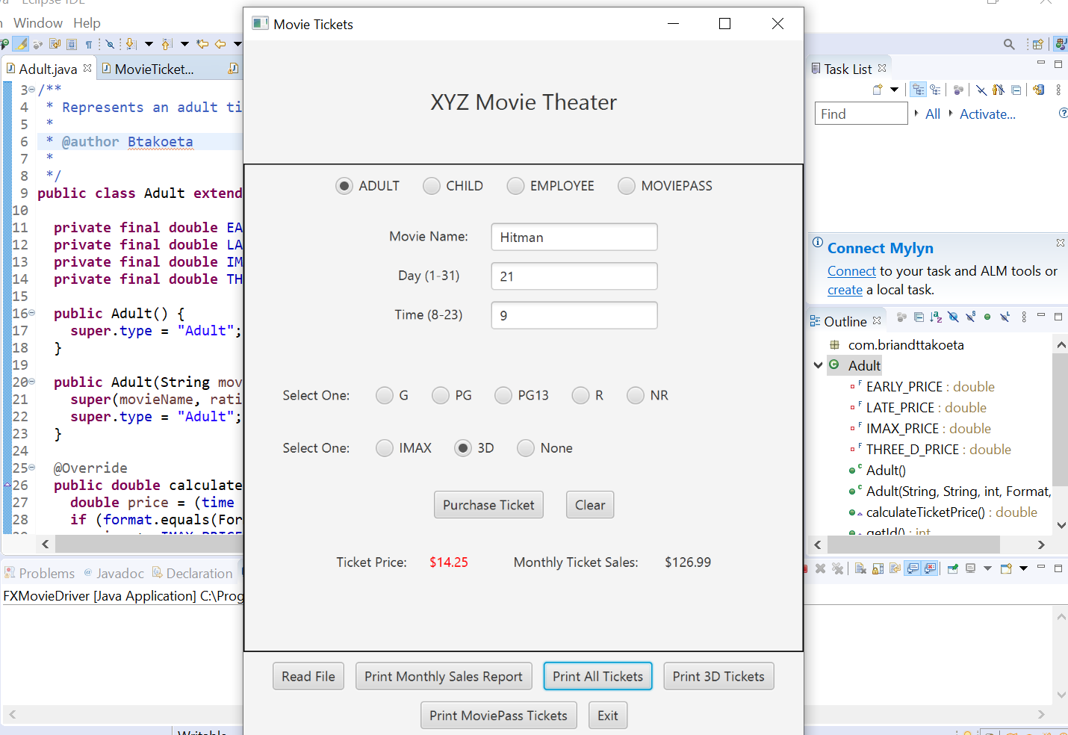

**Based on the following Input**

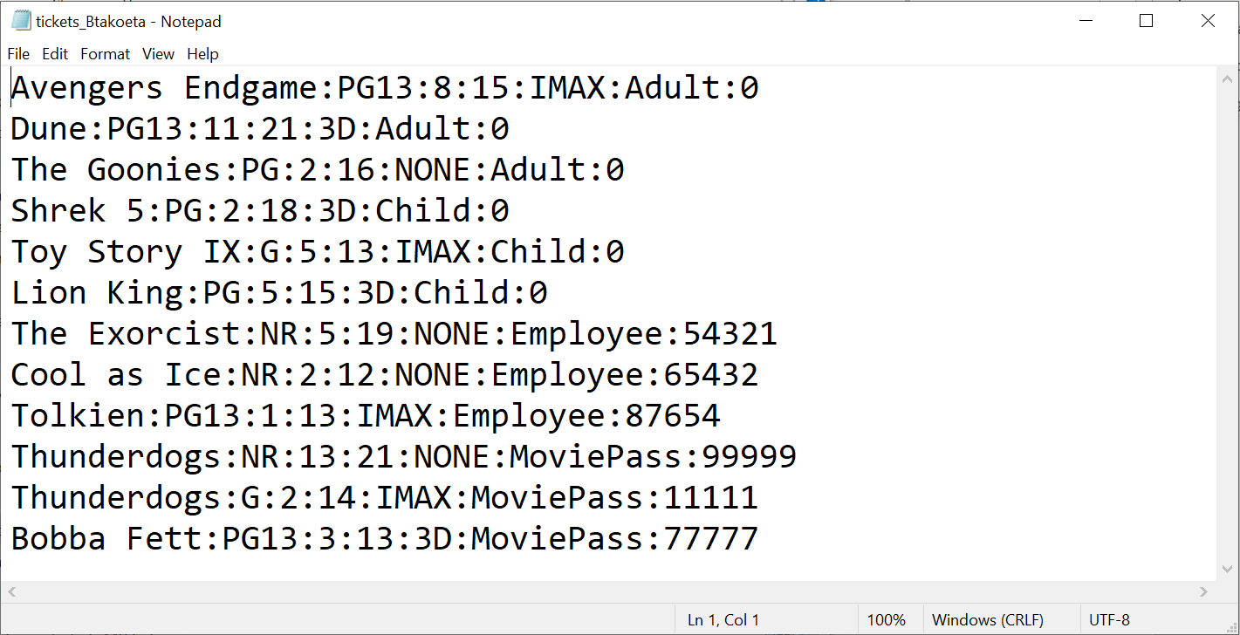

**Results**

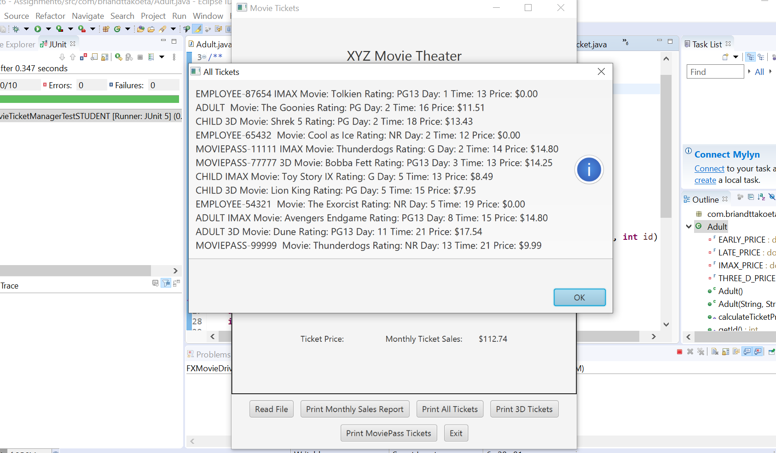

**Learning Experience**

This project is a summation of all the concepts I learned in this course from creating basic data element and driver classes, Junit testing, creating basic GUI applications, working with Arrays, reading files, enumeration, abstract methods amongst others. In addition to these concepts, the principles of Object-Oriented Programming which include Polymorphism, encapsulation (data or implementation hiding) and inheritance played a big part in the accomplishment of this movie ticket theater gui application.

Firstly, we were asked to create an XYZ Theater has four types of tickets Adult, Child, Employees, MoviePass. Through a certain number of rules such as 2 free movies for employees, we were able to provide input validation in accordance with the movie rating and the type of user.

The hardest part was to think of the logic behind the different Ticket childs. My original plan was to set the price inside the constructor using the calculatePrice method, calling the constructor when using the addTicket method. Since the price depends on the content of the ticketList, there was no way to set the price inside the ticket class since this class does not have access to the list. Instead. The calculatePrice uses the default price, which works with Adult and Child, and the price setting logic was placed inside the addTicket method. The method is a bit big and ugly (switch + nested if/else), and probably could be simplified but at least passes all tests.

In conclusion, this project reinforced my knowledge of the principles of Object-Oriented programming with Java.