**IDEATION**

There are mainly three components to be worked for given problem statement:

1. Payment
2. One paper cup from stack.
3. Filling specific amount of water

These components can be fulfilled using different types of mechanisms and operations. We considered these all alternatives for basic ideation and feasibility study:

1. **Payment**
2. **Cash payment**

The cash payment is most simple and commonly used type of the payment method in vending machines. The problem statement states that our product has to provide a cup of water and hence price will be nearly 2 rupees. For the 2 rupees there can be coin or notes used but as detection and handling of the notes is very difficult and problem causing hence we restricted our payment method to coin operations. The coin detection is comparatively easy and modules for the coin detection are readily available. These modules are compatible to Arduino and can be used for identifying one type of coins. The overall cost of this method is less but it requires the availability of coin with the customer.

**Advantages**:

* Easy for using for customers.
* No internet connection required.

**Disadvantages**:

* No real time monitoring possible
* Transactions to be monitored manually.

1. **Card payment:**

The payment using credit or debit card is an easy way and useful in cashless transactions. Making the card payment requires a setup for card payment and continuous internet connection to the setup. The connection can be given by using Wi-Fi modules now available even in remote areas. Having an internet connection to the setup can also be used for IOT based real time monitoring of the setup. This setup has more cost but more convenience.



**Advantages**:

* Easy tracking and recording of transactions.
* More secure than cash payments.

**Disadvantages**:

* Requires card for every customer.
* Requires network connection.

1. **Using online banking / UPI**

The payment using the UPI code is latest development in the money transactions. This type of payment is easy and fast but requires internet connection to the customer. The connection to the customer can also be given using Wi-Fi module but this has security issues. Also even if customer has internet connection and the payment is made, the signal about payment made or failed is to be given to the setup which ultimately needs an internet connection. This payment option also requires more investment and security threat due to the internet connection.

**Advantages**:

* More convenient and fast use.
* More secure payment.

**Disadvantages**:

* Requires internet connection for both customer and setup.
* Can be more time consuming in online transactions.

Depending on the advantages and disadvantage of different payment methods as above, the most feasible and easy method is accepting coins in cash from customers and providing them the service.

1. **Paper Cup Vending:**
2. **Removing from stack manually:**

Removing one cup at time from stack of cups can be easily done manually with hand. This is risky if one customer takes more than one cup or complete stack for other usage. This also has possibility of theft from other people. This mechanism is easy but not feasible to use in given case.

**Advantage**:

* No power required for the working of mechanism.
* No possibility of problem in receiving cup.

**Disadvantages**:

* No security to the paper cup stack.

1. **One cup separator manually operated.**

Removing one cup from stack can be done using a cup vending mechanism which separates one cup a time by manually operated lever. Using this mechanism is very easy also it secures all the cup stack to be stolen. But this mechanism also can give more than one cup at a time. Also the position where the cup is to be held for pouring water is not exactly known to the customer and there are chances of misplacing of cup and wastage of the water. This system is easy and less power consuming but less reliable and requires customer attention.

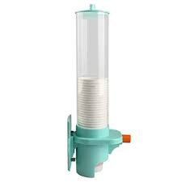

**Advantages**:

* Easy to operate than taking out cup from stack.
* More security to paper cup stack.

Disadvantages:

* No control over number of cups taken out.
* No control over position of cup with respect to water flow nozzle.

1. **Automatic Cup separator**

The automatic cup separator uses an automatic mechanism to separate one cup from the stack when the coin is detected, the cup is then moved through guide to a specific location in correct orientation. This method is completely automatic and no need for customer interaction and also there is no possibility of wastage of the water due to misposition of the cup when water is poured. The mechanism is actuated using motor like a servo motor and it is given signal from the Arduino for its functioning. This method gives out only one cup and hence there is no risk of taking out more than one or all the cups from the stack.

**Advantages**:

* Complete automatic system without customer intervention.
* Only one cup separated from stack and position is also foolproof.

**Disadvantages**:

* Electrical power required.
* Reliability of mechanism comes into picture due to automation.

Considering all the factors above for security of the paper cups and for correct positioning the completely automatic mechanism for paper cup separation from stack is more appropriate than manual mechanisms.

1. **Water filling:**

The water can be filled in the cup using a tap like opening or closing of the solenoid valve to start or stop the flow of water from tank. This system can use different types of sensors for the measurement of the water in the cup. Following are different types of measurement systems that can be used.

1. **Weight measuring of cup:**

The amount of water in the cup can be detected by measuring the weight of the cup while water is being filled in cup. This requires a pressure sensor to be placed at the position of cup. This has some problems as if the position of cup is offset to pressure sensor the reading given by it can change. Also the water spill from cup or during filling of water in cup. But this method has certain advantage as the measurement is direct and accurate.

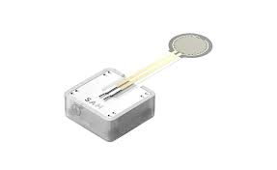

**Advantages**:

* Direct measurement of water quantity.
* More reliable and accurate.

**Disadvantage**:

* Water spilling on sensor is possible.
* Accuracy depends upon position of cup.

1. **Water flow time control:**

The actual flow rate of the water can be considered as constant for one cup of water filling and hence by knowing volume, amount of time required for the opening of valve is known. In this case the flow rate will change depending upon the height of water or level of water in tank. Hence the water level has to be monitored before each cup filling. This can be done using an ultrasonic sensor which gives water level continuously for calculating the flow rate depending on the height.

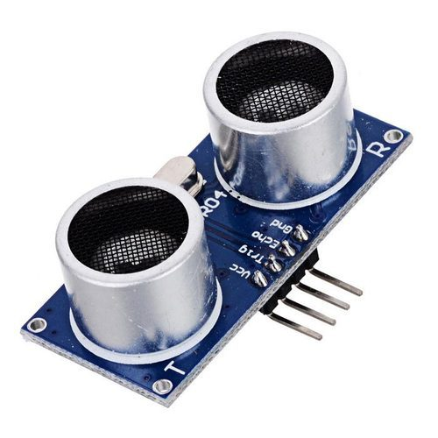

**Advantages**:

* No risk of contact of sensor and water.
* Easy time based operation.

**Disadvantages**:

* Measurement is indirect and depends on accuracy of calculations.
* Assumption of constant flow rate may not be useful in some conditions.

1. **Flow sensor:**

The flow sensor can be attached in series with the solenoid valve which consists of a small turbine connected to hall effect sensor. This flow sensor gives real time flow rate measurement and also can give actual water flow quantity in the cup. The sensor is very accurate and easy to use. Its working is independent of the position of cup or the water level in tank. This sensor is not depending on any other parameters like temperature or other environmental factors and gives fairly accurate readings and real time water quantity in the cup.

**Advantages**:

* More direct measurement is done.
* Direct reading of amount of water irrespective of flow rate is obtained.

**Disadvantages**:

* Possibility of blockage of turbine can stop the readings.
* Calibration of flow sensor for low flow rate is difficult.

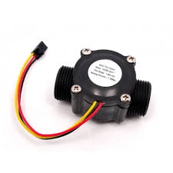

Depending on the all above considerations , use of flow sensor for water flow and quantity measurement is more suitable and reliable and hence flow sensor is used for water quantity determination.