UNIT I OVERVIEW & INSTRUCTIONS
Eight ideas – Components of a computer system – Technology – Performance – Power wall –Uniprocessors to multiprocessors; Instructions – operations and operands – representing instructions– Logical operations – control operations – Addressing and addressing modes.

What are the Eight Great Ideas in Computer Architecture? (2 marks)
Eight Great Ideas in Computer Architecture
- Design for Moore’s Law.
The Number of Transistors in a integrated circuit doubles approximately every two years. (Gordon Moore, one of the founders of Intel.)
When computer architects are designing or upgrading the design of a processor they must anticipate where the competition will be in 3-5 years when the new processor reaches the market.
- Use Abstraction to Simplify Design
- In computer architecture, a computer system is usually represented as consisting of five abstraction levels: hardware firmware, assembler, operating system and processes.
- Good abstraction layer facilitates easy reuse.
- Abstraction uses multiple levels with each level hiding the details of levels below it. For example:
- The instruction set of a processor hides the details of the activities involved in executing an instruction.
- High-level languages hide the details of the sequence of instructions need to accomplish a task.
- Operating systems hide the details involved in handling input and output devices.

- Make the common case fast
Making the common case fast will tend to enhance performance better than optimizing the rare case.
- Performance via parallelism
Doing different parts of a task in parallel accomplishes the task in less time than doing them sequentially. A processor has engages in several activities in the execution of an instruction. It runs faster if it can do these activities in parallel.
Parallel computing is a form of computation in which many calculations are carried out simultaneously, operating on the principle that large problems can often be divided into smaller ones which are then solved concurrently.
- Performance via pipelining
- Pipelining is a technique used in the design of computers to increase the instruction throughput (the number of instructions that can be executed in a unit of time).
- The basic instruction cycle is broken up into a series of pipeline stages.
- Rather than processing each instruction sequentially (one at a time, finishing one instruction before starting the next), each instruction is split up into a sequence of steps so that different steps can be executed concurrently (by different circuitry) and in parallel (at the same time).
- Pipelining increases instruction throughput by performing multiple operations at the same time (in parallel), but does not reduce instruction latency (the time to complete a single instruction from start to finish) as it still must go through all steps.
- Performance via prediction
- To improve the flow and throughput in a instruction pipeline, Branch predictors play a critical role in achieving high effective performance in many modern pipelined microprocessor architectures.
- Without branch prediction, the processor would have to wait until the conditional jump instruction has passed the execute stage before the next instruction can enter the fetch stage in the pipeline.
- A conditional branch is a type of instruction determines the next instruction to be executed based on a condition test. Conditional branches are essential for implementing high-level language if statements and loops.
- Unfortunately, conditional branches interfere with the smooth operation of a pipeline — the processor does not know where to fetch the next instruction until after the condition has been tested.
- Many modern processors reduce the impact of branches with speculative execution: make an informed guess about the outcome of the condition test and start executing the indicated instruction. Performance is improved if the guesses are reasonably accurate and the penalty of wrong guesses is not too severe.
- Hierarchy of memories
- Programmers want memory to be fast, large, and cheap, as memory speed often shapes performance, capacity limits the size of problems that can be solved, and the cost of memory today is often the majority of computer cost.
- Architects have found that they can address these conflicting demands with a hierarchy of memories, with the fastest, smallest, and most expensive memory per bit at the top of the hierarchy and the slowest, largest, and cheapest per bit at the bottom.
- Caches give the programmer the illusion that main memory is nearly as fast as the top of the hierarchy and nearly as big and cheap as the bottom of the hierarchy.
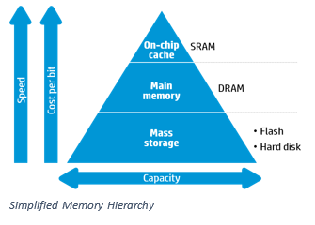
- Dependability via redundancy
- Computers not only need to be fast; they need to be dependable.
- Since any physical device can fail, we make systems dependable by including redundant components that can take over when a failure occurs and to help detect failures.
- Example: One of the most important ideas in data storage is the Redundant Array of Inexpensive Disks (RAID) concept. In most versions of RAID, data is stored redundantly on multiple disks. The redundancy insures that if one disk fails the data can be recovered from other disks.
Explain the Components of a computer system. (8) NOV/DEC 2014
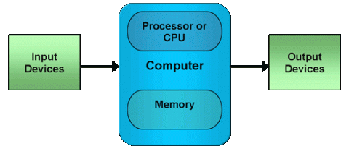
- Central Processing Unit (CPU):
  - Control Unit
  - Arithmetic and Logic Unit
  - Internal Registers
- Input/output :Data and instructions need to get into the system and results out
- Main memory :Temporary storage of code and results is needed
What are the Five Classic components in computer architecture? (2 marks)
- Five Classic components are:
1.Input 2. Output 3. Memory 4. Datapath 5. Control.
- The processor gets instructions and data from memory. Input writes data to memory, and output reads data from memory. Control sends the signals that determine the operations of the datapath, memory, input, and output.
- LCD: The most fascinating I/O device is probably the graphics display. Most personal mobile devices use liquid crystal displays (LCDs) to get a thin, low-power display.
- Touch screen: While PCs also use LCD displays, the tablets and smart phones of the Post PC era have replaced the keyboard and mouse with touch sensitive displays, which has the wonderful user interface advantage of users pointing directly what they are interested in rather than indirectly with a mouse.
- This technology can allow multiple touches simultaneously, which allows gestures that can lead to attractive user interfaces.
- The list of I/O devices includes a capacitive multitouch LCD display, front facing camera, rear facing camera, microphone, headphone jack, speakers, Wi-Fi network, and Bluetooth network.
- Integrated Circuits (IC’s): nicknamed Chips.
- The processor is the active part of the computer, following the instructions of a program. It adds numbers, tests numbers, signals I/O devices to activate, and so on. Occasionally, people call the processor the CPU, central processing unit.
- The datapath performs the arithmetic operations, and control tells the datapath, memory, and I/O devices what to do according to the wishes of the instructions of the program.
- The memory is where the programs are kept when they are running; it also contains the data needed by the running programs. The memory is built from DRAM chips. DRAM stands for dynamic random access memory.
- Cache memory consists of a small, fast memory that acts as a buffer for the DRAM memory. Cache is built using a different memory technology, static random access memory(SRAM). SRAM is faster but less dense, and hence more expensive, than DRAM. SRAM and DRAM are two layers of the memory hierarchy.
Define ISA: Instruction set Architecture.
- The interface between a computer’s software and its hardware.
- A computer’s Assembly Language
- Advantage: Allows different computer types (with the same ISA) to run identical software.
Define Application binary interface (ABI).
The Operating system will encapsulate the details of doing I/O, allocating memory, and other low level system functions so that application programmers do not need to worry about such details.
The combination of the basic instruction set and the OS interface provided for application programmers is called the Application binary interface.(ABI).
- A Safe place to save Data.
- Volatile and Non volatile Memory.
- Main Memory or Primary Memory.
- Secondary Memory
- Flash Memory.
- Communicating with other Computers.
What are the advantages of network computers? (2 marks)
- Communication: Information is exchanged between computers at high speeds.
- Resource sharing: Rather than each computer having its own I/O devices, computers on the network can share I/O devices.
- Nonlocal access: By connecting computers over long distances, users need not be near the computer they are using.
- LAN, WAN

Technologies for building Processors and Memory
- Processors and memory have improved at an incredible rate to try to win the race to design a better computer.
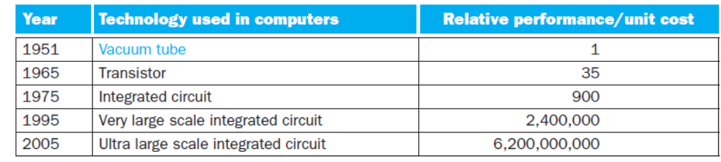
- A transistor is simply an on/off switch controlled by electricity.
- Vacuum tube An electronic component, predecessor of the transistor, that consists of a hollow glass tube about 5 to 10 cm long from which as much air has been removed as possible and which uses an electron beam to transfer data.
- This increase in transistor count for an integrated circuit is popularly known as Moore’s law, which states that transistor capacity doubles every 18–24 months.
- The manufacture of a chip begins with silicon, a substance found does not conduct electricity well, it is called a semiconductor.
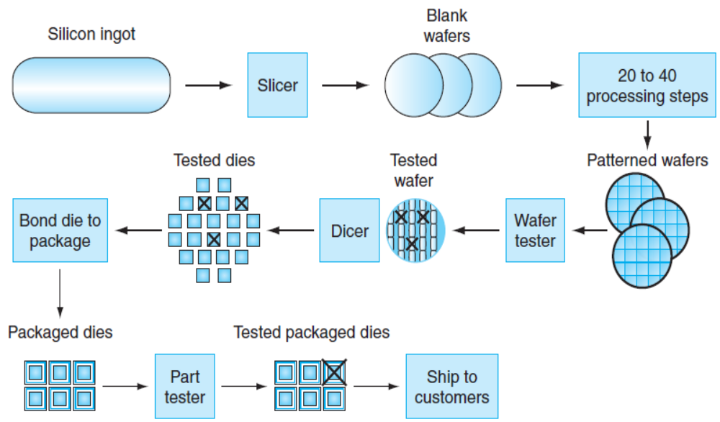
- The IC manufacturing process starts with a silicon crystal ingot.
- The Ingots are 8-12 inches in diameter and about 12 to inches long.
- An Ingot is finely sliced into wafers no more than 0.1 inches thick.These wafers then go through a series of processing steps, during which patterns of chemicals are placed on each wafer, creating the Transistors, conductors, and insulators.
- Defect: A microscopic flaw in a wafer or in patterning steps that can result in the failure of the die containing that defect.
- Die: The patterned wafer is then chopped up, or diced, into components, called dies(The individual rectangular sections that are cut from a wafer)
- Yield: The percentage of good dies from the total number of dies on the wafer.
- Dicing enables you to discard only those dies that were unlucky enough to contain the flaws, rather than the whole wafer. This concept is quantified by the yield of a process, which is defined as the percentage of good dies from the total number of dies on the wafer.
- Once found good dies, they are connected to the input/output pins of a package, using a process called bonding.
- Another important design constraint is power.
  - Power must be brought in and distributed around the chip.
  - Power is dissipated as heat and must be removed.
  - The power is proportional to the product of the number of transistors switched. Thus, in general, higher transistor counts lead to higher power.
- CMOS (Complementary Metal Oxide Semiconductor) is the dominant technology for integrated circuits. Here the power is consumed only during switching. It allow a processor to “sleep” and conserve power.

Performance:
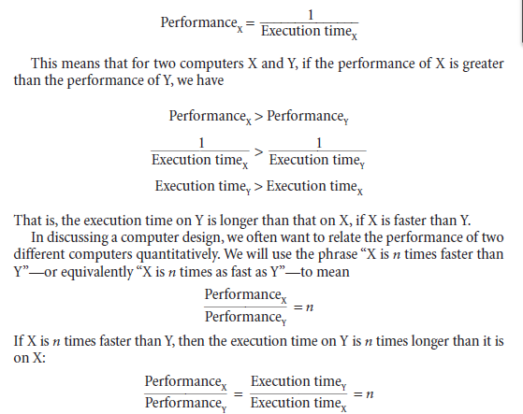

Example
Time taken to run a program = 10s on A, 15s on B

Relative performance =Execution Time_{B} / Execution Time_{A}
=15s/10s
=1.5
So A is 1.5 times faster than B

State the CPU Performance Equation and discuss the factors that affect performance. (8)
NOV/DEC 2014
- Time taken by the system to execute a program.
- Response time or execution time: The total time required for the computer to complete a task, including disk accesses, memory accesses, I/O activities, operating system overhead, CPU execution time, and so on.
- Throughput: The total amount of work done in a given time.
- Bandwidth: The amount of data that can be carried from one point to another in a given time period (usually a second). This kind of bandwidth is usually expressed in bits (of data) per second (bps). Occasionally, it's expressed as bytes per second (Bps).
Processor clock:
- Processor circuits are controlled by a timing signal called a clock(seconds)
- The clock defines regular time intervals, called clock cycles. (or ticks, clock ticks, clock periods, clocks, cycles)
- Designers refer to the length of a clock period both as the time for a complete clock cycle (e.g., 250 picoseconds, or 250 ps) and as the clock rate (e.g., 4 gigahertz, or 4 GHz), which is the inverse of the clock period.
- Clock rate (frequency) = cycles per second (1 Hz = 1 cycle/sec)

Instruction Performance
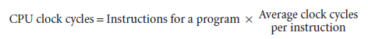
The term clock cycles per instruction, which is the average number of clock cycles each instruction takes to execute, is often abbreviated as CPI

- IPC – Instructions per cycle = 1/CPI;

CPI Example
- Computer A: Cycle Time = 250ps, CPI = 2.0
- Computer B: Cycle Time = 500ps, CPI = 1.2
- Same ISA
- Which is faster, and by how much?
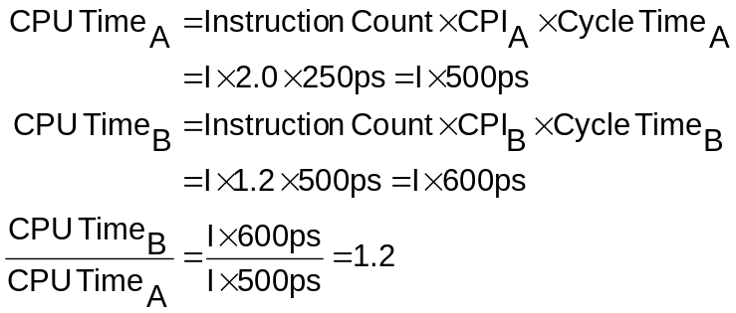

CPI in More Detail
- 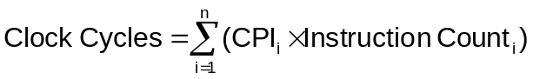If different instruction classes take different numbers of cycles

Basic performance equation:

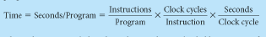

Classic Performance:
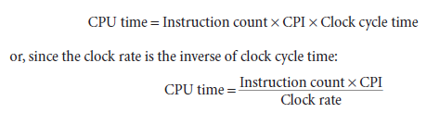

- Parameters which influence the performance are
    - Clock rate.
    - Type and number of instructions available
    - Average time required to execute an instruction
    - Memory access time
    - Power dissipation in the system
    - Number of I/O devices and types of I/O devices connected
    - The data transfer capacity of the bus
- For best performance, the following factors must be considered
  - Compiler
  - Instruction set
  - Hardware design
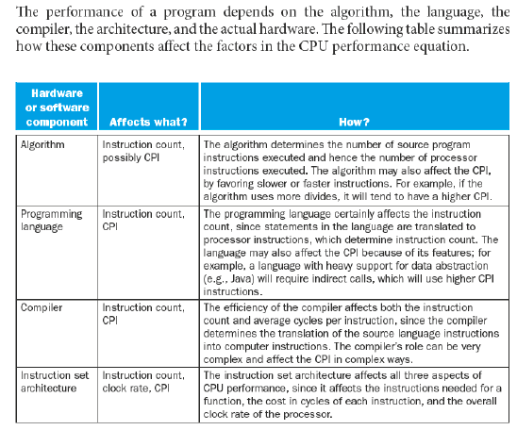
Performance Improvement
- Pipelining and superscalar operation
- Pipelining: by overlapping the execution of successive instructions
- Superscalar: different instructions are concurrently executed with multiple instruction pipelines.
- Clock rate improvement
- Improving the integrated-circuit technology makes logic circuits faster, which reduces the time needed to complete a basic step.
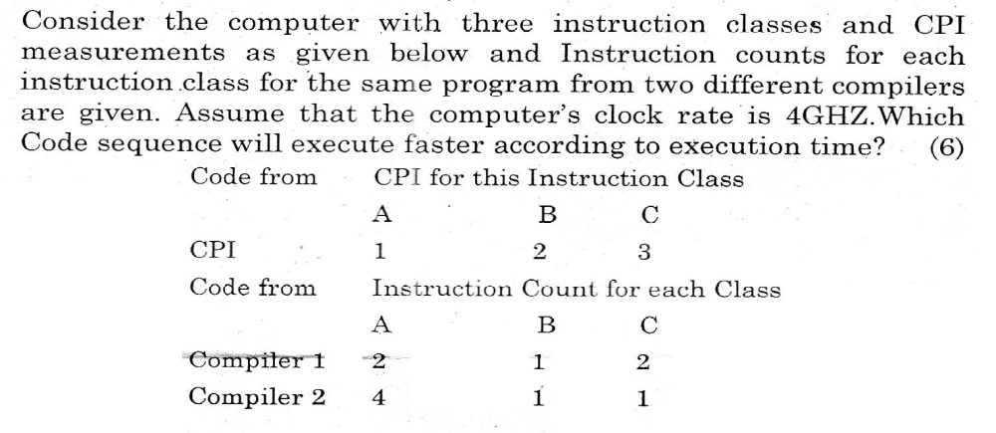
Solution:
Which code executes more instructions?
Instruction count for compiler 1=2+1+2=5
Instruction count for compiler 2=4+1+1=6
So, Compiler 2 executes more instruction than compiler 1.
COMPILER 1:
Instruction count (IC) = 2+ 1+ 2=5
Clock Cycles = Clock Cycles /instruction * instruction
= 1*2+2*1+3*2
=2+2+6
=10
Average Clock Cycle (CPI) =10/5=2
Execution Time= 2/4=.5sec
COMPILER 2:
Instruction count (IC) = 4+ 1+ 1=6
Clock Cycles = Clock Cycles /instruction * instruction
= 1*4+2*1+3*1
=4+2+3
=9
Average Clock Cycle (CPI) =9/6=1.5
Execution Time= 1.5/4=.375 sec
Compiler 2 is faster than compiler 1 as it takes fewer clock cycles though the instruction is more (6).
So Compiler 2 will have faster execution time.
Performance can be improved by
- Reducing the number of clock cycles.
- Increasing the clock rate.

Example:
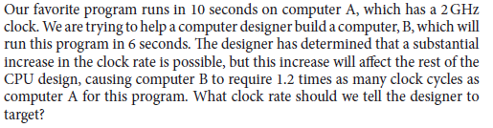

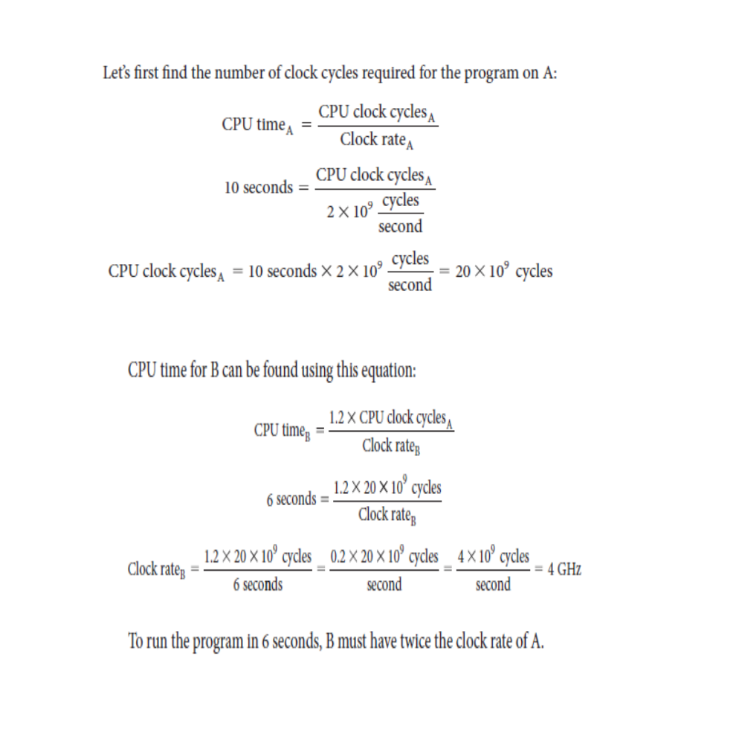

Note:
Increasing the processor speed by increasing the clock rate would generate much heat.

Power-wall:
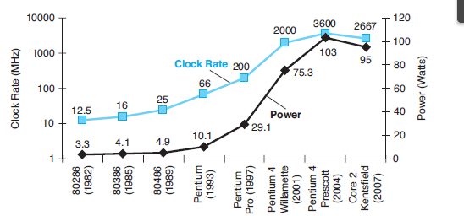
1. Power is the biggest challenge facing the computer designer for every class of computer.
2. First, power must be brought in and distributed around the chip which includes hundreds of pins and multiple interconnection layers just for power and ground.
3. Second, power is dissipated as heat and must be removed.
Without raising the processor clock rate have to improve the performance without power dissipation.
Modern processors provide features to manage heat:
- Reduce clock rate, thereby reducing the power.
The design goal for the late 1990’s and early 2000’s was to drive the clock rate up. This was done by adding more transistors to a smaller chip.
More transistors mean more power, thus more heat.
This reflects the practical experience gained with dense chips that were literally
“hot”; they radiated considerable thermal power and were difficult to cool.
Law of Physics: All electrical power consumed is eventually radiated as heat.
Each CPU is nothing more than a collection of transistors, acting as switches.
A modern CPU might have about a billion transistors on a single chip. The IBM Power 6 chip has 790 million transistors in an area of 341 mm².
The dominant technology for integrated circuits is called CMOS (complementary metal oxide semiconductor). For CMOS, the primary source of energy consumption is so-called dynamic energy—that is, energy that is consumed when transistors switch states from 0 to 1 and vice versa.
The power equation for a single transistor can be written as
Power = K (Capacitive Load)•(Voltage)²•(Frequency Switched)
- Frequency switched is a function of the clock rate.
- The capacitive load per transistor is a function of both the number of transistors connected to an output (called the fan out) and the technology, which determines the capacitance of both wires and transistors.
Although dynamic energy is the primary source of energy consumption in CMOS, static energy consumption occurs because of leakage current that flows even when a transistor is off. In servers, leakage is typically responsible for 40% of the energy consumption. Thus, increasing the number of transistors increases power dissipation, even if the transistors are always off. A variety of design techniques and technology innovations are being deployed to control leakage, but it’s hard to lower voltage further.
Solutions to the problem of the Power Wall:
- Include sophisticated and costly cooling technologies.
- CPU chips with multiple processors per chip are called “multicore”.
- Pipeline processor
Rather than continuing to improve single–program performance, recall a multicore chip is just a CPU chip with multiple processors.
Multi–core technology
- A multi-core processor is a single computing component with two or more independent actual processing units (called "cores"), which are the units that read and execute program instructions.
- The term "multicore" is also used to describe multiprocessor systems.
- A multi-core processor implements multiprocessing in a single physical package.
Note:
If your application consists only of a single thread, then your whole multi-CPU-system won't help you much as it will still only use one CPU for your application. (However, overall performance may still improve as the OS will run other applications on the other CPUs so they don't intermingle with the first one).
The multi–core technology will
- enables the system to perform more tasks with a greater overall system performance
- deliver full parallel execution of multiple software threads, and
- reduce the amount of electrical power to do the computations.
Note:
The dual core processor is likely to consume less power, but can it do the same amount of work per unit time as the faster single core processor.
Uniprocessors to Multiprocessors:
What is the difference between uniprocessor and multiprocessor?
Uniprocessor :
A type of architecture that is based on a single computing unit. All operations ( additions, multiplications, etc ) are done sequentally on the unit.
Multiprocessor :
A type of architecture that is based on multiple computing units. Some of the operations ( not all, mind you ) are done in parallel and the results are joined afterwards.
- Increasing the clock speed of Uniprocessor has reached saturation and cannot be increased beyond a certain limit because of power consumption and heat dissipation issues.
- As the physical size of chip decreased, while the number of transistors/chip increased, clock speed increased, which boosted the heat dissipation across the chip to a dangerous level. Cooling & heat sink requirement issues were there.
3. There were limitations in the use of silicon surface area.
4. There were limitations in reducing the size of individual gates further.
5. To gain Performance within a single core, many techniques like pipelining, super pipelined, superscalar architectures are used .
6. Most of the early dual core processors were running at lower clock speeds, the rational behind is that a dual core processor with each running at 1Ghz should be equivalent to a single core processor running at 2 Ghz.
7. The Problem is that this does not work in practice when the applications are not written to take advantage of the multiple processors. Until the software is written this way, unthreaded applications will run faster on a single processor than on a dual core cpu.
8. In Multi-core processors, the benefit is more on throughput than on response time.
Explain how the multicore processor takes less power.
Can you get better performance from a dual-core system or a dual-processor system?
You should understand that having two processors does not double a machine's performance. There are some main reasons for this.
- In order for a machine to benefit from multiple processors (or multiple cores for that matter), the machine must be running multiple threads.
- The inherent overhead in multi-CPU systems. Some of each CPU's power is lost to scheduling tasks. This is necessary because the computer must have some way of deciding which thread will run on each CPU.
- Even more performance is lost to communications occurring between processors.
I order to eliminate most of the delay incorporate two CPUs on the same die (the same chip). And so dual-core CPUs were born.

What is Instructions?
- is an order given to a computer processor by a computer program.
- each instruction is a sequence of 0s and 1s that describes a physical operation that a computer has to perform (such as "Add", ”sub” etc.)
- Steps that must be followed for completing a task.
Define Instruction set.
- The complete collection of instructions that are understood by a CPU for its execution.
- Machine Code
- Binary
- Usually represented by assembly codes
What are the elements of machine instruction?
- operation code (Opcode) and operand
- Opcode- operations to be performed (such as "Add", ”sub” etc.)
- Opcodes are represented by abbreviations, called mnemonics
- Source operand- inputs for the operation
- Result operand-produces a result
- Next instruction reference-tells from where to fetch the next instruction.
Define Opcode with example.
- opcodes are represented by mnemonics that indicate the operation.
- Example:ADD, SUB, MUL, DIV, LOAD, STORE
Illustrate the various numbers of Addressing formats that an instruction can contain.
- one address instruction (LOAD D)
- Two address instruction (MOV A,B)
- Three address instruction ( ADD A, B, C)

What are the various types of Instruction?
- Data processing-ALU
- Data storage-movement of data into or out of register or memory location.
- Data movement-I/O instruction
- Control-test and branch instruction
Explain the various general types of instruction set operations in detail.
• Data transfer
• Arithmetic
• Logical
• Conversion
• I/O
• System control
• Transfer of control
.

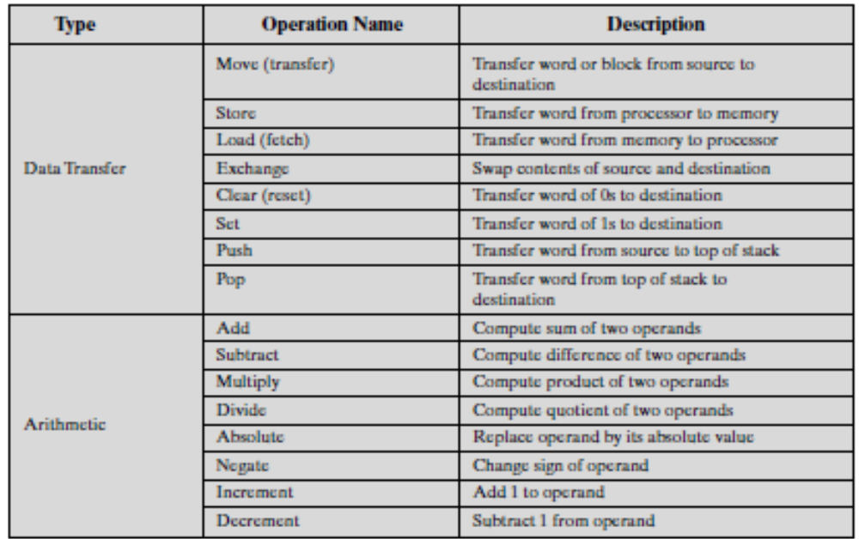
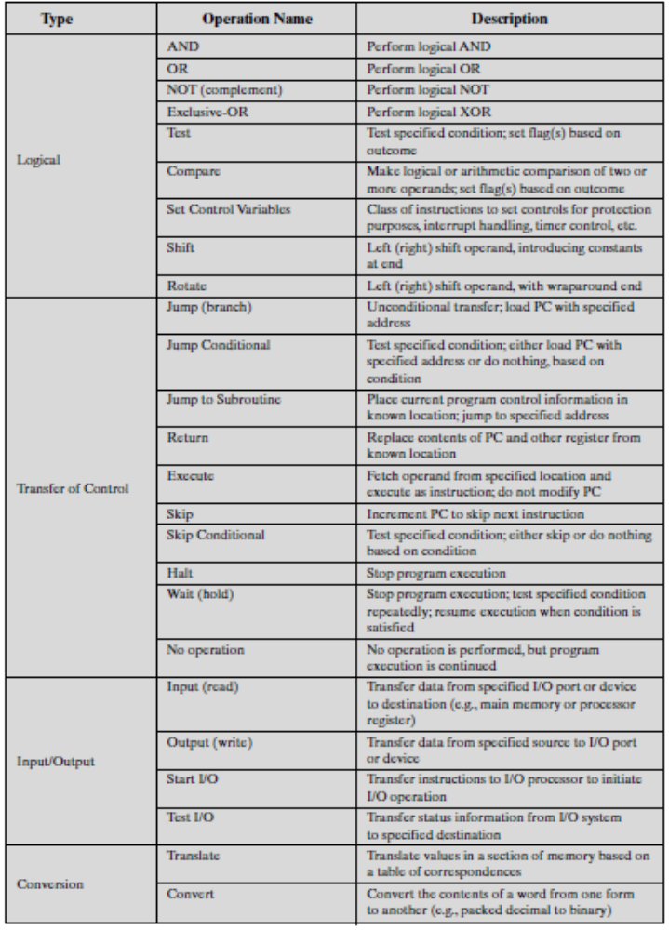

What is MIPS?
- Microprocessor without Interlocked Pipeline Stages (MIPS)
- is a reduced instruction set computer (RISC) instruction set architecture (ISA)
- MIPS instruction performs only one operation at a time.
- 32 bit architecture: word length, address length.
- 32 General Purpose Registers
Note:
- You can measure the speed of a computer in MIPS but that is Million Instruction Per Second.
- Very large number of registers may increase the clock cycle time
Example: add a, b, c (instructs a computer to add the two variables b and c and to put their sum in a.)
- The following sequence of instructions adds the four variables:
  - add a, b, c # The sum of b and c is placed in a.
  - add a, a, d # The sum of b, c, and d is now in a.
  - add a, a, e # The sum of b, c, d, and e is now in a.
- Thus, it takes three instructions to take the sum of four variables.
- The words to the right of the sharp symbol (#) on each line above are comments for the human reader, and the computer ignores them.
Note: every instruction should always have three operands, no more and no less.
Comparison of High-level programming language with MIPS instruction:
High-level programming language:
a = b + c;
d = a – e;

MIPS instruction:
add a, b, c
sub d, a, e
Units of Data

- BIT: one binary digit (0 or 1)
- BYTE: an 8-bit binary string
- WORD: a string of n bits (n is called word length)
  - The natural unit of access in a computer,
  - usually a group of 32 bits; corresponds to the size of a register

Instruction Representation

- Each instruction is represented by a sequence of bits.
- The instruction is divided into fields, corresponding to the constituent elements of the instruction.
- Instruction format : A form of representation of an instruction composed of fields o binary numbers.
- A simple example of an instruction format is
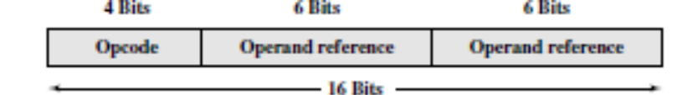
As
- With most instruction sets, more than one format is used.
- During instruction execution, an instruction is read into an instruction register (IR) in the processor.
- It is difficult for both the programmer and the reader to deal with binary representations of machine instructions. Thus, it has become common practice to use a symbolic representation of machine instructions.
- Opcodes are represented by abbreviations, called mnemonics that indicate the operation.
- Common examples include
ADD Add
SUB Subtract
MUL Multiply
DIV Divide
LOAD Load data from memory
STOR Store data to memory
- Operands are also represented symbolically. For example, the instruction
ADD R, Y
Source and result operands can be in one of four areas:
- Main or virtual memory
- Processor register
- Immediate: The value of the operand is contained in a field in the instruction being executed.
- I/O device
Programming languages have simple variables that contain single data elements asin registers, but they also have more complex data structures—arrays and structures. These complex data structures can contain many more data elements than there are registers in a computer.
The processor can keep only a small amount of data in registers, but computer memory contains millions of data elements. Hence, data structures (arrays and structures) are kept in memory. Instructions that transfer data between memory and registers. Such instructions are called data transfer instructions.

What are the various types of Operands?
- Addresses (memory) or Memory Operands [LOAD & STORE]

- Numbers or constant or immediate operands.
- Characters
- Logical data

Addressing Modes
The term addressing modes refers to the way in which the operand of an instruction is specified. Information contained in the instruction code is the value of the operand or the address of the result/operand.
An addressing mode specifies how to calculate the effective memory address of an operand by using information held in registers and/or constants contained within a machine instruction or elsewhere.
Addressing modes | Example Instruction | Meaning | When used
Register | Add R4,R3 | R4 <- R4 + R3  EA=R4 | Operands are located in registers.  Limited number of registers.  Very fast execution
Immediate | Add R4, #3 | EA=OPERAND=VALUE  R4 <- R4 + 3 | For constants. Immediate addressing supplies the actual value and is normally prefixed with a #.No memory reference to fetch data.  Fast
Direct | Add R1, (1001) | EA=(address field)  R1 <- R1 + M[1001] | Useful in accessing static data. It  uses the number as a memory location where the value is stored
Indirect | (R), (LOC) | EA = ((address field)) | Multiple memory accesses to find operand.  Hence slower
Indexed | X(R) | EA=[R]+X  X denotes the constant given in instruction  R is the register involved. | Useful in array addressing. The address of the operand is obtained by adding to the contents of the general register (called index register) a constant value.
Relative:  Base relative  PC relative | X(PC)  X(B) | EA=[PC]+X  EA=[B]+X | Appropriate for structure (records) accessing.
Auto-  increment | (R2)+ | R1 <- R1 +M[R2]  R2 <- R2 + d | Useful for stepping through arrays in a loop.  R2 - start of array  d - size of an element
Auto-  decrement | Add R1,-(R2) | R2 <-R2-d  R1 <- R1 + M[R2] | Same as autoincrement.  Both can also be used to implement a stack as push and pop
NOTE: EA refers to Effective Address.
REGISTER ADDRESSING
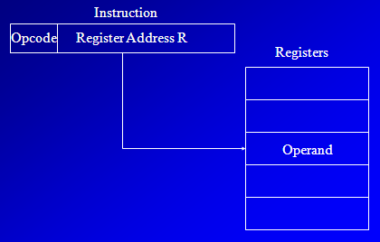

REGISTER INDIRECT ADDRESSING
EA = (R)
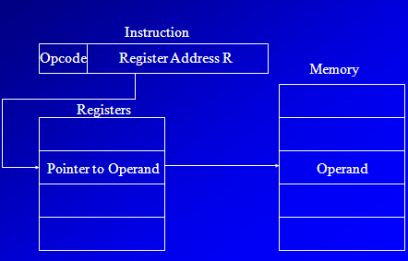
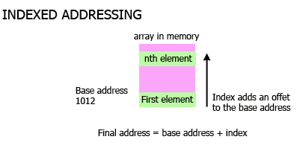

DIRECT ADDRESSING
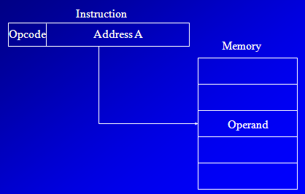
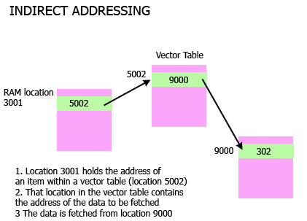

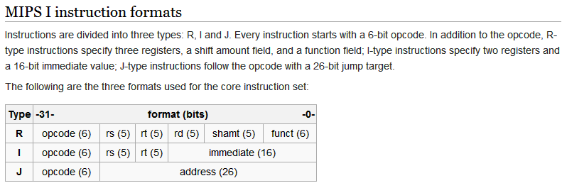
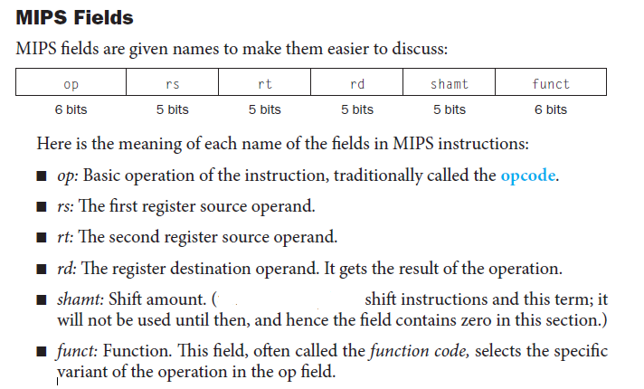
Instruction format:
A form of representation of an instruction composed of fields of binary numbers.

Representing instructions with MIPS
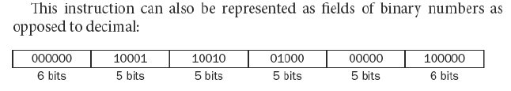
Logical operations
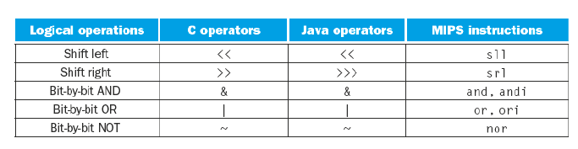
Note:
- shift left logical (sll)
- shift right logical (srl).
- immediate (andi) and
- or immediate (ori).

Instructions for making decisions:

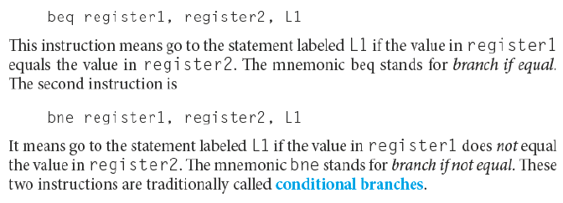
Compiling if-then-else into Conditional Branches
if (i == j) f = g + h; else f = g – h;
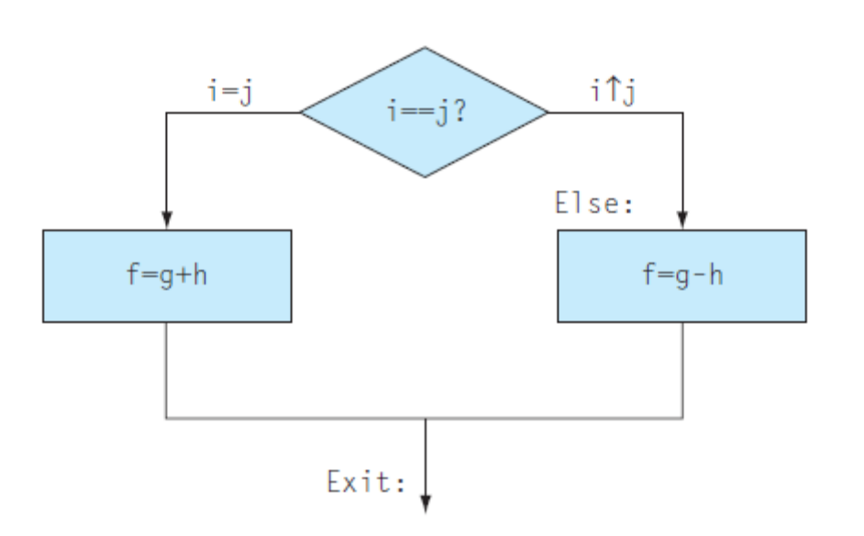
Amdahl's law is used to find the maximum expected improvement to an overall system when only part of the system is improved. It is often used in parallel computing to predict the theoretical maximum speedup using multiple processors.

Amdahl’s law states that in parallelization, if P is the proportion of a system or program that can be made parallel, and 1-P is the proportion that remains serial, then the maximum speedup that can be achieved using N number of processors is 1/((1-P)+(P/N).
If N tends to infinity then the maximum speedup tends to 1/(1-P).
Speedup is limited by the total time needed for the sequential (serial) part of the program. For 10 hours of computing, if we can parallelize 9 hours of computing and 1 hour cannot be parallelized, then our maximum speedup is limited to 10x.

