UNIT IV
LINEAR DATA STRUCTURES – STACKS, QUEUES
Stack.
Stack is a linear data Structure and it is an ordered collection of elements in which insertions and deletions occur at only one end of the list called the Top. The fundamental operations performed on a stack are Push and Pop. It follows Last in First Out principle.
Example: Pile of coins, a Stack of trays in cafeteria.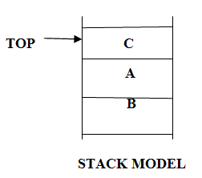

basic operations that can be performed on a stack
The basic operations that can be performed on a stack are
• Push operation
• Pop operation
• Peek operation
• Empty check
• Fully occupied check
STACK :
A Stack is a linear data Structure which follows Last in First Out (LIFO) principle, in which both insertion and deletion occur at only one end of the list called the Top.

TOP C
A
B

STACK MODEL
EXAMPLE:
Pile of coins, a Stack of trays in cafeteria.
OPERATIONS ON STACK:
The fundamental operations performed on a stack are
1. Push
2. Pop

ARRAY IMPLEMENTATION OF STACK

Stack can be implemented using arrays and pointers.

Array Implementation
In this implementation each stack is associated with a pop pointer, which is -1 for an empty stack.
- To push an element X onto the stack, Top pointer is incremented and then set stack [Top]=X.
- To pop an element, the stack [Top] value is returned and the top pointer is decremented. Pop an element stack or push on a full stack will exceed the array bounds.

ROUTINE TO PUSH AN ELEMENT ONTO A STACK(Insertion)

void push (int x, Stack S)
{
if(IsFull(S))
Error(“Full Stack”);
else
{
Top = Top+1;
S[Top]=X;
}
}
int IsFull (Stack S)
{
if (Top+1 = = Arraysize)
return (1);
}

ROUTINE TO POP AN ELEMENT FROM THE STACK(Deletion)

void Pop (Stack S)
{
if (IsEmpty (S))
error (“Empty Stack”);
else
{
X = S[Top];
Top = Top-1;
}
}
int IsEmpty(Stack S)
{
if(Top==-1)
return(1);
}

ROUTINE TO RETURN TOP ELEMENT OF THE STACK

int TopElement (Stack S)
{
if (!IsEmpty (S))
return S[Top];
else
Error (“Empty Stack”);
return 0;
}

LINKED LIST IMPLEMENTATION OF STACK

- Push operation is performed by inserting an element at the front of the list
- Pop operation is performed by deleting at the front of the list
- Top operation returns the element at the front of the list.

Initially Empty Header(S)

S

400

Push(10)

S 500
10

400 500
Push(20)

S 100
20
10

400 100 500
Pop()-20 gets deleted.

S 500
10

400 500

DELECARATION FOR LINKED LIST IMPLEMENTATION

struct node;
typedef struct node *Stack;
int IsEmpty (Stack S);
Stack CreateStack (void);
void MakeEmpty (Stack S);
void push (int X, Stack S);
int Top (Stack S);
void Pop (Stack S);
struct node
{
int Element;
struct node *Next;
};

ROUTINE TO PUSH AN ELEMENT ONTO A STACK
void Push (int X, Stack S)
{
struct node * Newnode;
Newnode =malloc (sizeof (struct node));
if (Newnode == NULL)
Error (“Out of Space”);
else
{
Newnode->Element = X;
Newnode->Next = S->Next;
S ->Next = Newnode;
}
}

ROUTINE TO RETURN TOP ELEMENT IN A STACK (PEEK)
int Top (Stack S)
{
if (!IsEmpty (S))
return S->Next->Element;
Error (“Empty Stack”);
return 0;
}

ROUTINE TO POP FROM A STACK
void Pop (Stack S)
{
struct node *Temp;
if (IsEmpty (S))
Error (“Empty Stack”);
else
{
Temp = S->Next;
S->Next = S->Next->Next;
Free (Temp);
}
}
APPLICATIONS OF STACK

Some of the applications of stack are:

- Evaluating arithmetic expression
- Balancing the symbols
- Tower of Hanoi
- Function Call
- 8 Queens Problem
- Towers of Hanoi

Towers of Hanoi is one of the example illustrating the recursion technique. The problem is moving a collection of N disk of decreasing size from one pillar to another pillar. The movement of the disk is restricted by the following rules:

Rule 1: Only one disk could be moved at a time.
Rule 2: No larger disk could ever reside on a pillar on top of a smaller disk.
Rule 3: A 3rd Pillar could be used as an intermediate to store one or more disks, while they were being moved from source to destination.

Recursive Solution:

N-represents the number of disks.

Step 1: If N=1, move the disk from A to C.
Step 2: If N=2, move the 1st disk from A to B.
Then move the 2nd disk from A to C.
Then move the 1st disk from B to C.
Stpe 3: If N=3, repeat the step (2) to move the first 2 disks from A to B using C as intermediate.
Then the 3rd disk is moved from A to C. Then repeat the step (2) to move 2 disks from B to C using A as intermediate.
In general, to move N disks. Apply the recursive technique to move N-1 disks from A to B us using A as an intermediate.
RECURSIVE ROUTINE FOR TOWERS OF HANOI

void hanoi ( int n, cahr s, char d, char i)
{
/* n==> no. Of disks, s---->source, d----->destination i----->intermediate */
if (n==1)
{
print (s,d);
return;
}
else
{
hanoi (n-1, s, i, d);
print (s,d);
hanoi (n-1, i ,d,s );
return;
}
}

convert infix expression to postfix expression with an example of(A+(B*C-(D/E^F)*G)*H).

INFIX TO POSTFIX CONVERSION:
Read the infix expression one character at a time.
Step 1: If the character is an operand, place it on to the output.
Step 2: If the character is an operator, push it onto the stack. If the stack operator has a higher or equal priority than input operator then pop that operator from the stack and place it onto the output.
Step 3: If the character is a left paraenthesis, push it onto the stack.
Step 4: If the character is a right paraenthesis, pop all the operators from the stack till it encounters left paraenthesis, discard both the paraenthesis in the output.
INFIX EXPRESSION: A+(B*C-(D/E^F)*G)*H
READ CHARACTER STACK OUTPUT

A
A

+ + A

(
( + A

B ( AB
+

* * AB
(
+

* ABC
C (
+

- - ABC*
(
+

(
( - ABC*
(
+

(
D - ABC*D
(
+

/
(
/ - ABC*D
(
+

/
E ( ABC*DE
-
(
+

^
(
^ - ABC*DE/
(
+

)
^
(
F - ABC*DE/F^
(
+

*
* - ABC*DE/F^G
(
+

)
*
G - ABC*DE/F^G*
(
+

)
*
) - ABC*DE/F^G*-
(
+

* ABC*DE/F^G*-H
*
+

No input stack empty ABC*DE/F^G*-H*+

INFIX TO POSTFIX EXPRESSION

Program

#include<stdio.h>
#include<alloc.h>
#include<process.h>
#include<conio.h>
#define SIZE 20
char Expr[SIZE];
char Stack[SIZE];
int Top=-1;
void push(char ch);
void pop();
void infix_to_postfix();
int m,l;
void main()
{
char ch;
clrscr();
printf("Program to covert infix expression into postfix expression:\n");
printf("Enter your expression & to quit enter fullstop(.)\n");
while((ch=getc(stdin))!='\n')
{
Expr[m]=ch;
m++;
}
l=m;
infix_to_postfix();
getch();
}
void push(char ch)
{
if(Top+1 >= SIZE)
{
printf("\nStack is full");
}
else
{
Top=Top+1;
Stack[Top] = ch;
}
}
void pop()
{
if (Top < 0)
{
printf("\n Stack is empty");
}
else
{
if(Top >=0)
{
if(Stack[Top]!='(')
printf("%c",Stack[Top]);
Top=Top-1;
}
}
}
void infix_to_postfix()
{
m=0;
while(m<l)
{
switch(Expr[m])
{
case '+' :
case '-' :
while(Stack[Top] =='-' || Stack[Top] =='+' ||Stack[Top] =='*' ||Stack[Top] =='/' ||Stack[Top] =='^' && Stack[Top] !='(')
pop();
push(Expr[m]);
++m;
break;

case '/' :
case '*' :
while(Stack[Top] =='*' ||Stack[Top] =='/' ||Stack[Top] =='^' && Stack[Top] !='(')
pop();
push(Expr[m]);
++m;
break;
case '^':
push(Expr[m]);
++m;
break;
case '(':
push(Expr[m]);
++m;
break;
case ')':
while(Stack[Top]!='(')
pop();
pop();
++m;
break;
case '.' :
while (Top >= 0)
pop();
exit(0);
default :
if(isalpha(Expr[m]))
{
printf("%c",Expr[m]);
++m;
break;
}
else
{
printf("\n Some error");
exit(0);
}
}
}
}

Output

Program to covert infix expression into postfix expression:
Enter your expression & to quit enter fullstop(.)
a+b*c.
ab+c*

(ii) Evaluate the following postfix expression abcd+e*+f+* where a=3 b=2 c=5 d=6 e= 8 f=2
A) Evaluating Postfix Expression:

Read the postfix expression one character at a time until it encounters the delimiter ‘#’.

Step 1: If the character is an operand, push its associated value onto the attack.
Step 2: If the character is an operator, POP two values from the stack, apply the operator to them and push the result onto the attack.

Example:
abcd+e*+f+* where a=3 b=2 c=5 d=6 e= 8 f=2.

Let us consider the symbols A,B,C,D,E has the associated values:

SYMBOL | VALUE
A | 3
B | 2
C | 5
D | 6
E | 8
F | 2

READ CHARACTER STACK

A

3

2
B 3

5
2
C 3

6
D 5
2
3

+ 30
2
3

8
E 30
2
3

240
* 2
3

+ 242
3

f 2
242
3

+ 244
3

* 732

Result:732

Balancing Expression
checks if expression is correctly parenthesized using stack
PROGRAM:
#include<stdio.h>
#include<conio.h>
#include<stdlib.h>
void push(char);
void pop(void);

Struct Node
{
char data;
Node *next;
};
Node *top=NULL;
void push(char ele)
{
Node *newNode=new Node(ele);
if(top== NULL)
{
top=newNode;
}
else
{
newNode->next=top;
top=newNode;
}
}
void pop(void)
{
if (top==NULL)
{
cout<<"\n STACK IS EMPTY\n";
}
else
{
Node *temp=top;
top=top->next;
free(temp);
}
}
const size=25;
void main()
{
int i=0;
Node Nd;
char expr[size];
clrscr();
printf("\nENTER THE EXPRESSION:");
scanf(“%s”,expr);
while(expr[i]!='\0')
{
if(expr[i]=='(')
Nd.push(expr[i]);
if(expr[i]==')')
{
if(top==NULL)
{
Printf(“PARANTHES IS NOT BALANCED\n");
getch();
exit(0);
}
else
Nd.pop();
}
i++;
}
if(top==NULL)
printf("\nPARANTHES IS BALANCED\n");
else
printf("\nPARANTHES IS NOT BALANCED\n");
getch();
}

Queue ADT.
A queue is a linear data structures which follows FIRST IN FIRST OUT(FIFO) principle, in which insertion is performed at Rear end and deletion is performed at Front end.
QUEUE
Dequeue(Q) Enqueue(Q)

FRONT REAR

QUEUE MODEL

Example: Waiting Line in Reservation Counter.

OPERATIONS ON QUEUE:
The fundamental operations performed on queue are:
Enqueue:
The process of inserting an element in the queue.
Dequeue:
The process of deleting an element in the queue.

EXCEPTIONAL CONDITIONS

Overflow
Attempt to insert an element when the Queue is full is said to be overflow.

Underflow
Attempt to delete an element, when the Queue is empty is said to be underflow.

ARRAY IMPLEMENTATION OF QUEUE

Queue can be implemented using arrays and pointers.

Array Implementation:
In this implementation, queue Q is associated with two pointers namely Rear pointers and Front pointer. To insert an element X onto the Queue Q, the Rear pointer is incremented by 1.

ROUTINE TO ENQUEUE:
void Enqueue(int X)
{
if(Rear+1>=max_Arraysize)
print(“Queue overflow”);
else
{
Rear=Rear+1;
Queue[Rear]=X;
if(Front==-1)
Front=0;
}
}
ROUTINE TO DEQUEUE:
void dequeue()
{
if(Rear==-1)
print(“Queue underflow”);
else
{
X=Queue[Front];
if(Front==Rear)
{
Front=-1;
Rear=-1;
}
else
Front=Front+1;
}
}

LINKED LIST IMPLEMENTATION OF QUEUE

- Enqueue operation is performed at the end of the list.
- Dequeue operation is performed at the front of the list.

Enqueue (10)

Q 500
10

400 500
Front,Rear
Enqueue (20)

Q 500
10
20

400 500 100
Front Rear

Dequeue()

Q 100
20

400 100

DECLARATION FOR LINKED LIST IMPLEMENTATION OF QUEUE ADT:

struct node;
typedef struct node *Queue;
int IsEmpty (Queue Q);
Queue CreateQueue (void);
void MakeEmpty (Queue Q);
void Enqueue (int X, Queue Q);
void Dequeue(Queue Q);
struct node
{
int *Element;
struct node *Next;
}*Front=NULL,*Rear=NULL;

ROUTINE TO CREATE AN EMPTY QUEUE

struct CreateQueue()
{
Queue Q
Q=malloc (sizeof(struct node));
if (Q == Null)
Error (“Out of Space”);
MakeEmpty (Q);
return Q;
}
void MakeEmpty (Queue Q)
{
if (Q == NULL)
Error (“Create Stack First”);
else
while (!IsEmpty (Q))
Dequeue(Q);
}

ROUTINE TO ENQUEUE AN ELEMENT ONTO A QUEUE

void Enqueue (int X, Queue Q)
{
Struct node * Newnode;
Newnode =malloc (sizeof (struct node));
if (Rear== NULL)
{
Newnode->Element = X;
Newnode->Next =NULL;
Front= Newnode;
Rear= Newnode;
}
else
{
Newnode->Element = X;
Newnode->Next =NULL;
Rear->Next= Newnode;
Rear= Newnode;
}
}

ROUTINE TO DEQUEUE AN ELEMENT FROM THE QUEUE:

void Dequeue()
{
struct node *Temp;
if (Front==NULL)
Error (“Empty Queue”);
else
{
Temp = Front;
if(Front==Rear)
{
Front=NULL;
Rear=NULL;
}
else
{
Front=Front ->Next;
Print(Temp->element);
free (Temp);
}}
circular queue with example
In Circular Queue, the insertion of a new element is performed at the very first the location of the queue if the Queue is full, in which the first element comes just after the last element.
Advantages:(better than linear queue)
It overcomes the problem of unutilized space in linear queues, when implemented as arrays. To perform the insertion of an element in to the circular queue, the position of the element is calculated by the relation as Rear=(Rear+1)% maxsize
And then set CQ[Rear]=value.
ROUTINE TO INSERT AN ELEMENT IN CIRCULAR QUEUE
void CEnqueue(int X,CQueue CQ)
{
If(Front==(Rear+1)%maxsize)
print(“Queue is overflow”);
else
{
if(Front==-1)
Front=Rear=0;
Else
Rear=(Rear+1)%maxsize;
CQ[Rear]=X;
}}}
ENQUEUE()
FRONT
Q[5]
Q[0] Q[5] Q[0]
10
20
30

q[4]
Q[4]

Q[1] Q[1]

Q[3] Q[3]
Q[2]
Q[2] REAR

FRONT
Q[5]
REAR Q[0]
50 10
20
40 30

Q[4]
Q[1]

Q[3]
Q[2]

ROUTINE TO DELETE A N ELEMENT FROM CIRCULAR QUEUE:
void Cdequeue()
{
if(Rear==-1)
print(“Queue underflow”);
else
{
X=CQ [Front];
if(Front==Rear)
{
Front=-1;
Rear=-1;
}
else
Front=(Front+1)%maxsize;
Printf(“deleted element is %d”,CQ[X]);
}
}

DEQUEUE()

FRONT
Q[5]
Q[0] Q[5] Q[0]
10
20
30

20
30

q[4] FRONT
Q[4]

Q[1] Q[1]

Q[3] Q[3]
Q[2]
Q[2] REAR
REAR

double ended queue that is implemented as an array
In Double ended Queue, insertion and deletion operations are performed at both the ends.
10 20 15 30 25 40
DELETION INSERTION
DELETION
INSERTION
Front End Rear End

INPUT RESTRICTED DEQUE
In this type insertions are allowed at one end and deletions are allowed at both ends.

FRONT REAR

DELETION
................
DELETION INSERTION

OUTPUT RESTRICTED DEQUE

In this type deletions are allowed at one end and insertions are allowed at both ends.

FRONT REAR
INSERTION

.................
DELETION INSERTION

Insertion at the Rear End
Step 1: Check for the overflow condition.
Step 2: If it is true, display that the queue is full.
Step 3: Otherwise, if the rear and front pointers are at the initial values (-1). Increment both pointers. Goto Step 5.
Step 4: Increment the Rear pointers.
Step 5: Assign the values to Q[Rear]

ROUTINE TO INSERT AN ELEMENT AT REAR END

void Insert_rear(int X,DQueue DQ)
{
if(Rear==Arraysize-1)
{
Printf(“Queue Overflow”);
}
else
{
Rear=Rear+1;
DQ[Rear]=X;
if(Front==-1)
{
Front=0;
}
}
Insertion At The Front End
Step 1: Check the front pointer, if it is in the first position (0) then display an error message that the value cannot be inserted at the front end.
Step 2: Otherwise, decrement the front pointer.
Step 3: Assign the value to Q [Front].

ROUTINE TO INSERT AN ELEMENT AT FRONT END

void Insert_front(int X,DQueue DQ)
{
if(Front==0)
{
Printf(“cannot insert at fornt position”);
}
Else
{
if(front==-1)
{
Front=Front+1;
DQ[Front]=X;
if(Rear==-1)
Rear=0;
}
else
{
Front=Front-1;
DQ[Front]=X;
}
}
}

Deletion At The Rear End

Step 1: Check the Rear pointer. If it is in the initial value then display that the value cannot be deleted.
Step 2: Otherwise, delete element at the rear position.
Step 3: If the rear and front pointers are at the same pointers, reinitialize both the pointers.
Step 4:Otherwise, decrement the rear pointer.

ROUTINE TO DELETE AN ELEMENT AT REAR END

Void Delete_rear(DQueue DQ)
{
Int X;
If(Rear==-1)
{
Printf(“Queue is empty”);
}
else
{

X=DQ[Rear];
if(Front==Rear)
{
Front=-1;
Rear=-1;
}
else
{
Rear=Rear-1;
}
}
}

Deletion from Front End
Step 1: Check for the underflow condition. If it is true display that the queue is empty.
Step 2: Otherwise, delete the element at the front position, by assigning X as Q[Front].
Step 3: If the Rear and Front pointer points to the same position (ie.,) only one value is present, then reinitialize both the pointers.
Step 4: Otherwise, Increment the front pointer.

ROUTINE TO DELETE AN ELEMENT FROM FRONT END

void Delete_front(int X,DQueue DQ)
{
int X;
if(Front==-1)
{
Printf(“Queue is underflow”);
}
else
{
if(front==Rear)
{
Front=-1;
Rear=-1;
}
else
{
Front=Front-1;
}
}
}

Program to create a queue from stack.
/* Program to implement a queue using two stacks */
#include<stdio.h>
#include<stdlib.h>
/* structure of a stack node */
struct sNode
{
int data;
struct sNode *next;
};
void push(struct sNode** top_ref, int new_data);
int pop(struct sNode** top_ref);

/* structure of queue having two stacks */
struct queue
{
struct sNode *stack1;
struct sNode *stack2;
};

void enQueue(struct queue *q, int x)
{
push(&q->stack1, x);
}

int deQueue(struct queue *q)
{
int x;
if(q->stack1 == NULL && q->stack2 == NULL)
{
printf("Q is empty");
getchar();
exit(0);
}

/* Move elements from stack1 to stack 2 only if
stack2 is empty */
if(q->stack2 == NULL)
{
while(q->stack1 != NULL)
{
x = pop(&q->stack1);
push(&q->stack2, x);
}
}
x = pop(&q->stack2);
return x;
}

/* Function to push an item to stack*/
void push(struct sNode** top_ref, int new_data)
{
struct sNode* new_node =
(struct sNode*) malloc(sizeof(struct sNode));
if(new_node == NULL)
{
printf("Stack overflow \n");
getchar();
exit(0);
}
new_node->data = new_data;
new_node->next = (*top_ref);
(*top_ref) = new_node;
}

/* Function to pop an item from stack*/
int pop(struct sNode** top_ref)
{
int res;
struct sNode *top;

if(*top_ref == NULL)
{
printf("Stack overflow \n");
getchar();
exit(0);
}
else
{
top = *top_ref;
res = top->data;
*top_ref = top->next;
free(top);
return res;
}
}

int main()
{
struct queue *q = (struct queue*)malloc(sizeof(struct queue));
q->stack1 = NULL;
q->stack2 = NULL;
enQueue(q, 1);
enQueue(q, 2);
enQueue(q, 3);
printf("%d ", deQueue(q));
printf("%d ", deQueue(q));
printf("%d ", deQueue(q));
getchar();
}

UNIT V
SORTING, SEARCHING AND HASH TECHNIQUES

Insertion sort with example.
INSERTION SORT
One of the simplest sorting algorithms is the insertion sort. Insertion sort consists of n - 1 passes. For pass p = 2 through n, insertion sort ensures that the elements in positions 1 through p are in sorted order. Insertion sort makes use of the fact that elements in positions 1 through p - 1 are already known to be in sorted order. Figure shows a sample file after each pass of insertion sort. Figure shows the general strategy. In pass p, we move the pth element left until its correct place i found among the first p elements. The code in Figure implements this strategy. The sentinel in a[0] terminates the while loop in the event that in some pass an element is moved all the way to the front. Lines 3 through 6 implement that data movement without the explicit use of swaps. The element in position p is saved in tmp, and all larger elements (prior to position p) are moved one spot to the right. Then tmp is placed in the correct spot.
void insertion_sort( int a[ ], int n )
{
int i,j,tmp;
for( i=0; i < n; i++ )
{
tmp = a[i];
for( j = i; tmp < a[j-1]&&j>0; j-- )
a[j] = a[j-1];

a[j] = tmp;
}
}

Example:
Consider an unsorted array: 34,8,64,51,32,21
Original 34 8 64 51 32 21 Positions Moved
----------------------------------------------------------
After i = 2 8 34 64 51 32 21 1
After i = 3 8 34 64 51 32 21 0
After i = 4 8 34 51 64 32 21 1
After i = 5 8 32 34 51 64 21 3
After i = 6 8 21 32 34 51 64 4

ANALYSIS OF INSERTION SORT:
Best Case Analysis-O(N)
Average Case Analysis-O(N²)
Worst Case Analysis-O(N²)
LIMITATIONS OF INSERTION SORT
- It is relatively efficient for small lists and mostly-sorted lists.
- It is expensive because of shifting all following elements by one.

SHELL SORT:
Shell sort was invented by Donald Shell. It improves upon bubble sort and insertion sort by moving out of order elements more than one position at a time. It works by arranging the data sequence in a 2-dimensional array and then sorting the columns of the array using insertion sort.
In shell sort the whole array is first fragmented into K segments, where K is preferably a prime number. After the first pass the whole array is partially sorted. In the next pass, he value of K is reduced which increases the size of each segment and reduces the number of segments. The next value of K is chosen so that it is relatively prime to its previous value. The process is repeated until K=1,at which the array is sorted. The insertion sort is applied to each segment, so each successive segment is partially sorted. The Shell sort is also called as Diminishing Increment Sort, because the value of K decreases continuously.
Routine for Shell sort
void shellsort(int a[ ], int N )
{
int i, j, k;
int tmp;
for( k = N/2; k > 0; k =k/ 2 )
for( i = k+1; i<=N; i++ )
{
tmp = a[i];
for( j = i; j > k&&a[j-k]>tmp; j =j- k )
{
a[j] = a[j-k];
}
a[j] = tmp;
}
}
Example:
Consider an unsorted array as follows. 81 94 11 93 12 35 17 95 28 58
Here N=10, the first pass as K=5 (N/2=10/2)
81 94 11 93 12 35 17 95 28 58

After 5-sort 35 17 11 28 12 18 94 95 96 58

In second pass, K is reduced to 3.
35 17 11 28 12 18 94 95 96 58

After 3-sort 28 12 11 35 17 81 58 95 96 94

In third pass, K is reduced to 1.
28 12 11 35 17 81 58 95 96 94

The final sorted array is
11 12 15 17 28 35 41 58 75 81 94 95 96
ANALYSIS OF SHELL SORT:
Best Case Analysis-O(N log N)
Average Case Analysis-O(N^{1.5})
Worst Case Analysis-O(N²)
LIMITATIONS OF SHELL SORT
- It requires relatively small amount of memory.
- It is one of the fastest algorithms for sorting small number of elements.

MERGE SORT
The most common algorithm used in external sorting is the merge sort. This algorithm follows Divide and Conquer strategy. In dividing Phase, the problem is divided into smaller problem and solved recursively. In Conquering phase, the partitioned array is merged together recursively. Merge sort is applied to the first half and second half of the array. This gives two sorted halves, which can then recursively merged together using the merging algorithm.
It is a fine example of a recursive algorithm. The fundamental operation in this algorithm is merging two sorted lists. Because the lists are sorted, this can be done in one pass through the input, if the output is put in a third list. The basic merging algorithm takes two input arrays a and b, an output array c, and three counters, aptr, bptr, and cptr, which are initially set to the beginning of their respective arrays. The smaller of a[aptr] and b[bptr] is copied to the next entry in c, and the appropriate counters are advanced. When either input list is exhausted, the remainder of the other list is copied to c. An example of how the merge routine works is provided for the following input.
24,13,26,1,2,27,38,15
24 13 26 1 2 27 38 15

24 13 26 1
2 27 38 15

38 15
24 13
26 1
2 27

24
13
26
1
2
27
38
15

13 24
1 26
2 27
15 38

1 13 24 26
2 15 27 38

Now the Merging Algorithm is applied as follows,
Let us consider first 4 elements 1,13,24,26 as A array and the next 4 elements 2,15,27,38 as B array. First the element 1 from A array and element 2 from B array is compared, then the smallest element 1 from A array is copied to an output array C. Then pointers Aptr and Cptr is incremented by one.

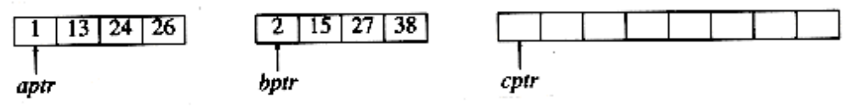

Next the element 13 from A array and element 2 from B array is compared, then the smallest element 2 from B array is copied to an output array C. Then pointers Bptr and Cptr is incremented by one. This proceeds until A array and B array are exhausted, and all the elements are copied to an output array C.
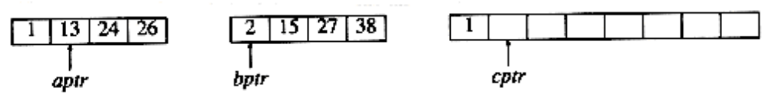
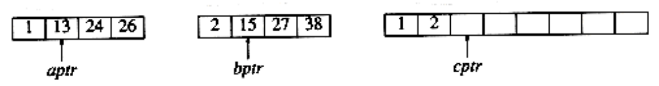

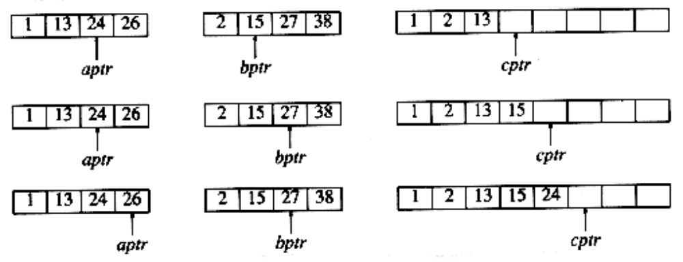

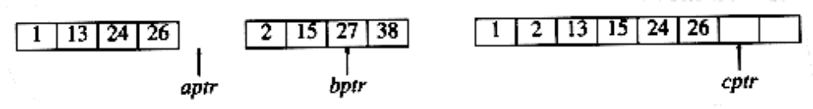
Since A array is exhausted, the remaining elements of B array is then copied to C array.

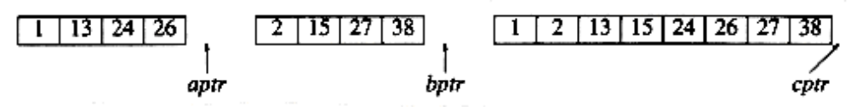

Routine for Merge sort Algorithm:

void mergesort( int A[],int temp[], int n )
{
m_sort( a, temp, 0, n-1 );
}

Void msort( int A[],int temp [ ], int left, int right )
{
int center;
if( left < right )
{
center = (left + right) / 2;
msort(A, temp, left, center );
msort( A, temp, center+1, right );
merge( A, temp, left, center+1, right );
}
}

MERGE ROUTINE
void merge(int A[], int B[], int Aptr, int Bptr, int Cptr)
{
int n,m;
int C[n+m]; //n-number of elements in A array, m-number of elements in B array
while(Aptr<n&&Bptr<m)
{
if(A[Aptr]<B[Bptr])
{
C[Cptr]=A[Aptr];
Aptr++;
Cptr++;
}
else
{
C[Cptr]=B[Bptr];
Bptr++;
Cptr++;
}
}
while(Aptr<n)
{
C[Cptr]=A[Aptr];
Aptr++; Cptr++;
}
while(Bptr<m)
{
C[Cptr]=B[Aptr];
Bptr++; Cptr++;
}
}

ANALYSIS OF MERGE SORT:
Best Case Analysis-O(N log N)
Average Case Analysis-O(N log N)
Worst Case Analysis-O(N log N)
LIMITATIONS OF MERGE SORT
- Merge sort sorts the larger amount of data making use of external storage device.
- It requires extra memory space.
ADVANTAGES:
- It has better cache performance.
- Merge sort is a stable sort.
- It is simpler to understand.

Quick Sort:
Routine for Quick sort
Void q_sort( input_type a[], int left, int right )
{
int i, j,pivot;
if( left < right )
{
pivot = left
i=left+1;
j=right;
while(i<j)
{
while( a[i] <= pivot )
i=i+1;
while( a[j] > pivot )
j=j-1;
if( i < j )
{
temp=a[i]; //swap a[i]& a[j]
a[i]=a[j];
a[j]=temp;
}
}
temp=a[pivot];
a[pivot]=a[j];
a[j]=temp;
q_sort( a, left, j-1 );
q_sort( a, j+1, right ); //recursively done for partitioned array
}
}

Example

Consider an unsorted array as follows,
45, 28, 90,1,46,39,33,87
Here Pivot=40,i=20,j=30
- The value of i is incremented till a[i]<=a[pivot] and the value of j is decremented till a[j]>a[pivot], this process is repeated until i<j.
- If a[i]>a[pivot] and a[j]<a[pivot] and also if i<j, then swap a[i] and a[j].
- If i>j then swap a[j] and a[pivot].
Once the correct location for pivot is found, then partition array into left sub array and right sub array, where left sub array contains all the elements less than the pivot and right sub array contains all the elements greater than the pivot.

45 28 90 1 46 39 33 87
pivot i j

45 28 90 1 46 39 33 87

Pivot i j //swap a[i],a[j]...,if i<j

45 28 33 1 46 39 90 87
Pivot i j

45 28 33 1 46 39 90 87 //swap a[i],a[j]...,if i<j
pivot i j

45 28 33 1 39 46 90 87
Pivot i j

45 28 33 1 39 46 90 87 //swap pivot and j
pivot j i

39 28 33 1 45 46 90 87 now split the array into two arrays(pivot to j-1)
pivot j i and (j to end)

Now, the pivot element has reached its correct position. The elements lesser than the pivot {39,28,33,1} is considered as left sub array. The elements greater than the pivot {45,46,90,87} is consider as right sub array. Then the qsort procedure is applied recursively for both these arrays. [use divide and conquer technique].

The final result is,

1 28 33 39 45 46 87 90

HASHING FUNCTIONS
A hashing function is a key-to-address transformation which acts upon a given key to compute the relative position of the key in an array. A Key can be a number, a string, a record etc.
A SIMPLE HASH FUNCTION
Hash (key value)=key_value Mod Table_size
(Or)
Hash (key value)=(key_value % Mod Table_size)
Example:
Hash (5) = 5 mod 4=1
The key value ‘5’ is placed in the relative location “1” in the hash table.
A good hash functions should
- Minimize collisions
- Be easy and quick to compute
- Distribute key values evenly in the hash table
- Use all the information provided in the key
ROUTINE FOR SIMPLE HASH FUNCTION
Hash (char *key, int Table_size)
(
Int Hashvalue = 0
While (*key 1 = ‘10’)
Hash value = Hash value + *key;
*key ++;
Return hash_value % Table_size;
}
Type declaration for open hash table

typedef struct list_node *node_ptr;
struct list_node
{
Int element;
node_ptr next;
};
typedef node_ptr LIST;
typedef node_ptr position;

/* LIST *the_list will be an array of lists, allocated later */
/* The lists will use headers, allocated later */

struct hash_tbl
{
unsigned int table_size;
LIST *the_lists;
};

Find routine for open hash table
Position find(int key, HASH_TABLE H )
{
position p;
LIST L;
L = H->the_lists[ hash( key, H->table_size) ];
p = L->next;
while( (p != NULL) && (p->element != key) )
/* Probably need strcmp!! */
p = p->next;
return p;
}

Insert routine for open hash table
Void insert(int key, HASH_TABLE H )
{
position pos, new_cell;
LIST L;
pos = find( key, H );
if( pos == NULL )
{
new_cell = (position) malloc(sizeof(struct list_node));
if( new_cell == NULL )
fatal_error("Out of space!!!");
else
{
L = H->the_lists[ hash( key, H->table size ) ];
new_cell->next = L->next;
new_cell->element = key; /* Probably need strcpy!! */
L->next = new_cell;
}
}}

Extendible hashing to resolve collision.
Amount of data is too large to fit in main memory
- Main consideration is the number of disk accesses required to get data
- Open addressing or separate chaining is used, collisions could cause several blocks to be examined
- When the table gets too full, rehashing step requires O(N) disk accesses
- Use of idea in B-Trees
- Choose of M so large that B-Tree has a depth of 1
- Problem: Branching factor is too high, requires to much time to determine which leaf the data was in
Time to perform this step is reduced

Insert the data: 000100,010100,011000,001000,100000,101000,111000,111001,101110,101110,001010,001011

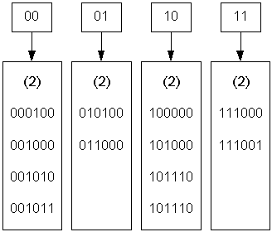
If more data to accommodate then the previous table can be extended like the below table.

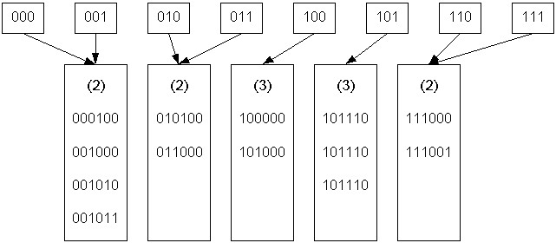
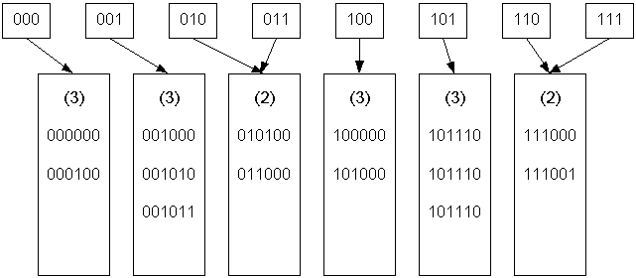

OPEN ADDRESSING
It is also called as closed hashing, which is an alternative to resolve the collisions with linked lists. In this hashing system, if the collision occurs , alternative cells are tried until an empty cells is found. i.e., cells H₀(X),H₂(x),.....are tried in succession.
There are 3 common resolution strategies, they are
1. Linear probing
2. Quadratic Probing
3. Double hashing
LINEAR PROBING
In linear probing, for the ith probe the position to be tried is in a linear function.
F(i)=i //where i is the number of times the occurrence of collision.
Hi(X)=(Hash(X)+i) mod table_size
Where, Hash(X)=key_value%table_size;
In linear probing, the position in which a key can be stored is found by sequentially searching all position starting from the position calculated by the hash function until an empty cell is found.
If the end of the table is reached and no empty cells has been found, then the search is continued from the beginning of the table. It has a tendency to create clusters in the table. Insert : 89,18,49,58,69
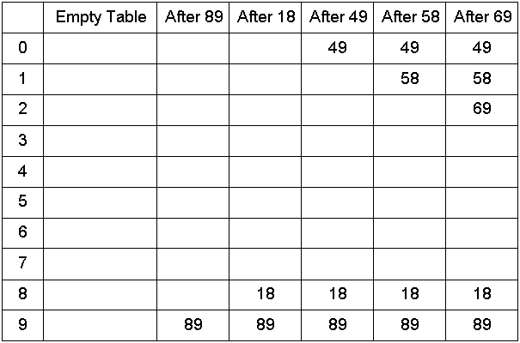
In the above example, first collision occurs when 49 is inserted, which is placed in the next available spot, namely spot 0, which is open. The next collision occurs when 69 is inserted, which is placed in the next available spot, namely spot 2. The collision is for 58 is handled in the similar manner.

Advantage:
It does not requires pointers.

Disadvantage:
It forms the clusters, which degrades the performance the hash table. For storing the retrieving data.

QUADRATIC PROBING
It is a collision resolution method that eliminates the primary clustering problem of liner probing. In quadratic probing, rather than always moving one slot, it move i² slots from the point of collision where the i is the number of attempt to resolve the collision. Insert : 89,18,49,58,69
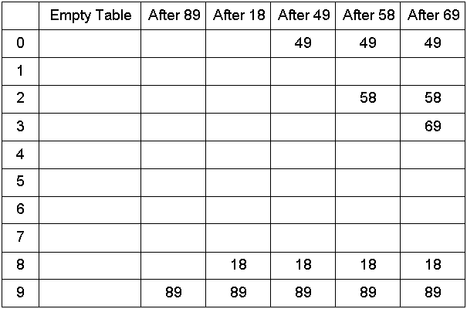

F(i)=i²
Hi(X)=(Hash(X)+i²) mod table_size
Where, Hash(X)=key_value%table_size;

Routine for quadratic probing:

int Hash (int i, int key, int table_size)
{
return ((Hash (key) + i*i) % table_size);
}

DOUBLE HASHING:
It uses the idea of applying a second hash function to the key when a collision occurs. The result of second hash function will be the number of positions from the point of collision to insert. It must never evaluate to zero.

F(i)=i*Hash(x)
Hi(X)=(Hash(X)+i*Hash₂(X)) mod table_size
Where, Hash(X)=key_value%table_size;

A popular second hash function is : Hash₂(key)=R-(key % R) where R is a prime number that is smaller than the size of table.
Insert : 89,18,49,58,69 -----using Hash₂(X)=R-(X % R) here R=7 (prime)
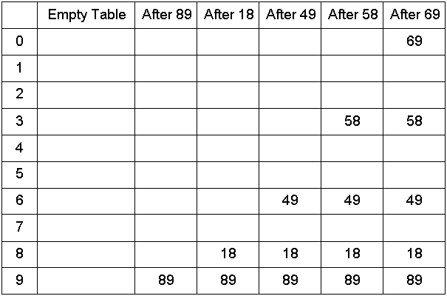

BUBBLE SORT
Bubble Sort is one of the simplest internal sorting algorithms. Bubble Sort works by comparing two consecutive elements and the largest element among these two bubbles towards right at the end of the first pass the largest element gets sorted and placed at the end of the sorted list. This process is repeated for all pairs of element gets until it moves the largest element to the end of the list in that iteration. Bubble sort consists of (n-1) passes, where ‘n’ is the number of elements to be sorted. In the 1st pass the largest element will be placed in the n^{th} position. In 2nd Pass the second largest element will be placed in the (n-1)^{th} position. In (n-1) ^{th} pass only the first two elements are compared.
Bubble sort Routine:
Void bubblesort(int a[],int n)
{
int temp,i,j;
for(i=0;i<n-1;i++)
{
for(j=0;j<n-1;j++)
{
if(a[j]>a[j+1])
{
temp=a[j];
a[j]=a[j+1];
a[j+1]=temp;
}
}
}
}

Consider an unsorted list as follows:
Pass 1: 8 3 9 5 1

3 8 9 5 1

3 8 9 5 1

3 8 5 9 1

Pass 1-Output:
3 8 5 1 9

Passes(i) of Bubble Sort:

i=0 3 8 5 1 9
i=1 3 5 1 8 9
i=2 3 1 5 8 9
i=3 1 3 5 8 9

Sorted list 1 3 5 8 9

RADIX SORT
Radix Sort is one of the linear sorting algorithm for integers. It is a generalised form of bucket sort. It can be performed using buckets from 0 to 9. It is also called as Binsort,card sort. It works by sorting the input based on each digit. In First pass, all the elements are sorted according to the least significant digit. In second pass, the elements are arranged according to the next least significant digit and so ontill the most significant digit. The number of passes in a Radix Sort depends upon the number of digits in the given numbers.
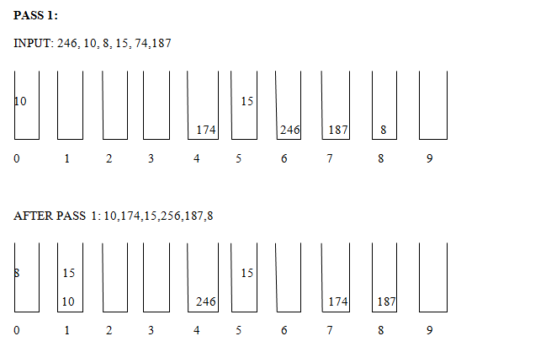
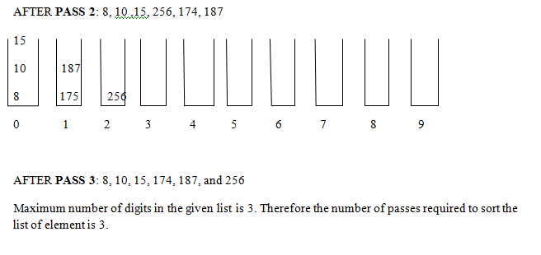
HASHING TECHNIQUES
The implementation of hash tables is frequently called hashing. Hashing is a technique used for performing insertions, deletions and finds in constant average time.

TYPES OF HASHING:
Static Hashing
In static Hashing, the hash function maps search key values to a fixed set of locations.
Dynamic Hashing
In Dynamic hashing, the hash table can grow to handle more items. The associated hash function change as the table grows.
HASH TABLE
The ideal hash table data structure is merely an array of some fixed size, containing the keys. Typically, a key is a string with an associated value (for instance, salary information).
- A hash table is portioned into array of buckets.
- Each bucket has many slots and each slot holds one record.
Location Slot 1

1
5

2

2
3
4
Hash Table
HASHING FUNCTIONS
A hashing function is a key-to-address transformation which acts upon a given key to compute the relative position of the key in an array. A Key can be a number, a string, a record etc.
A SIMPLE HASH FUNCTION
Hash (key value)=key_value Mod Table_size
(Or)
Hash (key value)=(key_value % Mod Table_size)
Example:
Hash (5) = 5 mod 4=1
The key value ‘5’ is placed in the relative location “1” in the hash table.
- OPEN HASHING (SEPARATE CHAINING)
The first strategy, commonly known as either open hashing, or separate chaining, is to keep a list of all elements that hash to the same value. For convenience, our lists have headers. To perform a find, we use the hash function to determine which list to traverse. We then traverse this list in the normal manner, returning the position where the item is found. In this method, the table can never overflow, since the linked list are only extended upon the arrival of new keys.
INSERTION
Example: Insert: 1,4,81,0,25,16,9,36,64,49
Insert 1: Hash(k)=k % Table size
Hash(1)=1%10=1
Insert 4: Hash(4)=4%10=4
Insert 81: Hash(81)=81%10=1
To perform an insert, we traverse down the appropriate list to check whether the element is already in place (if duplicates are expected, an extra field is usually kept, and this field would be incremented in the event of a match). If the element turns out to be new, it is inserted either at the front of the list or at the end of the list, whichever is easiest. This is an issue most easily addressed while the code is being written. Sometimes new elements are inserted at the front of the list, since it is convenient and also because frequently it happens that recently inserted elements are the most likely to be accessed in the near future .
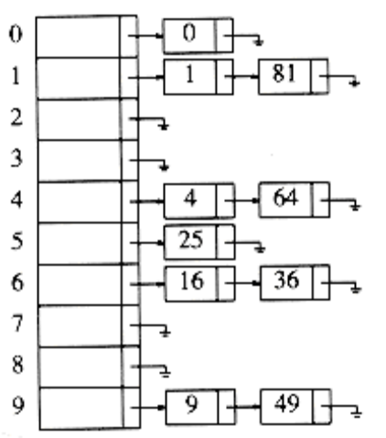

Figure 5.6 An open hash table

Type declaration for open hash table

typedef struct list_node *node_ptr;
struct list_node
{
Int element;
node_ptr next;
};
typedef node_ptr LIST;
typedef node_ptr position;

/* LIST *the_list will be an array of lists, allocated later */
/* The lists will use headers, allocated later */

struct hash_tbl
{
unsigned int table_size;
LIST *the_lists;
};

Find routine for open hash table
Position find(int key, HASH_TABLE H )
{
position p;
LIST L;
L = H->the_lists[ hash( key, H->table_size) ];
p = L->next;
while( (p != NULL) && (p->element != key) )
/* Probably need strcmp!! */
p = p->next;
return p;
}

Insert routine for open hash table
Void insert(int key, HASH_TABLE H )
{
position pos, new_cell;
LIST L;
pos = find( key, H );
if( pos == NULL )
{
new_cell = (position) malloc(sizeof(struct list_node));
if( new_cell == NULL )
fatal_error("Out of space!!!");
else
{
L = H->the_lists[ hash( key, H->table size ) ];
new_cell->next = L->next;
new_cell->element = key; /* Probably need strcpy!! */
L->next = new_cell;
}
}}

Advantage:
1.More number of elements cn be inserted as it uses array of linked lists.
2.Collision resolution is simple and efficient.
Disadvantage:
1.It requires pointers, which occupies more memory space.
2.It takes more effort to perform a search, since it takes time to evaluate the hash function and also to traverse the list.

OPEN ADDRESSING
It is also called as closed hashing, which is an alternative to resolve the collisions with linked lists. In this hashing system, if the collision occurs , alternative cells are tried until an empty cells is found. i.e., cells H₀(X),H₂(x),.....are tried in succession.
There are 3 common resolution strategies, they are
1. Linear probing
2. Quadratic Probing
3. Double hashing
LINEAR PROBING
In linear probing, for the ith probe the position to be tried is in a linear function.
F(i)=i //where i is the number of times the occurrence of collision.
Hi(X)=(Hash(X)+i) mod table_size
Where, Hash(X)=key_value%table_size;
In linear probing, the position in which a key can be stored is found by sequentially searching all position starting from the position calculated by the hash function until an empty cell is found.
If the end of the table is reached and no empty cells has been found, then the search is continued from the beginning of the table. It has a tendency to create clusters in the table. Insert : 89,18,49,58,69
In the above example, first collision occurs when 49 is inserted, which is placed in the next available spot, namely spot 0, which is open. The next collision occurs when 69 is inserted, which is placed in the next available spot, namely spot 2. The collision is for 58 is handled in the similar manner.

Advantage:
It does not requires pointers.

Disadvantage:
It forms the clusters, which degrades the performance the hash table. For storing the retrieving data.

QUADRATIC PROBING
It is a collision resolution method that eliminates the primary clustering problem of liner probing. In quadratic probing, rather than always moving one slot, it move i² slots from the point of collision where the i is the number of attempt to resolve the collision. Insert : 89,18,49,58,69

F(i)=i²
Hi(X)=(Hash(X)+i²) mod table_size
Where, Hash(X)=key_value%table_size;

Routine for quadratic probing:

int Hash (int i, int key, int table_size)
{
return ((Hash (key) + i*i) % table_size);
}

DOUBLE HASHING:
It uses the idea of applying a second hash function to the key when a collision occurs. The result of second hash function will be the number of positions from the point of collision to insert. It must never evaluate to zero.

F(i)=i*Hash(x)
Hi(X)=(Hash(X)+i*Hash₂(X)) mod table_size
Where, Hash(X)=key_value%table_size;

A popular second hash function is : Hash₂(key)=R-(key % R) where R is a prime number that is smaller than the size of table.
Insert : 89,18,49,58,69 -----using Hash₂(X)=R-(X % R) here R=7 (prime)

REHASHING:
If the table gets too full, then the rehashing method builds new table that is about twice as big and scan down the entire original hash table, computing the new hash value for each element and inserting it in the new table.
Rehashing is very expensive operation, the running time is O(N), since there are N elements to rehash and the table size is roughly 2N.
Rehashing can be implemented in several ways with quadratic probing such as,
- Rehash, as soon as the table is half full.
- Rehash only when an insertion fails
- Rehash when the table reaches a certain load factor.
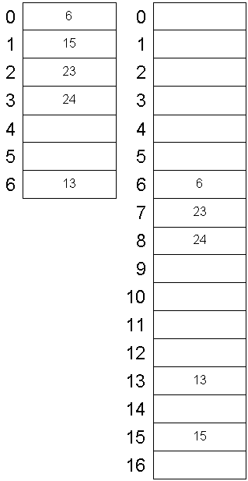

ROUTINE FOR REHASHING FOR OPEN ADDRESSING
HashTable Rehash(HashTable H)
{
int i,oldsize;
cell *oldcells;
oldcells=H->Thecells;
oldsize=H->Table_size;
H=InitializeTable(2*oldsize);
for(i=0;i<oldsize;i++)
{
if(oldcels[i].info==Legitimate)
insert(oldcells[i].Element,H);
free(oldcells);
return H;
}
BINARY SEARCH
This code implements binary search in c language. It can only be used for sorted arrays, but it's fast as compared to linear search. If you wish to use binary search on an array which is not sorted then you must sort it using some sorting technique say merge sort and then use binary search algorithm to find the desired element in the list. If the element to be searched is found then its position is printed.

int BinarySearch(int array[], int n, int key)
{
int low = 0, high = n-1, mid;
while(low <= high)
{
mid = (low + high)/2;
if(array[mid] < key)
{
low = mid + 1;
}
else if(array[mid] == key)
{
return mid;
}
else if(array[mid] > key)
{
high = mid-1;
}
}
return -1;
}

Example
The list to be searched: L = 1 3 4 6 8 9 11. The value to be found: X = 4.
Compare X to 6. It's smaller. Repeat with L = 1 3 4.
Compare X to 3. It's bigger. Repeat with L = 4.
Compare X to 4. It's equal. We're done, we found X.
ANALYSIS OF BINARY SEARCH
Best Case Analysis-O(1)
Average Case Analysis-O(log N)
Worst Case Analysis- O(log N)

