Blair_Intro_Md

Blair Thomas

2023-01-31

## **I am Blair Thomas.**

#### I am originally from Los Angeles, California.

My family now lives in Seattle, Washington. I live off campus with three of my friends with myself being the only business major in the house. I am very interested in all sorts of music. I also enjoy watching movies, specifically those released before the year 2000. Upon graduating I would like to seek a career in Project Management as the psychological aspect of managing a team of diverse people intrigues me.

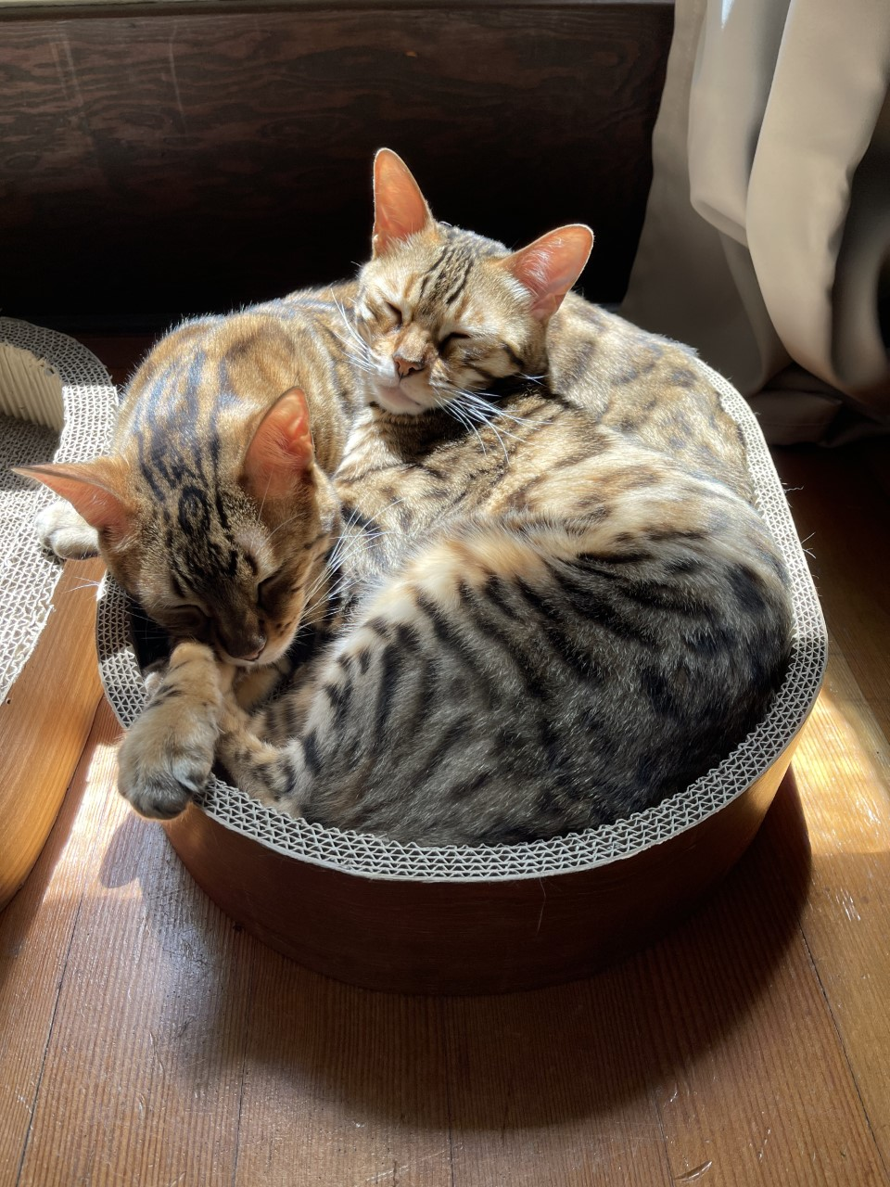

*A picture of my two cats, Elliot and Dexter*

| Seattle Restaurants I like | Favorite Dish |
| --- | --- |
| Mirch Masala | Goan Coconut Curry with Lamb |
| Fats Chicken and Waffles | Fat’s Sampler |
| Carmelo’s Tacos | Al Pastor Quesadilla |
| Pagliacci Pizza | South Philly |

[*A cat cafe in PDX I want to check out*](https://www.purringtonscatlounge.com)