Case_study1

Bthyw

9/2/2021

### Combine into a single data.frame

Divvy_Trips_2020_Q1<-Divvy_Trips_2020_Q1 %>%   
 rename(trip_id= ride_id,bikeid= rideable_type,start_time= started_at,end_time= ended_at,from_station_id= start_station_id,from_station_name= start_station_name,to_station_id=end_station_id,to_station_name= end_station_name, usertype=member_casual)  
Divvy_Trips_2020_Q1<-Divvy_Trips_2020_Q1 %>%   
 select(-c(start_lat,start_lng,end_lat,end_lng))  
  
Divvy_Trips_2019<- rbind(Divvy_Trips_2019_Q3,Divvy_Trips_2019_Q4)  
Divvy_Trips_2019<-Divvy_Trips_2019 %>%   
 select(-c(gender,birthyear,tripduration))  
all_trips<-rbind(Divvy_Trips_2019,Divvy_Trips_2020_Q1)

all_trips$from_station_id<-as.character(all_trips$from_station_id)  
all_trips$to_station_id<-as.character(all_trips$to_station_id)  
  
all_trips$usertype<-all_trips$usertype %>%   
 recode("casual"="Customer","member"="Subscriber")

### Time interval

all_trips$date<-as.Date(all_trips$start_time)  
all_trips$day<-format(as.Date(all_trips$date),"%d")  
all_trips$month<-format(as.Date(all_trips$date),"%m")  
all_trips$year<-format(as.Date(all_trips$date),"%Y")  
  
all_trips$day_of_week<-format(as.Date(all_trips$date),"%A")  
  
all_trips$ride_length<-difftime(all_trips$end_time,all_trips$start_time)  
all_trips$ride_length<-as.numeric(as.character(all_trips$ride_length))

### Oversee data trends by using table

all_trips$day_of_week<-ordered(all_trips$day_of_week,levels=c("Sunday","Monday","Tuesday","Wednesday","Thursday","Friday","Saturday"))  
#all_trips$year<-ordered(all_trips$year,levels=c("2019","2020"))  
aggregate(all_trips$ride_length~all_trips$usertype+all_trips$day_of_week,FUN = mean)

## all_trips$usertype all_trips$day_of_week all_trips$ride_length  
## 1 Customer Sunday 3871.6677  
## 2 Subscriber Sunday 910.7714  
## 3 Customer Monday 3577.4999  
## 4 Subscriber Monday 843.2026  
## 5 Customer Tuesday 3832.1473  
## 6 Subscriber Tuesday 837.5502  
## 7 Customer Wednesday 3964.5198  
## 8 Subscriber Wednesday 822.4797  
## 9 Customer Thursday 3895.5877  
## 10 Subscriber Thursday 824.2099  
## 11 Customer Friday 4144.4606  
## 12 Subscriber Friday 823.7175  
## 13 Customer Saturday 3460.4535  
## 14 Subscriber Saturday 991.1996

### Analyze ridership data by type and weekday

all_trips<-all_trips %>%   
 mutate(weekday=wday(start_time,label = TRUE)) %>%   
 group_by(weekday,usertype) %>% #then cal the number of rides&average time duration  
 summarise(number_ride=n(),average_duration=mean(ride_length)) %>%   
 arrange(usertype,weekday)

## `summarise()` has grouped output by 'weekday'. You can override using the `.groups` argument.

### Visualize the number of rides by rider type

ggplot(data = all_trips,mapping = aes(x=weekday,y=number_ride,fill=usertype))+  
 geom_col(position = "dodge")

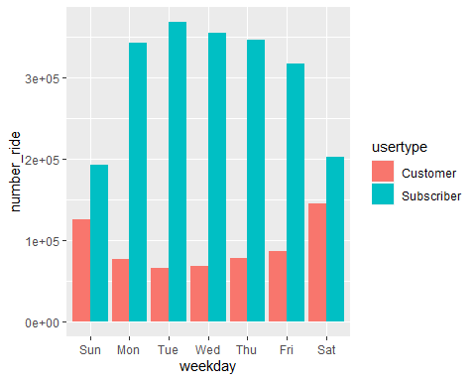 ### Visualize the average duration

ggplot(data = all_trips,mapping = aes(x=weekday,y=average_duration,fill=usertype))+  
 geom_col(position = "dodge")

