**GROUP PROJECT REPORT**

**PROBABILITY AND STATISTICS**

**ANALYSIS OF THE EFFECT OF COFFEE CONSUMPTION ON STUDENT ACADEMIC PERFORMANCE**



Christopher Abie Diaz Doviano (NIM: 00000067692)

Ray Anthony Pranoto (NIM: 00000066655)

Nicholas Alven Gandra (NIM: 00000066511)

**FACULTY OF ENGINEERING AND INFORMATICS**

**INFORMATION SYSTEM STUDY PROGRAM**

**NUSANTARA MULTIMEDIA UNIVERSITY**

**2022**

**RESEARCH TOPIC**

ANALYSIS OF THE EFFECT OF COFFEE CONSUMPTION ON STUDENT ACADEMIC PERFORMANCE

**RESEARCH TOPIC DESCRIPTION**

Coffee is one of the largest agricultural commodities in Indonesia. Coffee is considered to be a tradition and lifestyle for Indonesians. Coffee that is roasted until dark brown, then ground into coffee powder, and brewed is a drink that is often favored by most Indonesian people. Besides having a distinctive and aromatic taste, coffee also contains caffeine in it. This caffeine has various benefits such as being able to awaken concentration, maintain focus and stamina, and improve memory/memory (Br Ginting et al., 2022). In fact, caffeine in coffee can prevent diabetes and stroke with the right dose (Sicca, 2022).

Along with the times, coffee drinks are increasingly widely known, so they are famous among young Indonesians, especially students. Through this phenomenon, the term "coffee" is more often used. Coffee is the choice of students because of its benefits that can help them in carrying out every activity, be it academic or non-academic. Along with the increasing status of coffee, now there are lots of modern coffee shops that have provided various types of coffee to accompany their customers, from the type of serving*espresso* pure, to serving coffee mixed with various other additional products such as milk, cream, and others.

In this study, according to the phenomenon described earlier, the researcher wanted to test how much influence coffee has on student performance in pursuing their education level in college. The population of this study are active students who are on the Multimedia Nusantara University campus. Through this population, the sample will be aimed at students who have an interest in/have ever consumed coffee. Samples were taken using a questionnaire/survey using the technique*simple random sampling*. The focus of this research is to conclude whether coffee is effective in student academic sustainability.

# **CHAPTER I**

# **INTRODUCTION**

## Background

Coffee is widely known in the world, and has even become one of the most popular drinks in Indonesian society. Coffee in Indonesia originates from commodities brought by the Dutch during Indonesian colonialism, grown in lowland to mountainous tropical lands, which serve Robusta and Arabica coffees respectively. Until now, consuming coffee has become a common thing and is commonly practiced by Indonesian people. According to Ridder (2022), data on coffee consumption in Indonesia last year ranked fourth in the world after Colombia. This shows that coffee has a significant influence in the daily lives of Indonesian people. Not only that, coffee is also the most popular drink among students, especially in the college environment. College students are one of the groups that is highly influenced by coffee consumption, both in terms of health and academic activities.

The level of coffee consumption in Indonesia itself has increased 4-fold since its last year, namely 1990, with a total of 4.8 million sacks per 60 kilograms. This surge was influenced by the transition from tea to coffee consumption by most of the younger generation (Suharto, 2022). This much-discussed drink can now easily be obtained through outlets *coffee shop* nearest Equal to *trend* "coffee" among young people, the reason behind the ease of getting coffee is because more and more coffee shops have appeared in various places in Indonesia. Referring to toffin.id (2020), in 2019 coffee shops in Indonesia experienced a rapid increase, three times as many. The number of outlets in 2019 was 2,950, compared to the previous 3 years, namely in 2016 there were only around 1,000 outlets.

Therefore, research on "The Effect of Coffee Consumption on Student Academic Performance" is a research topic that researchers raise. This research is expected to provide a better understanding of the effect of coffee on student academic activities, and can provide useful recommendations for students.

## Problem Formulation

Based on the background that has been described previously, the formulation of the problem can be stated as follows:

1. How big is the influence of coffee consumption on the level of concentration and focus of students?
2. How often do students consume coffee and is the frequency of this consumption different?
3. Does the presence of coffee affect performance in achieving student academic achievement?
4. How big is the influence of coffee consumption on the academic achievement of students with different characteristics (such as gender, age, and major)?

## Research purposes

The purpose of this research:

1. Knowing how much influence coffee consumption has on the level of concentration and focus of students in each major.
2. Knowing the frequency of coffee consumption in college students and the level of this consumption frequency is different in each department.
3. Knowing whether coffee consumption affects performance in achieving student academic achievement.
4. Knowing the effect of coffee consumption on student academic achievement with different characteristics (such as gender, age, and major).

## Benefits of research

The benefits of this research are as follows:

1. Academically

This research is expected to contribute to the development of science, especially in the field of psychology. The results of this study can be used as a reference for academics who need to develop research on the effect of coffee on concentration and focus in students.

1. Theoretically

This research is expected to provide a new understanding of the effect of coffee on students' concentration and focus and the factors that influence it.

1. Practically

This research is expected to provide benefits for students, lecturers, and also universities in the use of coffee as a means of academic support. By knowing the effect and also the right frequency of coffee consumption, students can increase their concentration and productivity in studying and can increase their academic grades. In addition, this research can also provide benefits for industries working in the coffee sector, they can identify and develop products that are more suitable for students

# **BAB II**

# **THEORETICAL BASIS**

## Coffee

### Definition of Coffee

Coffee is a type of beverage that comes from the processing of coffee plant seeds. Coffee is classified into the Rubiaceae family with the genus Coffea. In general, coffee only has two species, namely Coffea arabica and Coffea robusta (Saputra E., 2008). Coffee can be classified as a psychostimulant drink that will keep people awake, reduce fatigue, and provide physiological effects in the form of increased energy (Bhara L.A.M., 2005).

### According to the members

According to Siswanto (2019), coffee is a beverage produced from roasted and ground coffee beans. Coffee contains caffeine, which can affect the central nervous system, resulting in a stimulant effect on the human body. According to Soetarno, et al. (2018), coffee is a beverage produced from coffee beans that have been processed and brewed with hot water. The coffee beans used come from two types of plants, namely Coffea arabica and Coffea robusta. According to Suhardi, et al. (2010), coffee is a drink brewed from processed coffee beans. The coffee beans used come from the coffee plant (Coffea sp.).

### Types of Coffee Types

#### Arabica (Coffee Arabica)

Arabica coffee is a type of coffee that comes from the Arabica coffee plant. Arabica coffee grows in mountainous areas which are at an altitude of approximately 600-2000 meters above sea level and this Arabica coffee plant requires a cool climate and has high rainfall. The shape of this coffee bean is oval in shape. This coffee includes coffee that is often traded around the world and this coffee is often enjoyed by the average person who wants to consume coffee.

#### Robusta

Robusta coffee is a type of coffee that comes from species*Coffea canephora.* The taste of Robusta coffee tends to have a more bitter taste compared to Arabica coffee. The reason why Robusta coffee is bitter is because the caffeine content in this coffee has a higher level compared to other coffees. Robusta coffee is generally used in coffee and instant coffee mixes for example Goodday coffee, Kapal Api, Luwak, etc. On average, the largest producer of Robusta coffee beans in the world is Vietnam.

#### Mongoose

Kopi Luwak is a type of coffee where the civet eats the coffee beans and then produces coffee beans from the civet's feces. The process is carried out with the aim of improving the taste quality of the coffee. Because civet coffee goes through a process that is not easy, civet coffee has a very high price and limited production quantities.

#### Crash

Is one type of coffee that is popular in Indonesia. Tubruk coffee is a traditional Indonesian coffee that can be found in various regions. Tubruk has the meaning of the word "break through" which means to penetrate or break, which from this meaning means simple coffee making. The way to make Tubruk coffee is that the coffee beans are roasted and then mixed with hot water and brewed without being separated so that the coffee beans will be mixed with water and the texture of the coffee is thick and thick. The taste of brewed coffee has a high level of caffeine so it has a bitter taste.

#### Latte

Latte is a type of coffee that is the result of a mixture of espresso and steamed milk. In a mixture of coffee and milk, the average person uses a ratio of 1:3 or 1:5 depending on personal preference. Latte generally includes a modern coffee because the presentation of the coffee is mixed with milk and there are also some coffee restaurants that add syrup or sugar so that the taste is not pure from coffee beans.

#### Macchiato

Macchiato coffee is a type of coffee which is the result of a mixture of espresso and milk foam which is located at the top. The meaning of the word "Macchiato" is taken from Italian which means "scratches/stains" so this drink is an espresso drink that is scribbled on with foam milk. Macchiato itself has 2 types, namely "Espresso Macchiato" which has a higher ratio of espresso than foam milk and "latte macchiato" which has a higher level of foam milk than espresso.

#### Espresso

Espresso coffee is a type of coffee that is brewed under high pressure and also the process of smoothing the beans is fast. The purpose of the process is to extract the oils and flavors in the ground coffee beans. Espresso is generally used as a coffee mixer for modern coffees, for example, cappuccino, Americano, and latte.

#### Cold Brew

Cold Brew is a type of coffee that is processed by soaking coffee grounds in cold water for a long time, ranging from 12 to 24 hours. This process is carried out to get a soft and sour taste so that the taste of the coffee is more pleasing to the mouth than other coffees.

### Benefits of Coffee

Increase concentration and focus: Caffeine in coffee can help increase concentration and focus, so it can help increase productivity and performance, then Reduce the risk of developing degenerative diseases: Coffee contains strong antioxidant compounds, which can help protect cells from damage caused by free radicals, and reduces the risk of developing degenerative diseases such as Alzheimer's and Parkinson's, also Lowers the risk of developing cancer: Several studies have shown that regular consumption of coffee may help reduce the risk of developing several types of cancer such as liver, pancreatic and colon cancer.

### Coffee impact

Coffee consumption must be maintained within reasonable limits. Caffeine in coffee can cause several side effects such as insomnia, anxiety, and increased heart rate if consumed in excessive amounts.

## Academic

### Definition of Academic

Academic is a field that studies a curriculum that is included in its function to increase knowledge in terms of education and is managed by an institution.

### Academic Influence on Students

Academic Education has an important role in the course of students because it is very influential in providing knowledge, skills and it is very likely that they will become successful people in the future such as providing opportunities to learn, improve skills, increase career opportunities, increase work experience and can also increase self-confidence in students, but academic influences can also have a negative impact on students, namely learning that becomes stressful, fatigue and also emotional and social pressure and it becomes important for students to be able to provide balance in their lives where they study and play.

## *Google Form*

### Understanding*Google Form*

*Google Form* is a service that makes it easy for users to conduct surveys. This online-based form is based on questions or questionnaires that can be customized by the creators.*Google Form* is an effective and practical service in obtaining certain information.

### Advantages and Disadvantages of*Google Form*

Advantage :

* *Google form* has a free service, which can be accessed by anyone without being charged by Google
* *Google form* has features that are very easy to use and can be accessed from anywhere by only needing the internet
* Has very flexible customization where users can customize the form they want to give to responders
* Data generated from*Google Form* can be saved automatically by Google Sheets
* Questionnaires given to respondents can be easily shared such as by e-mail, links for users

Weakness :

* *Google Form* has the downside of not having features for paid surveys or any other tool
* The users do not have freedom in designing and increasing creativity
* *Google Form* have a limited number of respondents on one form
* *Google Form* not always secure and very vulnerable to hackers and spam

# **CHAPTER III**

# **METHODOLOGY**

## Research methods

The method used in this study focuses on descriptive quantitative research. According to Creswell (in Kusumastuti et al., 2020: 3, 40) states that the quantitative research method is an approach that uses variable measurements with research instruments to examine relationships between variables. The data collected is in the form of numbers and analyzed using statistical procedures. On the other hand, descriptive quantitative research is a method that systematically describes important events and focuses on factual data. In this research method, variables are measured with research instruments and analyzed using relevant statistical procedures.

Descriptive quantitative research methods provide a factual and systematic description of the events studied, helping researchers understand the relationships between variables and identify patterns or trends in numerical data. In addition, descriptive quantitative research also provides a strong basis for further research development by formulating more specific research questions and formulating hypotheses that can be tested with other quantitative research methods.

### Independent Variable

Independent variables or independent variables are variables that affect (or are suspected of influencing) the dependent variable being studied and included in the research design so that its effect can be determined. These variables are sometimes called experimental variables or treatment variables (Fraenkel, 2012). The independent variables in this study include gender, age, frequency of coffee consumption, etc.

### Dependent Variable

According to Fraenkel (2012), the dependent variable "depends" on what the independent variables do to it, how the independent variables affect it. For example, a researcher studying the relationship between childhood success in mathematics and adult career choice would likely call the former the independent variable and subsequent career choice the dependent variable. Various variables to support this research are the level of achievement or satisfaction of students' academic results after consuming coffee.

## Method of collecting data

In this study, the use of primary data sources became the main focus and secondary data sources became validation instruments for the research conducted by the researchers. Primary data means data obtained directly without involving third parties, while secondary data is information or data obtained not through direct observation, but comes from the results of research conducted by previous researchers. Secondary data sources can be books and original primary reports contained in scientific publications or journal articles. Secondary data also includes information or data obtained from pre-existing sources, such as scientific journals, reference books, or statistical data from related institutions as stated by Jannah et al., (2023, 328).

According to Kusumastuti et al., (2020, 4), a questionnaire is a medium used in research to collect data through a series of predetermined questions with a standard structure. In carrying out the survey using a questionnaire, the researcher did not manipulate the research conditions, so that the data obtained could reflect the actual situation of the respondents involved. Researchers use primary data through surveys as a source of data to support analysis. Primary data collected using techniques*simple random sampling* withinvolves filling out questionnaires by a number of respondents who are active students at Multimedia Nusantara University. The questionnaire was carried out through*Google Form* which is spread evenly*online* through*group chat* like*Line, Whatsapp,* dll. The researcher chose the simple random sampling technique as the sampling method because of its practicality in terms of time and energy efficiency. Researchers decided to use the media*Google Form* Becauseenabling researchers to efficiently deliver online questionnaires to respondents, overcome geographic limitations, and speed up the data collection process. With a combination of techniques*simple random sampling* and media consumption*Google Form*, researchers can optimize the use of time and resources in this study.

In order to validate the findings and strengthen the arguments, the researchers used secondary data obtained from a research journal entitled "Relationship of Coffee Consumption to the Chance of Passing PSSKPD Student Block Exams Batch 2017 Faculty of Medicine, Udayana University" written by Dharmadi et al. in 2021. The reason the researcher chose the research journal is because the journal has relevance and similarities to the research being conducted by the researcher. In addition, the journal also provides raw data that can be used as a form of testing and verification of the research hypothesis. By using data from these journals, researchers can combine findings from previous research with findings from their own research, thus providing more strength and validity to the resulting arguments and conclusions. The use of secondary data from this research journal can also provide a solid framework and a stronger foundation for this research.

## Data Processing Methods

The data processing method in this study will adopt a holistic scientific approach, using inferential statistical methods as the main method and descriptive statistics as a supporting method. This approach was chosen because it provides a broad ability to dig up in-depth information and provide comprehensive answers regarding the effect of coffee consumption on student academic performance.

Inferential statistical methods will be the main basis in the analysis of this research data. This method will be used to test hypotheses and make generalizations based on a representative sample taken from the student population. By applying inferential analysis techniques such as hypothesis testing and regression analysis, this study aims to explore and reveal a more complex relationship between coffee consumption and student academic performance (Sugiyono, 2018: 3).

In addition, descriptive statistical methods will also be used as an initial approach in processing this research data. By using descriptive statistics, this study will provide a more in-depth description of the characteristics of the data collected. Through statistical analysis of average, variation, and distribution of data, the author was able to obtain a rich initial understanding of the profile of coffee consumption and student academic performance descriptively.

The combination of these two methods will provide a strong approach in processing this research data. Inferential statistical methods will be used to examine the complex relationship between coffee consumption and student academic performance, while descriptive statistical methods will provide an in-depth understanding of the characteristics of the observed data. By integrating these two methods, the author can obtain a comprehensive analysis and reliable conclusions from this research (Sugiyono, 2018: 3).

### Hypothesis Testing Techniques

#### Anova *(Analysis of Variance)*

The Anova test is a form of statistical hypothesis testing in which the writer draws conclusions based on inferential statistical data or groups. The null hypothesis of the Anova test is that the data are simply random from the same population so that they have the same mean and expected variance (Marpaung, 2017). ANOVA is widely used to analyze research data from various fields, both those carried out through experiments and surveys. This analysis is classified as a parametric analysis, so it requires fulfilling the assumption of normality of the data. In addition, the observed response variables must be quantitative with interval and ratio measurement scales (Kim, 2017). The Anova test is divided into two parts, namely One-Way Anova and Two-Way Anova.

To carry out the One-Way Anova test, there are steps to carry out the analysis, namely:

1. Checking the assumptions of Anova
2. Doing the average similarity hypothesis test

If the mean is the same, then it can be concluded that there is no significant difference in average. However, if there is one difference, there can be two possibilities, namely the same sample size (Tukey HSD) and different sample sizes (Tukey-Kramer). In order to test Anova, there are several assumptions that must be met

1. Numerical data must follow a Gaussian distribution
2. The variances of all populations are more or less the same.

To check the assumptions of ANOVA, you can use it in two ways, namely to check the assumptions of normality using the Q-Q plot (graph) and the Shapiro-Wilk and Anderson-Darling normality tests (formal), to check the assumptions of equality of variance using the boxplot (graph) and tests. variant Levene (formal). There are 3 formulas used for one-way Anova testing, namely SST (sum of squared), SSC (sum of squared columns), SSE (sum of squared errors).



SST = total number of squares

SSC = sum of squared columns

SSE = sum of squared errors

i = particular member of a treatment level

j = a treatment level

C = number of treatment levels

nj  = number of observations in a given treatment level

x(with the top line) don't know how to make it = grand mean

xj  (with the top line) don't know how to make it = mean of a treatment group or level

xij = individual value

Two-way ANOVA is used to perform an average comparison between two categorical factors that differ from one another. These two factors are independent factors, where the author wants to know whether there is a significant difference between the two factors with the independent variables (Renan P. Souza, 2020)

Based on (Afgani, M. W., 2020) To carry out the Two-Way Anova test, there are steps for carrying out the analysis, namely:

1. Identify the value of t (*number of treatments*) and the value of r (number of blocks)
2. Do n calculations (*total observation*)
3. Perform SS calculations (*sum of square*) namely SST, SSC, SSE (which has been discussed in the one-way Anova formula
4. Perform MS calculations (*mean square*)
5. Perform calculations F arithmetic
6. Interesting conclusion

Based on Yigit (2018), the two-way ANOVA formula is as follows:





σμ = standard deviation of the population mean

σ = Combined standard deviation

μi = i. Population average

μ = mean of the population mean

K = Comparing the number of populations

#### Pearson & Spearman

Pearson's correlation coefficient in statistical analysis is used to measure the degree of one-way linear relationship or with two continuous variables whose coefficient values ​​range from -1 to +1, with a similar interpretation. While Spearman is used to measure the relationship between monotonic and two variables whose relationship is not necessarily linear. Spearman's correlation coefficient is based on rank rather than actual value, and ranges from -1 to +1 with the same interpretation as Pearson's.

#### Wilcoxon & Mann-Whitney

The Wilcoxon data processing technique is used to test a condition or variable, on paired samples or used for before and after research, usually this Wilcoxon test is carried out on a larger search and is very similar to the enhanced Sign Test on the Wilcoxon Test as an example in journals that the author will show ((Dedy Rudianto, Nabila Nurita Putri, Muhammad Said, Jenika Maulina Anjani, Febi Erliyani, Triyani Muliawati, 2020)), that is, if the paired sample is greater than 25 then the distribution is calculated by approaching the normal distribution.

The Mann-Whitney data processing technique is a nonparametric test that is used to find out the differences in data that are paired with each other but are not normally distributed and there are also conditions used in research using the Mann-Whitney test as in (Rizky Normalia, 2022).

The requirements needed in processing the Mann-Whitney Test data according to Normelia (2022) are as follows:

* The data used must meet the requirements of the t test
* Has a normal value on the data normality test
* Don't always need assumptions when you want to get general conclusions



#### Chi-Square

Chi-square statistics are statistics analyzing selected parts of their data. Chi-square statistics are used under certain conditions, not t-tests or analysis of variance (ANOVA). Chi-squared is a nonparametric statistic, which I will explain in more detail. I will also discuss the rationale behind using the chi-square statistic (Mumba & Kraemer, 2019).

The chi-square statistic is used when variables are measured at nominal (also called categorical) levels. With nominal data, each category is mutually exclusive. This data can be seen as a basket, with each part of the data in only one basket (Connelly, L., 2019).

According to (Negara, I.C., & Prabowo, A., 2018) there are various requirements before conducting a test using Chi-Square.

1. There is no cell with a frequency value*Actual Count* (F0) of 0
2. If the form of a 2 x 2 contingency table then in that contingency you cannot use only 1 cell that has*actual Count*
3. If the form of the above table is 2 x 2 then the number of cells with frequency values*Actual Count* which is less than 5 cannot have a value of more than 20%

So that when these conditions are met, the Chi Square test can be formulated as stated by Negara, I.C., & Prabowo, A. (2018) from the formula above so that the writer can arrange the steps in the Chi-Square test:

1. Doing the formulation of the hypothesis H0 and H1

H0 : there is no significant effect between the two variables

H1 : there is a significant influence between the two variables

1. Finding the expected frequency value /*Actual Count* (No)

The formula is:

1. Calculates the Chi-Square distribution

χ 2 = Chi-square distribution

Oi = Value of the i-th observation

Ei = Expected value i-th

1. Determine the significance level (Ei)
2. Specifies the value from table X2
3. Significance rate (α) = 0.05
4. d.f = (Number of rows – 1) (Number of columns – 1)
5. Determine the criteria of the test

If χ2 count χ2 table, then H0 = Accepted

If χ2 count > χ2 table, then H0 = Rejected

If Sig. ≥ 0.05 then H0 = Accepted

If Sig. < 0.05 then H0 = Rejected

1. Comparing X2 count with X2 table with α decision H0 whether rejected or accepted
2. Making conclusions that aim to find out whether there is influence between variables.

### hypothesis

#### hypothesis I

H0 = There are differences in interest in coffee based on gender.

Ha = There is no difference in interest in coffee based on gender

Method = Anova*(Analysis of Variance)*

#### hypothesis II

H0 = There is a difference in the average spending on each coffee purchase based on the major.

Ha = There is no difference between the average spending on each purchase of coffee in a particular department.

Method = Anova*(Analysis of Variance) test*

#### hypothesis III

H0 = There is a linear relationship between age and the frequency of coffee consumption in a week.

Ha = There is no linear relationship between current age and the frequency of coffee consumption in a week.

Metode = Pearson & Spearman *correlation*

#### Hypothesis IV

H0 = There is a linear relationship between the age at which coffee is consumed and interest in coffee.

Ha = There is a non-linear relationship between the age at which coffee is consumed and interest in coffee.

Metode = Pearson & Spearman *correlation*

#### Hypothesis V

Ha = There is a difference in interest in coffee between those who feel more productive in their studies after consuming coffee and those who do not feel more productive.

H0 = There is no difference in interest in coffee between those who feel more productive in learning after consuming coffee and those who do not feel more productive.

Metode = Wilcoxon & Mann-Whitney *test*

#### Hypothesis VI

H0 = There is a difference in interest in coffee between those who regularly consume coffee and those who don't regularly.

Ha = There is no difference in interest in coffee for those who regularly consume coffee and those who don't.

Metode = Wilcoxon & Mann-Whitney *test.*

#### Hypothesis VII

H0 = There is a relationship between gender and satisfaction with academic results after consuming coffee.

Ha = There is no significant relationship between gender and satisfaction with academic results after consuming coffee.

Metode = Chi Square Goodness of *fit test (One-way Contingency Table)*

#### Hypothesis VIII

H0 = There is a relationship between interest in coffee and satisfaction with academic results after consuming coffee.

Ha = There is no relationship between interest in coffee and satisfaction with academic results after consuming coffee.

Metode = Chi Square Goodness of *fit test (One-way Contingency Table)*

### Hypothesis Assumptions

1. Hypothesis I

There are differences in interest in coffee based on gender

1. Hypothesis II

There are differences in the average spend on each coffee purchase by major.

1. Hypothesis III

There is a linear relationship between age and the frequency of coffee consumption in a week

1. Hypothesis IV

There is a linear relationship between the age at which coffee is consumed and interest in coffee.

1. Hypothesis V

There is a difference in interest in coffee between those who feel more productive in their studies after consuming coffee and those who do not feel more productive.

1. Hypothesis VI

There is a difference in interest in coffee between those who regularly consume coffee and those who don't regularly.

1. Hypothesis VII

There is a relationship between gender and satisfaction with academic results after consuming coffee.

1. Hypothesis VIII

There is a relationship between interest in coffee and satisfaction with academic results after consuming coffee.

## Research Instruments

Writer use*google form* as a research instrument directly to students as a form of one way to obtain data from various respondents. In the questionnaire that the author made there were 9 questions with the following details:

| No | Question | Reference |
| --- | --- | --- |
| 1 | How old are you now? | Puspita, B., & Fitriani, A. (2021). The Role of Coffee Consumption on Hypertension in Men of Productive Age (18-65 Years). Muhammadiyah Journal of Nutrition and Food Science (MJNF), 2(1), 13-23. |
| 2 | How big is your passion for coffee? | Dharmadi, N. A., Purnawati, S., & Adiputra, L. I. (2021). The Relationship between Coffee Consumption and the Chance of Passing the 2017 PSSKPD Student Block Exam, Faculty of Medicine, Udayana University. Udayana Medical Journal, 10(2), 21-26. |
| 3 | How many times do you consume coffee in a week? | Hitarini, A.A. (2018). THE RELATIONSHIP OF COFFEE DRINKING HABITS AND PHYSICAL FITNESS WITH EMPLOYEE PRODUCTIVITY AT UD. ELBA TAILOR & TEXTILE (Doctoral dissertation, DEPARTMENT OF NUTRITION). |
| 4 | What is your average production on each purchase of 1 coffee? | Hanipradja, R. S. A., Rasmikayati, E., & Saefudin, B. R. (2022). COFFEE CONSUMER BEHAVIOR IN THE COVID-19 PANDEMI. Journal of Agribusiness-Insighted Scientific Community Thought, 8(2), 1338-1356. |
| 5. | Do you feel more productive in your studies after consuming coffee? | Kamimori, G. H., Karyekar, C. S., Otterstetter, R., Cox, D. S., Balkin, T. J., Belenky, G. L., & Eddington, N. D. (2002). The rate of absorption and relative bioavailability of caffeine administered in chewing gum versus capsules to normal healthy volunteers. International Journal of Pharmaceutics, 234(1-2), 159-167. |
| 6 | Can you regularly consume coffee increase your academic grades? | Stachyshyn, S. (2017). Caffeine consumption habits, motivations, and experiences of New Zealand tertiary students: a thesis presented in partial fulfillment of the requirements for the degree of Master of Science in Nutrition and Dietetics at Massey University, Albany, New Zealand (Doctoral dissertation, Massey University). |
| 7 | How much effect does drinking coffee have on your concentration while studying or during exams? | Widyadari, P. S., Sutjana, I. D. P., & Dinata, I. M. K. (2021). Giving caffeine can increase the concentration of Udayana University Faculty of Medicine students. Udayana Medical E-Journal, 10(4), 102-105. |
| 8 | At what age did you start consuming coffee frequently? | Puspita, B., & Fitriani, A. (2021). The Role of Coffee Consumption on Hypertension in Men of Productive Age (18-65 Years). Muhammadiyah Journal of Nutrition and Food Science (MJNF), 2(1), 13-23. |
| 9 | Are you satisfied with your academic results after consuming coffee? | Erika, N.A. (2023). THE RELATIONSHIP BETWEEN ACADEMIC STRESS AND COFFEE DRINKING HABITS WITH INSOMNIA TRENDS IN FINAL SEMESTER STUDENTS (Doctoral dissertation, UIN Raden Intan Lampung). |

# **CHAPTER IV**

# **RESULTS AND ANALYSIS**

## **Survey Results**

**Part 1**

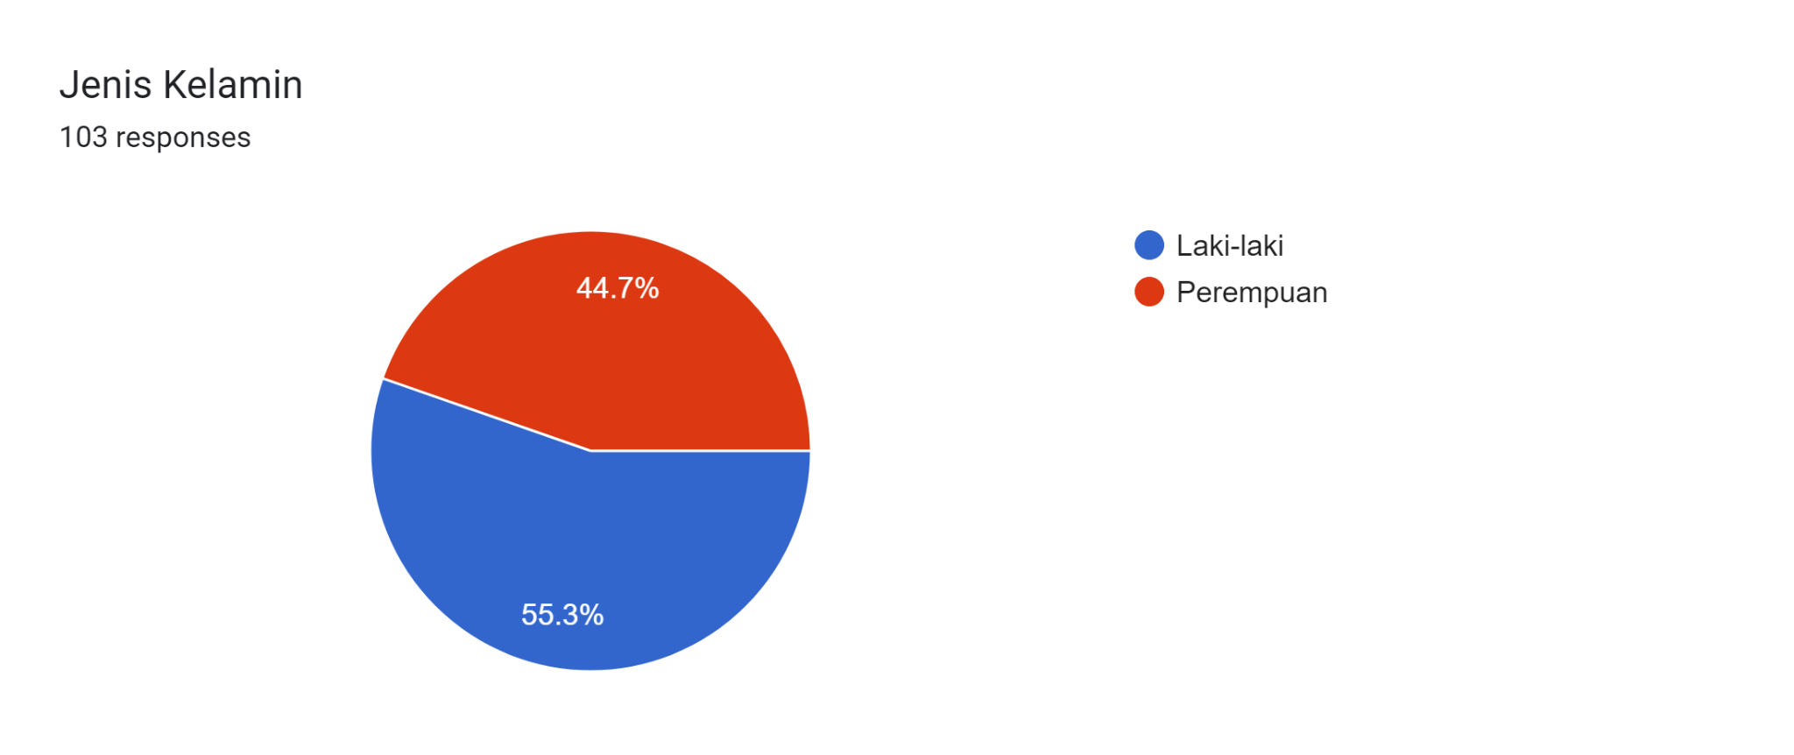

The survey results above show that of the number of respondents, namely as many as 103, as many as 55.3% or the equivalent of 57 people of male sex and as many as 44.7% or the equivalent of 46 people of female sex, in this writer can conclude that the fillers of respondents for this form dominated by men with a difference of 10.6%.

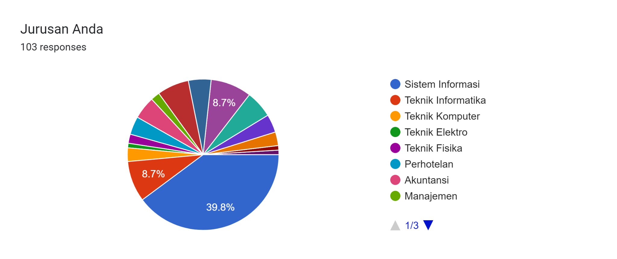

The survey results above show how many majors filled out the largest respondents to this survey question, namely Information Systems with 39.8% equivalent to 41 people and followed by other majors such as Informatics Engineering and Engineering Physics having the same percentage of 8.7% or the equivalent of 9 people and the writer can conclude that the department that dominates in filling out the writer's respondents is the Information Systems major and is followed by a fairly large percentage, namely Informatics Engineering and Physics Engineering

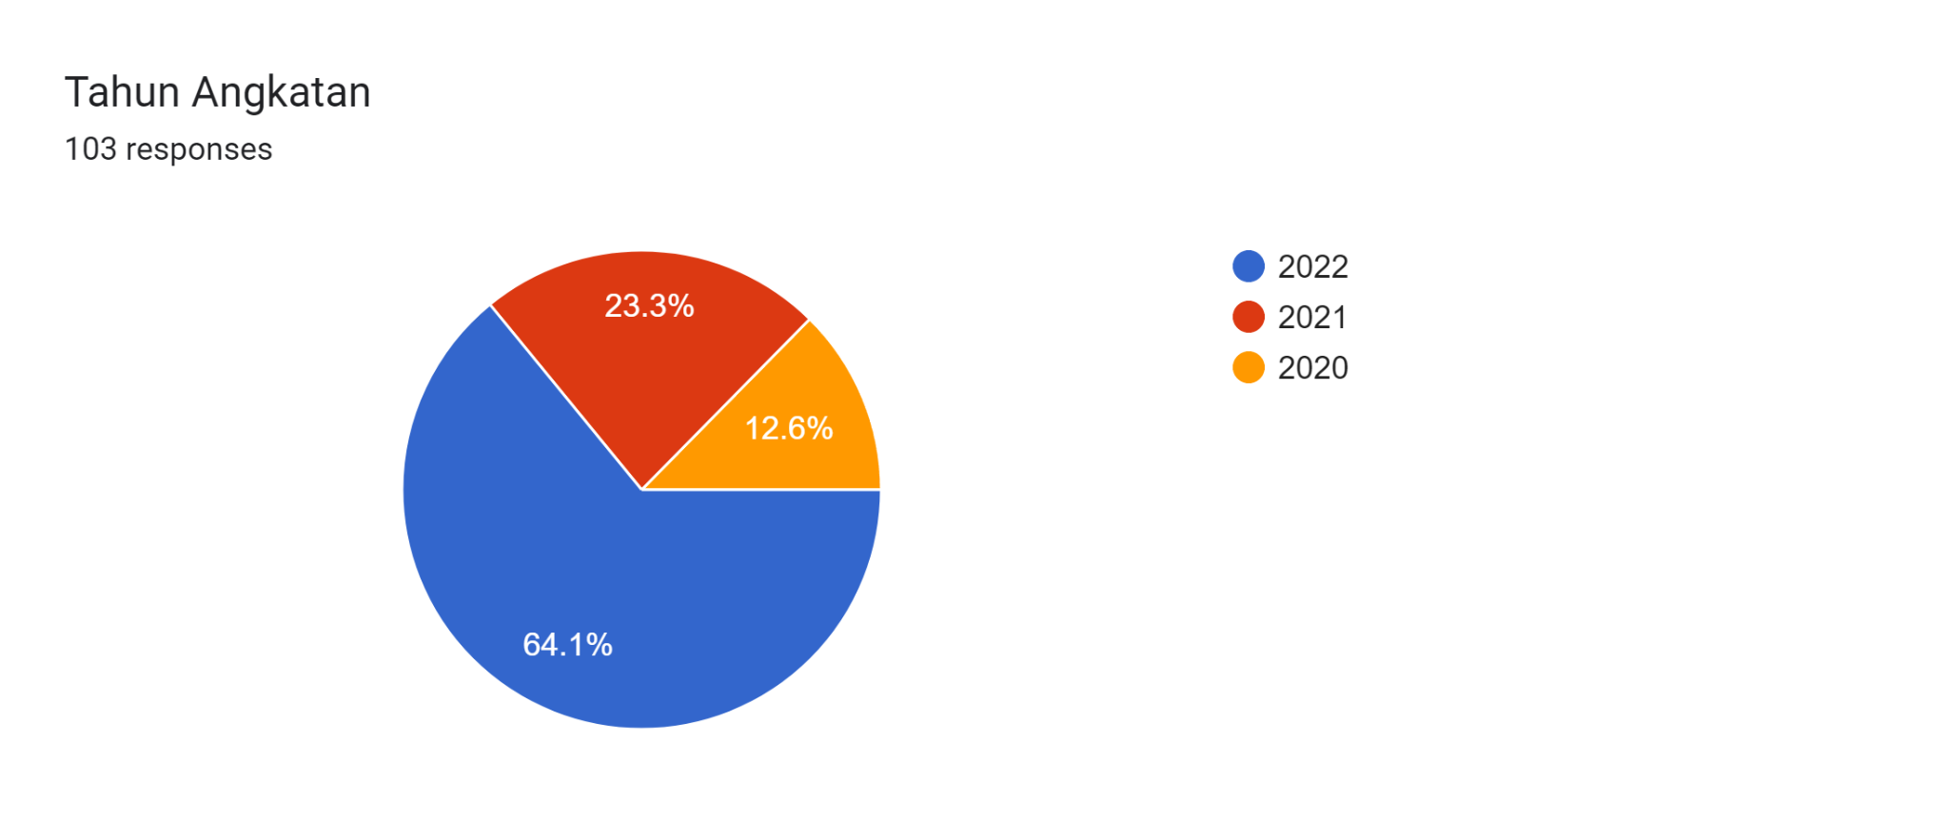

The results of the survey above show which batches have filled out the author's respondent form and the most who have filled out the author's respondents are the year 2022 with a total of 64.1% or the equivalent of 66 people and followed by the year 2021 with a total of 23.3% or the equivalent of 24 people and the most recent is the 2020 class with 12.6% or the equivalent of 13 people. The author can conclude that the 2022 class is very dominating in filling in the author's respondents and the second is the 2021 class year and the last is 2020.

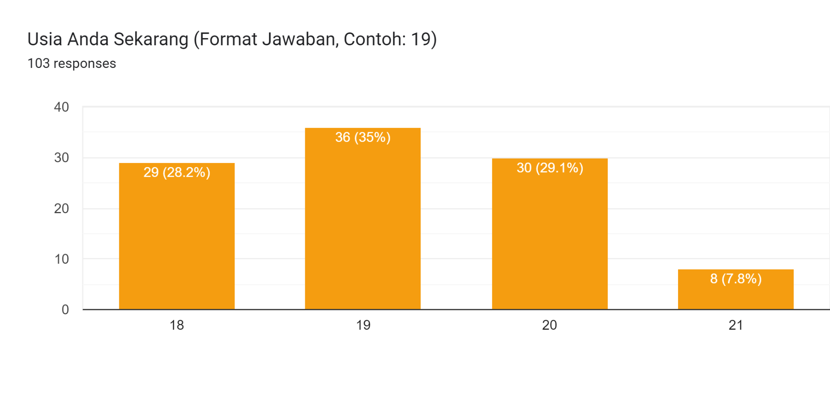

The survey results above show the data on the ages of the respondents who filled out the author's form and the most were at the age of 19 by 35% or the equivalent of 36, followed by the age of 20 by 29.1% or the equivalent of 29.1%, the age of 18 by 28.2% or the equivalent with 29 people and the most recent was 21 years of 7.8% or equivalent to 8 people. With this, the authors can conclude that the people who filled out the respondent form in this question were dominated by the age of 19 years, followed by the age of 20 years, 18 years and the least was 21 years of age.

**Part 2**

**Forms response chart. Question title: Seberapa besar minat Anda terhadap kopi?
. Number of responses: 103 responses.**

The survey results above show how much interest the respondents in the writer's form have about coffee using a scale of 1 to 5 to determine it, so the interest of the respondents in the form with a scale of 3 is 27.2% or the equivalent of 28 people, followed by a scale of 4 which is 24.3% or the equivalent 25 people, then scale 2 with 21.4% or the equivalent of 22 people and scale 5 with 18.4% or the equivalent of 19 people and the last is with 8.7% or the equivalent of 9 people. With this, the authors can conclude that respondents who like coffee are on a scale of 3 with 27.2% or the equivalent of 28 people and the least is on a scale of 1 with 8.7% or the equivalent of 9 people.

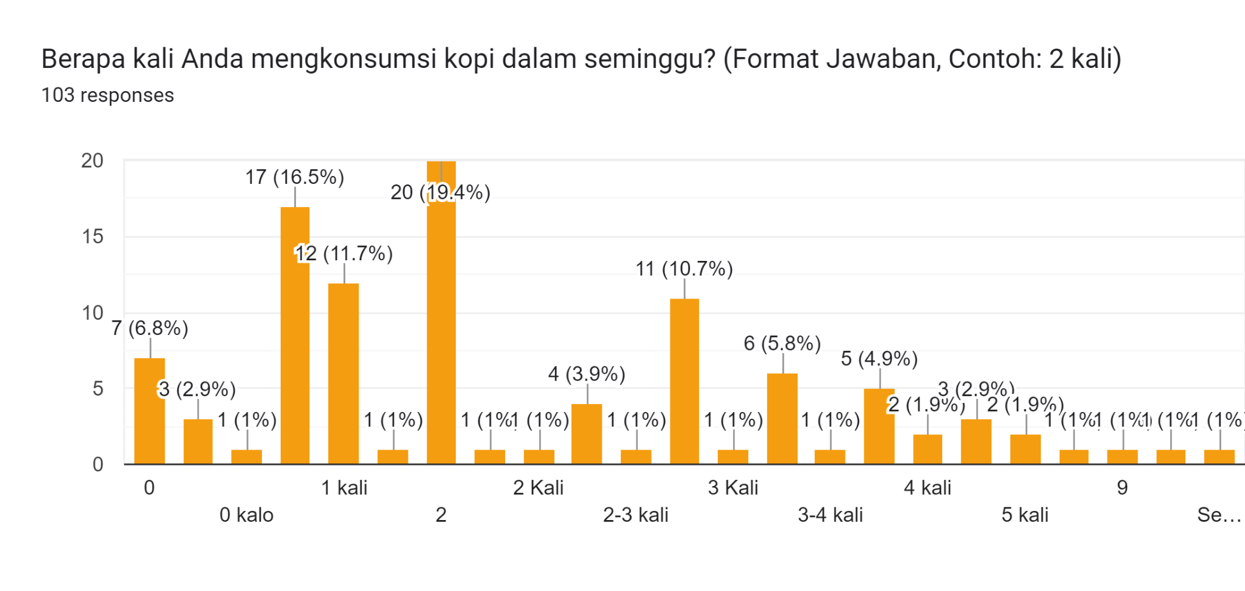

The survey results above show how many respondents our form has regarding how many times they consume coffee in a week, dominated by 1 time, 31 people, 2 times, 26 people, 3 times, 18 people, 4 times, 8 people, and 5 times, 5 people. and others. That way we can conclude that the respondents to our form consume coffee once a week.

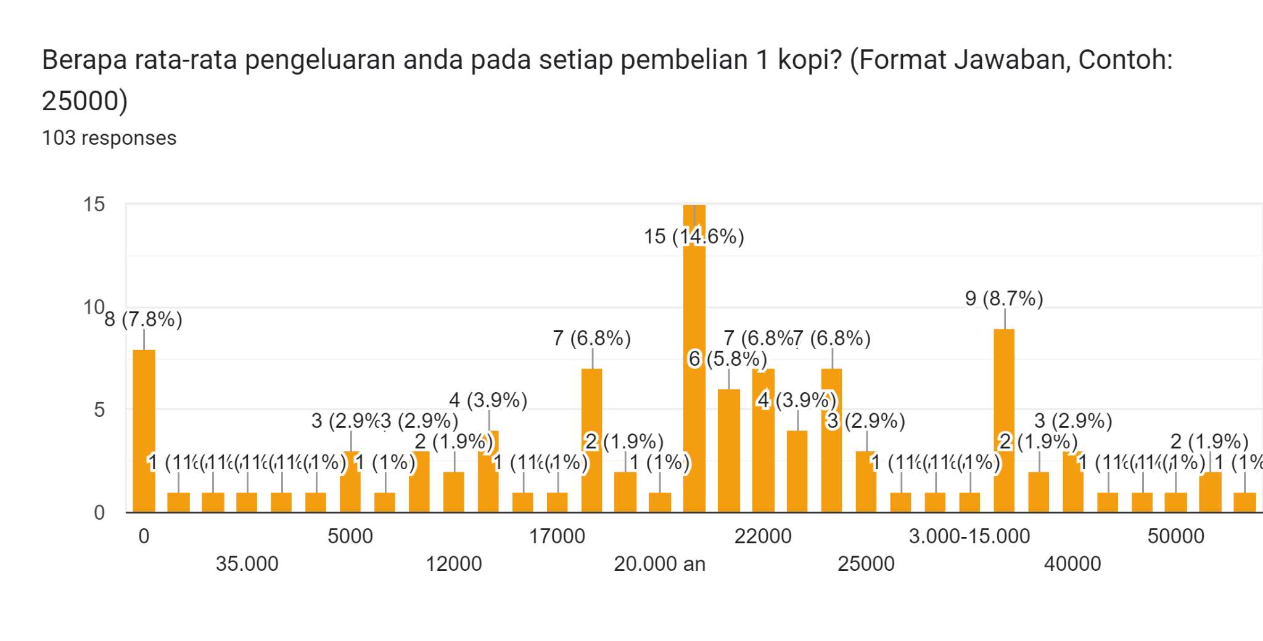

The survey results above show how much the average respondent spends from our form for every purchase of 1 copy and our survey results show that 14.6% or the equivalent of 15 people have spent 20000 thousand rupiah every time they buy coffee and as many as 8.7% or the equivalent of 9 people have spent 30000 thousand rupiahs to purchase 1 copy and 6.8% or the equivalent of 7 people have spent 18000 thousand rupiahs to purchase coffee and with this we can conclude that the average expenditure of our form respondents is 30000 thousand rupiahs with 14.6% or the equivalent 15 people, then followed by 8.7% or the equivalent of 9 people and finally 6.8% or the equivalent of 7 people.

Forms response chart. Question title: Apakah Anda merasa lebih produktif dalam belajar setelah mengonsumsi kopi? 
. Number of responses: 103 responses.

The survey results above show how much the productivity of our form respondents is towards learning after consuming coffee and by 63.1% or the equivalent of 65 people said yes that after drinking coffee they felt more productive in studying and as many as 36.9% or the equivalent of 38 people said no that after drinking coffee does not make you more productive while studying. With this we can conclude that on average the respondents to our form said yes that consuming coffee could make them more productive while studying.

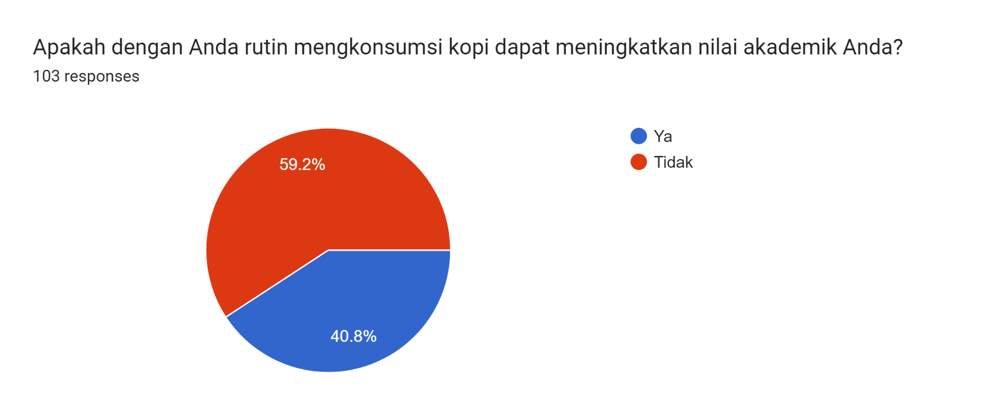

The survey results above show that whether consuming coffee regularly can increase academic scores or not and according to the survey, 59.2% or the equivalent of 61 people say no that consuming coffee cannot increase academic scores and 40.8% or the equivalent 42 people said yes that consuming coffee regularly could improve academic scores. In this way, we can conclude that the average respondent from our form said no, that consuming coffee regularly would not increase academic grades.

Forms response chart. Question title: Seberapa besar pengaruh minum kopi terhadap konsentrasi Anda saat belajar atau pada waktu ujian?
. Number of responses: 103 responses.

The survey results above show that how much influence does drinking coffee have on the concentration of our form respondents while studying or during exams and we test it in the form of a scale of 1-5 and on a scale of 3, which is 34% or the equivalent of 35 people, which means medium scale, then followed by a scale of 4 of 28.2% or the equivalent of 29 people which means agree, scale 2 of 17.5% or the equivalent of 18 people which means they do not agree, scale 1 of 10.7% or the equivalent of 11 people which means disagree and the last is scale of 5 with 9.7% or equivalent to 10 people which means strongly agree. In this way we can conclude that on average our respondents have a neutral vote where on a scale of 3 it is 34% or the equivalent of 34 people and is followed by a scale of 4, a scale of 2, a scale of 1 and the last is a scale of 5.

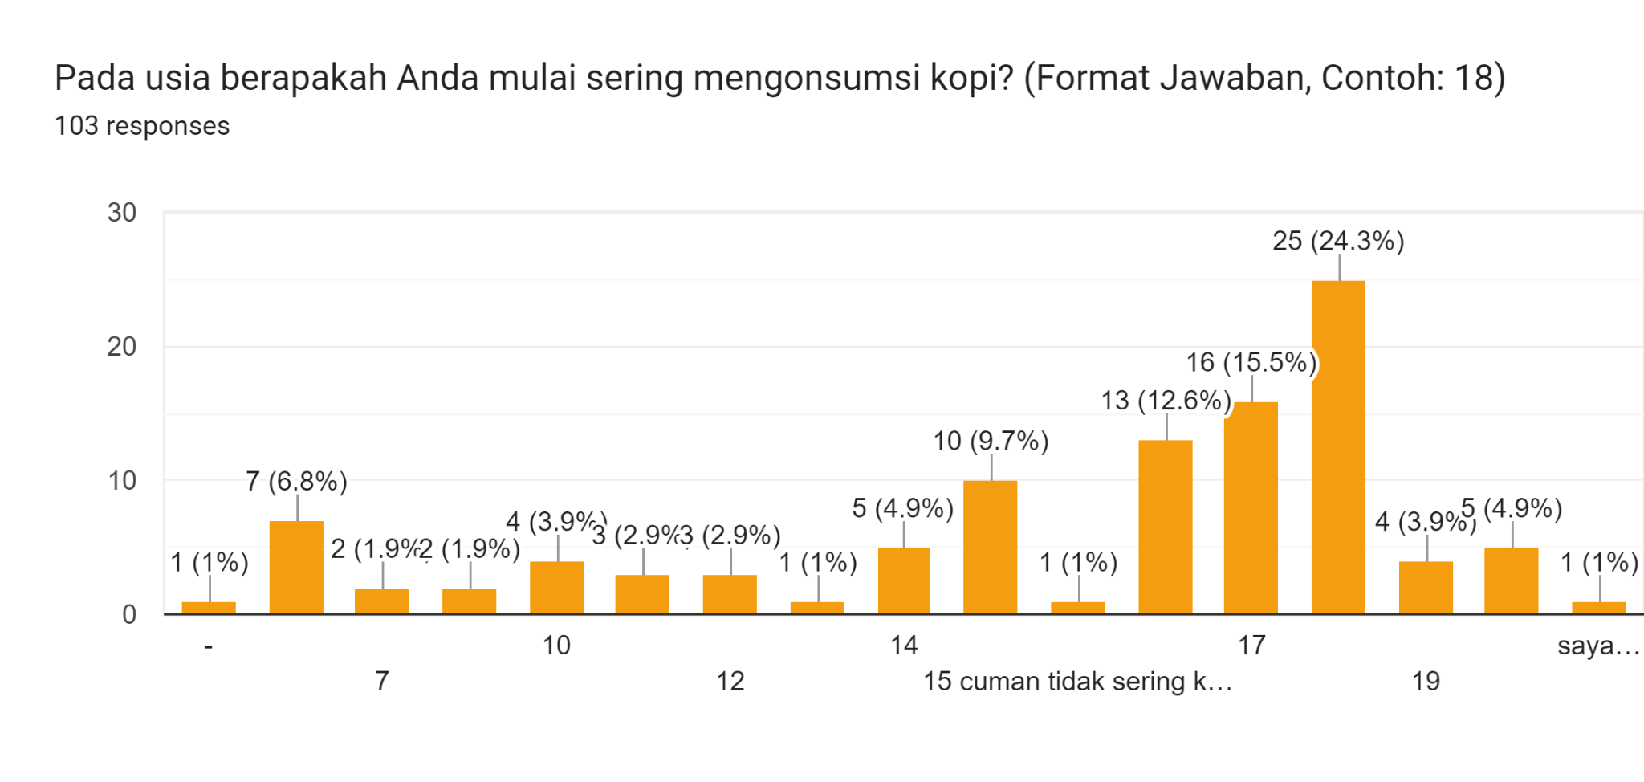

The survey results above show at what age did our form respondents often consume coffee and were dominated at the age of 18, which was 24.3% or the equivalent of 25 people, then followed by 17 years of age, which was 15.5%, or the equivalent of 16 people, and the last the most was at the age of 16 years by 12.6% or the equivalent of 13 people and in this way we can conclude that on average the respondents from our form have started to frequently consume coffee since the age of 18 which is equal to 24.3% or the equivalent of 25 people followed by age 17 years and 16 years.

Forms response chart. Question title: Apakah Anda merasa puas dengan hasil akademik Anda setelah mengomsumsi kopi?
. Number of responses: 103 responses.

The survey results above show whether our form respondents are satisfied with their academic results after drinking coffee and we divide them by a scale of 1-5, and are dominated by a scale of 3 which is 35% or the equivalent of 36 people which means neutral, then followed by a scale of 2 which amounted to 24.3% or the equivalent of 25 people which means they do not agree and scale 4 is 22.3% or the equivalent of 23 people which means they agree, scale 1 is 9.7% or the equivalent of 10 people which means they disagree and the last scale 5 is 8.7% or equivalent to 9 people which means strongly agree. We can conclude that on average our respondents have a neutral answer, namely a scale of 3, as many as 36 people about whether they feel satisfied with their academic scores after drinking coffee.

## **Data Seconds**

1. Secondary Data 1: Journal “Relationship between Coffee Consumption and Chances of Passing the 2017 PSSKPD Student Block Exam, Faculty of Medicine, Udayana University” (2021)

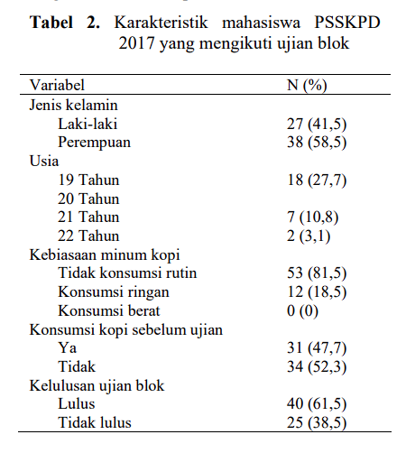

Source:<https://ojs.unud.ac.id/index.php/eum/article/view/71736/38986>

The fundamental reason for the selection of secondary data by the authors is due to the availability of raw data that can complement and validate the primary data in this study. This secondary data is sufficient to provide an overview or visualization of data regarding the influence of coffee consumption habits on passing the block exam through the available variables, such as gender, age, level of regular consumption, to data on the number of block exam passes. In this dataset, the authors find similarities with the data that the authors also process, so that it becomes relevant and comprehensive evidence if the authors use it as a basis for validating research conducted by the authors.

1. Secondary Data 2: Journal “Relationship between Caffeine Consumption and Student Learning Concentration at Mulawarman University” (2022)

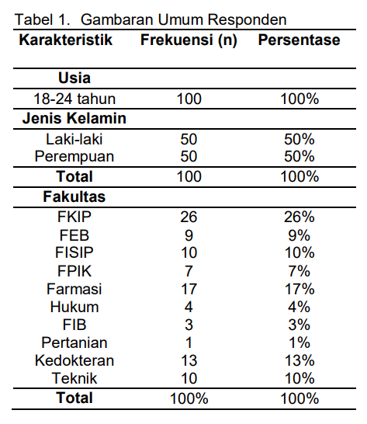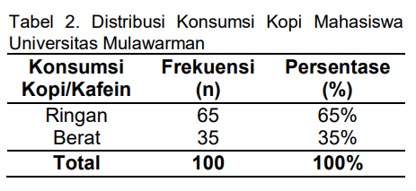

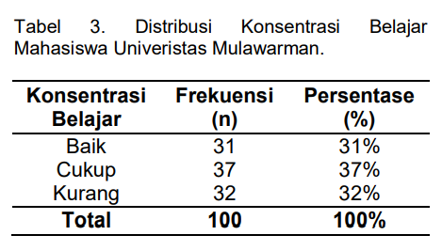

Source:<https://jurnal.stikesmm.ac.id/index.php/verdure/article/view/239/170>

The author determines the secondary data as the source of the second secondary datasetbased on the availability of raw data that can complement the primary data used. The use of secondary data provides a clear picture and visualizes the influence of coffee consumption habits on study concentration in Mulawarman University students, taking into account variables such as gender, age, faculty, level of regular consumption, and level of study concentration. After analysis, the authors found that the dataset had similarities with previously processed data, so its use as validation in this study was considered good and supported the advanced level.

## **Descriptive Statistics**

1. The age of the respondent filled out the questionnaire



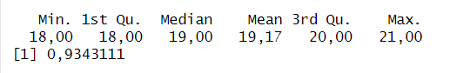

From the results above we can see that the result of the min is 18 then the 1st qu is 18, then the median age of the respondent is 19, then the mean age of the respondent is 19.17 then the 3rd qu is 20, and the max value or age limit the oldest in filling out the questionnaire is age 21. The standard deviation or standard deviation of the age of the respondents who filled out the coffee questionnaire is 0.9343111.

Value Frequency age of respondents who filled out a questionnaire about coffee



From the results above we can see that the age of the respondents aged 18 years there were 29 people who filled out the questionnaire, 19 years old there were 35 people who filled out the questionnaire, 20 people who filled out there were around 30 people, and aged 21 years there were around 8 people.

1. Respondents are very interested in coffee



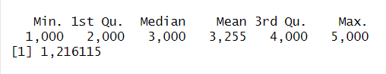

From the results above, a presentation of the respondent's interest is presented in the form of a scale of 1 to 5. From these results, the min value = 1, 1st qu = 2, the median of these results is 3, the mean is 3.255, 3rd qu = 4, and the max value is is 5. The standard deviation of the questionnaire questions is 1.216115.

The frequency of respondents' interest in coffee



The frequency of as many respondents who fill in scale 1 regarding the great interest in coffee is 8 people, then respondents who fill scale 2 are 22 people, scale 3 is 27 people, scale 4 is 26 people, and scale 5 there are as many as 19 people.

1. The number of respondents drinking coffee in a week



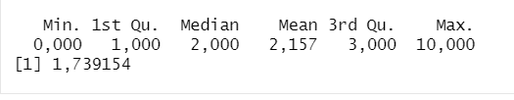  
From the results above we can see that the lowest value of respondents drinking coffee in a week is 0 followed by 1st Qu is 1, the median of the results of these questions is 2, the mean of the results of these questions is = 2.157, 3rd Qu = 3, and the max value or the highest value of respondents drinking coffee in a week is 10 times.

Then the standard deviation value or standard deviation of the results above is 1.739154.

The following is the frequency or total of each respondent drinking coffee in a week

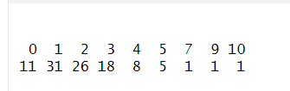

We can see and according to the summary of the picture above that the lowest value is 0 times and the highest value is 10 times.

1. The average expenditure of respondents in the purchase of one coffee



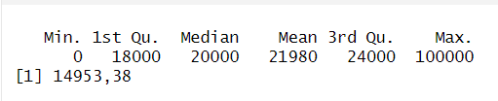

From the above results based on the question, namely the average expenditure of respondents in purchasing one coffee, the minimum or lowest value is 0 rupiah, then the 1st Qu value is Rp.18,000, the median value is Rp.20,000, the mean value is Rp.21,980, the value 3rd Qu Rp. 24,000, and the max or highest value in spending to buy coffee is Rp. 100,000. The value of the standard deviation or standard deviation of the questions above is IDR 14,953.38

1. The magnitude of the influence of coffee on learning concentration



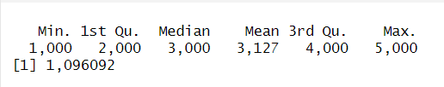

From the results above, the answers are presented on a scale of 1 to 5, therefore the min, 1stQu, median, mean, 4rdQu, and Max values ​​are values ​​from a scale of 1 to 5. The standard deviation of the questions above is 1.096092.

  
The following is the frequency of the number of each respondent choosing a scale to describe how much influence coffee has on learning concentration. From this scale the number of respondents who chose 1 was 9 people, chose 2 there were 18 people, chose 3 there were 36 people, chose 4 there were 29 people, chose 5 there were 10 people.

1. Age of respondents started drinking coffee



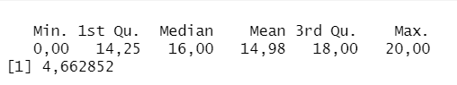

From the summary results above, a min value of 0 means that the respondent has never drank coffee, then 1st Qu = 14, median = 16, mean = 14.98, 3rd Qu = 18, and the max value is 20. Then The standard deviation of the results above is 4.662852.



From the results above, we can see the details regarding the number of respondents who filled in based on the age at which the respondents drank coffee. At age 0 it indicates that the respondent does not or does not like coffee so much that he has never tasted it.

1. Respondent satisfaction after consuming coffee can increase academic value

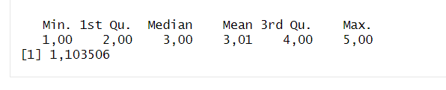

Data is presented in the form of a scale of 1 to 5, so the min to max values ​​follow a scale of 1 to 5.

  
Then following is the frequency of respondents in filling out a scale 1 to 5. Scale 1 is filled by 9 people, scale 2 is filled by 24 people, scale 3 is filled by 36 people, scale 4 is filled by 23 people, and scale 5 is filled by 10 people.

## Gaussian distribution

1. Respondent's Age Now



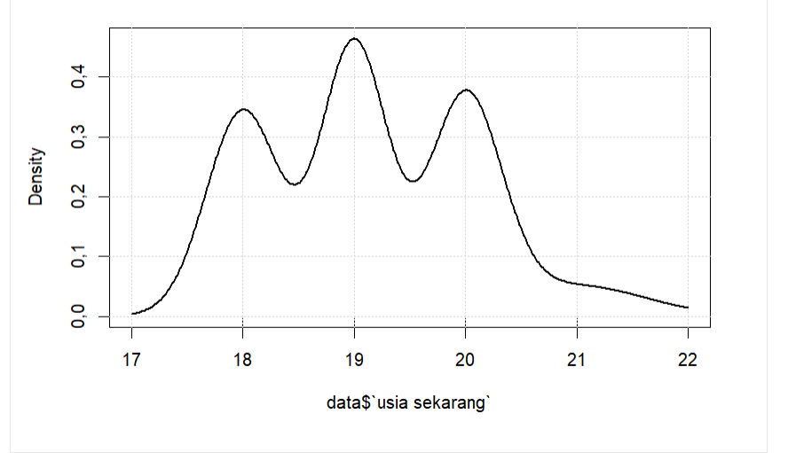

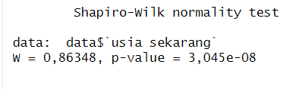

From the results above, we can see that the p-value indicates that the p-value is below alpha 0.05 which indicates that the data is not normally distributed. This has also been proven in the density plot above where a graph is not at a point with which can strengthen the statement that the data is not Gaussian distributed.

1. Large scale of respondents' interest in coffee



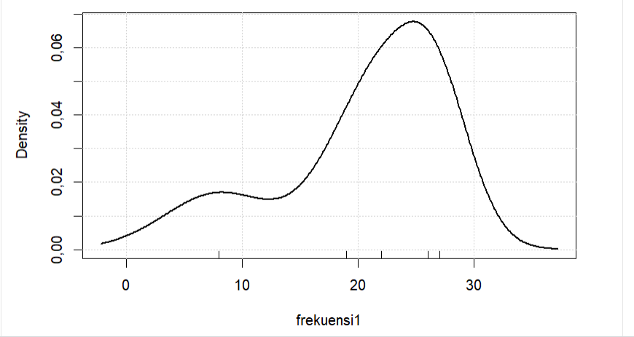

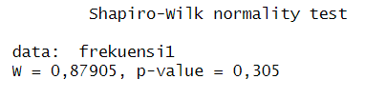

The results of the question above if we are based on a density plot, the data is not normally distributed or not a Gaussian distribution which indicates that the data is not quite right. However, based on the results of the Shapiro test, it indicates that the data is normally distributed based on the p-value, which is 0.305 above the p-value of 0.05, which indicates that the data is normally distributed.

1. Number of respondents drinking coffee in a week

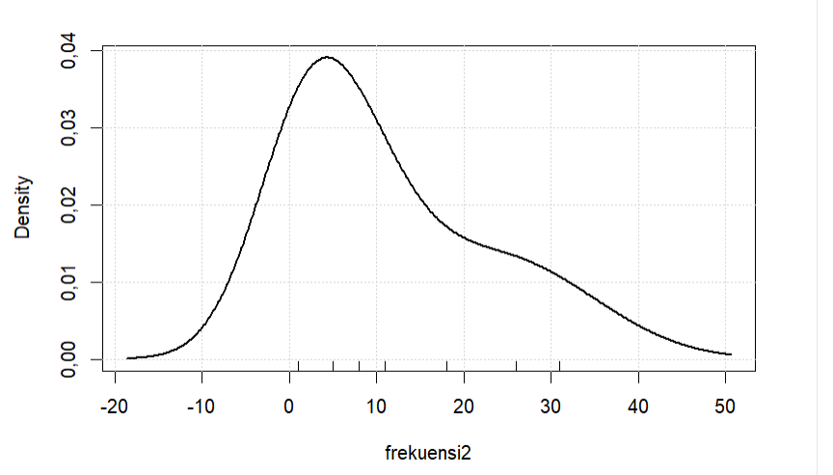

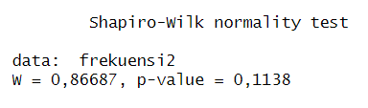

In the third question a data based on desityplot data is not normally distributed because a data is not at the midpoint of a graph. However, based on the Shapiro test, a p-value of 0.1138 indicates that it is higher than an alpha of 0.05 which indicates that the data is normally distributed.

1. The average expenditure of respondents in each purchase of one coffee

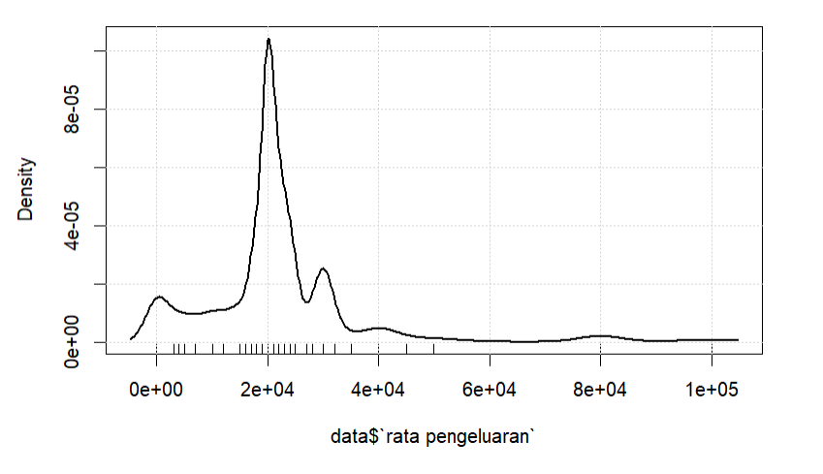

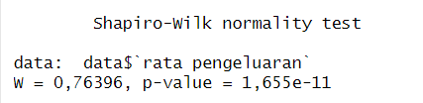

From the data above, based on the results of the density plot, it indicates that the data is not normally distributed and the line only stands out in the lower area. Then based on the results of the Shapiro test, the data is not normally distributed which has a value below 0.05, so the conclusion is that the data is not normally distributed.

1. Great effect of coffee on learning concentration

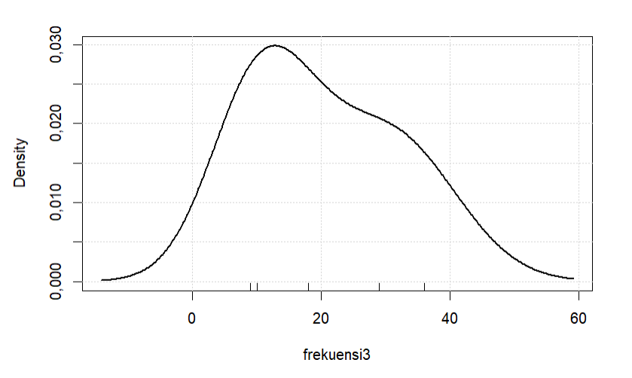

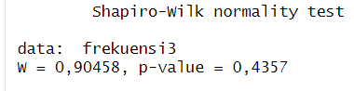

From the results above, based on the results of the density plot, it indicates that data is not at the midpoint of 30, which indicates that the data is not normally distributed or close to normal distribution. However, based on the results of the Shapiro test, it indicates that the data is normally distributed because the p-value is 0.4357 or above 0.05. So that a data is normally distributed.

1. Age of respondents consuming coffee

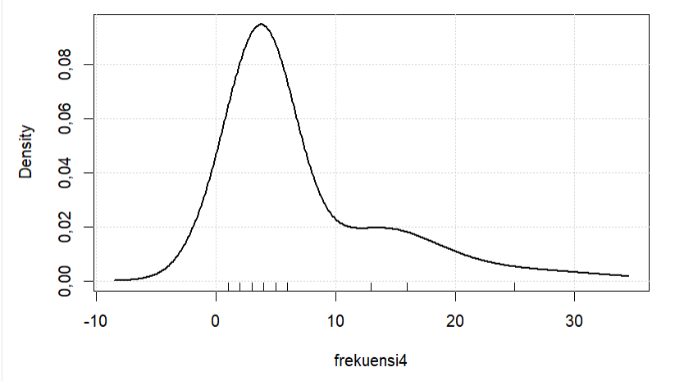

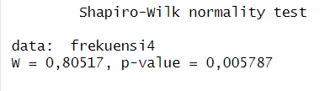

From the results above based on the density plot, it shows that the data is not at the midpoint, which is 30, which indicates that the data does not have a normal distribution and. However, testing with the Shapiro-test shows that the p-value is also not normally distributed, namely 0.005787, which if you want to get a normal distribution value, you have to be above 0.05, so the distribution is not normal.

1. Respondents' satisfaction with academic scores after consuming coffee

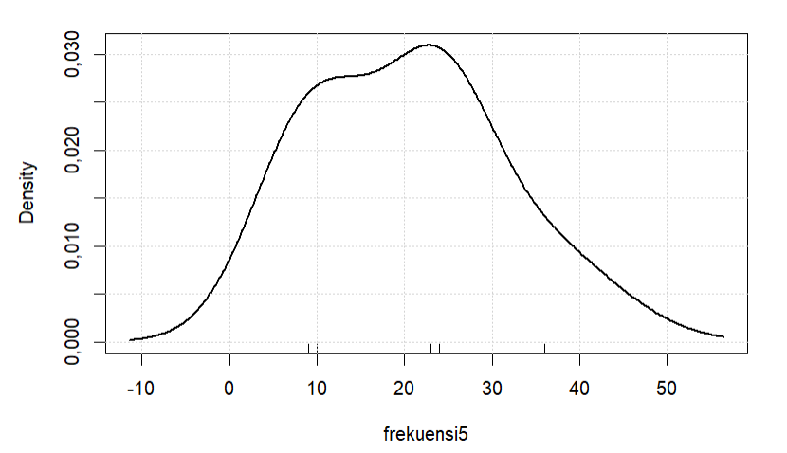

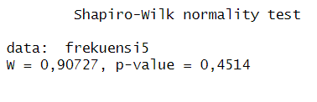

From the results of the data above, it shows that the density plot is not at the midpoint, namely 30, where 30 indicates that whether the data is normally distributed or not. After we did the Shapiro-test, the p-value showed 0.4514, which means that the distribution is normal. above 0.05, so the data is normally distributed.

## Hypothesis testing

1. Uji Anova

Hypothesis 1: There are differences in interest in coffee based on gender. (Dependent variable: Interest in coffee; Independent variable: Gender)



In the code above our group wants to change every value that says "Male" to number 1 and every word that says "Female" to number 2. Then I change the data type to the value of gender with a factor because to use ANOVA you have to change it to the form factor. Then because I compared the 2 groups to be compared in the ANOVA test, I compared sex with interest in coffee. Then the results are presented in the form of a summary of the ANOVA.

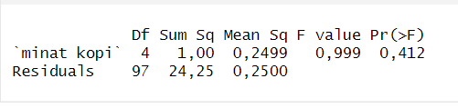

From the results above we can see that the value of the p-value is 0.412 which indicates a normally distributed data. So it can be concluded that there is no significant difference between the two groups with an interest in coffee

Hypothesis 2: There is a difference in the average spending on each coffee purchase based on your major. (Dependent variable: Average spend on each purchase of 1 copy; Independent variable: Your major)



From the code above I want to change each existing major to a value from 1 to 9 because it also depends on the number of majors that fill out our form.

Information system = 1

Visual Communication Design = 2

Machine Technique = 3

Management = 4

Journalism = 5

Film and Animation = 6

Strategic Comunication = 7

Informatics Engineering = 8

Accounting = 9

Then after the data is in the form of numbers, we enter it into the ANOVA function. The ANOVA that I compared between the 2 groups is the average expenditure on the respondent's major. Then it will produce the following output:

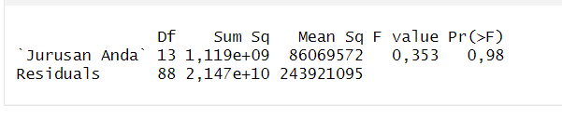  
From these results we can see that the p-value is 0.98 which indicates that there is no significant difference between the 2 groups.

1. Pearson and Spearman test

Hypothesis 3: There is a linear relationship between your current age and the frequency of coffee consumption in a week. (Dependent variable: Frequency of coffee consumption in a week; Independent variable: Your Current Age)



From the code above, we want a number of coffee times a week, we group them into 4 groups

0 to 1 times = 1

2 to 3 times = 2

4 to 5 times = 3

7 to 10 times = 4



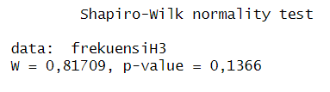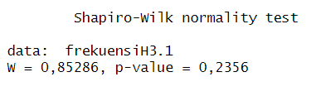

Then we go into the next step to do the Shapiro test first on each group that you want to test. Because from these results we will decide to use Pearson or Spearman in carrying out the test.

From the above results it is evident that the 2 groups tested, namely the respondent's current age and the number of times the respondent drinks coffee in a week, have a p-value above 0.05. Therefore, we will use the Pearson methodology to carry out the test.

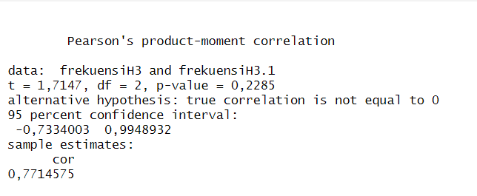

From the results above we can see that the p-value is 0.2285 with the Pearson test where the result means that it has a value above 0.05 or above alpha which indicates that there is a positive correlation between coffee a week and current age.

hypothesis 4 (age consuming coffee with interest in coffee)



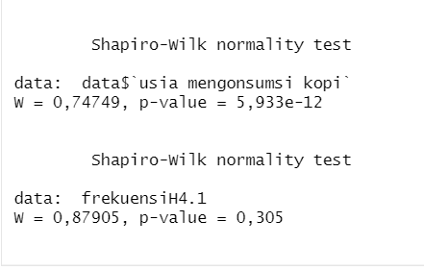

First, before carrying out the Pearson and Spearman tests, the thing to do is to use the Shapiro test to conduct tests on each existing group. From the results above, group 1 has a value below 0.05 and group 2 is normally distributed. Therefore it can be concluded that the Spearman methodology will be used in conducting the test.

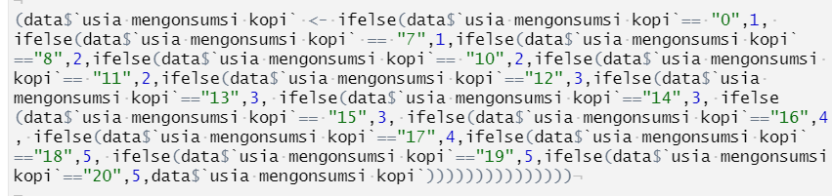

I grouped the data as follows in terms of the age at which they started consuming coffee

1 - 7 has a value of 1

8 - 12 has a value of 2

13 - 15 has a value of 3

16 - 17 has a value of 4

18 - 20 has a value of 5



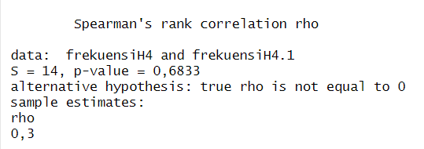

From the results above, we can see that using the Spearman methodology has a p-value of 0.6833 above 0.05 which indicates that there is a weak and monotonic positive relationship between the 2 groups.

1. Wilcoxon Test

hypothesis 5: There is a difference in interest in coffee between those who feel more productive in learning after consuming coffee and those who do not feel more productive. (Dependent variable: Interest in coffee; Independent variable: Feeling more productive in studying after consuming coffee)

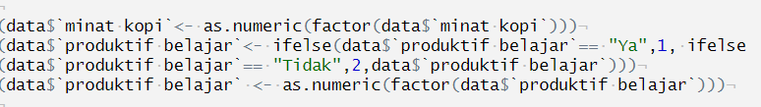

First, we first change the value of coffee interest into numerical form. Because to do a test on Wilcoxon, a data with a numeric data type is needed. Then change the learning productivity for each value that is still of type "String" into numeric form. "Yes" becomes 1 and "no" becomes 2.



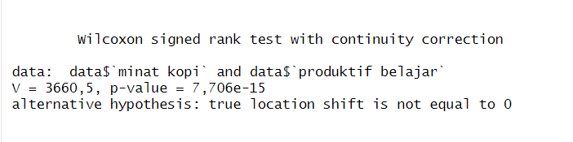

based on the results of the Wilcoxon signed rank test, strong evidence was found to reject the null hypothesis that the shift in location between the variables of interest in coffee and learning productivity is equal to 0. The very small P-value (7.706e-15) indicates that the difference between the two variables significantly significant. Therefore, it can be concluded that there is a significant difference between interest in coffee and the level of learning productivity.

Hypothesis 6: There is a difference in interest in coffee between those who consume coffee regularly and those who do not. (Dependent variable: Interest in coffee; Independent variable: Regular coffee consumption)

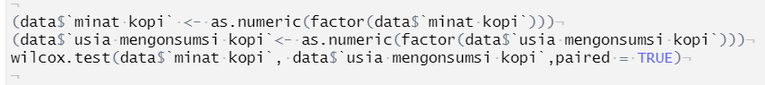

As with hypothesis 7, to do the Wilcoxon test, data with a numeric data type is needed. Then enter the Wilcoxon formula as above

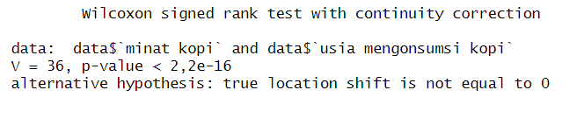

based on the results of the Wilcoxon signed rank test, strong evidence was found to reject the null hypothesis that the shift in location between coffee interest and coffee consuming age is equal to 0. A very small P-value (less than 2.2e-16) indicates that the difference between both variables significantly. Therefore, it can be concluded that there is a significant difference between interest in coffee and the age at which coffee is consumed.

1. Uji Chi Square

hypothesis 7: Gender with interest in coffee

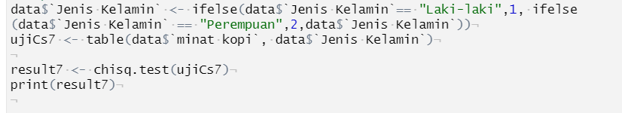

Similarly to the previous hypothesis we need to convert all String types to a number to represent each of those Strings.

Then we input a Chi Square test function and it produces the following output

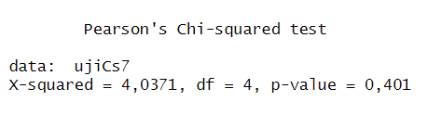

based on the results of the Pearson's Chi-squared test, no strong enough evidence was found to reject the null hypothesis. The p-value found (0.401) is greater than the specified significance level. Therefore, there is not enough statistical evidence to support a significant difference between the 2 groups tested.

Hypothesis 8: Interest in coffee on academic results



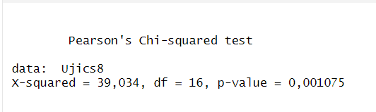

sufficient evidence is found to reject the null hypothesis. The p-value found (0.001075) is very small, much smaller than the specified significance level. Therefore, there is sufficient statistical evidence to support a significant difference between the 2 groups.

## Primary Data Relationship with Secondary Data

### Primary Data with Secondary Data 1

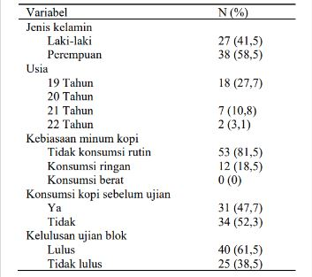

Uji Chi Square

Hypothesis 1: secondary data on sex by drinking coffee



Similar to the secondary data we want to change the total value of men is 27 and the total value of women is 38



Likewise with the data on drinking coffee, we want to change the data on non-coffee consumption to 53 and light consumption to 12 people.



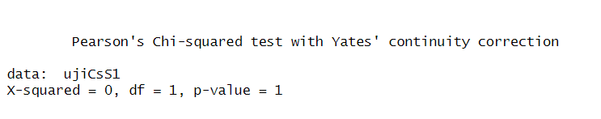

based on the results of the Pearson's Chi-squared test with Yates' continuity correction, no strong enough evidence was found to reject the null hypothesis. The p-value found (1) indicates that there is not enough statistical evidence to support a significant difference between the 2 groups.

### Primary Data with Secondary Data 2

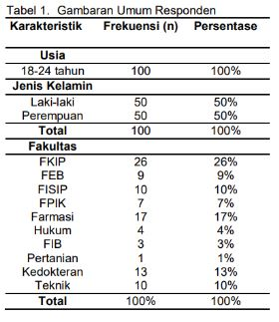

Hypothesis 1 secondary data 2



First we make all String data types convert into numbers. In the data above where we change

No consumption = 0

Light consumption = 65 people

Weight consumption = 35 people



Likewise with age by grouping as follows:

18 - 20 = 57 people

21 - 22 = 35 people

23 - 24 = 18 people



Then change the two types of data above into a factor with the aim that we can use the data to test Chi Square

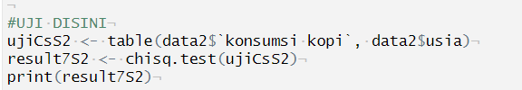

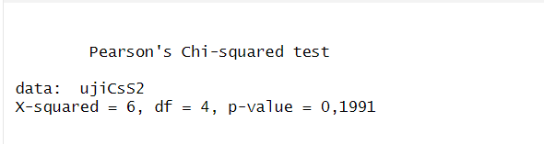

no strong enough evidence is found to reject the null hypothesis. The p-value found (0.1991) is greater than the specified significance level. Therefore, there is not enough statistical evidence to support a significant difference between the two groups tested.

Hypothesis 2 secondary data 2 (coffee consumption on learning concentration)



Changing the data type in each String to match the secondary data table

Good = 31

Enough = 37

Less = 32



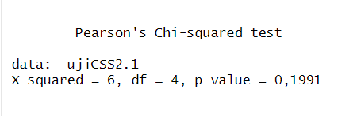

no strong enough evidence is found to reject the null hypothesis. The p-value found (0.1991) is greater than the specified significance level. Therefore, there is not enough statistical evidence to support a significant difference between the two groups tested.

Cor test (Hypothesis 3 secondary data 2): coffee consumption to age

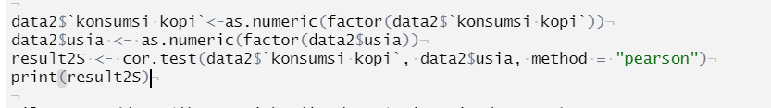

To use the cor test, the main requirement is that the data type must be numeric so that from the above code the data is converted into numeric form so that it can be processed.

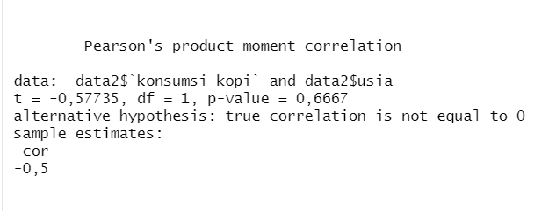

no strong enough evidence is found to reject the null hypothesis. The p-value found (0.6667) is greater than the specified significance level (0.05). Therefore, there is not enough statistical evidence to support a significant correlation between the 2 groups

Hypothesis 4 (coffee consumption on learning concentration)



Changing the learning concentration data type to be a numeric type so that it can be processed using chi Square.



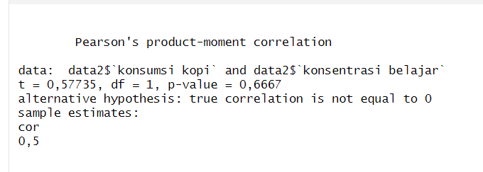

no strong enough evidence is found to reject the null hypothesis. The p-value found (0.6667) is greater than the specified significance level (0.05). Therefore, there is not enough statistical evidence to support a significant correlation between coffee consumption and learning concentration.

Wilcoxon Test (Hypothesis 5 secondary data 2): Coffee consumption on age

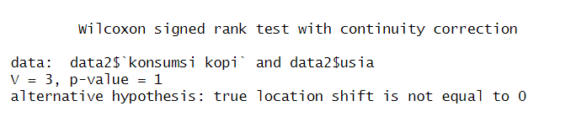

no strong enough evidence is found to reject the null hypothesis. The p-value found (1) is greater than the specified significance level (0.05). Therefore, there is not enough statistical evidence to support a significant shift in location between coffee consumption and age variables.

Hypothesis 6 secondary data 2: Coffee consumption on learning concentration



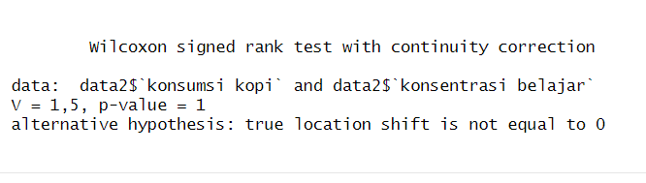

no strong enough evidence is found to reject the null hypothesis. The p-value found (1) is greater than the specified significance level (0.05). Therefore, there is not enough statistical evidence to support a significant shift in location between coffee consumption and learning concentration.

# **B.B.V**

# **CONCLUSIONS AND RECOMMENDATIONS**

## Conclusion

Coffee has become a very popular drink in Indonesia, including among university students. Coffee consumption has increased significantly in recent years, and it is now easily available through more and more coffee shops. In this context, research on the effect of coffee consumption on student academic performance is an interesting topic to study. This study aims to further understand the effect of coffee on students' academic activities and provide useful recommendations for them. On the other hand, coffee also has health benefits, such as increasing concentration, memory and stamina. Therefore, in this study, the researcher wanted to test how much influence coffee has on student performance in pursuing higher education through various hypotheses, and then used secondary data to validate this research. Previously, the primary data sample in this study was taken from a population of active students at Multimedia Nusantara University who had an interest in or had consumed coffee.

According to the hypothesis testing in this study that has been carried out, the following are the results of testing the hypothesis:

* There are differences in interest in coffee based on gender, where
* There are differences in the average spend on each coffee purchase by major
* There is a linear relationship between age and coffee consumption frequency in a week.
* There is a linear relationship between the age at which coffee is consumed and interest in coffee.
* There is a difference in interest in coffee between those who feel more productive in their studies after consuming coffee and those who do not feel more productive.
* There is a difference in interest in coffee between those who regularly consume coffee and those who don't regularly.
* There is a significant relationship between gender and satisfaction with academic results after consuming coffee.
* There is a significant relationship between coffee interest and satisfaction with academic results after consuming coffee.

Thus, this research is expected to provide valuable information about the effectiveness of coffee in the academic context of students.

## Suggestion

With the implementation of this research, the authors hope and desire to provide suggestions for:

* General: It is hoped that this research can provide a better understanding of the effect of coffee consumption on student academic performance. The results of this study can provide an understanding regarding coffee information and its side effects that are widely useful, especially for universities and other relevant agencies in understanding the impact of coffee consumption on academic achievement, so as to optimize learning strategies and policies related to welfare, performance, to health. student.
* Concerned students: for active students, it is hoped that students will pay more attention to their time management. Do not make coffee as an alternative solution when the workload is intentionally stacked.
* Future research: researchers who are interested in this research topic are expected to involve other variables that may affect the relationship between coffee consumption and student academic performance, such as sleep patterns, eating habits, physical activity, or psychological factors. In addition, research can be conducted using more in-depth methods, such as direct observation or in-depth interviews, to obtain a more comprehensive understanding of the factors that influence these relationships.

# REFERENCE

Br Ginting, S. S., Astiarani, Y., Santi, B. T., & Vetinly, V. (2022, February 23).*LEVEL OF KNOWLEDGE OF THE EFFECTS OF CAFFEINE CONSUMPTION AND CAFEINE INTAKE IN STUDENTS*. ejournal.undip. Retrieved May 7, 2023, from <https://doi.org/10.14710/jnc.v11i4.32930>

Dharmadi, A. C., Purnawati, S., & Adiputra, I. S. H. (2021, September 23).*ISSN 2597-8012 (Online) | Udayana Medika E-Journal*. The ISSN Portal. Retrieved May 16, 2023, from <https://portal.issn.org/resource/ISSN/2597-8012>

Fraenkel, J.R., Wallen, N.E., & Hyun, H.H. (2012).*How to Design and Evaluate Research in Education* (8th ed.). McGraw-Hill Education. <https://www.directtextbook.com/isbn/9780078097850>

Jannah, P. I., Eliana, D., Trisasri, R., Yanuari, N. P., Marga, A. D., & Saputra, R. K. (2023). Analysis of the Effectiveness of the Lactation Amenorrhea Method in Postpartum Mothers – Systematic Review.*Multidisciplinary Adijaya Journal*, *1 (02)*, 325-333. <http://e-journal.naureendigition.com/index.php/jam/article/view/263>

Kusumastuti, A., Khoiron, A. M., & Achmadi, T. A. (2020).*Quantitative Research Methods*. Deepublish. <https://books.google.co.id/books?id=Zw8REAAAQBAJ>

Ridder, M. (2022, May 10). *Export volumes of coffee-producing countries January 2022*. Statista. Retrieved May 1, 2023, from <https://www.statista.com/statistics/268135/ranking-of-coffee-exporting-countries/>

Sicca, S. P. (2022, February 1).*6 Benefits of Caffeine, Not Just Doping to Stay Up Late Page all - Kompas.com*. Kompas Health. Retrieved May 1, 2023, from <https://health.kompas.com/read/2022/02/01/200000168/6-manfaat-kafein-tidak-hanya-doping-untuk-betah-begadang?page=all>

Sugiyono. (2018).*Quantitative Research Methods*. Alphabet : Bandung.

Suharto, A. (2022, January 31). *Strengthening People's Economy, Rising Coffee Shop Business in Indonesia*. triphacks.id. Retrieved May 1, 2023, from <https://triphacks.id/menguatnya-ekonomi-rakyat-maraknya-bisnis-kedai-kopi-di-indonesia/>

*Toffin Indonesia Releases Research "2020 Brewing in Indonesia"*. (2019, December 17). Toffin Insight. Retrieved May 10, 2023, from <https://insight.toffin.id/toffin-stories/toffin-indonesia-merilis-riset-2020-brewing-in-indonesia/>

A. R. Pratiwi, & E. Gunawan. (2021). Analysis of physical and sensory characteristics of Aceh Gayo coffee with different brewing methods. Journal of Physics: Conference Series, 1755(1), 012027. <https://doi.org/10.1088/1742-6596/1755/1/012027>

S. B. Halim, S. Ramli, & S. H. Zakaria. (2020). The effect of cold brewing method and coffee-to-water ratio on sensory quality and antioxidant properties of coffee concentrate. Journal of Food Processing and Preservation, 44(4), e14415. <https://doi.org/10.1111/jfpp.14415>

Marpaung, J. L., Lumintang, R. C., & Sutrisno, A. (2017). Application of the ANOVA method for the analysis of the mechanical properties of coconut fiber composites.*Unsrat Mechanical Engineering Journal*, *6*(2).

Lusiana, E. D., & Mahmudi, M. (2021).*ANOVA for Experimental Research: Theory and Practice with R*. Brawijaya Press University.

Fraenkel, J.R., Wallen, N.E., & Hyun, H.H. (2012).*How to design and evaluate research in education* (Vol. 7, p. 429). New York: McGraw-hill.

Afgani, M. W., Paradesa, R., Testiana, G., Nery, R. S., & Syutaridho, S. (2020). Training on Processing Non-Normal Distributed Data in Two Way ANOVA Test with Interaction Using ARTool and SPSS.*E-Dimas: Community Service Journal*, *11*(4), 400-404.

Yigit, S., & Mendes, M. (2018). Which Effect Size Measure is Appropriate for One-Way and Two-Way ANOVA Models?: A Monte Carlo Simulation Study. *Revstat-Statistical Journal*, *16*(3), 295-313.

Afgani, M. W., Paradesa, R., Testiana, G., Nery, R. S., & Syutaridho, S. (2020). Training on Processing Non-Normal Distributed Data in Two Way ANOVA Test with Interaction Using ARTool and SPSS.*E-Dimas: Community Service Journal*, *11*(4), 400-404.

Connelly, L. (2019). Chi-square test. Medsurg Nursing, 28(2), 127-127.

Negara, I. C., & Prabowo, A. (2018, September). Use of the chi-square test to determine the effect of education level and age on IDU's knowledge of HIV-AIDS in the province of DKI Jakarta. In Proceedings of the National Seminar on Mathematics and Its Applications (Vol. 3).

Normelia , R. , Fortuna , T. D. , Putri , E. P. , & Widodo , E. (2022, January 31).*Mann-Whitney Analysis to Determine the Effectiveness of Vaccines on the Number of Covid-19 Patients in Indonesia | Normelia | Journal of Mathematical Science and Statistics*. UIN Suska e-Journal. Retrieved May 31, 2023, from<https://ejournal.uin-suska.ac.id/index.php/JSMS/article/view/15087/7264>

Rudianto, D., Putri, N. N., Said, M., Anjani, J. M., Erliyani, F., & Muliawati, T. (2020, October 30).*View of The Influence of E-learning Relationships in MAFIKI Courses at the Sumatra Institute of Technology Using the Wilcoxon Method*. Open Journal Systems. Retrieved May 31, 2023, from <https://journal.itera.ac.id/index.php/indojam/article/view/287/113>