BrickMore48 Flowcharts and Pseudocode
Flowcharts show the main branches and loops. Concise pseudocode retains key control logic, with simple operations written in plain language.

Algorithm 1 Text Inference and Shape Preserving Retiling
Input Text prompt and trained model Output One stud component, or a labeled draft or failure
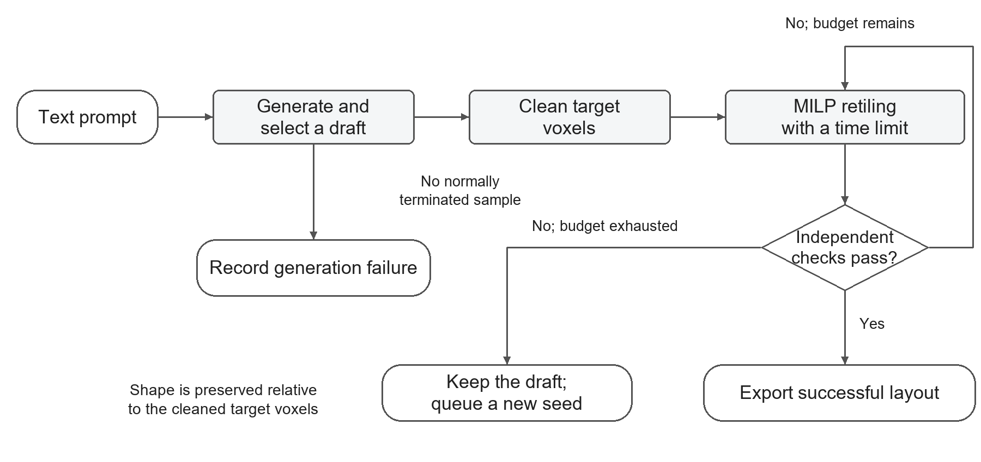
Figure 1 Text generation and shape preserving retiling

Pseudocode 1 Inference and retiling
01 Generate candidates in seed order; stop at the first complete, geometrically valid B;
02 If none is valid, choose the complete draft B with the fewest errors;
03 if B is absent then return FAILED;
04 C ← cleaned target voxels of B; save the raw output;
05 for τ ∈ {12, 60, 180} seconds do
06 B* ← solve an exact cover of C with one stud component within τ seconds;
07 if B* exists and passes independent checks then
08 Export B*; return (B*, SUCCESS);
09 end if
10 end for
11 Keep B and queue regeneration with a new seed;
12 return (B, DRAFT);
Notes. Seeds are 42, 104, and 2026; complete means normally terminated with EOS. Cleaning normalizes dimension conventions, filters unsupported bricks, clips out-of-bounds cells, and merges overlaps. Independent checks verify the inventory, bounds, absence of overlaps, exact coverage, and stud connectivity. Shape preservation is relative to the cleaned target C.
Sampling Temperature 0.7; top-p 0.9; at most 8192 new tokens; thinking disabled.

Algorithm 2 Assembly Repair by Local Bridge Retiling
Input Colored voxel model and time budget Output Repaired layout or a full-coverage failure draft
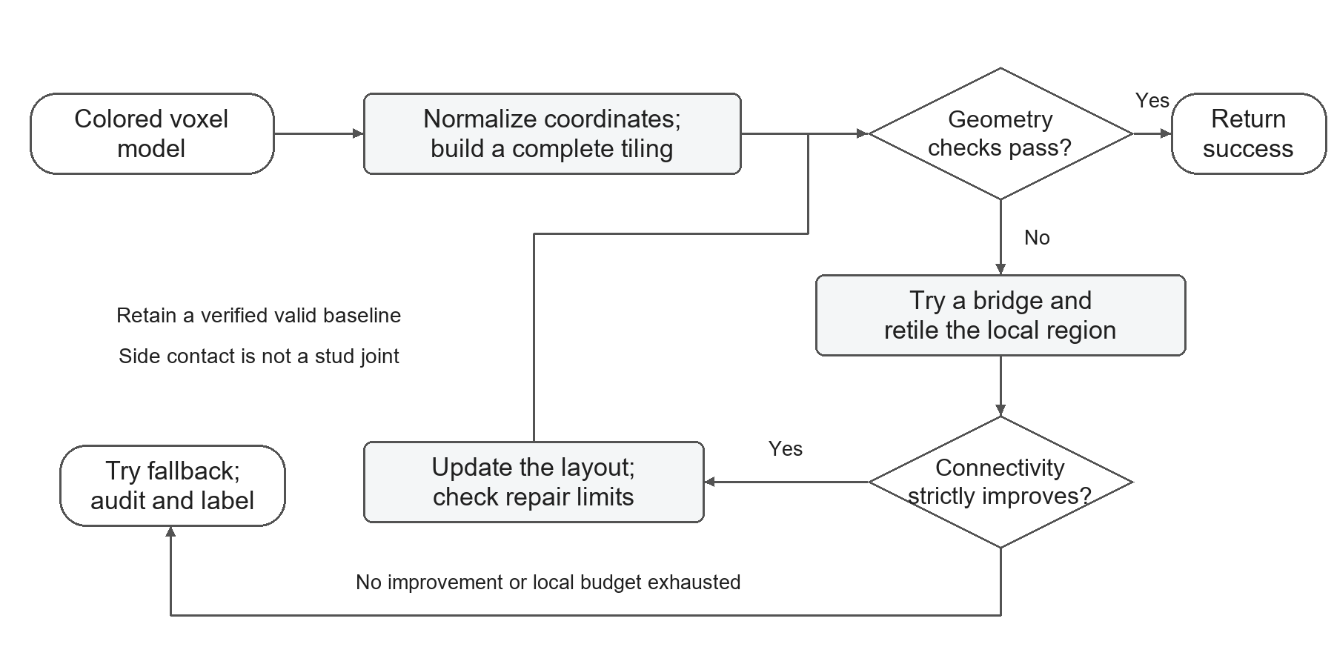
Figure 2 Local bridge retiling and repair

Pseudocode 2 Local bridge retiling
01 Swap y and z in O; validate bounds, colors, and ground contact;
02 if a baseline is independently verified and repair compliant then return it;
03 (B, C) ← the better of two complete monochrome tilings and its target;
04 for at most 64 local updates do
05 if the local budget is exhausted or geometry checks pass then break;
06 Try bridges in priority order; remove intersected bricks and retile the remainder;
07 M ← the better variant of the first candidate that strictly improves connectivity;
08 if M is absent then break;
09 (B, C) ← M; recheck repair limits;
10 end for
11 if geometry checks still fail and time remains then
12 Try the previous optimizer; accept only an independently verified valid fallback;
13 end if
14 return (B, C, SUCCESS or DRAFT according to the final audit);
Decision rule. Minimize ungrounded voxel count first, then ungrounded component count; this pair must strictly improve. Ties between variants favor fewer added voxels, then fewer bricks. A stud joint requires overlapping projections in adjacent layers; side contact does not qualify.
Repair limits. Local search uses about 82% of the budget. Local moves preserve original cells and colors; additions must lie within one grid step of the original model and stay within 2% of its voxel count. Baseline or fallback deletions require a valid total-change budget, deletion eligibility, and evidence of an additions-only failure. Drafts must still cover the entire target.
Acceptance Algorithm 1 requires one stud component. Algorithm 2 permits multiple grounded components. Geometry checks do not certify physical stability.
References BrickGPT, arXiv 2505.05469v3, pp. 5-6; project files gen_levels2.py and retile_core.py.

