**GSS Open Access Award Report - 2017**

# gss_logo_color-300.jpg

**Prepared by: Chantal Turpin, Director of University Relations &**

**Asura Enkhbayar, OAA Volunteer**

### Background

The GSS Open Access award was initiated in the year 2015, and based on that initial success was continued in 2016 and 2017. The GSS Open Access (OA) Award acknowledges graduate students who have published work in gold open access journals. The aim was to increase the visibility and prestige of such publications and support the open access movement’s ability to effectively disseminate research findings. The 2015, 2016, & 2017 GSS OA awards were jointly administered by the GSS and the SFU Library and consisted of up to six monetary awards of $125.00 each in 2015; up to seventeen monetary awards of $75 each in 2016; and up to twelve awards of $100.00 each in 2017.

### Adjudication of 2017 Awards

Applications were accepted from August 21st, 2017 to October to October 6th, 2017 and the winners were informed of their successful applications the week of October 23, 2017 in conjunction with Open Access Week 2017. The original application deadline of October 6th had to be extended until October 13th, 2017 because the library website had not been updated to reflect the information for the 2017 award. In total, we received 15 applications from 14 applicants and awarded 12 grants of $100 each, selected by random lottery from all qualified applications. All students were confirmed to be current graduate students, with all 12 (100%) recipients pursuing doctorate degrees. All applicants were also asked to complete the statement “open in order to..” which was the theme for the 2017 Open Access Week. The total budget for the award was $1250, with the GSS and the SFU Library each contributing $500, and a contribution from the VP Research office of $250. The Dean of Graduate Studies office declined a request to contribute financially to this award for this year. All but one of the winning papers had at least one co-author (5 of 12, 42%), with 6 having three or more co-authors (50%). Figure 1 depicts the distribution of applications across departments for the 2017 awards (compared to the 2015 & 2016 awards) and Figure 2 depicts where the applicants published for the 2017 awards (compared to the 2015 & 2016 awards).

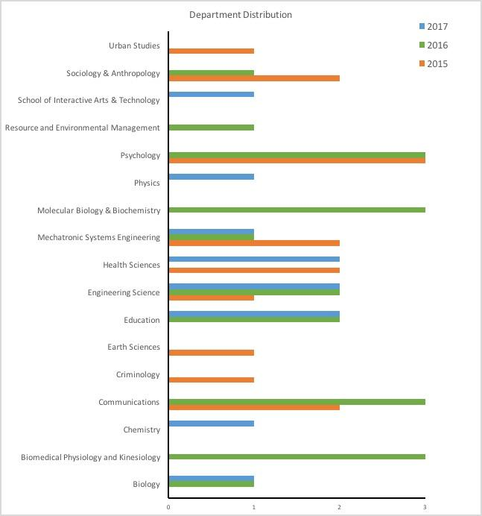

Figure 1. Department distribution of award recipients in 2017 compared to 2015 & 2016.

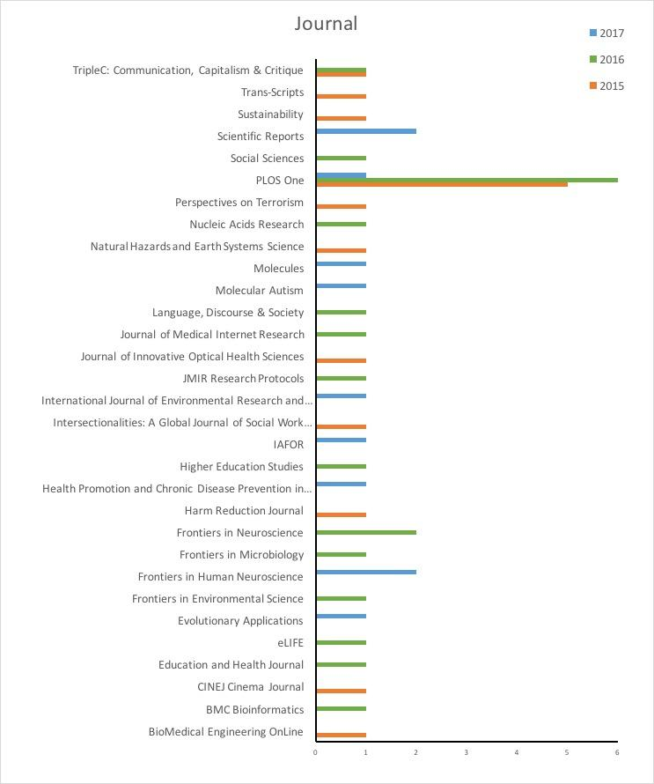

Figure 2. Journals of publication of successful applicants in 2017 compared to 2015 & 2016.

### Looking Ahead – 2018 Award

The Graduate Student Society has successfully conducted the Open Access Award (OAA) in the last three years. While the number of awarded students and their award sizes varied, there has always been positive feedback from the students. Considering the history of SFU as a home of strong voices supporting Open Access such as the Public Knowledge Project (PKP) and current international developments such as the aborted negotiations between national consortia and Elsevier (more details here: <https://www.the-scientist.com/news-opinion/universities-in-germany-and-sweden-lose-access-to-elsevier-journals--64522>) the importance and impact of Open Access on the campus is becoming visible. In 2018, we want to continue to optimize and improve our efforts at recognizing and rewarding examples of Open Scholarship in the form of Open Access publications at SFU. Thus, to work towards a more sustainable and successful OAA we want to reflect on the last three years and overhaul structural and operational elements of the award to achieve the desired improvements.

### **Reflecting on three years of OAA**

* **Financial**
  + The number and size of awards has been fluctuating over the last few years as (1) funding wasn't stable and (2) we also tried to optimize the size of the award. This year we are settling on $100 per award, which is the middle ground between 2017 (125) and 2016 (75) while we are also hoping to increase the volume of awards (20-30).
  + As the award is dependent on the funding and support of institutions within SFU, a better recognition of that contribution could help to incentivize continued and new support from SFU related entities.
* **Operations within GSS**
  + Even though the OAA is relatively low-effort, management and organization among and within GSS members has been a challenge. Thus, there is an interest in (1) streamlining and optimizing the workflow of the award and (2) and reorganizing the internal responsibilities.
* **Transparency**
  + The reports are an important tool for future OAAs as well as funders. In an effort to increase transparency we would like to (1) automatize parts of the reporting and (2) publicly publish the annual reports.

**What Will Change for the 2018 Award:**

Goals

* Rework application form with automation in mind
* Create Python scripts to:
  + Check eligibility of applicants
    - Have all mandatory fields been filled out in the form?
    - Is the publication venue listed in the DOAJ?
    - Has the applicant already received an award for the submitted work?
  + Tag those entries that could not be verified automatically for further manual revision
  + Run lottery to select winners
  + Automatically create plots and statistics for annual reports
* Rework responsibilities within GSS – this will primarily include shifting oversight responsibility of this award from the Director of University Relations to the Director of Graduate Services
* Increase reproducibility and transparency of the award structure
  + Create an openly available repository containing all materials and documented materials to run the award:
    - Common text templates for similar awards run at other universities and institutions
    - Marketing materials (images, logos, slides)
    - Python scripts for the actual execution of the award
    - Collection of tips and how-to’s (e.g., how to acquire initial funding? How to approach your library?)

Timeline

* Marketing material ready & beginning of application period: *September 01, 2018*
* End of application phase: *October 14, 2018*
* Announcement of winners: *October 22-28, 2018* (Open Access Week)

Budget

|  |  |  |  |
| --- | --- | --- | --- |
| *Organization* | *Requested* | *Approached* | *Confirmed* |
| Graduate Student Society | $1,000 | yes | yes |
| SFU Library | $1,000 | yes | yes |
| VP research | up to $500 | yes\* | tbd |
| Dean of Graduate Studies | up to $500 | yes\* | tbd |
| Public Knowledge Project (PKP) | up to $500 | yes | no |
| Publishing Program | up to $500 | no | tbd |
| Directory of Open Access Journals (DOAJ) | up to $500 | no | tbd |

\*Request for funding in progress

Budget goal of *$3,000* to be fully distributed to award winners.

**Application Criteria (italics are additions)**

1. The article has to be published or accepted for publication in a venue that is registered in the Directory of Open Access Journals (DOAJ) or *fulfill the formal requirements to be included.*
2. GSS OA Award will be open to current GSS members and recent graduates (within 1 year of convocation)
3. *Individual publications can only be awarded once but previous winners are welcome to apply with a different Open Access publication.*