Rover Vos & Nathalie Kamp

Write-up final Project Programming4WCI

**Synopsis**

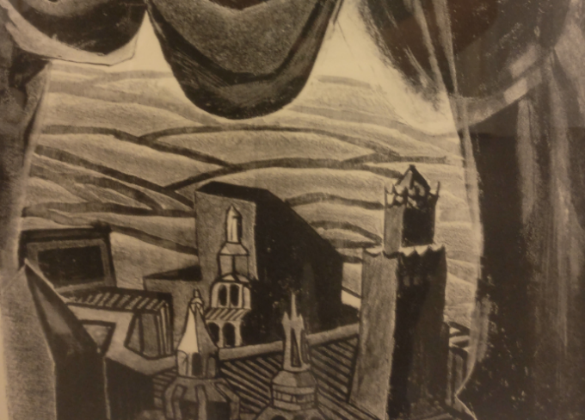We choose “Het land achter de gordijnen” (located on the first floor in the vrijnhof, near the piano). For our Program we made a Ghost city, we have one Ghost that can be moved through the arrow keys. I it comes near the lanterns we added they get turned on and if all the Lanterns are turned on a bell rings and many smaller ghosts appear in the background. We used the black rectangle on the left of the picture as a screen to display a little movie, this can be activated through clicking the screen.

**Usage and interaction**

Mouse clicked on Witch 🡪 witch laughs

Mouse clicked on Screen 🡪 Movie playing at Screen

Arrow keys 🡪 Ghost can be moved

If Ghost passes Lantern 🡪 Lantern lights up

If all Lanterns are lightened up 🡪 church bell is rang

🡪 more ghosts appear

Witch flies over the screen

Clouds moving in the background

Bats flying over the screen

**Architecture**

**main tab:** calls all the classes and handles everything related to the artwork

*method setup:* loading all the images and responsible for constructors

*method draw : calls all the classes, plays the bell and draws the images including the moon*

*method mouseClicked : calls Screen and Witch if mouse is clicked*

*method keyPressed : calls Ghost if keys are pressed*

**class Bat:** responsible for displaying and moving the bats

*method display: display the different pictures for the animation after each other*

*method move: keeping bats inside screen and making it move randomly*

**class Ghost:** handles everything related to the main ghost and the lanterns

*method display :* displays main ghost, handles the images

*method light :* checks if ghost is near lantern, if yes lights them up and checks if all are on

*method getMoved :* handles the ghosts movement through the arrow keys and keeps him in the screen

**class Ghosts**: responsible only for the ghosts in the background

*method move :* handling the movement of the ghosts in the back

*method show :* displaying the ghosts in the background

**class Lantern:** responsible for displaying, lightening and checking the lanterns

*method display: handles the displaying of the lanterns regarding to if they are on or off*

*method turnOn: tells if lanterns are on*

**class Screen:** responsible for checking if the mouse is over the screen and displaying it

*method display :* displaying the screen

*method isOver :* checking whether or not the mouse is over the Screen

**class Cloud:** responsible for displaying and moving the clouds

*method display :* displaying the clouds

*method moveClouds:* move the clouds from left to right and back to start if out of Screen

**class Witch:** responsible for displaying and moving the witch and for checking if she is clicked and laugh if so

*method display:* displaying the image of the witch

*method move:* making the witch move and putting her back into the screen if she leaves it

*method sound:* play the laughter if witch is clicked

