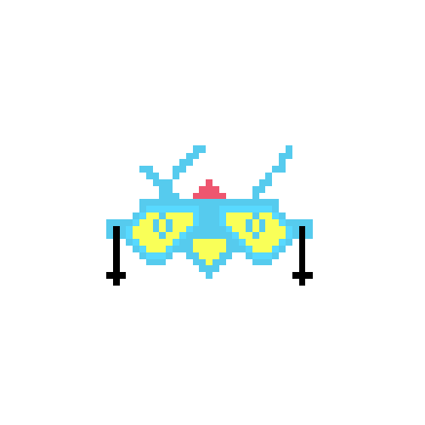

**Final Project Report**

**Beat Invaders**

**By Team Beat**

**Selected Topics in Game Engineering**

Final report

**Team Beat:**

Mano Marichal, Tim Sanders & Rover Vos

**Beat Invaders**

Beat Invaders is a game where the player imports any music track they like and the game will transform that track into a unique gameplay experience using the beat track of the song. The player then presses the spacebar to the beat of the music, every button press shooting a missile. The player needs to shoot these missiles at the incoming aliens by aiming at them with the mouse. Hitting the beats in succession without missing any will increase your combo score which also increases the damage your missiles do, visualised by the color of the missiles.

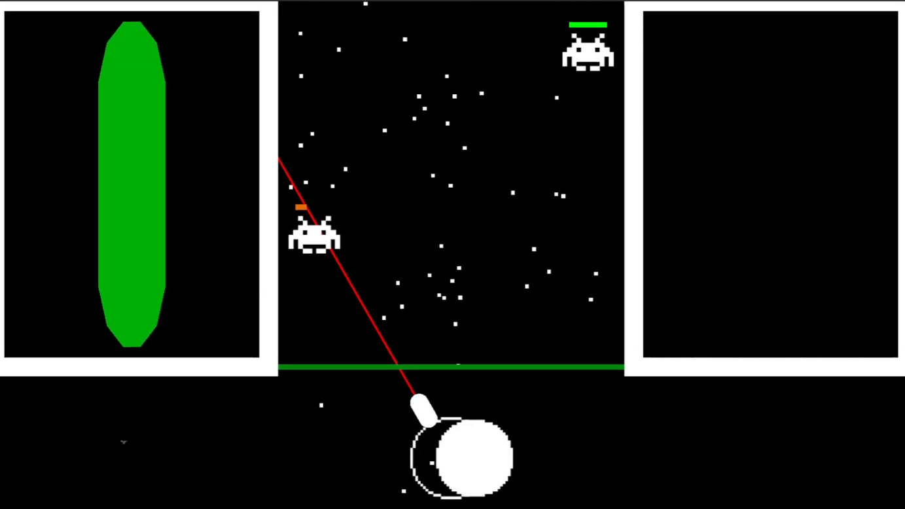

**Implementation**

The concept of the game was decided upon right after the first lecture. In the hallway, we chatted about some ideas and come up with a little rhythm game that uses one button.

To refine the game concept the team sat together and brainstormed for about an hour. After some sketching and bouncing ideas off each other, we came to the final concept which became the game. There were no implications while coming up with the game nor did we deviate from the original concept during development.

After coming up with the concept the team discussed who was going to work on what and in the end it was decided that Tim and Mano would code the game and that Rover would do all the paperwork. We made it clear who was going to create what for the game and everyone went to work.

Mano started coding the base functionality of the game while Tim would integrate the music system into the game. The moment Mano finished his part Tim started to implement the music and Mano continued with creating the shaders and SFX for the game.

Rover followed all the given deadlines and did most of the work for all the documentation for the project. GDD, Presentations, playtest documents, etc.

**Technologies**

The game was created in Unity. However at first, we were looking into using Godot, but in the end, we decided to use Unity, because it has better documentation on how to implement Spotify into the game.

The game was made in 2D for PC. At first, we wanted to make it a mobile game, but we decided against that because there were some issues with the usage of the Spotify API on mobile.

The Rider IDE was used to code everything in C#.

The shaders of the game were created using Unity’s build in shader graph. And with some prototyping in Shadertoy.

Something something Music.

GitHub was used to share the project with the team members.

**Organization Process**

At the start of the product, we discussed how we were going about creating this game and finishing this class. We decided that Mano would create the base game, Tim would implement the music integration afterwards and Rover would manage all the paperwork.

The milestones for this project were very simple. We said that Mano would finish the base game and Tim figured out how to implement the Spotify API into Unity by the end of May. Tim would then implement the music by the end of June while Mano was creating the Visual effects. Rover followed all the deadlines given by the course for hand-ins and presentations.

No task tracking was used, we only tracked the milestones. This is because the game had to be a rather small game and the milestones could be seen as tasks in larger games. Furthermore, most of the tasks were tracked by the lecture in the form of deadlines. Using those for most things was sufficient, only the development had to use a bit more tracking.

After each milestone completion, we had a group meeting to see the results and discuss feedback about the created work. This helped keep the group on one line and was a nice way to show each other our progress.

The game design document is structured in 3 parts. First the general information about the game. Description, team, genre, target audience, etc. Followed by the gameplay and the win/lose conditions. Then the game elements are discussed. The character, health, art, etc.

**Challenges and solutions**

There weren’t a lot of problems during this project, but here are a couple of challenges we encountered.

One of the major problems we found is the Spotify rules. Spotify doesn’t allow the usage of their API for games. So we had to divert from that and implemented a simpler system with preset music. In the end, we implemented songs into the game ourselves. This was a rather

Team Beat is missing one crucial team member. An artist. The three of us are engineers. To solve this we decided to not think too much about the art. We kept everything super basic. Mano however did want to practice making shaders and that is why Beat Invaders has some awesome visual effects.

**Workload distribution**

The workload of the project was well balanced. The programming was nicely split up in two and all the paperwork was about the same workload. It was very nice that we discussed at the start about who was going to do what. Because of that everyone knew from the start what they had to do and everyone agreed on doing their part.

Mano is the Game designer and Programmer

Tim is the Game designer and Programmer

Rover is the Game designer and Secretary