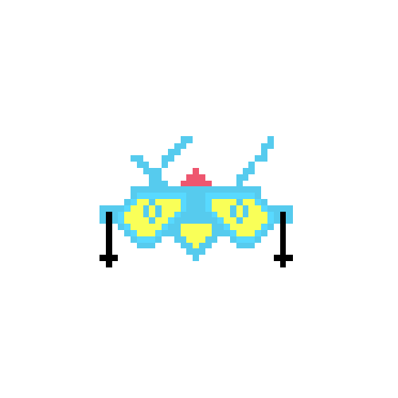

**Game Design Document**

**Beat Invaders**

**By Team Beat**

**Selected Topics in Game Engineering**

Game Design Document

**Team Beat:**

Mano Marichal, Tim Sanders & Rover Vos

Game Analysis

Team

* Mano
  + Game Design and Programmer
* Tim
  + Game Design and Programmer
* Rover
  + Game Design and Secretary

General Information

**Game description**

The greatest musicians needed to protect the planet against the incoming alien invaders! The space marine's new beat tech requires only the people with the best rhythm to fire missiles on the beat of your favourite music. Defend the planet in our one-button outer space missile launchers! Can you defend the planet against the looming invasion?

**Unique Selling Points**

Implement any song you like

Near infinite replayability

One-Button game

**Genre**

Rhythm Action

**Atmosphere**

* Flashy, all the on-screen effects are very flashy and the gameplay feels very exciting.
* Player input is required, this depends heavily on the music imported by the player.

**Target Audience**

Anyone between the ages of 10-30 that enjoys playing games and listening to music.

**Inspiration**

* Space Invaders
* Guitar Hero/Beat Saber
* Bits & Bops

Gameplay

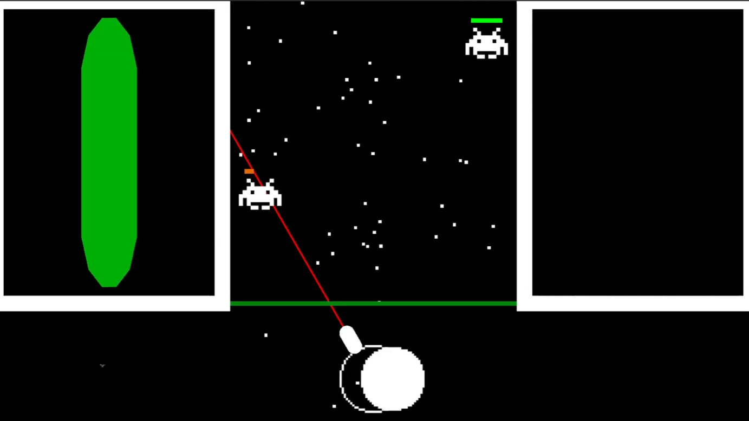

Core gameplay

The player starts by loading in their favourited music track. For the duration of the track, the player presses one button on the rhythm of the music while aiming with their mouse at the incoming aliens. Pressing the button shoots a missile at the aliens. Keep hitting the notes on the beat to increase your combo score which increases the damage of your missiles. Miss a beat and lose your combo and thus your damage. If an alien lands the player takes damage, losing all your health means defeat. The player regains health by keeping their combo up.

Win condition:  
Make it to the end of the song without losing all your health.

Lose condition:  
Let too many aliens pass through depleting your heath fully

Leaderboard:  
If the player makes it through the whole song they receive a score for their performance. This score is placed on the leaderboard.

Game elements

**The Player Character**

The player controls this little turret by moving the mouse around. Pointing the red line to where the mouse is.

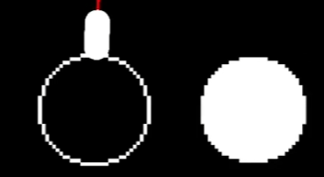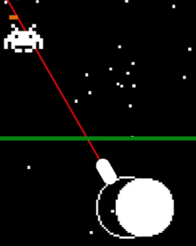

**Beats**

The filled white circles at the bottom of the screen are the beats. When they touch the player character the player can press a button to hit the beat. Depending on how the beat and the player overlap the player gains more/fewer combo points. More overlap is more combo points and vice versa.



**Health**

The player's health is shown with a green bar at the left of the screen. If depleted the player loses this round. Health is regained by hitting the beats.

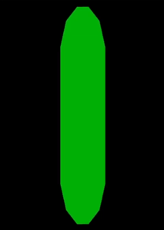

**Enemies**

The model for the enemies is fully inspired by Space Invaders. The enemies move down from the top of the screen towards the player, if they hit the green line the player takes damage. The enemies can get killed by shooting missiles at them.

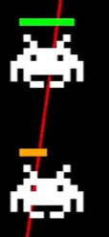

**Music**

The music of the game is music implemented by the player. Any music works and the game converts the imported track into a unique experience.