**Post Mortem: The daily life of a GSE student**

Rover Vos

Student number: 12235834

Course: Practical Game Engineering

Course code: 780.212

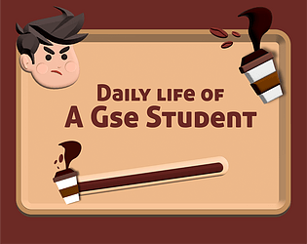

*The daily life of a GSE student* is a satire game on the real daily life of a Game studies and engineering student. It’s about a student who needs to finish its exams and requires a lot of caffeine to do so. Because of this, Demonbert offered a special type of coffee and now your entire life is hold together by coffee. Or at least that was the goal. Most of the mechanics are placed in the game, but many of the story aspects have not been implemented.

The game play is very straight forward. You walk around the university(With wasd) in search for two bosses to defeat. While walking around you can throw cups of coffee(With space) to fight off the hoard of other students(Figure x). If you get overwhelmed by the other students your caffeine meter will go down and you will be game over. The two bosses(Figure x), should have been 3, are based around teachers who where willing to be part of the game and even helped us with voice-overs. The boss mechanics are a form of a quiz(Figure x) where you get asked a multiple-choice question and can walk into a corner to answer them. Most of the questions are very straight forward and some can be quite funny. We wanted to make all the questions funny, but we didn’t managed to do so.

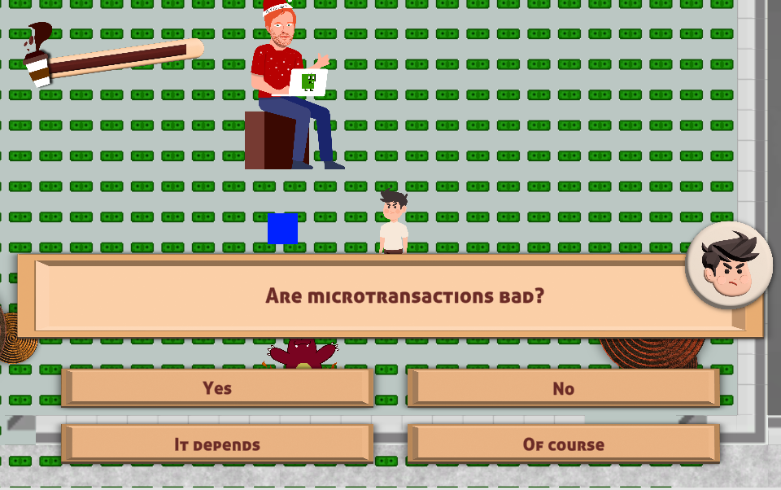

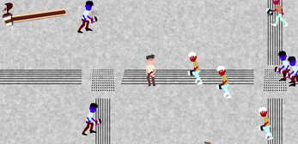

The team was composted of 5 people. Jey, Elias, Deniz, Chris and myself. Jey’s focus was on creating the game in Unity. Elias composed all the music for the game. Deniz did all the art for the game. Chris created all the sound effects and did the voice-over recordings. I did the level design. Everyone worked on the game design aspect in different amounts. The communication in team was quite nice. We didn’t do much for it, we just started working and stayed at one table talking to each other a lot. Whenever someone needed something or someone needed help it was asked and solved. It was a very nice team to work in and every I think everyone was quite happy with the team dynamic in the end.

The time management of the game jam was not the best. We had a goal and just tried to achieve it. Outside of how late we stopped jamming and how earlier we started again no real time plan was made. Everyone did take their own breaks in addition to the food breaks provided by the jam. During the jam we did discuss the timeline a lot. Many mechanics, art assets and sound effects have been cut out during the development of the game. To enhance this further we decided to first focus on having something of a game that has a start and an end. After that we started adding additional aspects. Which we never got to. We cut up the game enough to just be done with the basic game in the end.

One of the things I particularly enjoyed during the game jam was the first time I heard the sound track. Followed by hearing all the sound effects. I am super happy with how the sound of this game ended up.

When looking at the other side of the coin and think about the things that went wrong during the game jam.