crystal oscillator

ht12 sop

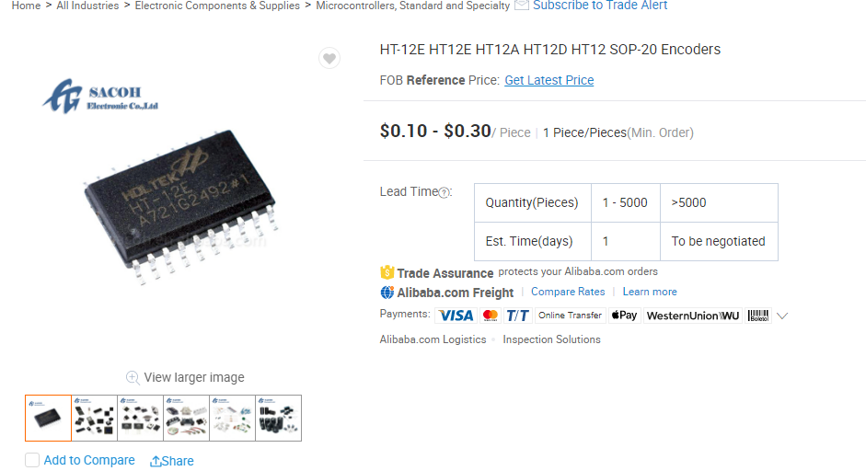

Ht12 dip

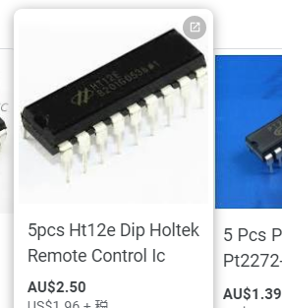

F115 transmitter

https://www.aliexpress.com/item/32340601145.html