[10:25 AM] Mihir Bava

like 1

[10:25 AM] Fatinah Hayat

Zak, can you help me with the pdf in the break please? It is not letting me copy it to vs

[10:25 AM] Tanzina Rahman

<video width="640" height="360" controls>

    <source src="mov_bbb.mp4" type="video/mp4">

    Your browser does not support the video tag.

  </video>

like 1

[10:25 AM] Jason Umeyor

like 1

[10:26 AM] Zeinab Abu

like 1

[FireShot Capture 011 - Document - 127.0.0.1.png](https://justit831.sharepoint.com/sites/msteams_737ddd/Shared%20Documents/General/FireShot%20Capture%20011%20-%20Document%20-%20127.0.0.1.png)

[10:31 AM] Erica SAMBA-NGOIE

[Screenshot 2023-11-23 at 10.30.22.png](https://justit831.sharepoint.com/sites/msteams_737ddd/Shared%20Documents/General/Screenshot%202023-11-23%20at%2010.30.22.png)

[10:33 AM] Zakirullah Pardis

<https://www.w3schools.com/html/html_entities.asp>

[10:38 AM] Zakirullah Pardis

<https://www.w3schools.com/html/html_symbols.asp>

HTML Symbols

W3Schools offers free online tutorials, references and exercises in all the major languages of the web. Covering popular subjects like HTML, CSS, JavaScript, Python, SQL, Java, and many, many more.

[10:40 AM] Zakirullah Pardis

<https://www.w3schools.com/html/html_emojis.asp>

HTML Emojis

W3Schools offers free online tutorials, references and exercises in all the major languages of the web. Covering popular subjects like HTML, CSS, JavaScript, Python, SQL, Java, and many, many more.

[10:42 AM] Zakirullah Pardis

<https://www.toptal.com/designers/htmlarrows/symbols/>

HTML Symbols, Entities and Codes — Toptal Designers

Easily find HTML symbols, entities, characters and codes with ASCII, HEX, CSS and Unicode values; including copyright sign, trademark sign and at symbol.

[10:51 AM] Erica SAMBA-NGOIE

how do you get it to stop constantly asking to save the PDF?

[10:53 AM] Jason Umeyor

open it it in a live server

[10:53 AM] James Vethamony

You can use <object data="url_of_pdf" instead of <iframe src ="url_of_pdf"

[10:54 AM] Zakirullah Pardis

11:20

[12:15 PM] James Vethamony

[JamesV_Day4_06.PNG](https://justit831.sharepoint.com/sites/msteams_737ddd/Shared%20Documents/General/JamesV_Day4_06.PNG)

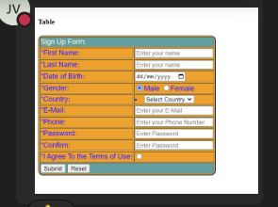

[12:15 PM] Zakirullah Pardis

I would like you to create a clothing website: having some pictures, heading, paragraphs, link, buttons if necessary

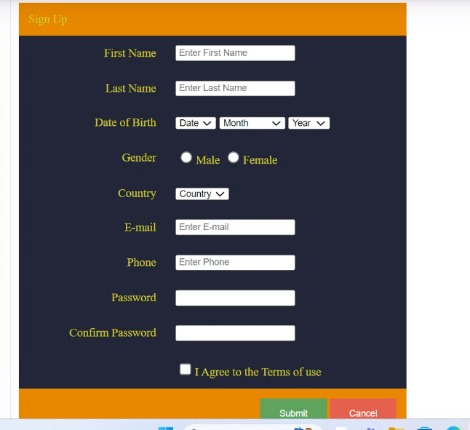

[12:33 PM] Fatinah Hayat

thank you

[12:33 PM] Zakirullah Pardis

I would like you to create a clothing website: having some pictures, heading, paragraphs, link, buttons if necessary

[12:33 PM] Mihir Bava

Thank you!

[12:33 PM] Philip Jabry

can i sell chickens instead of clothes? chickens are more versatile

[12:33 PM] James Vethamony

Very simple clothing website:

like 1

[JamesV_Day4_07.PNG](https://justit831.sharepoint.com/sites/msteams_737ddd/Shared%20Documents/General/JamesV_Day4_07.PNG)

[12:34 PM] Erica SAMBA-NGOIE

ok just create a simple site with tables?

[12:34 PM] Nikita Shah

like 1

[Screenshot 2023-11-23 123348.png](https://justit831.sharepoint.com/sites/msteams_737ddd/Shared%20Documents/General/Screenshot%202023-11-23%20123348.png)

[12:34 PM] Johanna Chambers

like 1

[Screenshot 2023-11-23 at 12-33-50 Document.png](https://justit831.sharepoint.com/sites/msteams_737ddd/Shared%20Documents/General/Screenshot%202023-11-23%20at%2012-33-50%20Document.png)

[12:34 PM] James Vethamony

Website  code:

    <h1 style = "color: red; background-color: green; font-family: Arial, Helvetica, sans-serif;">Christmas Clothing</h4>

        <table>

          <td>Mens <img src="../HTML/Images/ClothingWebsite/Wk10Menstier1.webp" width = "40%" alt="Mens"></td>

          <td>Womens <img src="../HTML/Images/ClothingWebsite/Wk10WomensTier1.webp"width = "40%" alt="Women"></td>

          <td>Kids <img src="../HTML/Images/ClothingWebsite/Wk10kidstier1.webp" width = "40%"alt="Kids"></td>

        </table>

        <p>

            <h3>Christmas Cloting Website</h3>

            <p>Lorem ipsum dolor sit amet consectetur adipisicing elit. Autem adipisci pariatur est in, accusantium exercitationem fugit voluptates, corporis eaque officia vitae quaerat! Architecto voluptates mollitia accusantium tempore blanditiis deserunt quaerat!</p>

        </p>

    <nav>

        <div class="heading">

          <h4>Site Links</h4>

        </div>

        <ul class="nav-links">

          <li><a class="active" href="index.html">Home</a></li>

          <li><a href="pages/about.html">About</a></li>

          <li><a href="pages/services.html">Services</a></li>

          <li><a href="pages/contact.html">Contact</a></li>

        </ul>

      </nav>

[12:34 PM] Johanna Chambers

like 1

[Screenshot 2023-11-23 at 12-33-50 Document.png](https://justit831.sharepoint.com/sites/msteams_737ddd/Shared%20Documents/General/Screenshot%202023-11-23%20at%2012-33-50%20Document.png)

[12:34 PM] James Vethamony

Website  code:

    <h1 style = "color: red; background-color: green; font-family: Arial, Helvetica, sans-serif;">Christmas Clothing</h4>

        <table>

          <td>Mens <img src="../HTML/Images/ClothingWebsite/Wk10Menstier1.webp" width = "40%" alt="Mens"></td>

          <td>Womens <img src="../HTML/Images/ClothingWebsite/Wk10WomensTier1.webp"width = "40%" alt="Women"></td>

          <td>Kids <img src="../HTML/Images/ClothingWebsite/Wk10kidstier1.webp" width = "40%"alt="Kids"></td>

        </table>

        <p>

            <h3>Christmas Cloting Website</h3>

            <p>Lorem ipsum dolor sit amet consectetur adipisicing elit. Autem adipisci pariatur est in, accusantium exercitationem fugit voluptates, corporis eaque officia vitae quaerat! Architecto voluptates mollitia accusantium tempore blanditiis deserunt quaerat!</p>

        </p>

    <nav>

        <div class="heading">

          <h4>Site Links</h4>

        </div>

        <ul class="nav-links">

          <li><a class="active" href="index.html">Home</a></li>

          <li><a href="pages/about.html">About</a></li>

          <li><a href="pages/services.html">Services</a></li>

          <li><a href="pages/contact.html">Contact</a></li>

        </ul>

      </nav>

[12:35 PM] Johanna Chambers

where do we submit the clothing website once your off teams?

like 1

[12:35 PM] Nikita Shah

Hi Zakirullah Pardis, just reminder, I will not able to attend tomorrow's class.          Thank You

[12:37 PM] Johanna Chambers

thank you!

[12:37 PM] Philip Jabry

bye all

[12:37 PM] Zakirullah Pardis

**Johanna Chambers**

where do we submit the clothing website once your off teams?

I will create a folder into the team, you can upload it there