[9:17 AM] Tanzina Rahman

like 1

[9:18 AM] Luqman Ali

[9:18 AM] Akansha Dhote

like 1

[Screenshot 2023-11-24 at 09.18.15.png](https://justit831.sharepoint.com/sites/msteams_737ddd/Shared%20Documents/General/Screenshot%202023-11-24%20at%2009.18.15.png)

[9:19 AM] Fatinah Hayat

like 1

[9:20 AM] Fisayo Runsewe

done 2nd tsk

[9:21 AM] James Vethamony

like 1

[JamesV_Day5_01.PNG](https://justit831.sharepoint.com/sites/msteams_737ddd/Shared%20Documents/General/JamesV_Day5_01.PNG)

[9:21 AM] Johanna Chambers

i want to printscreen my code but I dont know how to only can do the live server page

like 1

[Screenshot 2023-11-24 at 09-20-32 Day5.png](https://justit831.sharepoint.com/sites/msteams_737ddd/Shared%20Documents/General/Screenshot%202023-11-24%20at%2009-20-32%20Day5.png)

[9:22 AM] Muhammad Khan

like 1

[9:22 AM] Erica SAMBA-NGOIE

like 1

[Screenshot 2023-11-24 at 09.21.02.png](https://justit831.sharepoint.com/sites/msteams_737ddd/Shared%20Documents/General/Screenshot%202023-11-24%20at%2009.21.02.png)

[9:24 AM] Fisayo Runsewe

like 1

[Screenshot 2023-11-24 at 09.23.34.png](https://justit831.sharepoint.com/sites/msteams_737ddd/Shared%20Documents/General/Screenshot%202023-11-24%20at%2009.23.34.png)

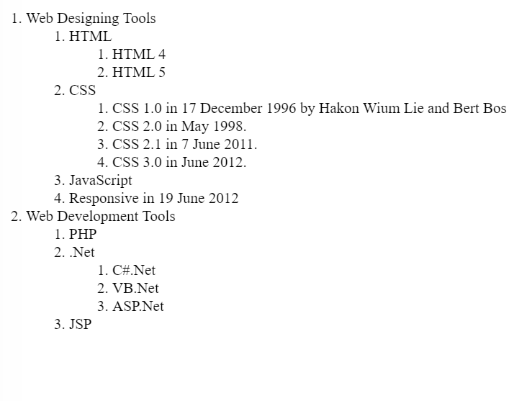

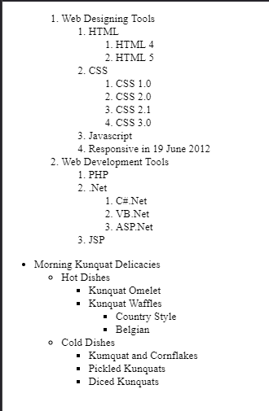

Morning Kunquat Delicacies

Hot Dishes

Kunquat Omelet

Kunquat Waffles

Country Style

Belgian

Cold dishes

Kunquat and Cornflakes

Pickled Kunquats

Diced Kunquats