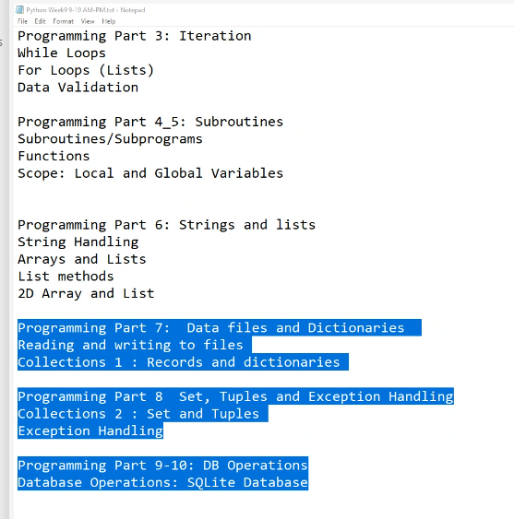

[11:11 AM] James Vethamony

import os

file_path = '<filepath>/fake_file.txt'

# ^ your file path

try:

    if os.path.exists(file_path):

        with open(file_path, 'w') as file:

            file.write("Testing\n")

        print("successfully written to the file")

    else:

        print("Error: File not found")

except Exception as e:

    print("An error occurred:", e)

^ i did it like that

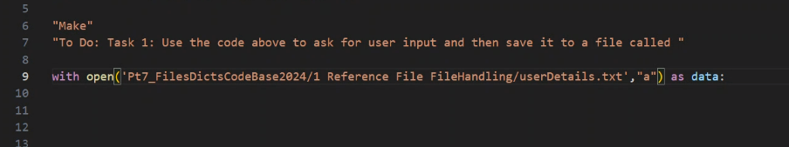

christopherb@justit.co.uk