**HTML:**

<body>

    <h2>Basic Calculator</h2>

    <form class="container calculator">

        <input type="text" id="numberone">

        <p style="display: inline; color:snow;"> + </p>

        <select name="" id="dropD" width="10">

            <option value="operate">Operation</option>

            <option value="plus">+ plus</option>

            <option value="minus">- minus</option>

            <option value="multiply">* multiply</option>

            <option value="divide">/ divide</option>

            <option value="power">^ power</option>

        </select>

        <input type="text" id="numbertwo" />

        <input type="button" id="calc" value="Calculate!" onclick="calculate()" />

        <input type="number" id="result" disabled /> <!-- JS will create a value and insert the result -->

        <input type="reset" id="reset" name="reset">

    </form>

    <script src="/JavaScript/JSday9/calculator.js"></script>

</body>

</html>

**CSS:**

// The function below will take 2 values and will perform an operatrion on them

function addit(valueOne, valueTwo) {

  //convert strings to numbers and add together

  return Number(valueOne) + Number(valueTwo); // convert string value to a number value

};

function subtract(valueOne, valueTwo) {

  //convert strings to numbers and subtract 2nd from 1st

  return Number(valueOne) - Number(valueTwo); // convert string value to a number value

};

function prod(valueOne, valueTwo) {

  //convert strings to numbers and multiply together

  return Number(valueOne) * Number(valueTwo); // convert string value to a number value

};

function quot(valueOne, valueTwo) {

  //convert strings to numbers and divide 2nd into 1st

  if (valueTwo == 0){

    return 0 // Cannot divide by zero

  } else {

    return Number(valueOne) / Number(valueTwo); // convert string value to a number value

  }

};

function powr(valueOne, valueTwo) {

  //convert strings to numbers and raises the 1st by the power of the 2nd

  return Math.pow(Number(valueOne), Number(valueTwo)); // convert string value to a number value

};

function operate() {

  return 0

};

  // define some basic variables we need for the calculate function

  const operator = document.getElementById("dropD.value") // operation

  const numberOne = document.getElementById("numberone") //INPUT 1

  const numberTwo = document.getElementById("numbertwo") //INPUT 2

  let oper = document.getElementById("dropD.value") //Operation value

  //Calculate - the fuction that brings it all together

  function calculate(){

    //calculate calls the appropriate function and valueOne and valueTwo are provided inside brackets

    switch(dropD.value){

      case "plus":

        var calc = addit(numberOne.value, numberTwo.value);

        result.value = calc.toString();

      break;

      case "minus":

        var calc = subtract(numberOne.value, numberTwo.value);

        result.value = calc.toString();

      break;

      case "multiply":

        var calc = prod(numberOne.value, numberTwo.value);

        result.value = calc.toString();

      break;

      case "divide":

        if(numberTwo.value == 0){

          var calc = 0;

        } else {

        var calc = quot(numberOne.value, numberTwo.value);

        result.value = calc.toString();

        }

      break;

      case "power":

        var calc = powr(numberOne.value, numberTwo.value);

        result.value = calc.toString();

      break;

      case "operate":

        var calc = 0;

        result.value.color = "red";

        result.value = calc.toString();

      break;

    }

  };

**LIVE SERVER:**

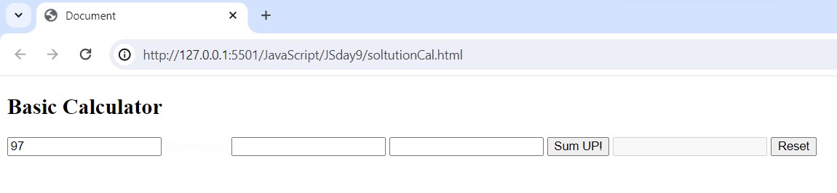

butAb = false

butBb = false

butB = false

butC = false

butDb = false

butD = false

butEb = false

butE = false

butF = false

butGb = false

butG = false

