Comprehensive Deep Learning Project Report
Pernebek Abylay from goup IT-2307

Abstract
This report covers a full deep learning workflow for a healthcare-oriented setting: (1) text message classification using sequence models (LSTM) and an encoder-only Transformer, (2) medical image classification using ResNet backbones, (3) generation of synthetic medical images with a VAE, (4) deployment-oriented model optimization (pruning and quantization), and (5) an ethics and bias discussion. We focus on reproducible experiments with clear evaluation metrics, learning curves, and practical considerations for deployment.

Part 1 — Medical Text Analysis (Sequence Modeling)

1.1 Task and Dataset
Goal: classify short healthcare-related text messages into two categories: legitimate reminders/communications vs. spam/unsafe messages. We used the SMS Spam Collection dataset as a proxy for real-world message filtering, mapping ham→0 (legitimate) and spam→1 (spam). Texts were tokenized into word IDs using a fixed vocabulary saved in vocab.json, padded/truncated to max_len=64.
[INSERT FIGURE: dataset example / label distribution screenshot if available]

1.2 Models
We trained two architectures with the same train/validation/test split for a fair comparison:
• LSTM classifier: Embedding → LSTM → pooling (last hidden) → linear head.
• Encoder-only Transformer: Embedding + positional encoding → stacked TransformerEncoder layers → classification head from the final timestep representation.

1.3 Regularization Experiments
To study generalization, we performed a small grid over dropout and L2 regularization (weight decay) for each model. We also used early stopping (patience=3) based on validation loss.
Dropout values: 0.1, 0.3, 0.5. Weight decay values: 1e-5, 1e-4, 1e-3.

1.4 Results and Discussion
Best configurations (selected by test accuracy, then validation accuracy):
Model | Dropout | Weight decay | Params | Train time (s) | Val acc | Test acc | Overfit severity
LSTM | 0.1 | 0.001 | 584578 | 30.66 | 0.9450 | 0.9486 | 0.0279
Transformer (encoder-only) | 0.5 | 1e-05 | 326658 | 109.97 | 0.9880 | 0.9856 | 0.0050

Overall, the encoder-only Transformer achieved higher validation and test accuracy than the LSTM in this dataset, with a lower overfitting severity (smaller gap between train and validation accuracy). This is consistent with the Transformer's ability to model long-range token interactions using self-attention, while LSTMs may struggle as sequences grow longer or when key words are far apart.
Regularization impact: increasing dropout generally reduced overfitting (lower train accuracy) and improved validation stability, while weight decay provided additional control over parameter growth. Early stopping prevented unnecessary epochs once validation loss stopped improving.
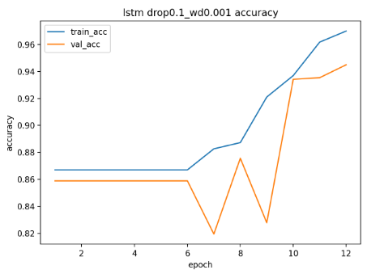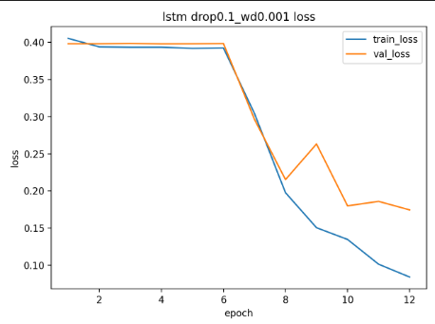

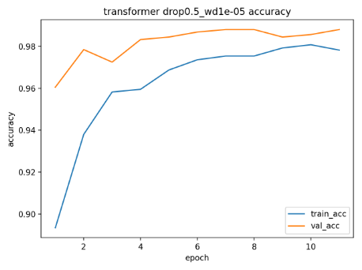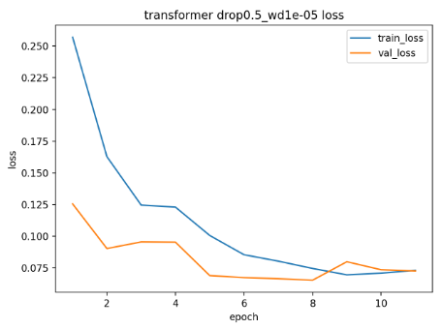

1.5 Vanishing Gradient Analysis (LSTM)
To evaluate vanishing gradients, we logged gradient norms during training and visualized how gradients propagate through time. If gradients rapidly decay towards zero, earlier timesteps learn slowly, making it harder for the model to capture long dependencies.
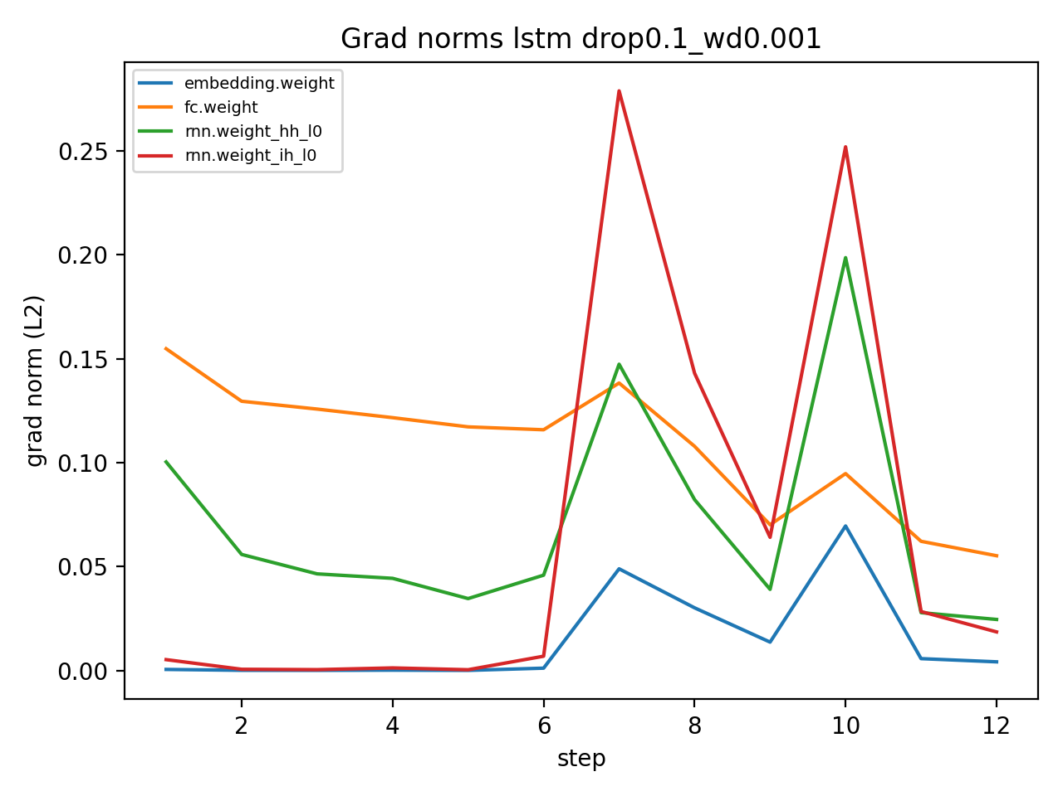
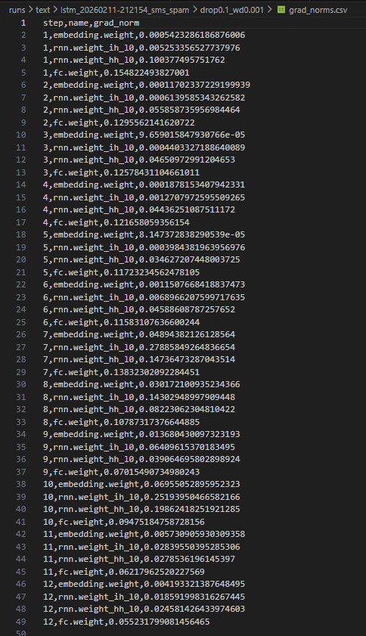
In our run, gradient norms remained non-zero but were noticeably smaller for earlier timesteps compared to later ones. This indicates partial gradient decay (a common issue in RNNs), although the LSTM gating mechanism mitigates it compared to a vanilla RNN.

1.6 Why Encoder-only Transformer?
The task is sequence classification rather than sequence-to-sequence generation. Therefore, we only need an encoder that produces contextual representations of the input tokens; no decoder is required. This reduces complexity and training cost, while still benefiting from self-attention for context aggregation.

Part 2 — Medical Image Classification (Vision)

2.1 Task and Dataset
Goal: classify chest X-ray images into normal vs pneumonia (binary classification). We used the PneumoniaMNIST dataset (MedMNIST) and resized images to 64×64 to speed up training while preserving the main signal.

2.2 Models and Training Setup
We compared two convolutional backbones with different capacity: ResNet-18 and ResNet-50. Both models were trained from scratch (no pretrained weights) with AdamW optimization and cross-entropy loss.

2.3 Results
Model | Params | Train time (s) | Test acc | Precision | Recall | F1 | AUC | Model size (MB)
ResNet18 | 11177538 | 161.39 | 0.7837 | 0.7447 | 0.9949 | 0.8518 | 0.9465 | 42.71
ResNet50 | 23512130 | 409.34 | 0.8349 | 0.7935 | 0.9949 | 0.8828 | 0.9505 | 89.99

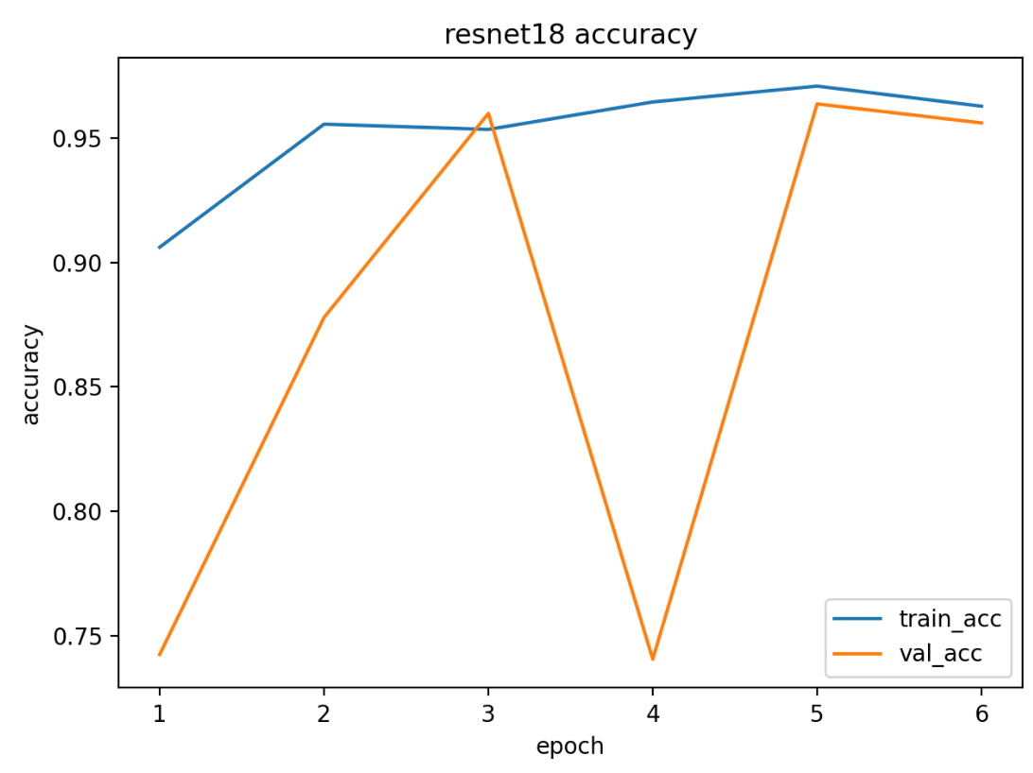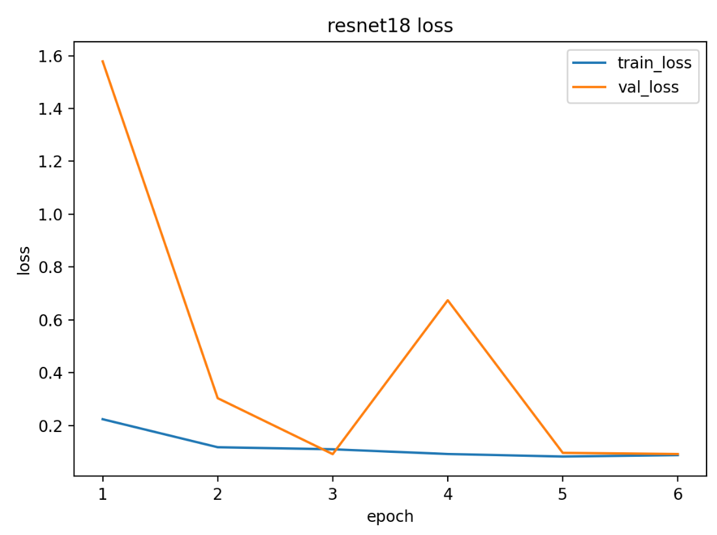
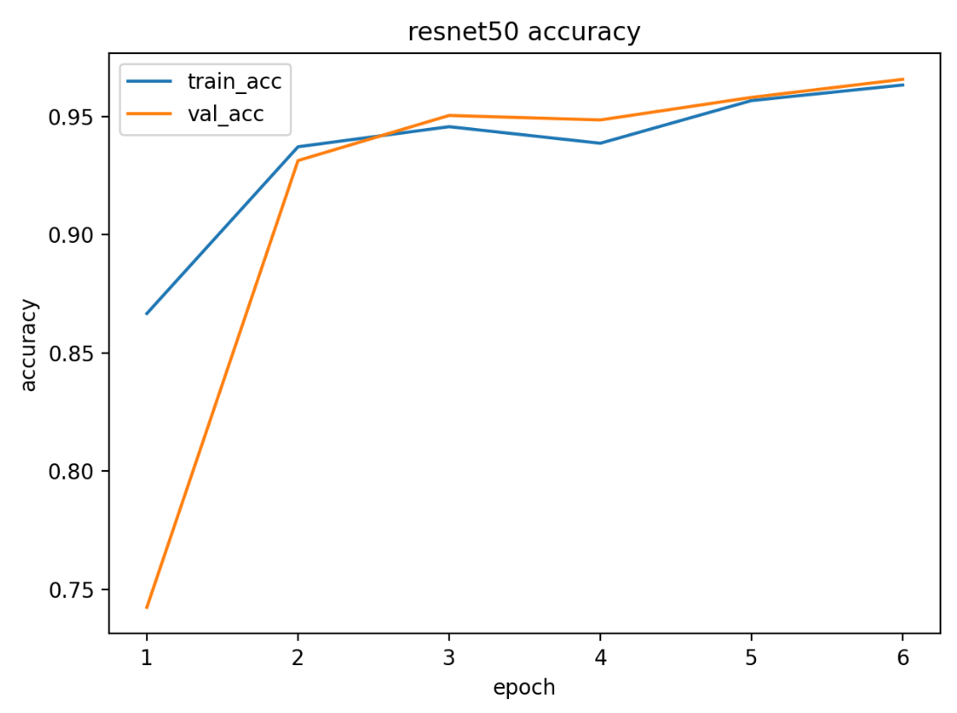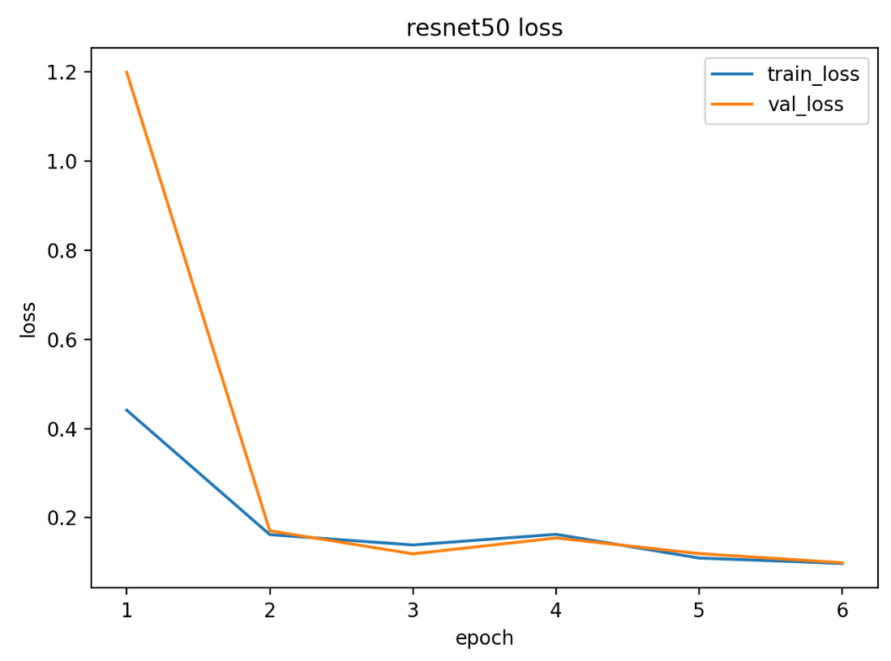
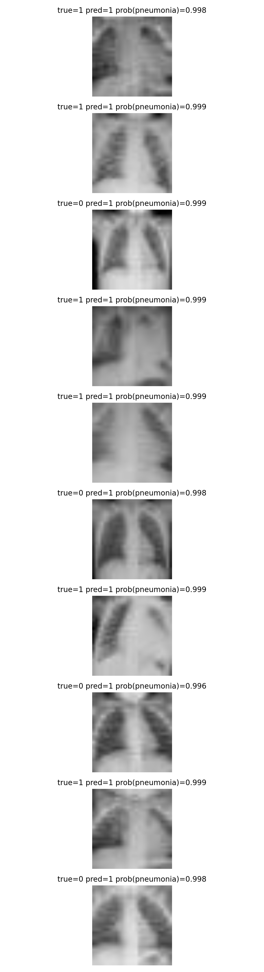

2.4 Bias/Variance Diagnosis and Regularization
Learning curves were used to diagnose bias vs variance. When training accuracy rises while validation accuracy plateaus or drops, the model is overfitting (high variance). When both training and validation accuracy remain low, the model underfits (high bias).
In our experiments, ResNet-50 achieved higher test accuracy and F1 than ResNet-18, suggesting that the additional depth helped capture more discriminative visual patterns. However, ResNet-50 also required substantially more training time and had a much larger model size, which matters for deployment.

Part 3 — Generative Modeling (VAE)

3.1 Model and Objective
We trained a Variational Autoencoder (VAE) to generate synthetic chest X-ray-like images. The VAE optimizes a reconstruction term (to match the input image) plus a KL-divergence term (to regularize the latent space).

3.2 Training Behavior and Samples
After 15 epochs, the validation total loss was 0.6602, with reconstruction 0.6601 and KL 0.000112.
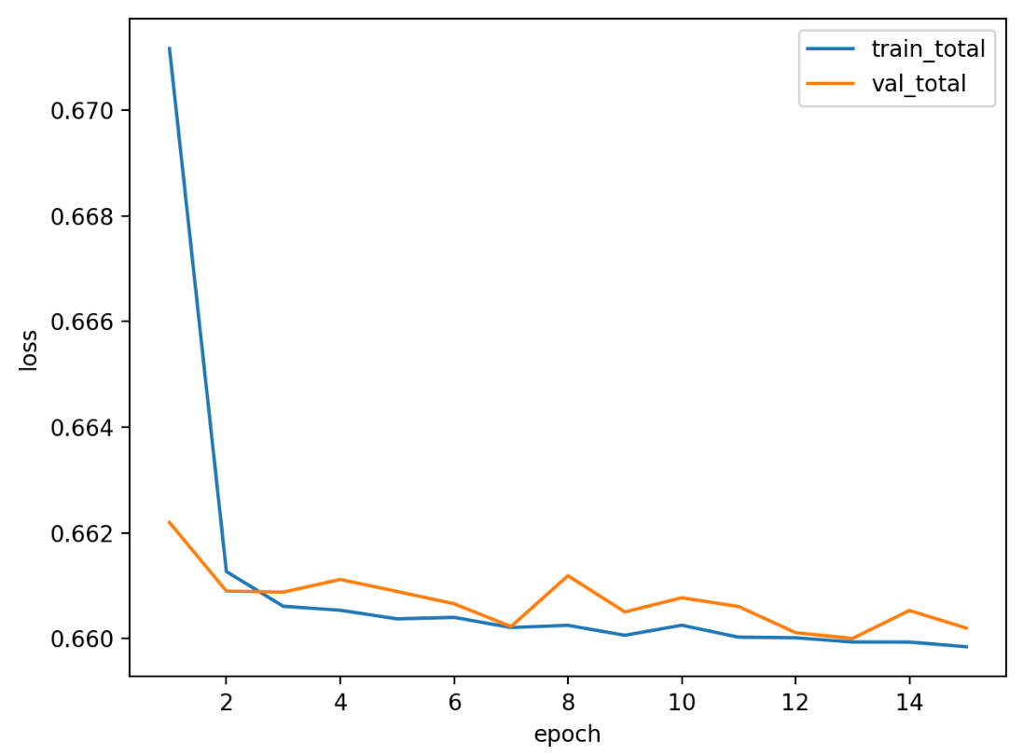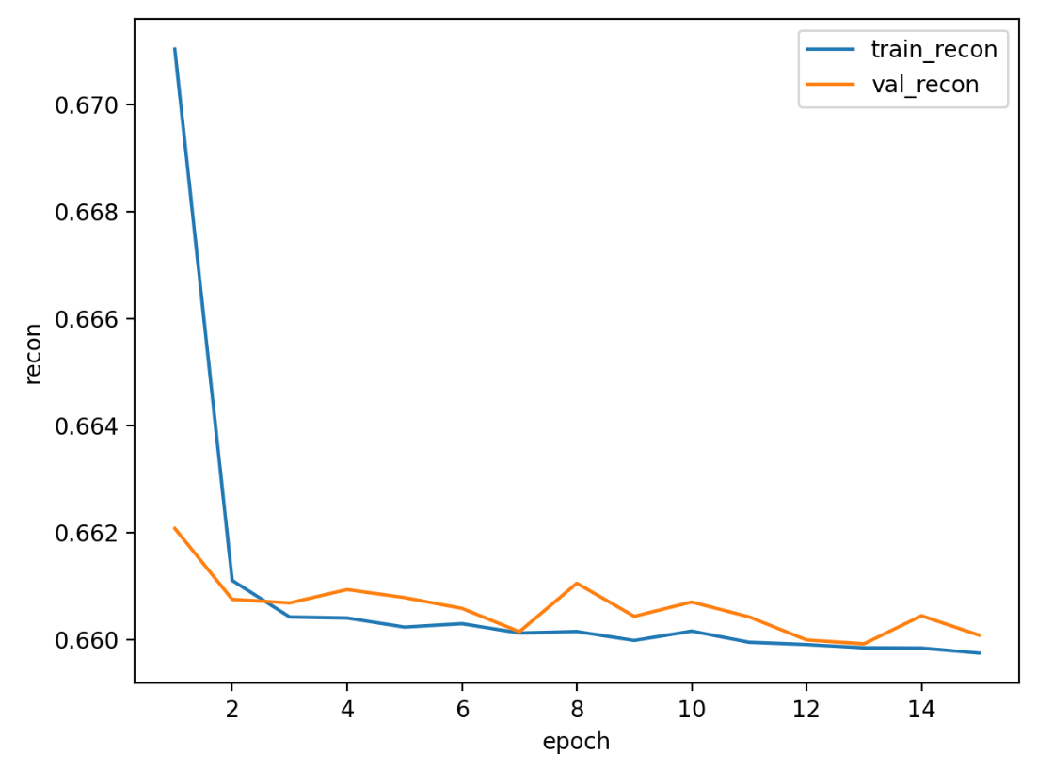
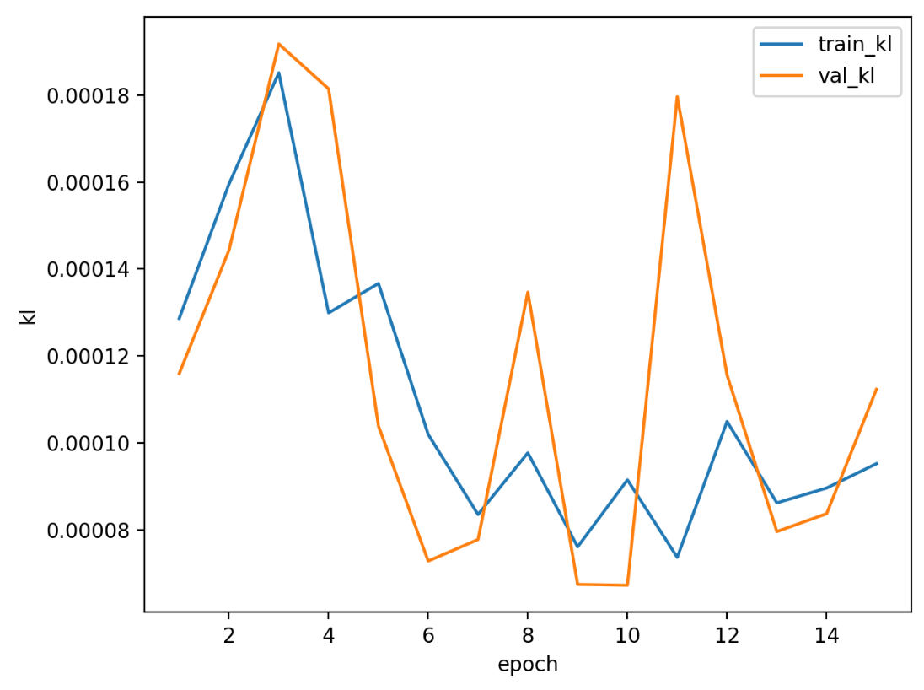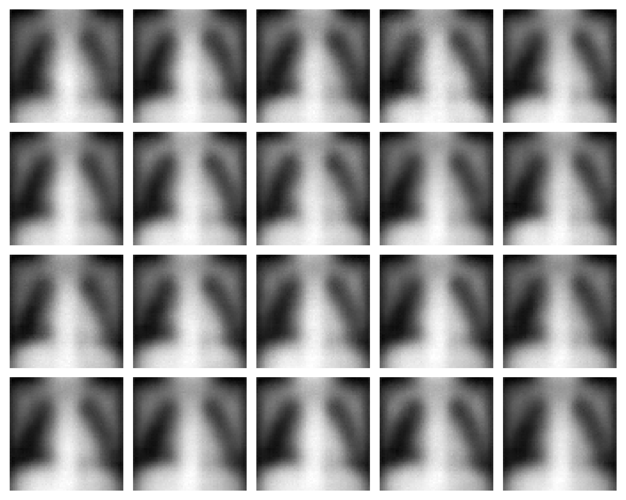

3.3 Reflection (Challenges and Usefulness)
The main challenge in VAE training is balancing image quality and latent regularization: if the KL term is too small the latent space may be poorly structured, while too large KL can degrade reconstructions. Despite this, VAEs are attractive for healthcare prototyping because they can create realistic-looking samples for pipeline testing and data augmentation research, though synthetic data does not automatically guarantee privacy.

Part 4 — Deployment and Optimization
To reduce inference cost for edge or resource-limited clinical settings, we applied two optimization techniques to the ResNet-18 vision model:
• Pruning: unstructured L1 pruning (30%) on Conv2d and Linear weights.
• Quantization: dynamic int8 quantization on Linear layers (CPU).

4.1 Benchmark Results
Variant | Size (MB) | Time (ms) | Test acc | Test F1 | Test AUC
baseline | 42.71 | 341.64 | 0.7837 | 0.8518 | 0.9465
pruned_0.3 | 42.71 | 313.14 | 0.7035 | 0.8083 | 0.9420
pruned_0.3+quant_int8 | 42.71 | 303.22 | 0.7035 | 0.8083 | 0.9420

Pruning and quantization reduced inference time on CPU. In this run, pruning introduced a noticeable accuracy/F1 drop compared to the baseline, which indicates that unstructured pruning at 30% removed some informative weights. In practice, pruning amount should be tuned (e.g., 10–20%) and validated to maintain clinical performance.

Part 5 — Ethics, Bias, and Fairness
Deploying deep learning in healthcare is high-stakes: errors can affect patient outcomes. Key concerns include privacy, bias, interpretability, and rigorous clinical validation.

5.1 Bias Sources
Potential bias sources in medical imaging and messaging include: (1) sampling bias (data collected from limited hospitals or devices), (2) label noise (inconsistent diagnosis or annotation), (3) domain shift (different scanners, demographics, or protocols), and (4) class imbalance (rare conditions). Even if a model performs well on a benchmark, it may fail on a new hospital population.

5.2 Fairness and Evaluation Practices
If demographic attributes are available, fairness should be evaluated by subgroup (e.g., age ranges, sex, site/hospital). Useful checks include comparing sensitivity/recall across groups and verifying calibration (predicted risk matches observed frequency). When demographics are unavailable, a practical alternative is external validation on a different dataset or site to test generalization.

5.3 Privacy and Synthetic Data
Synthetic generation can support development and sharing, but privacy is not guaranteed by default. Models may memorize training examples, so privacy-preserving techniques (e.g., differential privacy training, membership inference testing) and strict governance are still needed when handling sensitive data.

5.4 Recommendations
1) Require external validation and subgroup evaluation before clinical use, and continuously monitor performance after deployment.
2) Use interpretable tooling (e.g., Grad-CAM for images) and implement human-in-the-loop review for uncertain cases.
3) Maintain strong data governance: de-identification, access control, audit logging, and documented model cards.

Conclusion
We implemented and compared core deep learning approaches for text and vision tasks, trained a VAE to generate synthetic images, and performed deployment-oriented optimization with pruning and quantization. Results show that higher-capacity models (Transformer for text, ResNet-50 for vision) can improve accuracy, but increase compute cost; optimization and careful validation are required for safe deployment in healthcare.

https://github.com/Bublik-05/Comprehensive-Deep-Learning-Project.git

