

COMMUNITY ENGAGEMENT PROJECT REPORT

CampusLoop Student Rental Marketplace
A responsive showcase demo for student to student rentals at DYPIT Pimpri

Submitted for the Community Engagement Project
Second Year, First Semester, Bachelor of Engineering
Department of Artificial Intelligence and Data Science
Student | Roll number
Rujal Sharma | C-25
Sudhanshu Pendalwar | C-46
Shlok Mishra | C-60
Vansh Jain | C-61

Project guide Prof. Ifrah Sutar
Academic year 2026–2027

Abstract
CampusLoop explores how students could share useful items within a college community. The current deliverable is a responsive React and Vite showcase demo. It lets visitors browse sample listings, search and filter by category, publish a listing, request rental dates, review requests as an owner, complete a return, and rate a completed rental. Four switchable sample profiles represent second year AI and Data Science students at DYPIT Pimpri.
The demo stores changes in the current browser through localStorage. It has no live accounts, identity verification, shared database, server API, payment gateway, deposit handling, or escrow. Prices shown in the interface are estimates. The project demonstrates a rental workflow and an interface direction; it does not establish real transaction safety or measured environmental impact.

Project scope at a glance
Included in the current demo | Outside the current demo
Responsive catalog, search, filters and item details | Real student registration or identity checks
Listing creation and owner controls | Backend API or multi-device database
Date requests, owner decisions and return flow | Payments, deposits, escrow or disputes
Demo profiles, ratings and local persistence | Production deployment and notifications

Acknowledgement
We thank our project guide, Prof. Ifrah Sutar, and the Department of Artificial Intelligence and Data Science for their guidance during the Community Engagement Project. We also thank classmates whose everyday need to borrow and share equipment helped frame the problem.

1 Introduction

1.1 The problem
Students may need a calculator, drafter, camera, textbook, or cycle for only a short period. Buying every item can be costly, while informal borrowing through messages gives students little structure for dates, price, availability, or handoff. CampusLoop tests whether a clear campus-focused rental interface can make that process easier to understand.

1.2 Objectives
- Make relevant items easy to discover through search, categories and clear listing cards.
- Show a complete request and return journey for both borrower and owner.
- Explain price, condition, dates and sharing terms before a request is sent.
- Demonstrate how reuse might reduce duplicate purchases, without claiming measured savings.

1.3 Current scope
The application is a local showcase for DYPIT Pimpri. It starts with sample items and four switchable profiles. Interactions are saved only in the browser that performs them. This makes it suitable for project demonstration and UX evaluation, but it cannot coordinate rentals between separate devices.

1.4 Community relevance
A campus is a practical setting for short-distance handoffs and repeated use of student equipment. Reuse may reduce the need for some new purchases, but this prototype has not measured waste reduction or verified real-world adoption.

2 Background and design rationale
The original project concept drew on collaborative consumption, circular-economy thinking and Sustainable Development Goal 12. The current demo narrows that concept to the interactions that can be shown honestly without an operational service. It focuses on discoverability, readable item details, and clear borrower and owner states. The product would need verified accounts, moderation, reliable shared storage and a suitable payment model before real campus use.

3 System design

3.1 Application architecture
CampusLoop runs as a client-side web application built with React and Vite. React components render the screens and interaction states. Plain CSS provides the responsive layout and visual system. Sample catalog data supplies the initial listings. A marketplace logic module handles rental calculations, validation and status transitions. localStorage saves demo changes on the same browser.
Layer | Current implementation | Purpose
Interface | React components and CSS | Catalog, details, forms and rental views
Demo logic | src/lib/marketplace.js | Date checks, pricing and status transitions
Sample content | src/data.json | Initial item catalog
Persistence | Browser localStorage | Keep changes on the current browser

3.2 Functional modules
Module | Behavior in the demo
Explore | Search, category filters, sort order and item details
Listings | Publish an item and pause an available listing
Requests | Choose dates, accept sharing terms and send an owner request
My rentals | Borrowing and lending views with status-dependent actions
Profiles | Switch among four sample second year AI and Data Science students
Reset | Restore the starting sample data

3.3 Booking rules
The request form shows an estimated rent from the daily rate and selected duration. A request can last at most 30 days. The demo blocks requests for one’s own item and overlapping active requests. The owner can confirm or decline a request; the borrower can request a return, after which the owner confirms it. A borrower can rate a completed rental. The sharing terms clarify that no money or deposit is collected by the demo.

4 Implementation

4.1 Interface redesign
The updated interface uses top navigation on desktop and a compact menu on smaller screens. The home page introduces the purpose and category entry points. The catalog presents photos, condition, owner and price together so visitors can compare items. Item details place the request action beside the practical information needed to decide. Forms use plain labels and short guidance. Borrowing, lending, listings and profile switching each have a distinct destination.
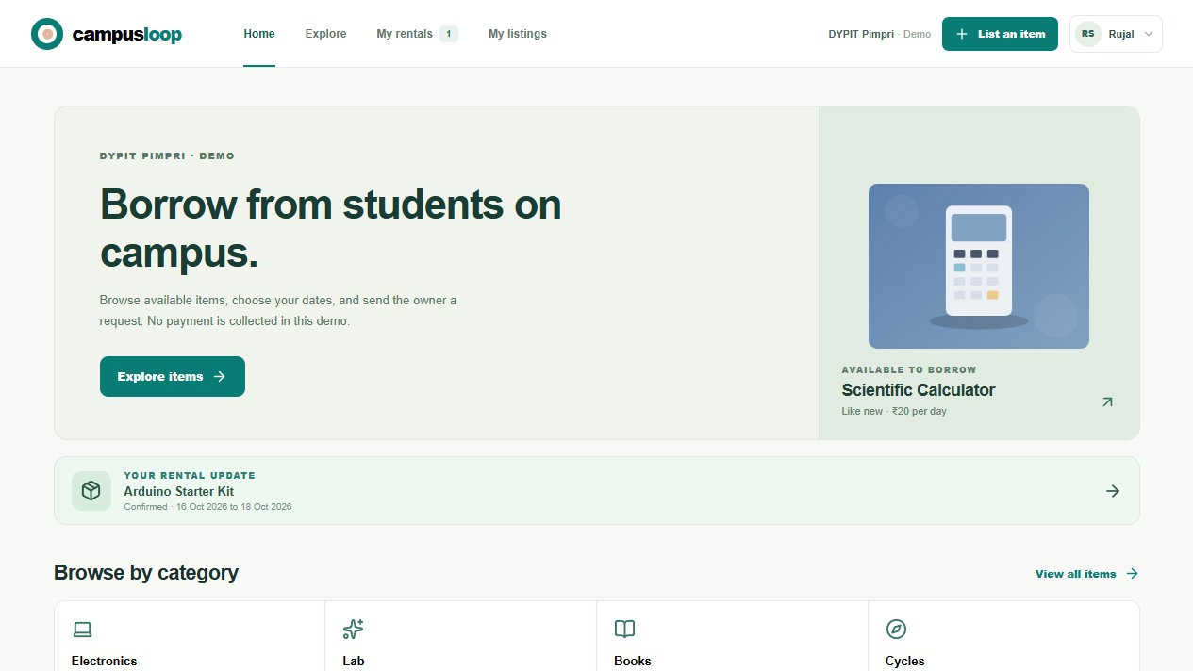
Figure 4.1 Current CampusLoop home screen

4.2 Sample student profiles
Name | Roll number | Branch and year
Rujal Sharma | C-25 | AI and Data Science, second year
Sudhanshu Pendalwar | C-46 | AI and Data Science, second year
Shlok Mishra | C-60 | AI and Data Science, second year
Vansh Jain | C-61 | AI and Data Science, second year

5 Prototype screens
The following captures are from the running current demo on 13 October 2026. They show sample content and browser-local state, not live student activity.
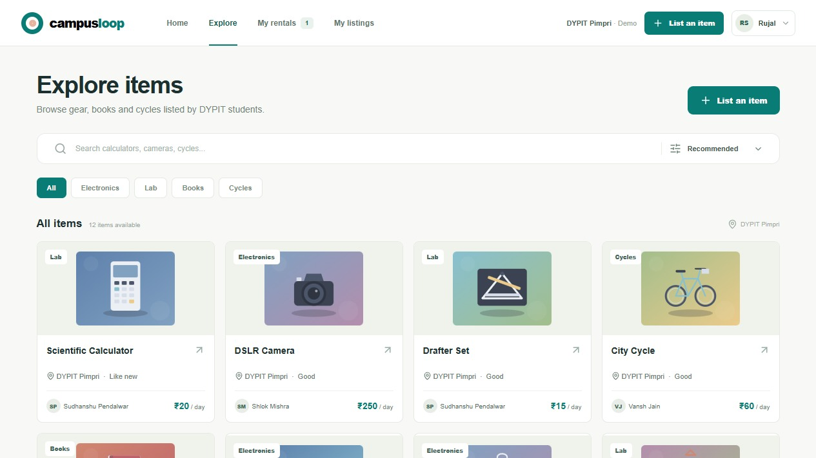
Figure 5.1 Searchable item catalog with category filters and sorting
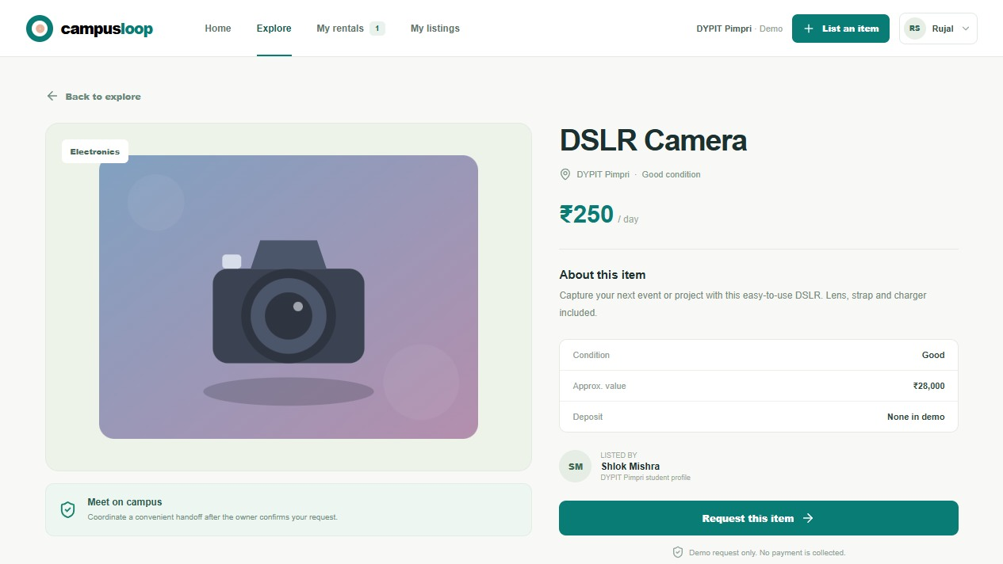
Figure 5.2 Item details with condition, estimated daily rent and owner

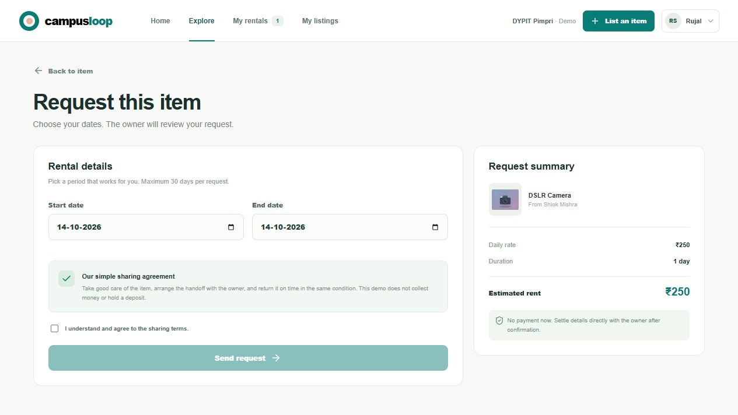
Figure 5.3 Date request and sharing terms; no payment is collected
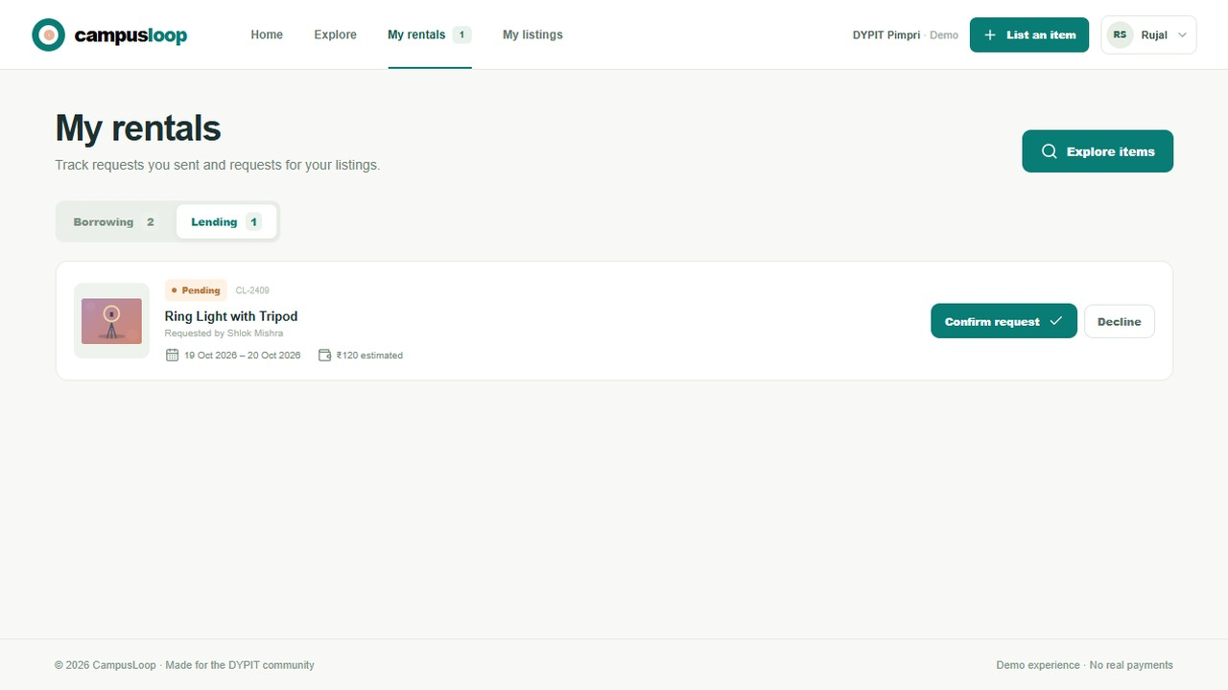
Figure 5.4 Lending view and booking status

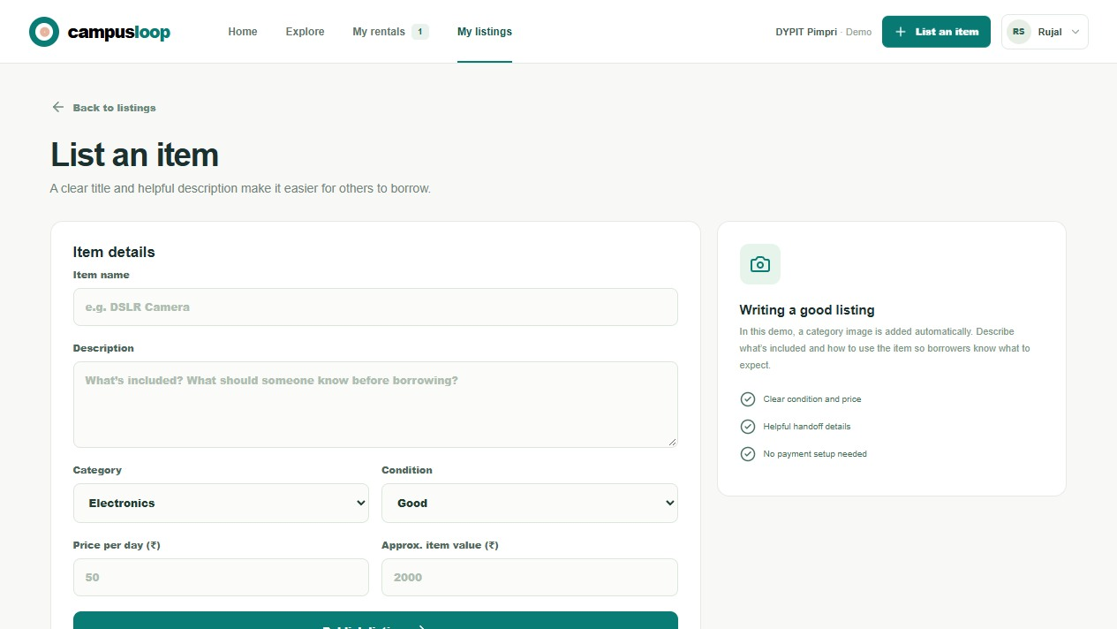
Figure 5.5 Publish a demo listing with category, condition and price
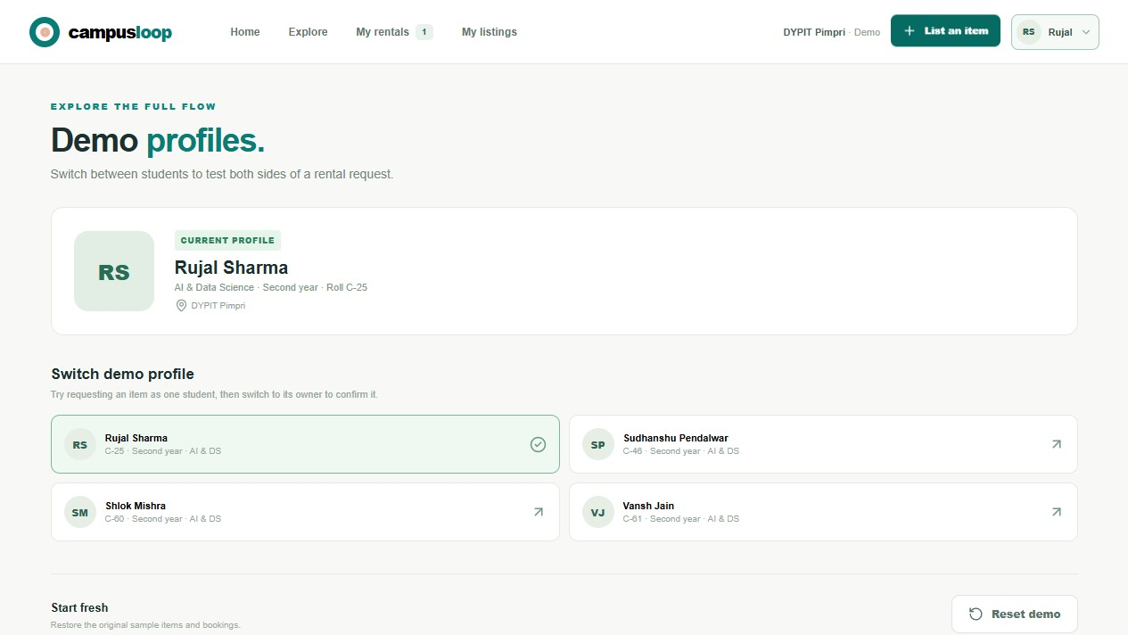
Figure 5.6 Switchable demo profiles using project team names and roll numbers

6 Verification and limitations

6.1 Demonstrated checks
Scenario | Expected demo behavior
Search or filter the catalog | Matching sample items remain visible
Request one’s own listing | Request is prevented
Select more than 30 days | Request is rejected
Choose dates that overlap an active request | Conflicting request is prevented
Send a valid request | It appears in the owner’s lending view
Confirm return and rate | Rental reaches completed state and rating is available

The repository includes automated tests for core marketplace logic, plus lint and build commands. The screenshots in this report were taken from the running application. This report does not claim production security, real payment testing or multi-user deployment.

6.2 Limitations
- Demo profiles are selectable; they are not authenticated identities.
- localStorage does not synchronize data across browsers or devices.
- There is no moderation, dispute resolution, delivery tracking or real deposit.
- A successful request in the demo is only a visual state change. Students would need to arrange any real handoff independently.

7 Conclusion and future work
CampusLoop now presents a complete, understandable rental journey as a local showcase. A student can find an item, request dates, switch to the owner profile to decide, record a return, and rate the result. The redesign makes those steps visible and keeps the payment boundary explicit. It is a useful prototype for demonstrating the community-sharing concept, while real campus operation remains future work.

Future work
- Add authenticated student accounts and an appropriate verification process.
- Introduce a shared backend and database so separate students see the same listings and requests.
- Define moderation, safety, dispute and data-retention policies with the institution.
- Evaluate demand and usability with real students before deciding whether payments or deposits are needed.
- Add notifications and improve accessibility and mobile testing.

References
[1] R. Botsman and R. Rogers, What’s Mine Is Yours: The Rise of Collaborative Consumption, Harper Business, 2010.
[2] Ellen MacArthur Foundation, Towards the Circular Economy, 2013.
[3] United Nations, Sustainable Development Goal 12: Responsible Consumption and Production, sdgs.un.org/goals/goal12.
[4] CampusLoop repository README and application source, accessed 13 October 2026.

