ROAD TRAFFIC CRASH HOTSPOT ANALYSIS
Birmingham, United Kingdom (2020 - 2024)
A Spatial Statistical Investigation of Collision Clustering Using DfT STATS19 Road Safety Data

Prepared by Bubuya Zelembu Dube
Track/Railway Engineer | Data Analytics Portfolio Project
July 2026

Tools: Python (pandas, geopandas, PySAL/esda) · SQL (SQLite) · QGIS · Power BI · Microsoft Excel
Data source: Department for Transport (DfT) STATS19 Road Safety Data

Table of Contents
Executive Summary 3
1. Background & Objective 4
2. Study Area & Data 5
3. Methodology 5
4. Findings 6
5. Site-Level Review of Priority Hotspots 8
6. Interactive Dashboard 12
7. Recommendations 12
8. Limitations 13
9. Conclusion 13
Appendix A - Tool Stack Summary 14
Appendix B - STATS19 Coding Reference 14
Appendix C - Data Source & References 14

Executive Summary
This report presents a spatial statistical analysis of 10,817 road traffic collisions recorded in Birmingham, United Kingdom, between 2020 and 2024, using the Department for Transport's STATS19 road safety dataset. The objective was to move beyond simple visual density mapping and identify locations where collision frequency is statistically too high to be explained by chance, providing local road safety stakeholders with an evidence-based, defensible basis for prioritizing limited intervention resources.
Global spatial autocorrelation testing (Moran's I) confirmed that crashes in Birmingham are not randomly distributed. They cluster strongly and significantly (Moran's I = 0.56, p = 0.001, z = 49.6). Local hotspot detection using the Getis-Ord Gi* statistic, applied to a 500-metre grid covering the study area, identified 105 statistically significant hotspot cells (5.5% of the study area) accounting for approximately 35% of all recorded collisions in the five-year window.
Site-level review of the five highest-confidence hotspots revealed distinct, actionable risk profiles. A complex multi-arm gyratory at Bordesley Circus, a pedestrian-generator junction in Sparkbrook, a school-adjacent ring-road site at Parkes Avenue, a night-time economy district at Lower Essex Street, and a ring-road/retail convergence point near the Mailbox. Notably, three of the five sites sit directly on Birmingham's ring-road corridor system, indicating that a corridor-level engineering review may be more effective than treating these as isolated black-spots.
A specific investigation into the Lower Essex Street hotspot, initially hypothesized to be a late-night, alcohol-related pattern given its location within Birmingham's Gay Village nightlife district, found a more nuanced picture. While darkness was associated with 59% of crashes at this site, the majority occurred with street lighting present and functioning, and the temporal pattern pointed toward winter dusk hours rather than late-night activity specifically. This finding changed the recommended intervention from a lighting upgrade to targeted pedestrian crossing infrastructure.
The analysis was delivered through a full data-analytics tool stack. Python was used for data processing and spatial statistics, SQL for structured querying, QGIS for cartographic output, and Power BI for an interactive stakeholder-facing dashboard. Seven specific, site-linked recommendations are presented in Section 7.

1. Background and Objective

1.1 Problem Statement
Local authorities and road safety teams operate under persistent resource constraints: safety audits, signage upgrades, lighting improvements, and speed enforcement cannot be applied uniformly across an entire city. Effective prioritization requires knowing not just where crashes have historically occurred, but where their concentration is statistically meaningful, as distinct from areas that simply carry more background traffic volume and therefore more crashes in raw terms.
This project was undertaken to demonstrate an end-to-end, statistically rigorous approach to that prioritization problem, using Birmingham as the study city and full engineering interpretation layered on top of the statistical output, reflecting the author's professional background in railway and civil infrastructure engineering.

1.2 Objectives
- Identify statistically significant crash hotspots within Birmingham using established spatial statistical methods (Moran's I, Getis-Ord Gi*), rather than relying on visual density estimation alone.
- Ground the statistical findings in real-world site context through targeted location review.
- Produce a decision-ready set of outputs covering cartographic map, interactive dashboard, and written findings, suitable for a road safety stakeholder audience.
- Demonstrate a complete, portfolio-representative data analytics tool stack: Python, SQL, GIS, and business intelligence dashboarding.
2. Study Area and Data

2.1 Study Area
The study area is the Birmingham Local Authority District (ONS geography code E08000025), England's second-largest city by population. Birmingham was selected for its combination of high collision volume, a mixed road environment spanning motorway-adjacent corridors, a dense urban grid, and a defined ring-road system, and strong data availability through the national STATS19 reporting framework.

2.2 Data Source
Collision-level data was obtained from the Department for Transport's STATS19 Road Safety Data, published via data.gov.uk. STATS19 is the UK's official police-reported road collision dataset. The data paid particular attention to location, date and time, severity, number of vehicles and casualties, road type and class, speed limit, junction detail, light and weather conditions, and local authority.

2.3 Study Window
The analysis covered the 2020 - 2024 dataset. At the time of analysis, STATS19 final validated data was available only through 2024. 2025 data existed solely in provisional form, with final publication scheduled for July 2026. The 2020–2024 window was therefore selected to preserve a genuine five-year study period using only final, validated data.

2.4 Dataset Summary
Metric | Value
Total collision records (Birmingham, 2020–2024) | 10,817
Records with valid coordinates | 10,817 (100%)
Fatal collisions (severity 1) | 99
Serious collisions (severity 2) | 1,917
Slight collisions (severity 3) | 8,801
Coordinate reference system (analysis) | EPSG:27700 (British National Grid)

3. Methodology

3.1 Tools & Environment
- Python (pandas, geopandas, PySAL / esda, shapely) - data cleaning, geocoding, and spatial statistics
- SQL (SQLite) - structured storage and querying of the cleaned dataset
- QGIS - cartographic visualization and final map production
- Microsoft Power BI - interactive, filterable stakeholder dashboard
- Microsoft Excel - exploratory summary checks throughout the pipeline

3.2 Data Preparation
Raw STATS19 collision records were filtered to Birmingham (ONS code E08000025) and the 2020 - 2024 window using pandas. Records were converted to point geometries from latitude/longitude, then reprojected to the British National Grid (EPSG:27700) to enable accurate, distance-based spatial analysis in metres rather than decimal degrees.

3.3 Grid Aggregation
Rather than running spatial statistics directly on raw point locations, which can produce unstable results at high point density, crash points were aggregated onto a regular 500-metre × 500-metre grid covering the full extent of the study area, producing 1,911 grid cells. Each cell was assigned a crash count via spatial join. A 500m cell size was selected as a balance between spatial resolution and statistical stability. This was considered to be fine enough to distinguish specific corridors and junctions, coarse enough to avoid excessive empty-cell noise.

3.4 Global Spatial Autocorrelation - Moran's I
Before proceeding to local hotspot detection, Moran's I was calculated across the full grid using Queen contiguity spatial weights to test whether crash counts exhibit genuine spatial clustering, as opposed to a random spatial pattern that would make hotspot analysis meaningless. A statistically significant, strongly positive Moran's I value confirmed that hotspot analysis is a valid method for this dataset.

3.5 Local Hotspot Detection - Getis-Ord Gi*
The Getis-Ord Gi* statistic was applied to identify which specific grid cells constitute statistically significant hot (or cold) spots, as distinct from cells that are simply part of the general background pattern. Each cell was classified into a confidence tier 90%, 95%, or 99% based on its z-score and simulated p-value, following standard convention (z > 1.65/1.96/2.58 respectively, with corresponding p-value thresholds).

3.6 Site-Level Verification
The five grid cells with the highest Gi* z-scores were converted back to real-world latitude/longitude coordinates and reviewed individually using satellite and street-level imagery, to ground the statistical output in actual road geometry, land use, and local context. This was an essential step to converting a statistical finding into an actionable engineering recommendation.
4. Findings

4.1 Headline Statistics
10,817  Total Collisions | 0.56  Moran's I | 105  Significant Hotspot Cells | ~35%  Share of Crashes in Hotspots

4.2 Global Clustering Is Confirmed
Moran's I returned a value of 0.56 against an expected value of approximately 0 under complete spatial randomness, with a z-score of 49.6 and a simulated p-value of 0.001. Birmingham's crashes are strongly and significantly spatially clustered, not randomly distributed across the city. In plain terms, a small number of locations experience a disproportionate concentration of collisions, and this pattern is far too strong to be attributable to chance. This finding is the statistical justification for proceeding to local hotspot detection.

4.3 Local Hotspots Identified
Getis-Ord Gi* analysis classified 105 of the 1,911 grid cells (5.5% of the study area) as statistically significant hotspots, distributed across three confidence tiers as shown below. No statistically significant cold spots were identified, which is a common and expected result in urban collision datasets of this density.
Classification | Cell Count | % of Grid
Hot Spot — 99% confidence | 36 | 1.9%
Hot Spot — 95% confidence | 40 | 2.1%
Hot Spot — 90% confidence | 29 | 1.5%
Not Significant | 1,806 | 94.5%

4.4 Spatial Distribution of Hotspots
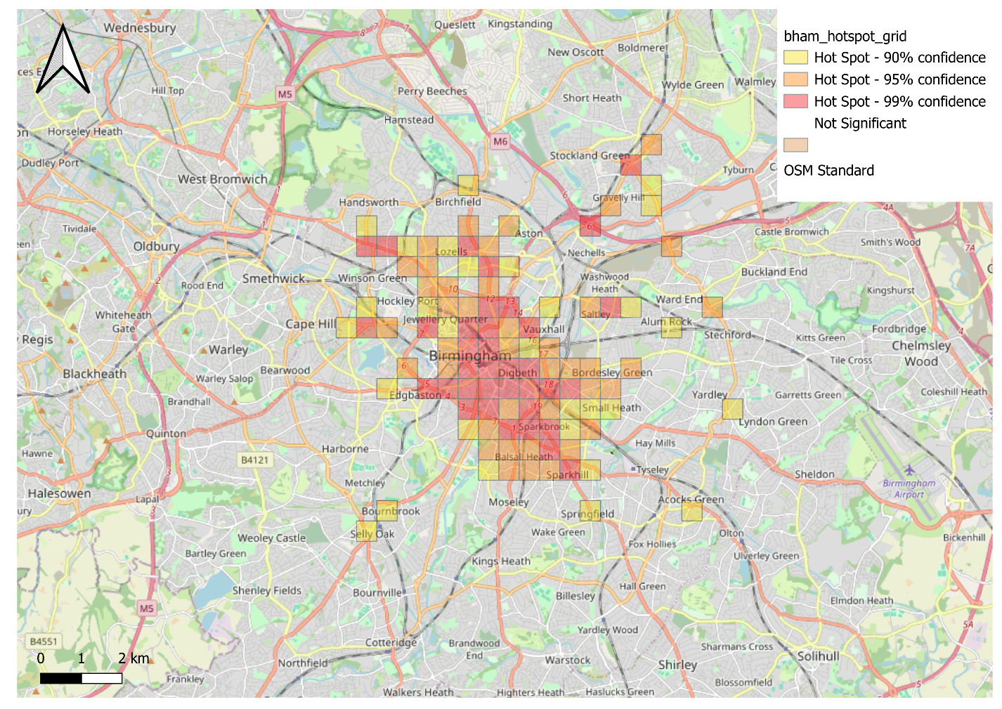
Figure 1: Statistically significant crash hotspots, Birmingham, 2020–2024. Cartography: QGIS. Basemap: OpenStreetMap contributors. Source: DfT STATS19 Road Safety Data.
The highest-intensity hotspot cells concentrate around Birmingham's city centre, with a secondary corridor of significant cells extending southwest toward Edgbaston/Ladywood. This is not a scattered, random pattern of isolated points but a connected corridor structure, consistent with the strong Moran's I result in Section 4.2.

4.5 Temporal Trend
2020 | 2021 | 2022 | 2023 | 2024
1,802 | 2,137 | 2,383 | 2,199 | 2,296

Total collision volume dipped in 2020 (1,802 records) relative to subsequent years, consistent with reduced traffic volumes during COVID-19-related restrictions, before rising through 2022 - 2024. Notably, serious-severity collisions rose from 308 in 2020 to 459 in 2024, a steeper proportional increase than overall volume. This suggested this trend merited independent investigation beyond the spatial clustering analysis (see Section 8).

5. Site-Level Review of Priority Hotspots
Statistical significance identifies where a problem is concentrated; it does not by itself explain why. The five highest-confidence (99%) hotspot cells were reviewed individually using satellite and street-level imagery to ground the statistical findings in real engineering and land-use context - the step that converts a set of coordinates into an actionable recommendation.

5.1 Area 1: Small Heath Highway, approaching Bordesley Circus Roundabout (103 crashes, 99% confidence)
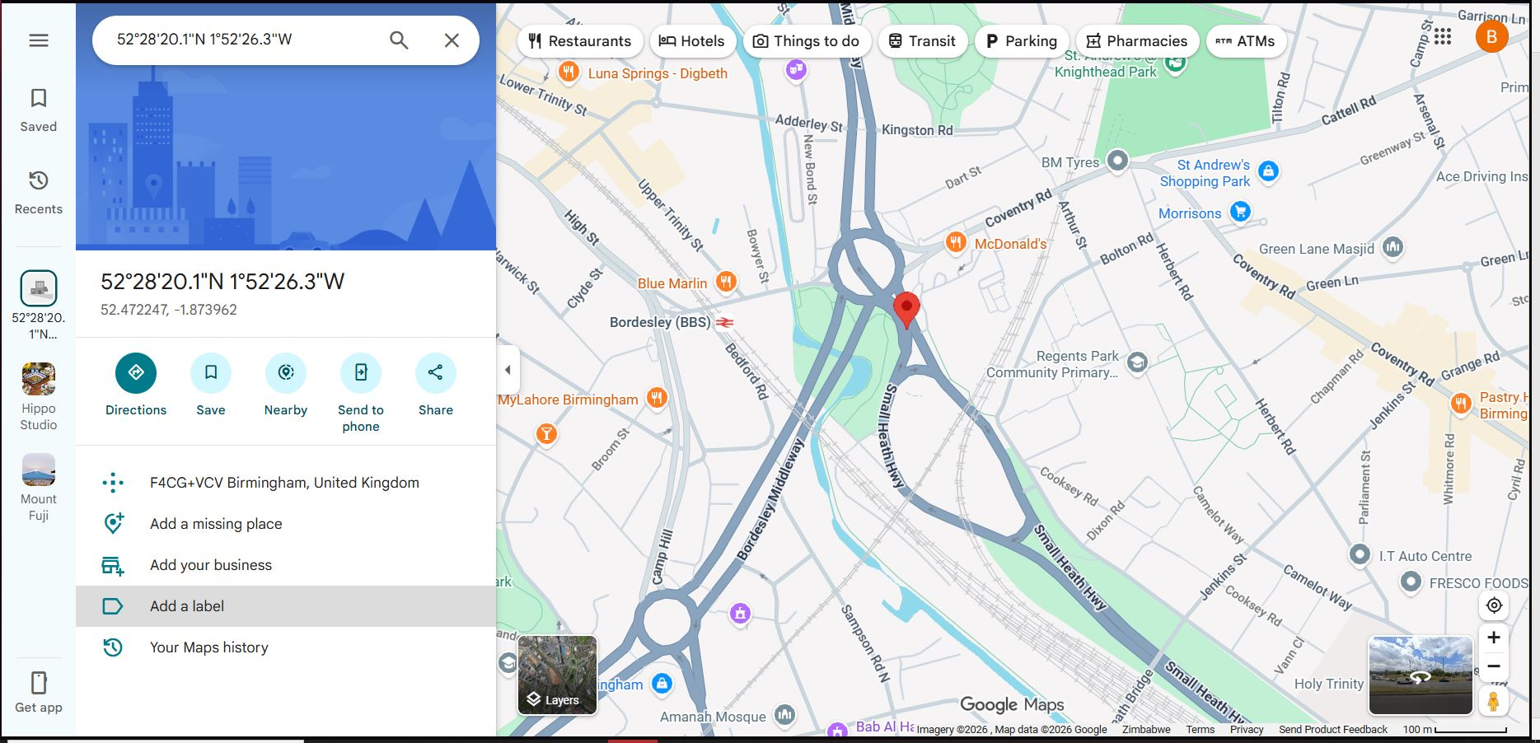
Figure 2: Small Heath Highway, approaching Bordesley Circus Roundabout.
The highest-intensity cell in the study sits at a complex multi-arm gyratory where Coventry Road, Bordesley Middleway, Small Heath Highway, and Green Lane converge. The junction combines significant geometric complexity, multiple converging approaches requiring weaving and lane changes shortly after entry, with a high concentration of adjacent trip-generating land uses, including a retail park, several fast-food outlets, and Bordesley rail station, producing heavy turning-movement volume layered on top of already-complex geometry. A primary school sits in close proximity. This is a classic complex-junction risk profile, in which crash causation is more plausibly linked to conflicting vehicle movements and elevated driver decision-load than to any single localized design defect.

5.2 Area 2: Highgate Road / Queen Street Intersection (98 crashes, 99% confidence)
A busy arterial intersection in Sparkbrook, situated in the immediate vicinity of multiple fast-food outlets and Highgate Hall. The land-use mix suggests a pedestrian-vehicle conflict profile rather than a purely vehicle-to-vehicle one. Fast-food outlets generate frequent short-stop, in-and-out traffic alongside pedestrian crossing movements at irregular, informal points which is a well-documented contributor to both crash frequency and, disproportionately, pedestrian casualty severity.
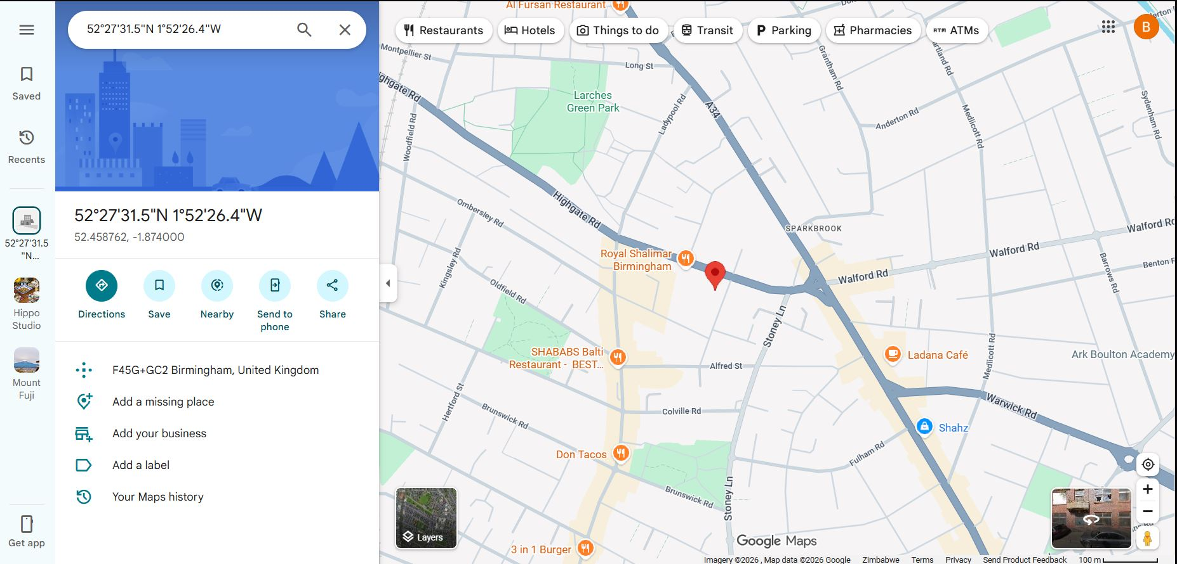
Figure 3: Highgate Road / Queen Street Intersection.

5.3 Area 3: Parkes Avenue, near Belgrave Village (74 crashes, 99% confidence)
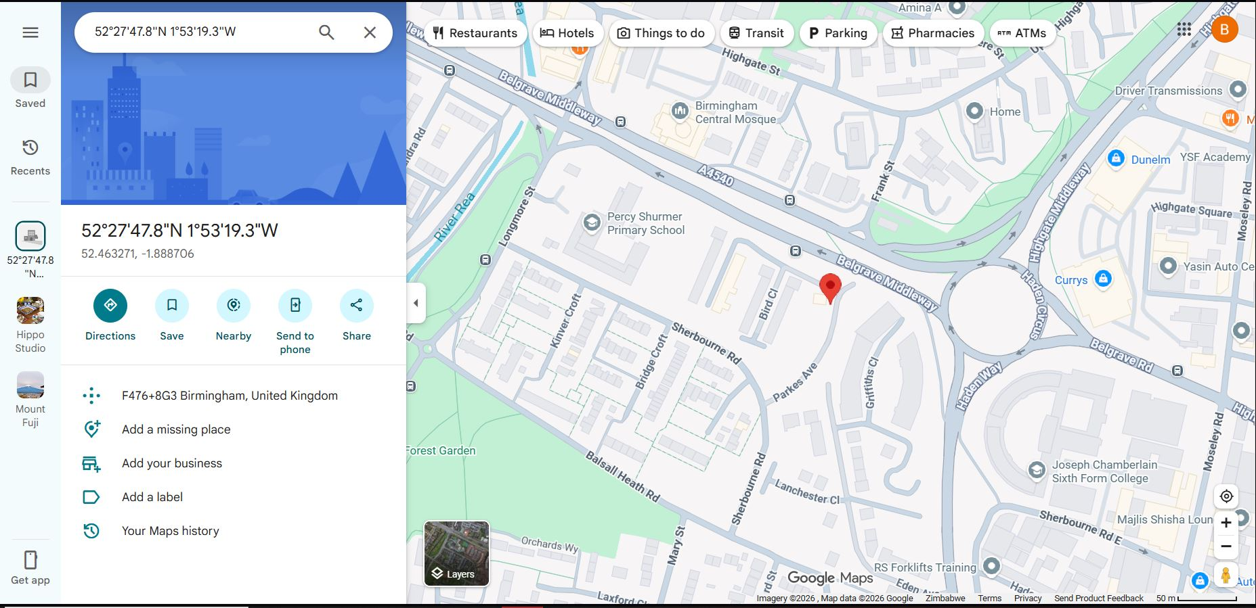
Figure 4: Parkes Avenue, near Belgrave Village.
This site sits close to Percy Shurmer Primary School and the Haden Circus roundabout on the A4540 ring road (Belgrave Middleway). Two risk factors compound here, a high-speed, high-volume ring-road environment directly adjacent to a school catchment area, and a transient population associated with local bed-and-breakfast accommodation who are less likely to be familiar with local road layout and crossing points than long-term residents.

5.4 Area 4: Lower Essex Street, approaching Kent Street (Night-Time Economy District) (56 crashes, 99% confidence)
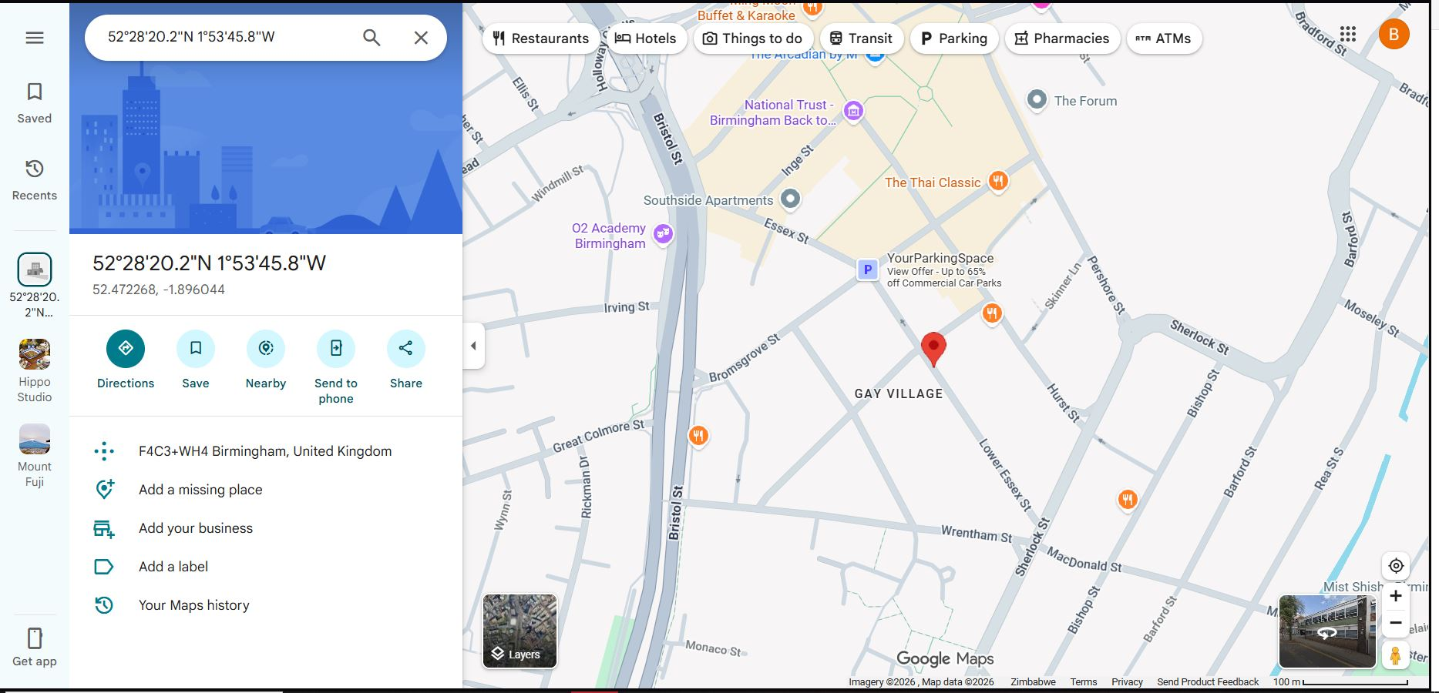
Figure 5: Lower Essex Street, approaching Kent Street (Night-Time Economy District).
This location sits within Birmingham's Gay Village, in the vicinity of multiple nightlife venues. A follow-up query against the underlying crash-level data (Section 5.5) both partly confirmed and partly revised the initial hypothesis that this hotspot is driven by late-night, venue-related activity.

5.4.1 Data Check - Contributing Factors
Of the 56 crashes recorded within the grid cell, 33 (59%) occurred in darkness (STATS19 light_conditions codes 4–7). Critically, 30 of those 33 darkness-related crashes occurred with street lighting present and functioning (code 4), with only 3 occurring under unlit or absent lighting (codes 5–6), ruling out a lighting-infrastructure gap as the primary cause. By clock time, only 23 of the 56 crashes (41%) fell within a strict late-night window (20:00 - 05:59), fewer than the darkness-condition total, indicating that a portion of darkness-related crashes are occurring during winter dusk hours (approximately 16:00 - 19:59) rather than late night specifically. This is a meaningful methodological finding in its own right. The initial hypothesis that a hotspot within a nightlife district must be driven by late-night, alcohol-related activity was only partially supported once tested against the data. The revised, evidence-based explanation points toward a visibility and pedestrian-expectation mismatch during low-light hours. This is most plausibly linked to informal mid-block crossing behaviour near venues, rather than either an infrastructure lighting deficiency or a purely late-night phenomenon. The corresponding recommendation was adjusted accordingly, in favour of pedestrian crossing infrastructure rather than a lighting upgrade.

5.5 Area 5: Suffolk Street Queensway, near the Mailbox (59 crashes, 99% confidence)
Located on Birmingham's inner ring road (Suffolk Street Queensway), adjacent to major retail (the Mailbox), Birmingham City Council Children's Services, and hotel/hospitality land uses. This site combines heavy through-traffic on a ring-road-standard carriageway with a high volume of pedestrians moving between retail, transit (New Street Station is nearby), and office destinations, a mismatch between road design speed and capacity on one hand, and actual pedestrian crossing demand on the other.
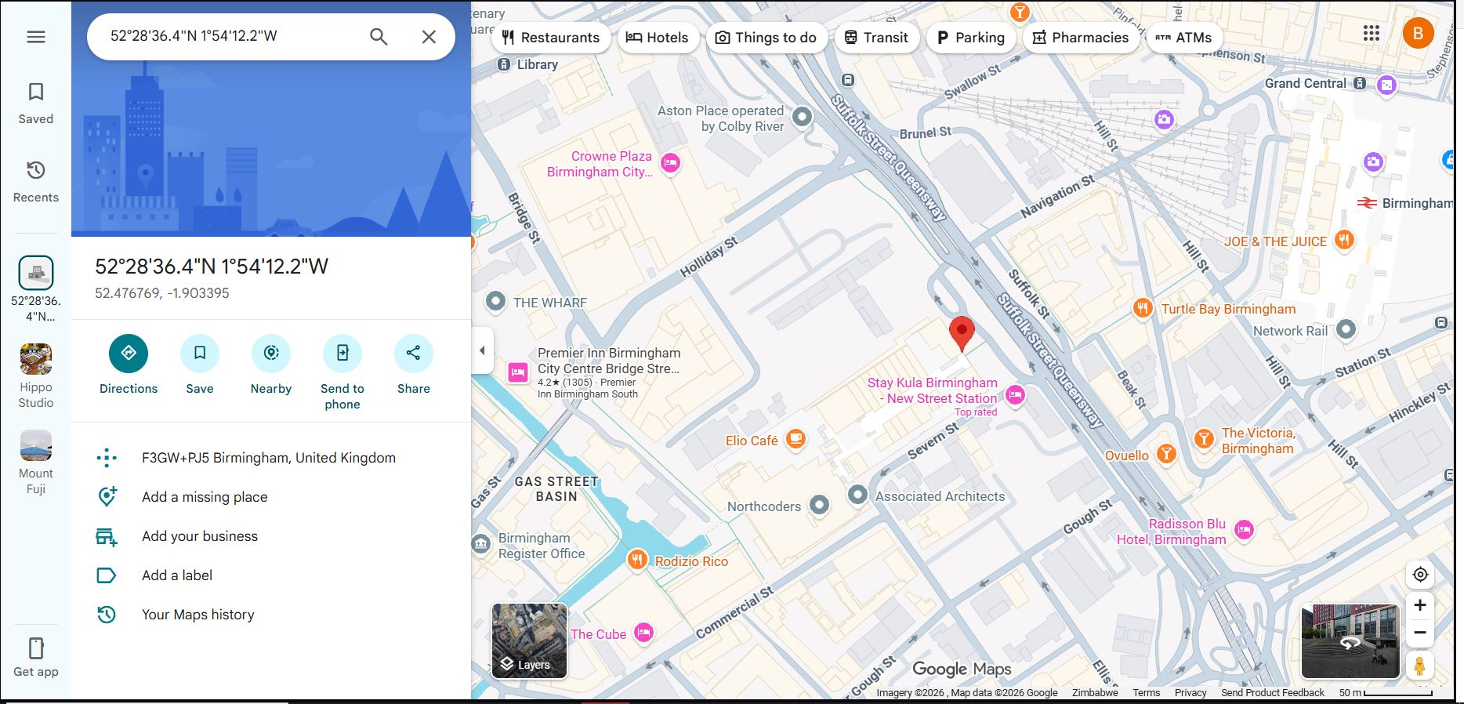
Figure 6: Suffolk Street Queensway, near the Mailbox.

5.6 Cross-Cutting Observation
Three of the five highest-confidence hotspots sit directly on or immediately adjacent to Birmingham's ring-road system, Small Heath Highway/Bordesley Middleway, Belgrave Middleway, and Suffolk Street Queensway respectively. This is consistent with the corridor-clustering pattern identified statistically in Section 4.4, and suggests that the ring-road corridor as a whole, rather than five unrelated black-spots, may warrant a coordinated corridor-level engineering review.

6. Interactive Dashboard
Findings were consolidated into an interactive Power BI dashboard, enabling stakeholders to filter collision data by year, severity, and lighting condition, and to explore the spatial distribution of hotspots directly. The dashboard combines a classified point map, year-over-year trend chart, and key performance indicators for total collisions and Killed/Seriously Injured (KSI) counts.
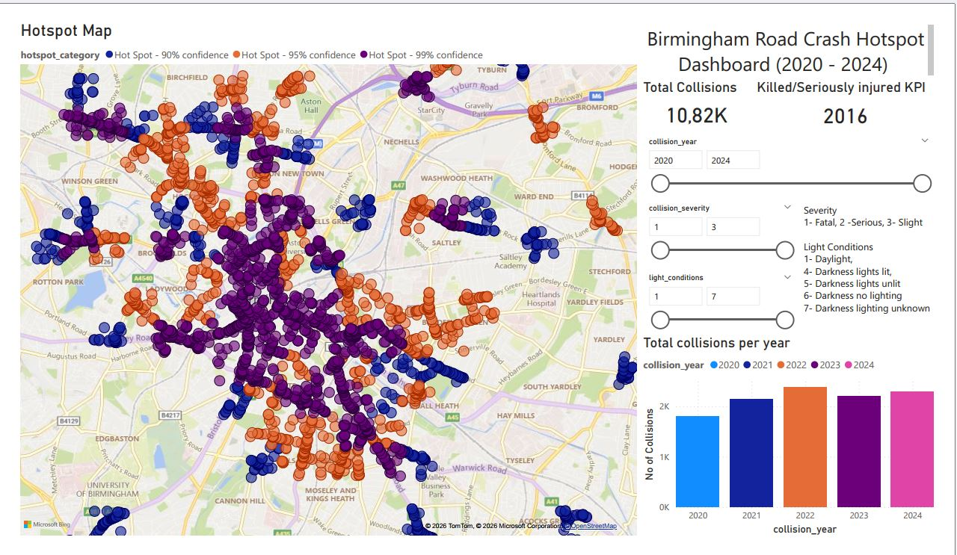
Figure 7: Birmingham Road Crash Hotspot Dashboard (Power BI)
The dashboard architecture uses a single flattened table (individual crash records pre-joined with their grid cell's hotspot classification) rather than a relational two-table model, avoiding cross-filter and cardinality issues encountered during development and ensuring slicers correctly propagate across all visuals.
7. Recommendations
- Commission a full engineering safety audit of the Bordesley Circus / Small Heath Highway gyratory (Area 1) as the top priority. Its combination of geometric complexity, weaving demand, and high adjacent trip generation makes it the single highest-value intervention target identified in this analysis.
- Treat the Belgrave Middleway / Suffolk Street Queensway / Small Heath Highway ring-road corridor as a unified review zone, rather than auditing Areas 1, 3, and 5 in isolation. Both the statistical clustering pattern and the shared ring-road context point toward corridor-level design or speed-management review.
- Conduct a targeted pedestrian-safety review at Areas 2 and 5, focused on crossing provision and signal timing near high footfall-generating land uses. These sites' risk profile is pedestrian-conflict driven rather than purely geometric, so infrastructure fixes such as formal crossings and pedestrian signal phasing are likely to outperform junction redesign alone.
- At Area 4, prioritize pedestrian crossing infrastructure over lighting upgrades. Data confirmed darkness is associated with 59% of crashes at this site, but street lighting is already present and functioning in nearly all of those cases, ruling out a lighting-infrastructure gap. Formal crossing points or pedestrian refuge islands near the venue cluster are the better-targeted intervention.
- Flag Area 3 (Parkes Avenue, near Percy Shurmer Primary School) for a dedicated school-zone safety assessment, given the combination of ring-road-adjacent traffic speeds and school catchment proximity.
- Investigate the rising serious-injury trend independently from overall crash volume. The disproportionate increase in serious-severity outcomes relative to total volume may reflect changes in vehicle mix, speed, or road-user behaviour warranting separate analysis.
- Cross-reference all five priority sites against planned infrastructure works, where hotspot locations overlap with roads already scheduled for resurfacing, signal upgrades, or redesign, safety improvements could be bundled into existing capital projects at lower marginal cost.
8. Limitations
- Grid-based aggregation (500m cells) necessarily smooths some spatial precision. A crash at a specific junction and a crash several hundred metres down the same road may fall within the same cell.
- STATS19 records only collisions reported to and recorded by police. Near-misses and unreported minor incidents are not captured, and under-reporting is a known, non-uniform limitation of police-recorded collision data generally.
- This analysis is diagnostic (identifying where and, through site review, offering plausible explanations of why) rather than strictly causal. Site-level findings in Section 5 are observational and would benefit from formal traffic engineering site visits and count data before being treated as conclusive.
- 2025 collision data was unavailable as final, validated STATS19 output at the time of analysis; final 2025 data is expected to be published in July 2026.
- The 500m grid cell size, while defensible, is one methodological choice among several reasonable alternatives. A sensitivity check at 250m or 1km resolution was outside the scope of this project but would strengthen future iterations.
9. Conclusion
This project set out to identify statistically significant road crash hotspots in Birmingham (2020 - 2024) and translate them into actionable, engineering-grounded recommendations. The process moved through five stages, cleaning and geocoding 10,817 STATS19 collision records in Python; aggregating them onto a 500m grid; confirming genuine spatial clustering with Moran's I; pinpointing significant hotspot cells with Getis-Ord Gi*; and grounding the five highest-confidence hotspots in real-world site context through satellite and street-level review. The results were clear and actionable. Crashes are strongly and non-randomly clustered (Moran's I = 0.56, p = 0.001), with 105 grid cells (5.5% of the study area) accounting for roughly 35% of all recorded collisions. Three of the five priority hotspots sit on Birmingham's ring-road corridor, pointing to a corridor-level rather than purely site-level problem. A data check at the Lower Essex Street hotspot showed the value of testing assumptions against evidence, revising an initial nightlife-driven hypothesis into a more precise winter-dusk, pedestrian-crossing finding. Delivered through a full analytics stack, Python, SQL, QGIS, and Power BI, this project demonstrates both technical range and the kind of applied engineering judgement needed to turn statistical output into practical safety recommendations.

Appendix A - Tool Stack Summary
Tool | Application in This Project
Python | Data cleaning, geocoding, spatial join, Moran's I, Getis-Ord Gi*, CSV/GeoPackage export
SQL (SQLite) | Structured storage and querying of the cleaned collision dataset
QGIS | Kernel density visualization, cartographic map production, print layout
Power BI | Interactive dashboard: hotspot map, KPI cards, year/severity/lighting slicers
Microsoft Excel | Exploratory summary checks and quick pivot validation throughout the pipeline

Appendix B - STATS19 Coding Reference

Collision Severity
- 1 - Fatal
- 2 - Serious
- 3 - Slight

Light Conditions
- 1 - Daylight
- 4 - Darkness, lights lit
- 5 - Darkness, lights unlit
- 6 - Darkness, no lighting
- 7 - Darkness, lighting unknown

Appendix C - Data Source & References
- Department for Transport (DfT). STATS19 Road Safety Data. Published via data.gov.uk.
- Office for National Statistics (ONS). Local Authority District geography codes.
- OpenStreetMap contributors. Basemap data used in QGIS cartographic output.
- Getis, A. & Ord, J.K. (1992). The Analysis of Spatial Association by Use of Distance Statistics. Geographical Analysis.
- Moran, P.A.P. (1950). Notes on Continuous Stochastic Phenomena. Biometrika.

