PROJECT TITLE:
MANUFACTURING PRODUCTION ANALYTICS USING PYTHON
PREPARED BY:
ONYEBUCHI UREMEH

ORGANIZATION:
PRIME MANUFACTURING LTD

DATE:
18TH JULY 2026

Table of Contents
1. Introduction
2. Objectives
3. Dataset Description
4. Tools Used
5. Methodology
6. Results and Findings
7. Challenges Encountered
8. Solutions Implemented
9. Conclusion
10. Recommendations
11. References

1. Introduction
This project analyzes one year (2025) of manufacturing production data covering three factories, twelve production lines, forty machines, and one hundred operators. The dataset records daily production runs, including planned versus actual output, defect counts, downtime, energy consumption, maintenance cost, and quality inspection scores, alongside environmental readings such as temperature and humidity.
The purpose of this analysis is to help management understand where production is performing well, where inefficiencies and quality issues are occurring, and what data-driven actions could improve output, reduce cost, and raise product quality. This matters because even small, recurring inefficiencies across dozens of machines and shifts compound into significant losses in output and cost over a full year.
The project solves the problem of scattered, unexamined production data by turning it into structured comparisons across factories, lines, machines, shifts, and operators, so that decisions about resourcing, maintenance, and process changes can be backed by evidence rather than assumption.

2. Objectives
- To explore and understand the structure and quality of the raw manufacturing dataset.
- To clean the dataset by resolving missing values, invalid entries, and outliers.
- To analyze production performance across factories, lines, machines, shifts, and operators.
- To group and aggregate data to compare business performance across operational areas.
- To visualize key patterns and trends in production, quality, downtime, energy, and cost.
- To produce a management report summarizing findings, concerns, and recommendations.

3. Dataset Description
The dataset (manufacturing_production_data.csv) contains 1,000 production records across 20 columns, covering the period from 1 January 2025 to 31 December 2025. After cleaning, all 1,000 records were retained as valid.
Key columns include:
- Production ID, Production Date, Factory, Production Line, Shift — identify and locate each production run.
- Machine ID, Machine Type, Operator ID — identify the equipment and personnel involved.
- Product Category — the type of appliance produced (Air Conditioner, Washing Machine, Refrigerator, Television, Microwave).
- Planned Production, Actual Production, Defective Units — core output and quality volume metrics.
- Downtime (Minutes), Production Hours — time-based operational metrics.
- Energy Consumption (kWh), Maintenance Cost ($), Unit Production Cost ($) — cost and resource metrics.
- Temperature (°C), Humidity (%), Quality Inspection Score — environmental and quality metrics.

4. Tools Used
- Python — used for data cleaning, transformation, and analysis.
- Pandas — used for grouping, aggregation, and statistical summaries.
- Matplotlib and Seaborn — used to build all charts and heatmaps.
- Jupyter Notebook — used as the working environment for the full analysis, from exploration to visualization.

5. Methodology

Step 1: Data Collection
The dataset was provided as a single CSV file (manufacturing_production_data.csv) containing one full year of daily production records.

Step 2: Data Exploration
The raw dataset was inspected for shape, column types, missing values, duplicate rows, cardinality, and summary statistics before any changes were made, to understand what cleaning would be required.

Step 3: Data Cleaning
- Removed exact duplicate rows (none were found).
- Converted Production Date to a proper date type.
- Filled missing numeric values (15 missing Downtime values) using the column median.
- Filled missing categorical values using the column mode.
- Dropped any rows missing critical identifiers (Production ID, Machine ID, Operator ID).
- Standardized text fields (trimmed whitespace, consistent title casing) across factories, lines, shifts, machine types, and product categories.
- Removed rows with negative values in any production, cost, or time metric.
- Removed rows where Defective Units exceeded Actual Production, which is not logically possible.
- Validated that Humidity and Quality Inspection Score fell within a 0–100 range, and Temperature within a realistic 0–60°C factory-floor range.
- Removed statistical outliers in Energy Consumption, Maintenance Cost, and Unit Production Cost using the interquartile range (IQR) method.

Step 4: Data Analysis
Two derived metrics were created to standardize comparisons across the dataset: Production Efficiency (%), calculated as Actual Production divided by Planned Production, and Defect Rate (%), calculated as Defective Units divided by Actual Production. These were used throughout the analysis, including:
- Factory-level performance (efficiency, defect rate, downtime).
- Production line performance within each factory.
- Machine-level performance, including the highest-downtime machines.
- Product quality by product category.
- Operational efficiency and cost per unit by factory.
- Downtime patterns by shift and machine type.
- Energy consumption by factory and its correlation with output.
- Maintenance cost by machine type and its correlation with downtime.
- Operator performance ranking by efficiency and defect rate.
- A full correlation matrix across all numeric variables.

Step 5: Grouping and Aggregation
Multi-level groupings (e.g. Factory × Production Line, Factory × Shift, Product Category × Factory) and pivot tables were built to compare performance across combinations of operational areas, and to identify the best- and worst-performing combinations.

Step 6: Data Visualization
Bar charts, heatmaps, a line chart, and a scatter-based comparison were created to make the patterns found in the grouped data easy to interpret at a glance. The most relevant of these are presented in the Results and Findings section below.

6. Results and Findings
Across all 1,000 cleaned production records, the factories produced 319,201 actual units against 341,586 planned units, an overall production efficiency of 92.85%. The average defect rate was 3.93%, and the average quality inspection score was 79.98. Total downtime across the year was approximately 1,000 hours, total maintenance spend was $1,317,897, and total energy consumption was 736,268 kWh.

6.1 Factory Performance
Factory B recorded the highest average efficiency (93.18%) while Factory A recorded the lowest efficiency (92.39%).
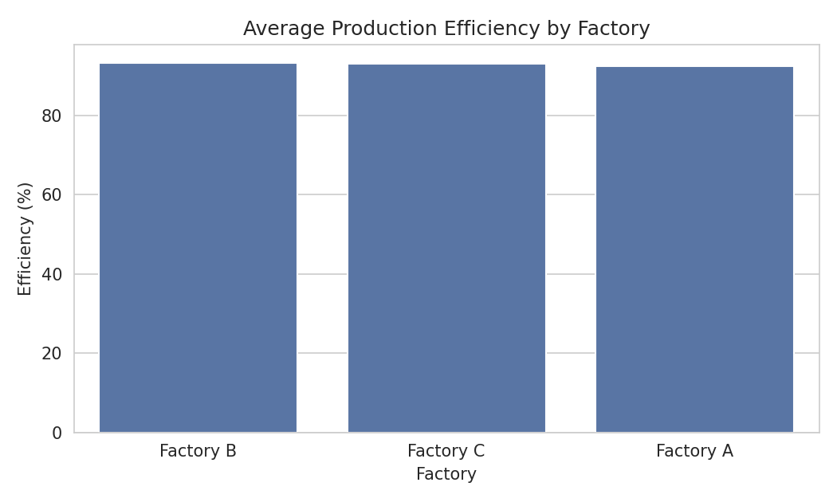
Figure 1: Average production efficiency by factory.

6.2 Production Line and Machine Performance
Factory C's Line D was the strongest performing line overall (94.19% efficiency), while Factory C's Line B was the weakest (91.30% efficiency) despite belonging to the same factory as the top performer — indicating the gap is line-specific rather than factory-wide. At the machine level, a small number of automatic and manual machines (including M104, M119, and M114) accounted for disproportionately high average downtime, each exceeding 85 minutes per run.

6.3 Product Quality
Air Conditioners had the highest average quality inspection score (81.47) and the lowest defect rate (3.73%), while Microwaves had the lowest average quality score (78.91). Washing Machines had the highest defect rate overall (4.31%), and this was most pronounced in Factory C specifically.
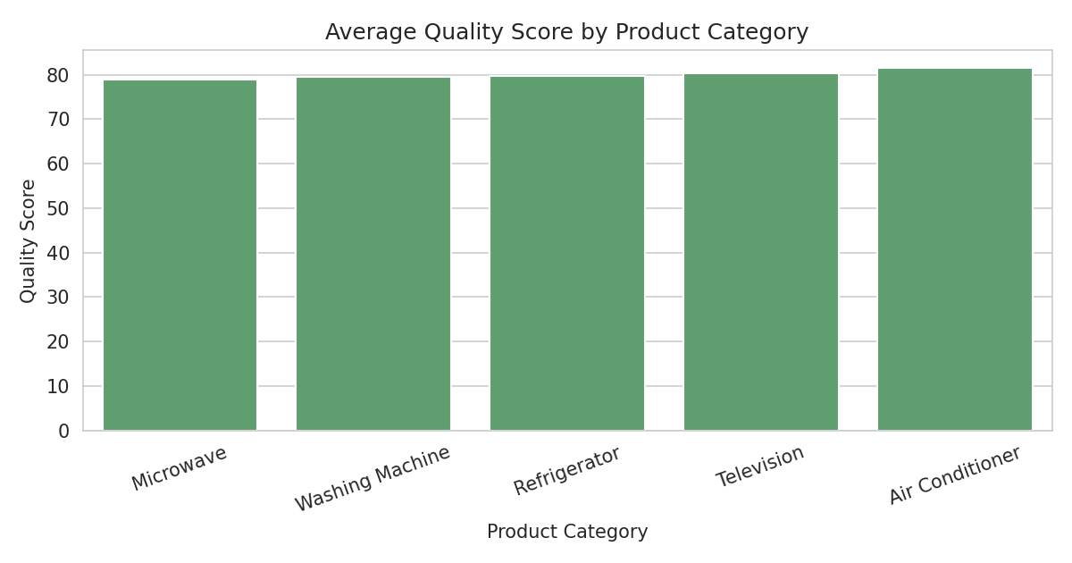
Figure 2: Average quality inspection score by product category.

6.4 Downtime, Energy, and Maintenance
Downtime was lowest during the Afternoon shift (57.3 minutes on average) and highest during Night shifts (61.5 minutes). Automatic machines had the lowest average downtime (58.8 minutes) compared to Manual and Semi-Automatic machines (around 60.6 minutes each). Energy consumption showed almost no correlation with actual production volume (r = -0.02), suggesting energy use is not being driven proportionally by output and may reflect inefficiency or idle consumption. Maintenance cost also showed a very weak correlation with downtime (r = 0.06), meaning higher maintenance spend is not reliably reducing downtime — Semi-Automatic machines had both the highest average maintenance cost ($1,367) and among the highest downtime.

6.5 Shift and Factory Interaction
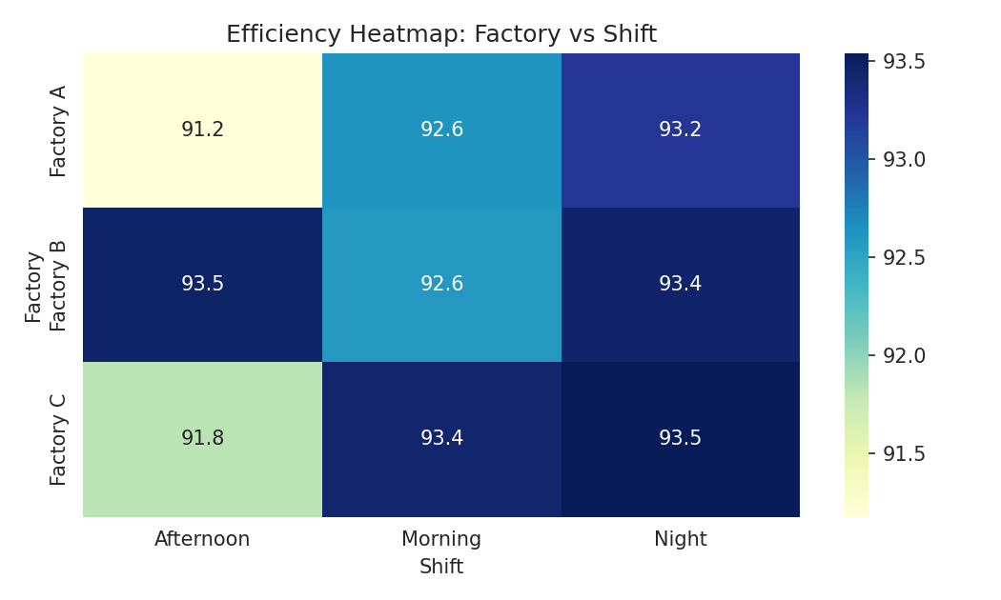
Figure 3: Efficiency heatmap across factory and shift combinations.
Factory A's Afternoon shift was its weakest combination (91.18% efficiency), while Factory B's Afternoon shift was its strongest (93.47%) — the same shift performs oppositely depending on the factory, pointing to local shift-management or staffing differences rather than a universal shift effect.
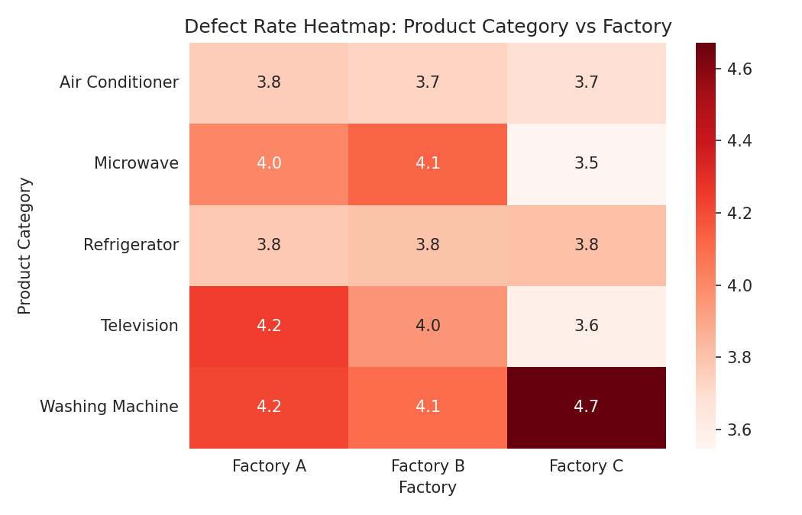
Figure 4: Defect rate heatmap by product category and factory.
Washing Machines produced in Factory C stood out with a notably higher defect rate (4.67%) than the same product in Factory A or B (around 4.1–4.2%), making this combination the clearest quality concern in the dataset.

6.6 Monthly Trend
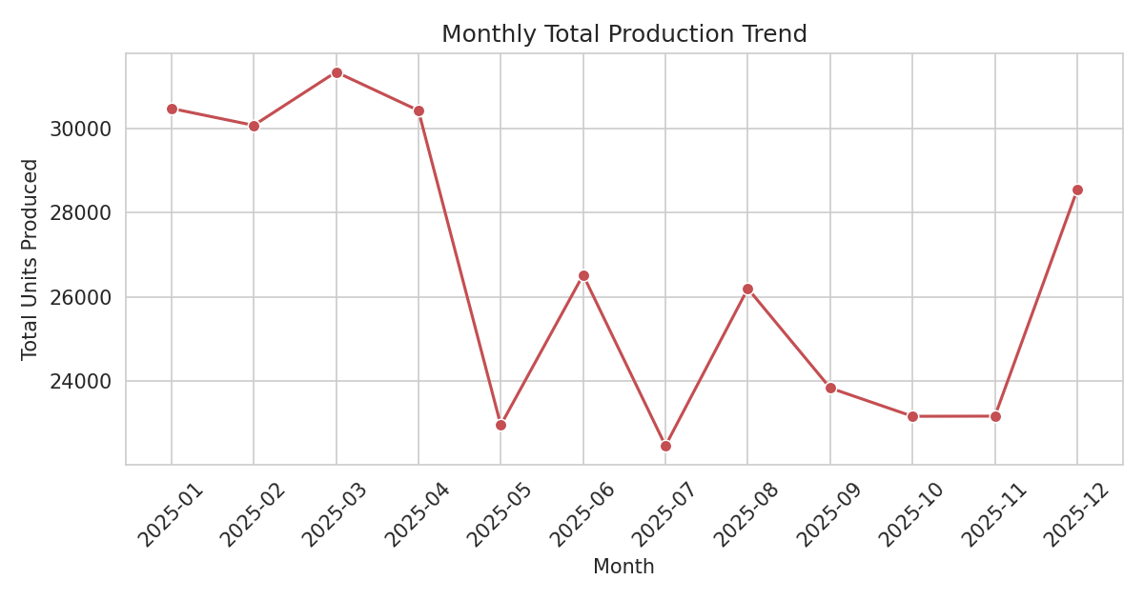
Figure 5: Monthly total production across 2025.
Total monthly production fluctuated across the year without a single sustained upward or downward trend, with several mid-year months (June–August) showing lower output than the January–April period, consistent with seasonal or planning-driven variation rather than a steady decline.

6.7 Cost Efficiency
Factory B delivered the best output-per-cost ratio (478.7 units per cost unit) while having the lowest unit cost, because its combination of unit cost ($237.89), quality score (80.65), and total output (113,887 units) was the most balanced. Factory C had the highest average unit production cost ($248.19) and the lowest output-per-cost ratio (411.8).

6.8 Workforce Performance
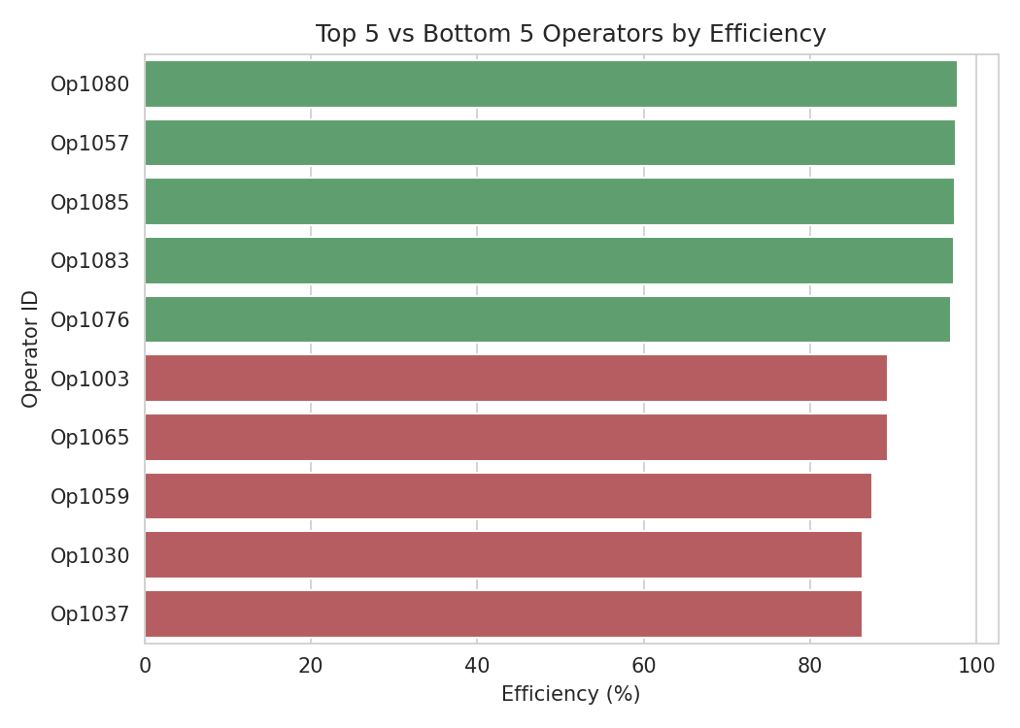
Figure 6: Top 5 and bottom 5 operators by average efficiency.
The top-performing operator (Op1080) averaged 97.70% efficiency with a low 1.82% defect rate. The lowest-performing operators (Op1030 and Op1037) averaged around 86.3% efficiency, an efficiency gap of over 11 percentage points between the best and weakest operators — a wider spread than the gap seen between the best and worst factories.

7. Challenges Encountered
- The Downtime (Minutes) column contained missing values that needed to be addressed before it could be used in aggregation.
- Some categorical text values had inconsistent spacing and casing, which risked splitting a single factory or line into multiple groups during aggregation.
- A small number of rows contained logically invalid values, such as Defective Units exceeding Actual Production.
- Continuous cost and energy columns contained extreme outliers that could distort average-based comparisons if left unaddressed.

8. Solutions Implemented
Challenge: Missing Downtime values.
Solution: Missing values were filled using the column median, which is less sensitive to outliers than the mean.
Challenge: Inconsistent text formatting in categorical columns.
Solution: All categorical text fields were trimmed of whitespace and standardized to a consistent title case before grouping.
Challenge: Logically invalid records.
Solution: Rows with negative values, and rows where defective units exceeded actual production, were filtered out of the dataset.
Challenge: Outliers in cost and energy columns.
Solution: The interquartile range (IQR) method was applied to Energy Consumption, Maintenance Cost, and Unit Production Cost to remove extreme values before analysis.

9. Conclusion
This project successfully explored, cleaned, and analyzed a full year of manufacturing production data across three factories. All six project objectives were achieved: the dataset was explored and documented, cleaned of missing values, invalid entries, and outliers, analyzed in depth across production, quality, downtime, energy, maintenance, and workforce dimensions, grouped and aggregated to compare performance across operational areas, visualized through charts and heatmaps, and summarized in this management report.
The analysis shows that overall production efficiency (92.85%) and defect rates (3.93%) are broadly consistent across factories, but meaningful gaps exist at more granular levels — specific production lines, specific machines, specific shift-factory combinations, and specific operators — that are not visible when looking only at factory-wide averages.

10. Recommendations
- Investigate the high-downtime machines identified (M104, M119, M114, and similar) individually, as they may need targeted maintenance or replacement rather than a factory-wide response.
- Review Factory C's Washing Machine production process specifically, given its notably higher defect rate compared to the same product elsewhere.
- Examine why Factory A's Afternoon shift underperforms relative to the same shift in other factories, to determine whether staffing, scheduling, or supervision changes could close the gap.
- Pair the highest-performing operators (such as Op1080) with lower-performing operators for mentoring, given the wide efficiency spread across the workforce.
- Review energy consumption practices, since energy use shows almost no relationship with output, which may indicate idle or inefficient equipment usage worth auditing.
- Reassess maintenance spending strategy for Semi-Automatic machines, which combine above-average maintenance cost with above-average downtime.
- Extend this analysis with additional years of data and, where possible, predictive modeling to forecast downtime or defect risk before it occurs.

11. References
Manufacturing production dataset provided for this internship project (manufacturing_production_data.csv).
Python, Pandas, Matplotlib, and Seaborn official documentation.

