Neural Machine Translation (NMT) is an impressive and transformative technology, particularly in the field of language processing. However, I don't believe it forms the very foundation of machine learning (ML). Rather, NMT is one of many advanced applications that have developed as a result of decades of research in ML. In simple terms, the journey to today’s advanced and complex ML systems has been shaped by contributions from multiple fields, including cybernetics and computer science (Fradkov, 2020), long before NMT emerged.

Initially, statistical methods and simple neural networks offered the first glimpse of how machines could learn from data. This led to the perceptron model, developed in the 1950s and 1960s, which played a key role in early ML development, showcasing the potential of neural networks (Fradkov, 2020). Then, these early concepts evolved into classic ML algorithms like decision trees, support vector machines, and regression models that were widely used to make predictions and classify information.

Later on, deep learning changed the game by allowing models to automatically learn complex patterns with very little human input. Innovations like convolutional neural networks (CNNs) for images and recurrent neural networks (RNNs) for sequences were some of the key breakthroughs that made this possible. When it comes to natural language processing, advanced models that we reviewed during the MSAI321 residency class, like sequence-to-sequence models combined with attention mechanisms, set the stage for the development of transformer architectures. As Stahlberg (2020) pointed out in his thorough review of neural machine translation, these innovations have transformed how we process language, making the models not only more fluent but also incredibly accurate.

However, while NMT stands out as one of the most impressive applications of deep learning, it's important to remember that it’s just one chapter in the foundation of machine learning. The foundation of ML stretches from early statistical methods to the creation of integrated systems that are now solving complex problems in fields like computer vision, robotics, healthcare, and beyond. As such, NMT should be viewed as a product of ML's evolution rather than its starting point or foundation.

**Figure 1.0**

*Evolutionary Path to Modern Machine Learning (Based on Fradkov, 2020)*

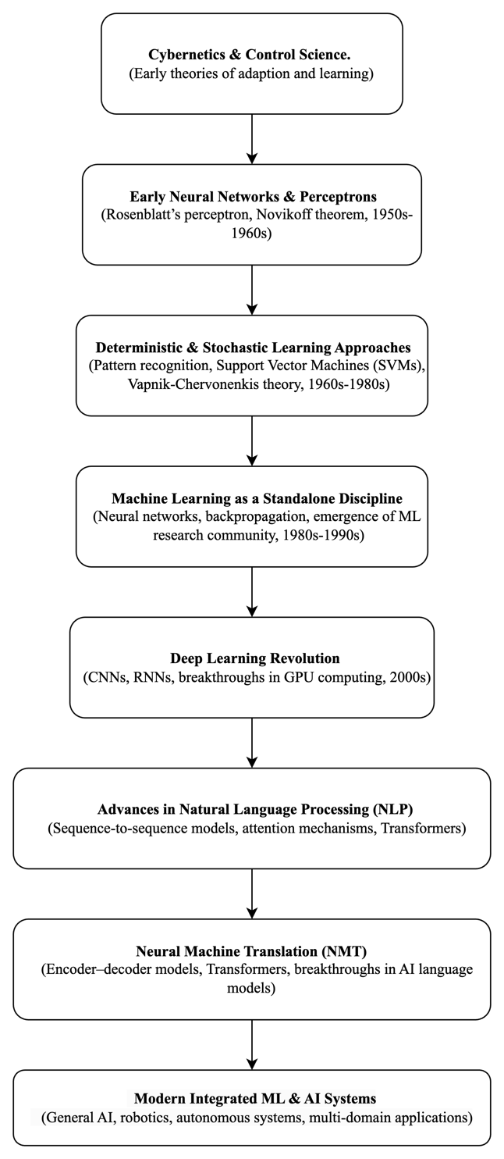

As shown in Figure 1.0 above, the evolutionary path to machine learning has come a long way from its early days in cybernetics and control theory. In the 1950s, the perceptron was introduced as one of the first neural network models, followed by advances in classical ML like Support Vector Machines (SVMs) that improved how computers recognized patterns. By the 1980s, backpropagation made it possible for neural networks to handle more complex problems, opening the door to real-world applications like speech recognition and financial modeling (Fradkov, 2020).

However, things really took off in the 2000s with the rise of deep learning. CNNs revolutionized image recognition, while transformers changed how computers understood and processed language. Neural Machine Translation (NMT) became a breakthrough, making automated translations much more natural and accurate. But NMT is just a piece in ML’s evolution. Today, machine learning is everywhere and it keeps improving with advancements in AI, automation, and decision-making (Fradkov, 2020).

**References**

Fradkov, A. L. (2020). Early history of machine learning. IFAC PapersOnLine, 53(2), 1385-1390. <https://doi.org/10.1016/j.ifacol.2020.12.1888>

Stahlberg, F. (2020). Neural machine translation: A review. Journal of Artificial Intelligence Research, 69, 343–418.

Qiu, X., Sun, T., Xu, Y., Shao, Y., Dai, N., & Huang, X. (2020). Pre-trained models for natural language processing: A survey. Science China Information Sciences, 63(10), 1872–1897.

Taye, M. M. (2023). Understanding of machine learning with deep learning: Architectures, workflow, applications and future directions. Computers, 12(5), 91. <https://doi.org/10.3390/computers12050091>