CS 462 Computer Networks – Final Exam Name:_Sam Strecker__

**Note***: Show all work. No points will be awarded if work is not shown even if the answer is correct. Please put your name on* ***every*** *sheet.*

1. Suppose a network uses distance-vector routing. Provide the routing tables for router C for every round until it converges.

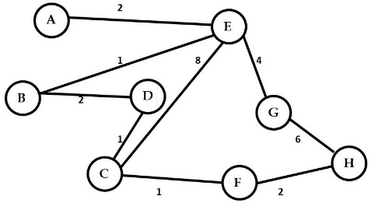

Series of rounds:

Dest NxtNode Cost Dest NxtNode Cost

A D 6 A B 5

B D 3 B B 2

Round 1 D D 1 D D 0 Round 2

E E 8 E B 3

F F 1 F C 2

G F 9 G B 7

H F 3 H C 4

Dest NxtNode Cost Dest NxtNode Cost

A E 3 A A 2

B B 0 B B 1

D D 2 D B 3

Round 3 E E 1 E E 0 Round 4

F D 4 F C 9

G E 5 G G 4

H D 6 H G 10

1. A channel has a data rate of R bps and a propagation delay of t seconds per kilometer. The distance between the sending and receiving nodes is L kilometers. Nodes exchange fixed-sized frames of B bits. Find a formula that gives the minimum sequence numbers field size of the frame as a function of R, t, B, and L (considering maximum utilization). Assume the processing at the nodes is instantaneous and all frames are negligible in size.

**Packet time (Pt) = distance between nodes x propagation delay**

**= L x t**

**Pt = 2 x L x t**

**Transmit frame time (Tft) = B/R**

**Total num of frames (Tnf) = {1 + ((2 x L x t) / (B /R))}**

**Total num of frames (Tnf) = {1 + ((2 x R x L x t) / B)}**

**k = log2 (Tnf)**

**k = {log2 (1 + ((2 x R x L x t) / B))}**

1. For the LAN segments shown below, apply the Bridge Spanning Tree algorithm to obtain a set of optimal ports. (Draw the corresponding tree with each node and LAN along with their corresponding cost). Show all work!

## L1

1 1 **L2**



B1

B2

2 1



B7

2 **L3** 3



1 2 1



B5

B3

B4

2 2  **L6**

2 1 3



**L4** 1



B6

**L5** 2



Draw connections that are in the final spanning tree below:

## L1

1 1 **L2**

B1

B2

2 1

B7

**L3** 3

1 2 1

B5

B3

B4

2  **L6**

1

**L4** 1

B6

**L5 2**

1. Consider a Go-Back-N protocol with a sender window size of *N* and a sequence number range of 1024. Suppose that at time *t* the next packet that the receiver is expecting has a sequence number of *k*. Assume that the medium does not re-order messages. Answer the following:
2. Assume the receiver has received packet *k-1* and has ACKed that and all other preceding

packets and the ACKs have been received at the sender. The sender’s window is

**[ k , k+ N - 1].** Justify your answer in terms of *k* and *N*.

1. Suppose that none of the ACKs have been received at the sender, the sender’s window is

**[k – N , k -1]**

1. What are all possible values of the ACK field in all possible messages currently propagating back to the sender at time t?

**All the possible values sent will be in the range k – N – 1 and k -1**

1. For the netID below:

**NetID Subnets required**

190.176.0.0 122

Determine the

1. **subnet mask (show work)**



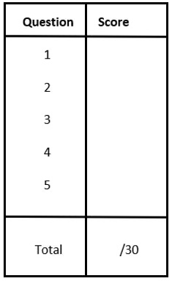

**190.176.11111110.00000000**

**255.255.254.0**

1. **first available host address of subnet one**(NOT subnet zero)

**190.176.00000100.00000001**

**190.176.2.1**

1. the **maximum number of hosts per subnet** for the network ID below?

**29 – 2 = 512 – 2 = 510 hosts**