Presentation Handout
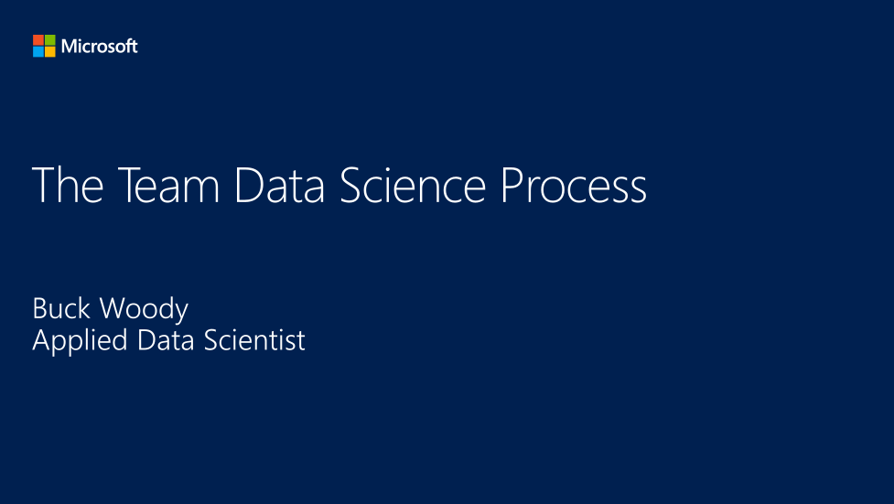

https://medium.com/adventures-in-consumer-technology/five-steps-to-approaching-machine-learning-for-your-business-af25e91743f2

Slide 2

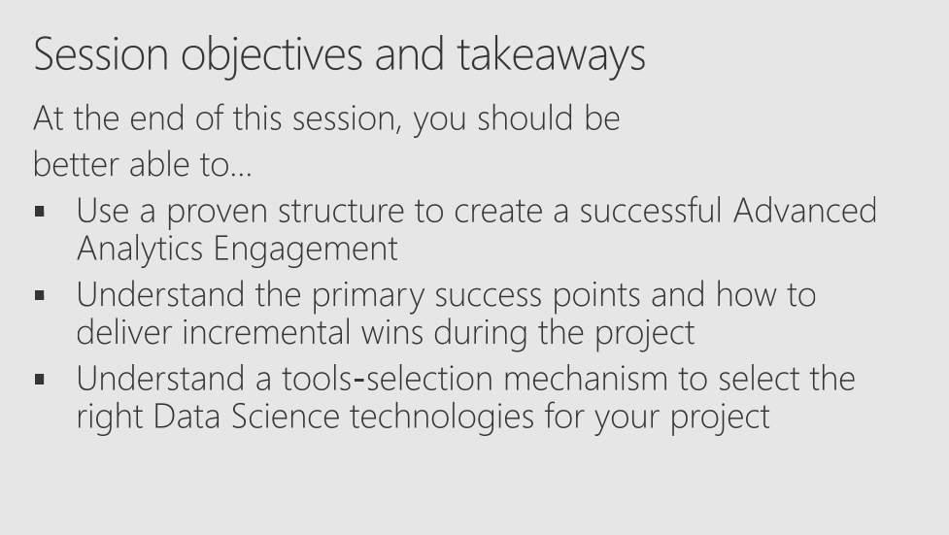

Slide 3

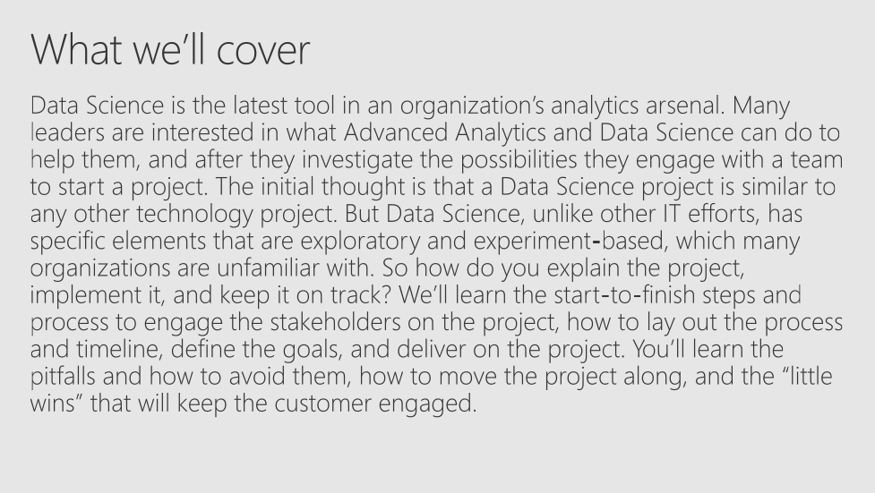

Slide 4

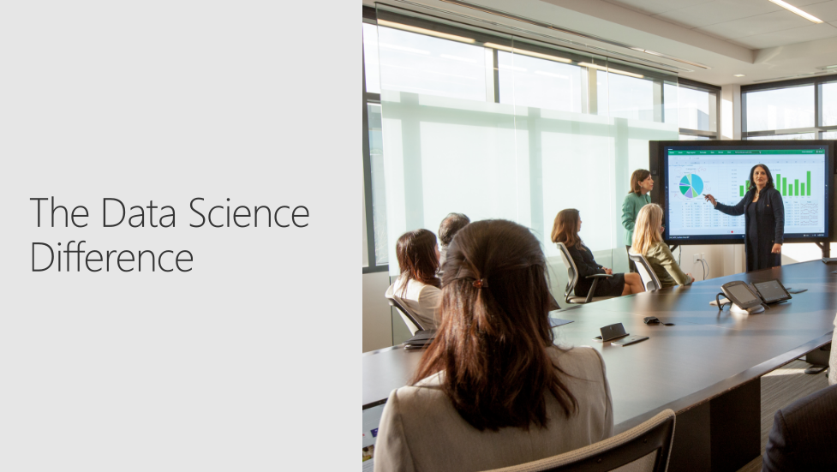

Slide 5

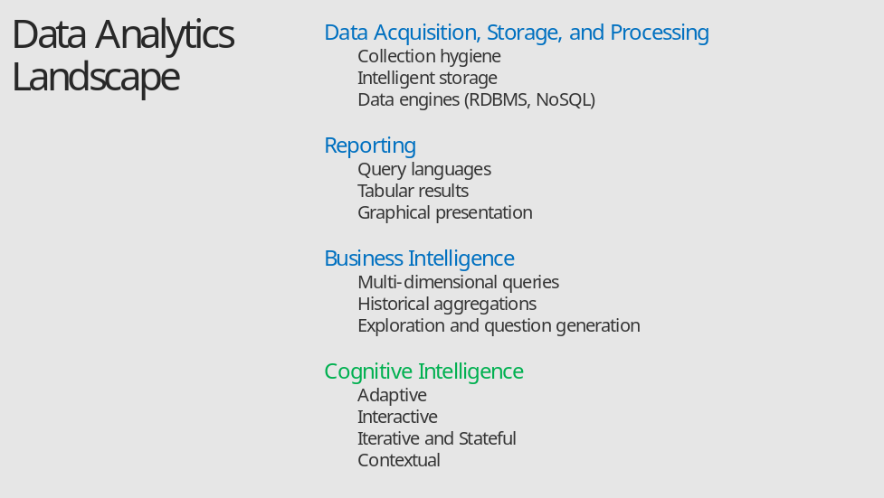

Slide 6

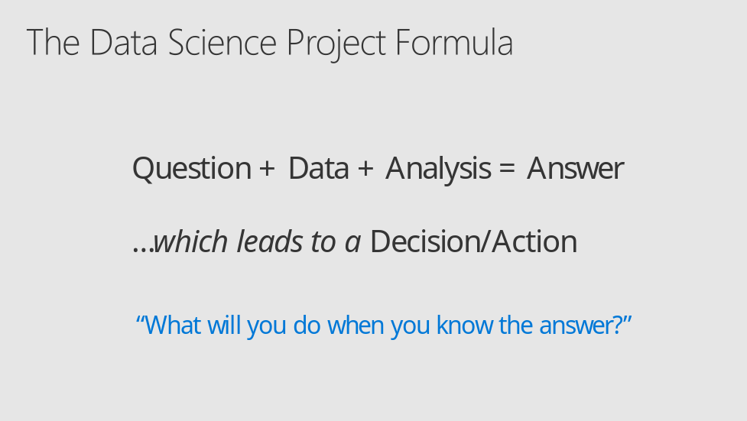

Slide 7

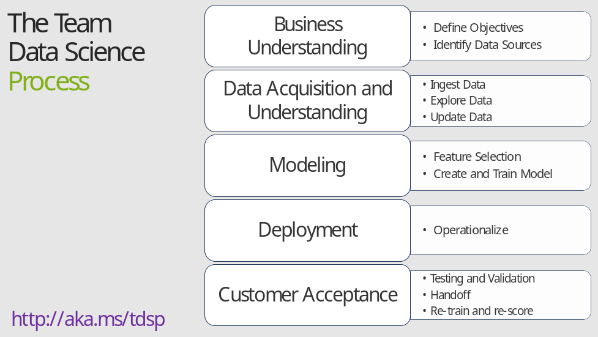

- It also references the Microsoft Business Analytics and AI process - https://docs.microsoft.com/en-us/azure/machine-learning/team-data-science-process/overview
- A complete process diagram is here - https://azure.microsoft.com/en-us/documentation/learning-paths/data-science-process/
- Some walk-throughs of the various services - https://azure.microsoft.com/en-us/documentation/articles/data-science-process-walkthroughs/
- An integrated process and toolset allows for a more close-to-intent deployment
- Iterations are required to close in on the solution – but are harder to manage and monitor – We’ll cover DevOps for Data Science in this course to assist.

Slide 8

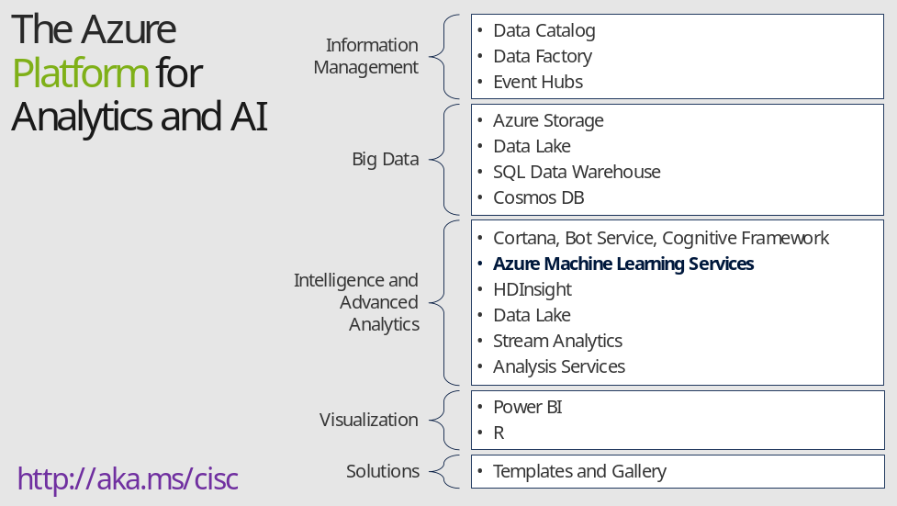

- Azure Data Catalog - http://azure.microsoft.com/en-us/services/data-catalog (Doc It)
- Azure Data Factory - http://azure.microsoft.com/en-us/services/data-factory/ (Move It)
- Azure Event Hubs - http://azure.microsoft.com/en-us/services/event-hubs/ (Bring It)
- Platform and Storage - Microsoft Azure – https://azure.microsoft.com/ Storage - https://docs.microsoft.com/en-us/azure/storage/ (Host It)
- Azure Data Lake - https://azure.microsoft.com/en-us/solutions/data-lake/ (Store It)
- Azure SQL Data Warehouse - http://azure.microsoft.com/en-us/services/sql-data-warehouse/ (Relate It)
- Azure Cosmos DB - https://docs.microsoft.com/en-us/azure/cosmos-db/introduction
- Cortana - https://developer.microsoft.com/en-us/Cortana and https://blogs.windows.com/buildingapps/2017/05/10/cortana-skills-kit-empowers-developers-build-intelligent-experiences-millions-users/#AXrmKPb74ugDDmG7.97 and https://www.microsoft.com/en-us/windows/cortana/cortana-skills/ (Say It)
- Cognitive Services - https://www.microsoft.com/cognitive-services
- Bot Framework - https://dev.botframework.com/
- Azure Machine Learning - https://docs.microsoft.com/en-us/azure/machine-learning/preview/ (Learn It)
- Azure HDInsight - http://azure.microsoft.com/en-us/services/hdinsight/ (Scale It)
- Azure Stream Analytics - http://azure.microsoft.com/en-us/services/stream-analytics/ (Stream It)
- Analysis Services - https://docs.microsoft.com/en-us/azure/analysis-services/analysis-services-overview
- Power BI - https://powerbi.microsoft.com/ (See It)
- All of the components within the suite - https://www.microsoft.com/en-us/cloud-platform/what-is-cortana-intelligence
- Templates - https://gallery.cortanaintelligence.com/browse?orderby=freshness%20desc&skip=0&categories=%5B%2210%22%5D and https://caqs.azure.net/#gallery

Slide 9

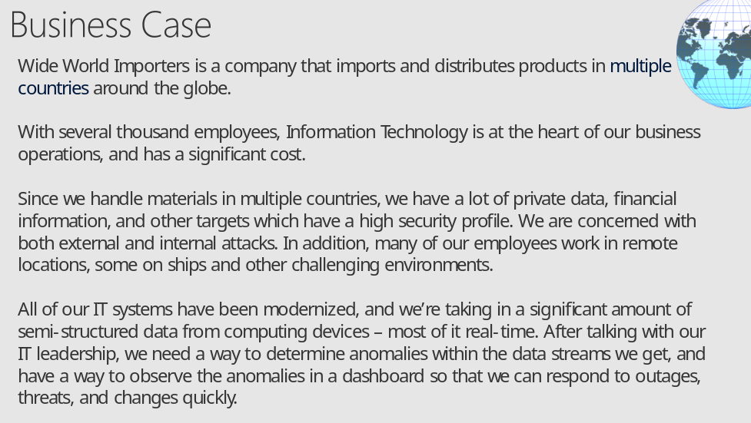

- More about Wide World Importers: https://docs.microsoft.com/en-us/sql/sample/world-wide-importers/overview
- Anomaly Detection: https://gallery.cortanaintelligence.com/Solution/Anomaly-Detection-in-Real-time-Data-Streams

Slide 10

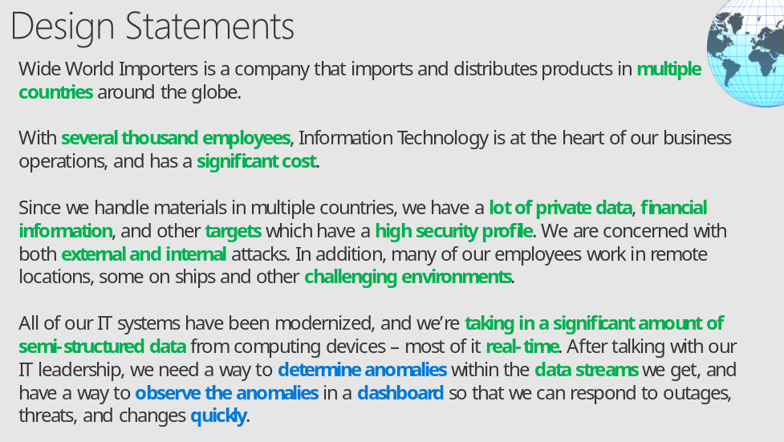

- More about Wide World Importers: https://docs.microsoft.com/en-us/sql/sample/world-wide-importers/overview
- Anomaly Detection: https://gallery.cortanaintelligence.com/Solution/Anomaly-Detection-in-Real-time-Data-Streams

Slide 11

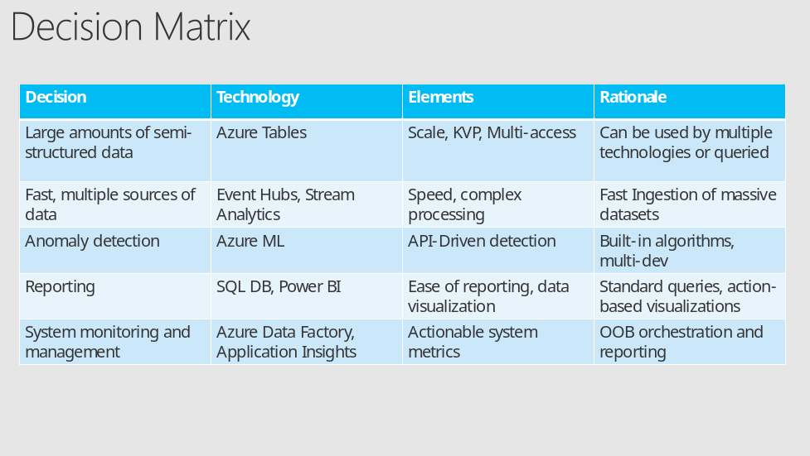

- Another approach on decision matrices: http://www.businessnewsdaily.com/6146-decision-matrix.html

Slide 12

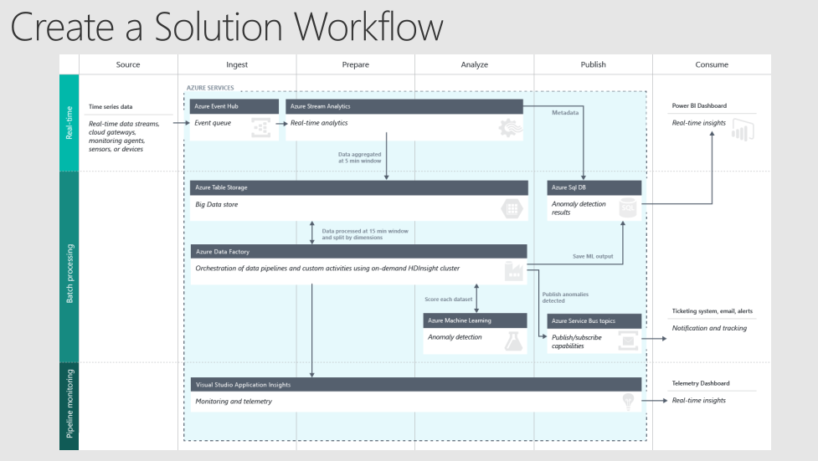

- Full description is here: https://github.com/Azure/itanomalyinsights-cortana-intelligence-preconfigured-solution/blob/master/Docs/IT%20Anomaly%20Insights%20Post%20Deployment%20Instructions.md
- Create your own Solution Templates: https://start.cortanaintelligence.com/CustomSolutions
- More solution tutorials: https://gallery.cortanaintelligence.com/browse?categories=%5B%227%22%5D&skip=0&orderby=trending%20desc&tags=%5B%22Solution%22%5D

Slide 13

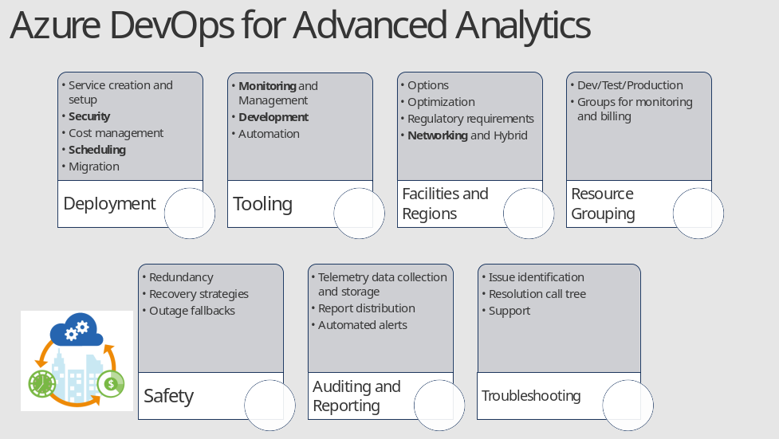

- Deployment
- Service Creation and Setup - https://azure.microsoft.com/en-us/offers/ms-azr-0003p/
- Authentication and Access - https://docs.microsoft.com/en-us/azure/active-directory/connect/active-directory-aadconnect
- Security best practices - https://docs.microsoft.com/en-us/azure/active-directory/role-based-access-control-configure
- Cost Management (Pricing) - https://azure.microsoft.com/en-us/pricing/
- Migrations - https://msdn.microsoft.com/en-us/library/dn727097.aspx
- Tools
- The Azure Portal - https://docs.microsoft.com/en-us/azure/azure-portal-overview
- PowerShell - https://docs.microsoft.com/en-us/powershell/azure/overview?view=azurermps-3.8.0
- CLI - https://docs.microsoft.com/en-us/cli/azure/install-azure-cli
- Others - Visual Studio, System Center, Jenkins, chef
- Azure Automation - https://azure.microsoft.com/en-us/services/automation/
- Facilities and Regions
- Locations - https://azure.microsoft.com/en-us/regions/
- Azure Trust Center - https://azure.microsoft.com/en-us/support/trust-center/
- Resource Grouping
- Resource Groups - https://docs.microsoft.com/en-us/azure/azure-resource-manager/resource-group-overview
- Using the ARM model - https://docs.microsoft.com/en-us/azure/azure-resource-manager/resource-group-template-deploy-portal
- Safety - https://docs.microsoft.com/en-us/azure/storage/storage-redundancy
- Auditing - https://msdn.microsoft.com/en-us/library/mt662411.aspx?f=255&MSPPError=-2147217396
- Troubleshooting and Support - https://azure.microsoft.com/en-us/blog/understanding-azure-troubleshooting-and-support/

Special considerations for Advanced Analytics:
- Account management
- Storage and redundancy
- Privacy and data protection
- Scheduling and Pipelined workflows
- Networking - https://www.simple-talk.com/cloud/cloud-data/azure-networking-sql-server-dbas/
- Optimization
- Security
- Advanced Analytics Services awareness – data transfer, storage and processing
- Dependencies and interactions

- Full tutorial: https://github.com/Azure/DevOps-For-AI-Apps/blob/master/Tutorial.md

Slide 14

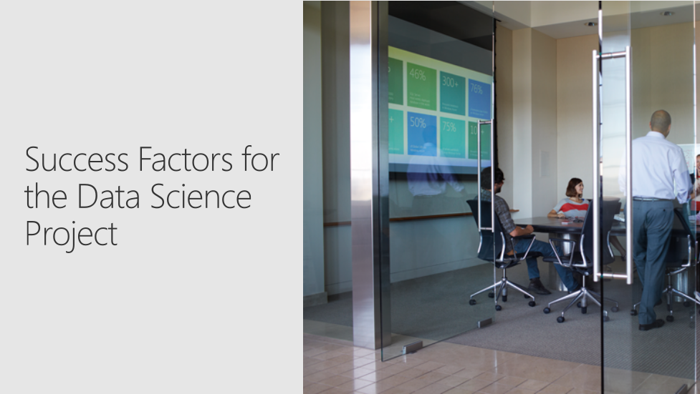

Slide 15

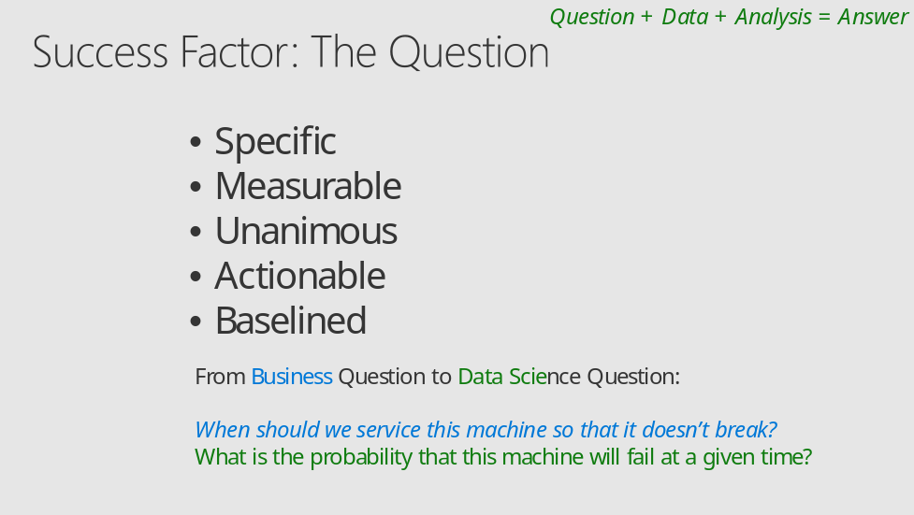

- The five questions data science can answer - https://docs.microsoft.com/en-us/azure/machine-learning/machine-learning-data-science-for-beginners-the-5-questions-data-science-answers
- The question you can answer with data - https://docs.microsoft.com/en-us/azure/machine-learning/machine-learning-data-science-for-beginners-ask-a-question-you-can-answer-with-data
- Copy other people’s work to do data science - https://docs.microsoft.com/en-us/azure/machine-learning/machine-learning-data-science-for-beginners-copy-other-peoples-work-to-do-data-science

Slide 16

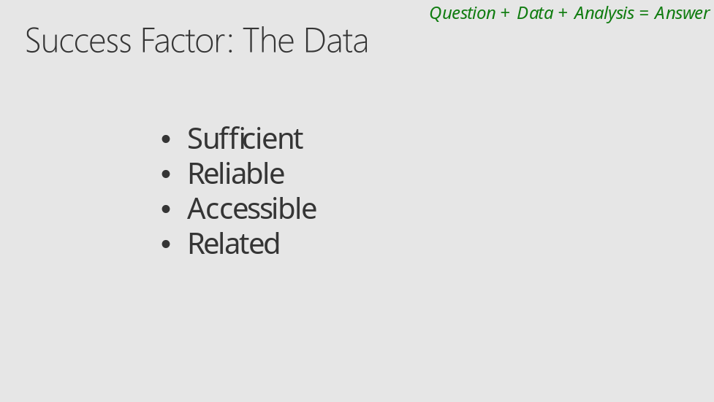

- Is your data ready for data science - https://docs.microsoft.com/en-us/azure/machine-learning/machine-learning-data-science-for-beginners-is-your-data-ready-for-data-science
- Correlation does not equal Causation - http://www.tylervigen.com/spurious-correlations

Slide 17

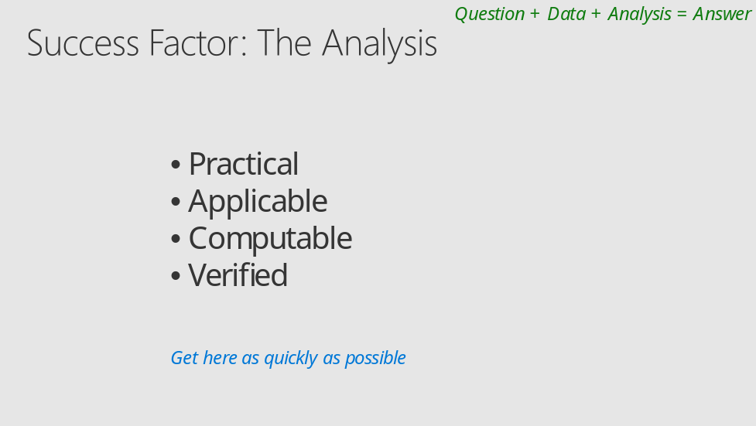

- Predict an answer with a simple model - https://docs.microsoft.com/en-us/azure/machine-learning/machine-learning-data-science-for-beginners-predict-an-answer-with-a-simple-model

Slide 18

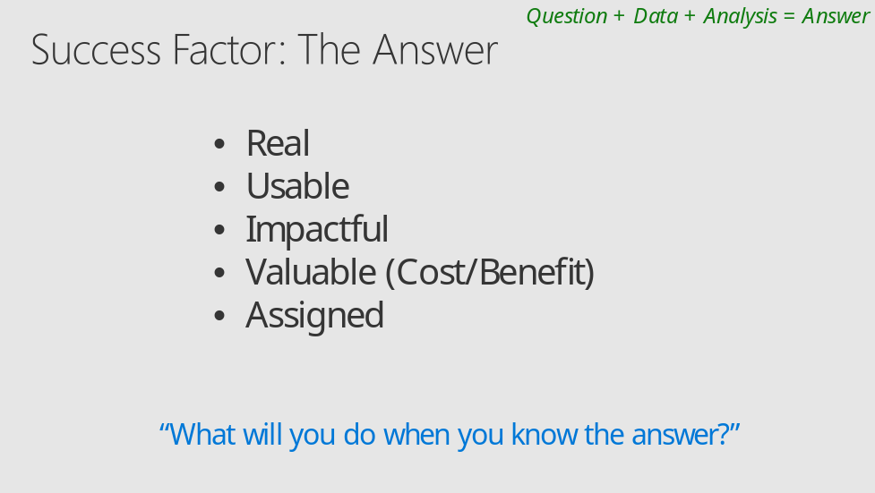

- Cost/Benefit Analysis: https://www.mindtools.com/pages/article/newTED_08.htm

Slide 19

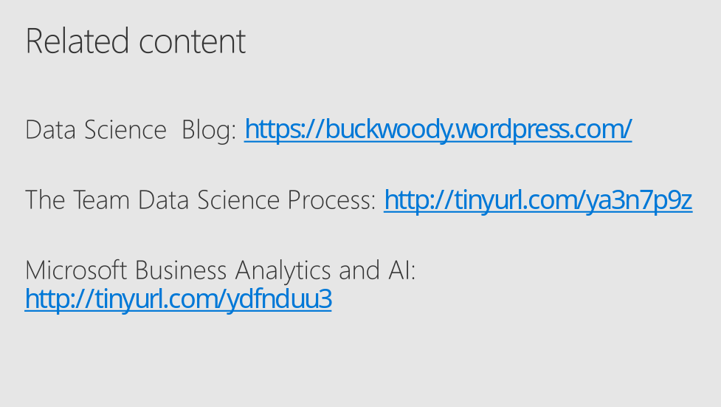

Slide 20



Slide 21



