VIETNAM GENERAL CONFEDERATION OF LABOR
TON DUC THANG UNIVERSITY
FACULTY OF INFORMATION TECHNOLOGY



HUYNH HAI QUAN – 525H0088

MIDTERM ESSAY

APPLIED LINEAR ALGEBRA FOR IT

HO CHI MINH CITY, 2026
VIETNAM GENERAL CONFEDERATION OF LABOR
TON DUC THANG UNIVERSITY
FACULTY OF INFORMATION TECHNOLOGY



HUYNH HAI QUAN – 525H0088

MIDTERM ESSAY

APPLIED LINEAR ALGEBRA FOR IT

Advised by
Professor Pham Quoc Duy

HO CHI MINH CITY, 2026
ACKNOWLEDGEMENT

I would like to express my sincere gratitude to Mr. Pham Quoc Duy, my instructor and mentor, for his valuable guidance and support throughout the midterm report for the Applied Linear Algebra course. He has been incredibly helpful and patient in providing me with constructive feedback and suggestions to improve my work. He has also encouraged me to deepen my understanding of mathematical concepts and how to effectively apply them using Python. I have learned a great deal from his expertise in this field, and I am honored and privileged to have him as my teacher.

Ho Chi Minh city, 5th April 2026.
Author
(Signature and full name)

Quan
Huynh Hai Quan

DECLARATION OF AUTHORSHIP
I hereby declare that this is my own project, guided by Mr. Pham Quoc Duy. The programming logic, source code, and results contained herein are my original work and have not been published or submitted in any form before.
Any mathematical concepts, programming libraries, or references utilized in this essay are standard course materials or appropriately applied tools for this specific assignment.
I take full responsibility for the content and academic integrity of my project. Ton Duc Thang University is not liable for any infringing rights or copyright issues that may arise during the implementation process.

Ho Chi Minh city, 3rd September 2023
Author
(Signature and full name)

Quan
Huynh Hai Quan

APPLIED LINEAR ALGEBRA FOR IT
ABSTRACT

This project focuses on the practical application of Linear Algebra concepts using the Python programming language and the NumPy library. The primary objective is to demonstrate proficiency in matrix operations, including addition, transpose, and multiplication, while resolving mathematical constraints such as dimension mismatches. Additionally, the project implements algorithmic logic to extract specific data types—such as prime numbers and odd sequences—from generated matrices. The results are documented through a series of five distinct execution trials to verify the consistency and accuracy of the implemented methodology.

TABLE OF CONTENT
LIST OF FIGURES v
ABBREVIATIONS vi
CHAPTER 1. METHODOLOGY OF SOLVING TASKS 1
1.1 Task 1a: Matrix Addition and Transpose Operations 1
1.2 Task 1b: Submatrix Selection and Multiplication 1
1.3 Task 1c: Extraction and Sorting of Odd Integers 2
1.4 Task 1d: Vector Extraction and Prime Number Summation 3
1.5 Task 1e: Row Analysis for Prime Number Density 4
1.6 Task 1f: Contiguous Odd Number Sequence Identification 5
CHAPTER 2. RESULTS 6
2.1 Trial 1 Results 6
2.2 Trial 2 Results 7
2.3 Trial 3 Results 8
2.4 Trial 4 Results 9
2.5 Trial 5 Results 10
REFERENCES 11

LIST OF FIGURES
Figure 2.1: Terminal output for Trial 1: Matrix initialization and Tasks 1a-1f .........6
Figure 2.2: Terminal output for Trial 2: Matrix initialization and Tasks 1a-1f .........7
Figure 2.3: Terminal output for Trial 3: Matrix initialization and Tasks 1a-1f .........8
Figure 2.4: Terminal output for Trial 4: Matrix initialization and Tasks 1a-1f .........9
Figure 2.5: Terminal output for Trial 5: Matrix initialization and Tasks 1a-1f .......10

ABBREVIATIONS

IT | Information Technology
NumPy | Numerical Python
1D / 2D | One – Dimensionals / Two – Dimensionals

METHODOLOGY OF SOLVING TASKS

Task 1a: Matrix Addition and Transpose Operations
Objective: Perform a composite matrix calculation involving addition, transpositions, and dot products to produce a final $10×10$result.

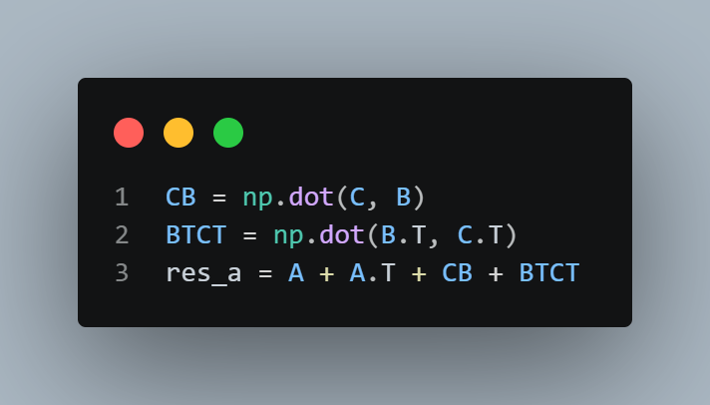

- CB: Uses np.dot(C, B) to calculate the product of matrix $C (10 × 2)$and$B (2 × 10)$, which results in a $10 × 10$matrix.
- BTCT: Uses np.dot(B.T, C.T) to multiply the transpose of B by the transpose of C $.$
- AT: Computes the transpose of the $(10 × 10)$matrix A, swapping its rows and columns.
- res_a: Combines all terms (A, $A^{T},$CB, and $B^{T}C^{T}$) through matrix addition to generate the final output.

Task 1b: Submatrix Selection and Multiplication
Objective: Randomly select k matching columns and rows from A and C to compute the product matrix $M = B.A'.C'$
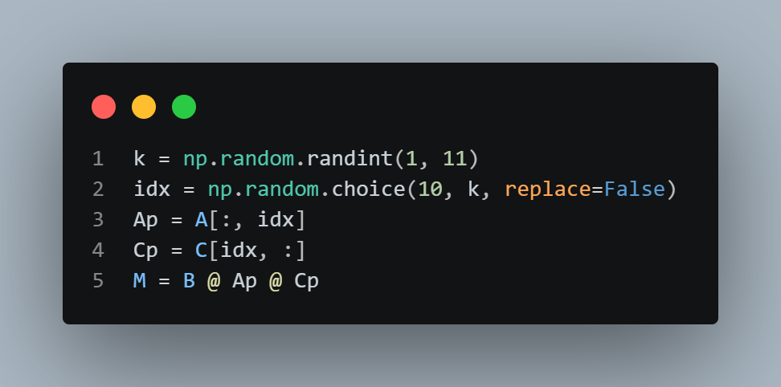

- k: Generates a random integer between 1 and 10 to define the size of the submatrices.
- idx: Uses np.random.choice to pick k unique, non-repeating indices from the range of 10.
- Ap & Cp: These lines use NumPy slicing to create submatrix $A'$ (all rows, selected columns) and $C'$ (selected rows, all columns).
- M: Uses the @ operator to perform sequential matrix multiplication ($B × A' × C'$), resulting in a $2 × 2$matrix.

Task 1c: Extraction and Sorting of Odd Integers
Objective: Isolate all odd integers within matrix A, ensuring the resulting vector $v$ contains only unique values sorted in descending order.

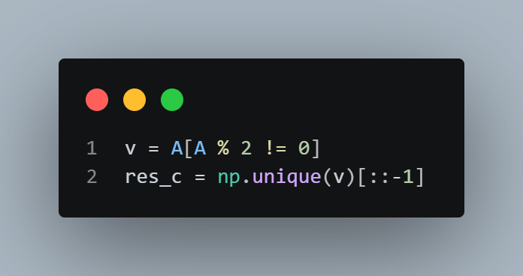

- $v:$ Uses the modulo operator % within a boolean mask to extract all elements in A that are not divisible by 2.
- res_c: Wraps the vector in np.unique() to discard duplicate values and then applies the [::-1] slice to reverse the default ascending sort into a descending one.

Task 1d: Vector Extraction and Prime Number Summation
Objective: Extract all prime numbers from A into vector $d$and compute a weighted sum S based on the position of each element.

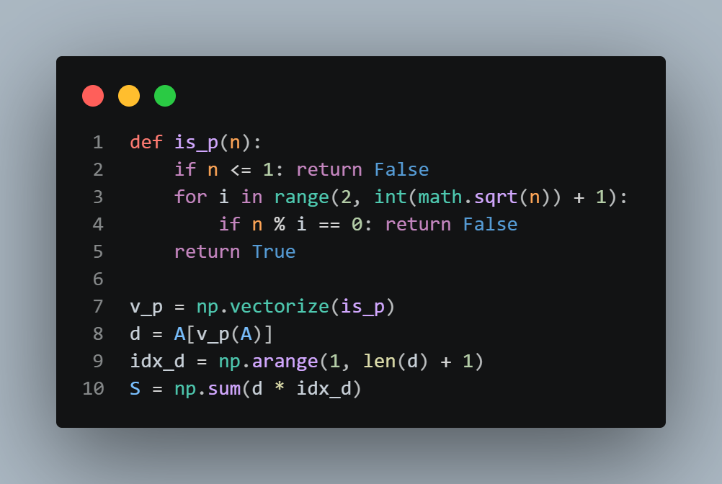

- is_p(n): A custom function that identifies prime numbers by checking for divisors up to the square root of $n$.
- v_p: Converts the scalar is_p function into a vectorized version that can be applied across the entire NumPy array.
- d: Filters matrix A through the v_p mask to store every identified prime number in a 1D array.
- idx_d: Generates a sequence of 1-based indices (1, 2, 3...) matching the length of the prime vector $d$.
- S: Multiplies each prime $d_{i}$ by its index $i$ and sums the results using np.sum().

Task 1e: Row Analysis for Prime Number Density
Objective: Identify the specific rows in matrix A that contain the highest frequency of prime numbers.

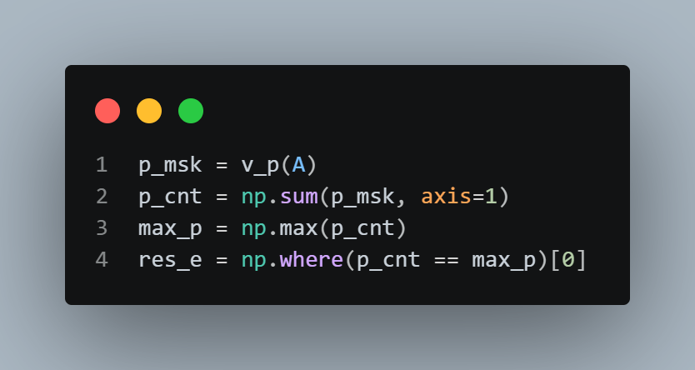

- p_msk: Creates a boolean matrix where each entry is True if the corresponding value in A is prime.
- p_cnt: Sums the boolean values along each row (axis=1) to get a count of primes per row.
- max_p: Calculates the maximum value present in the p_cnt array.
- res_e: Uses np.where to find all row indices where the prime count equals max_p.

Task 1f: Contiguous Odd Number Sequence Identification
Objective: Scan matrix A to find rows containing the longest sequence of
consecutive odd integers.

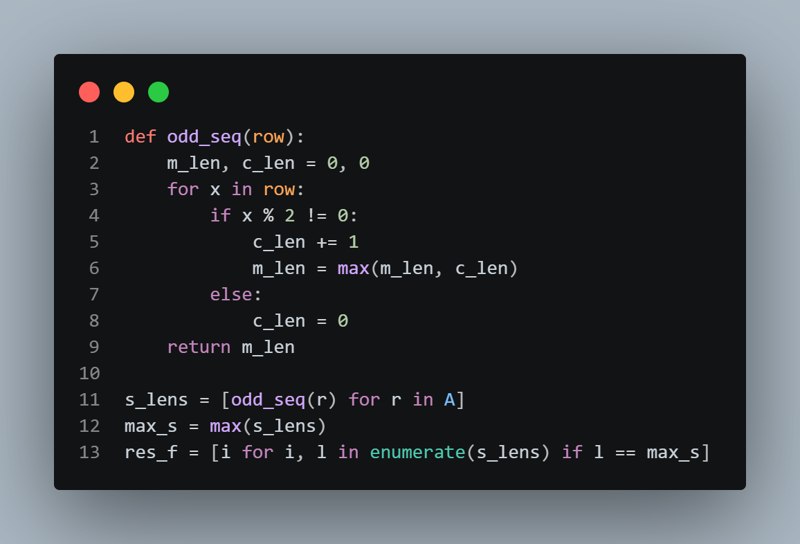

- odd_seq(row): Iterates through a row to calculate the length of consecutive odd numbers, resetting the count whenever an even number is encountered.
- s_lens: A list comprehension that applies the sequence counting logic to every row in matrix A.
- max_s: Finds the highest sequence length achieved across the entire matrix.
- res_f: Identifies and stores the indices of all rows that match the max_s length.

RESULTS

Trial 1 Results
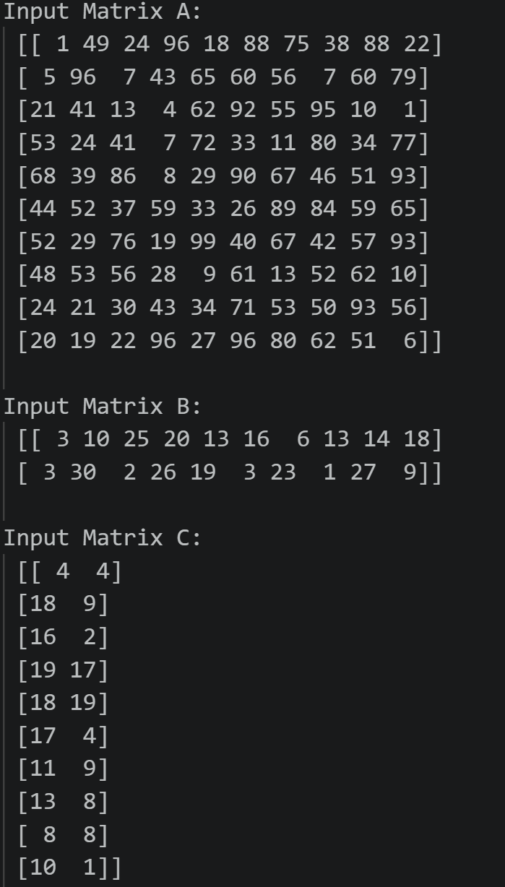

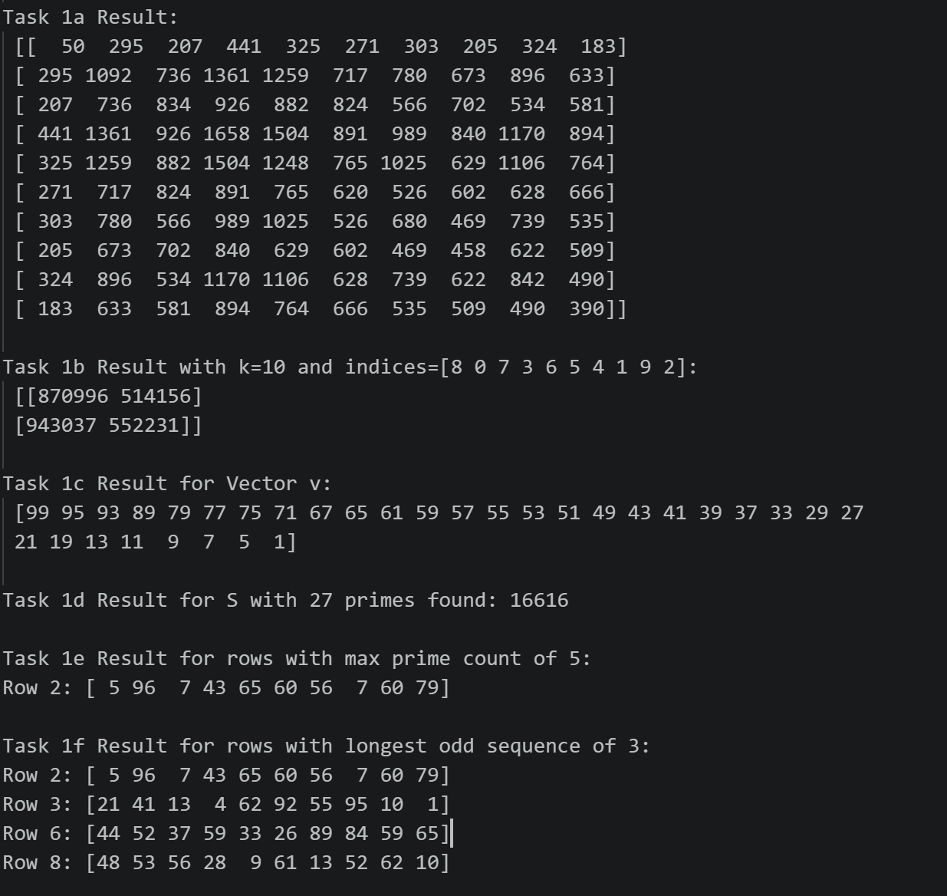
Figure 2.1 Terminal output for Trial 1: Matrix initialization and Tasks 1a-1f

Trial 2 Results
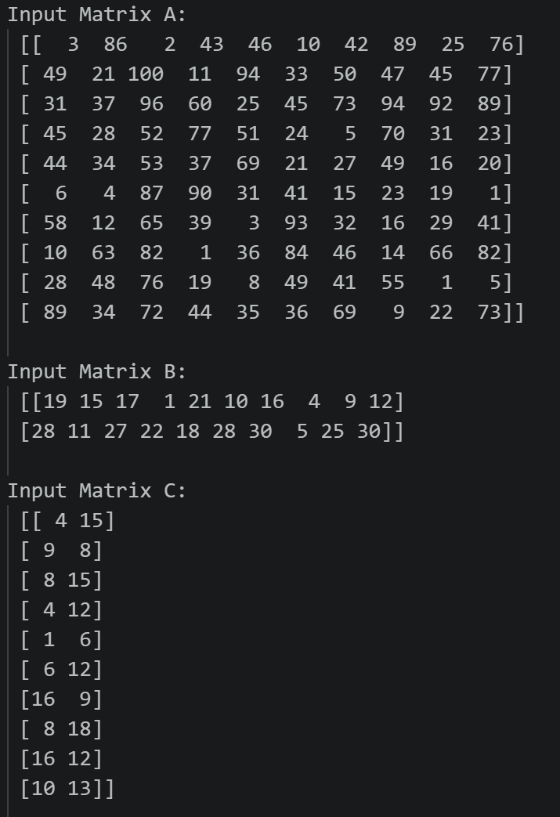

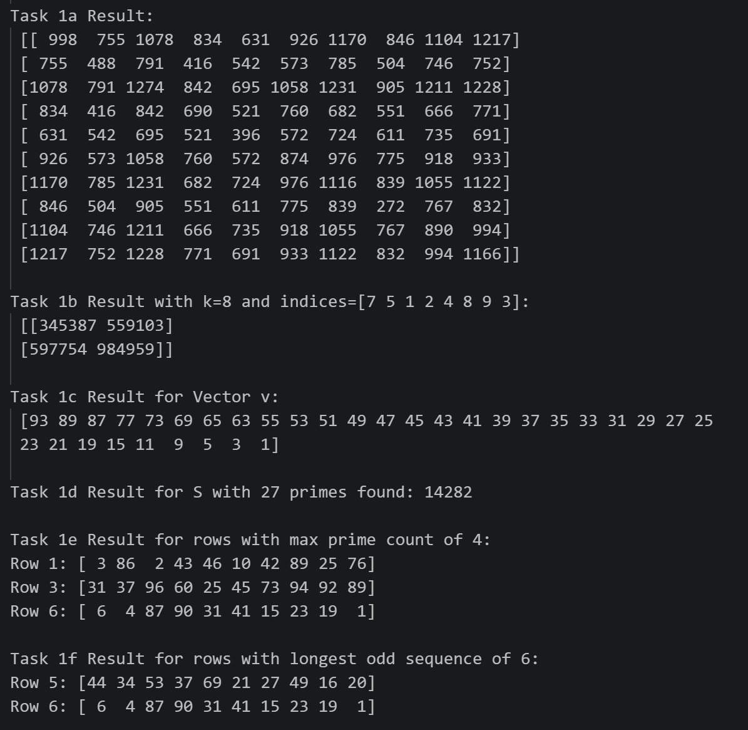
Figure 2.2 Terminal output for Trial 2: Matrix initialization and Tasks 1a-1f

Trial 3 Results
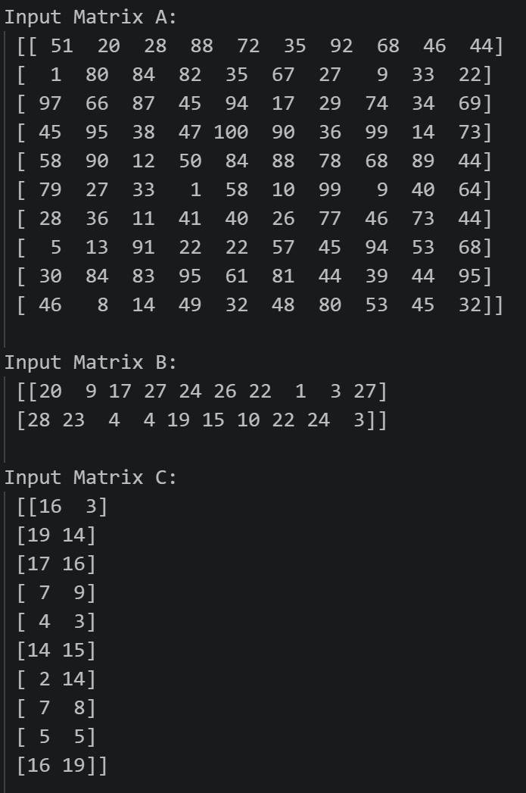
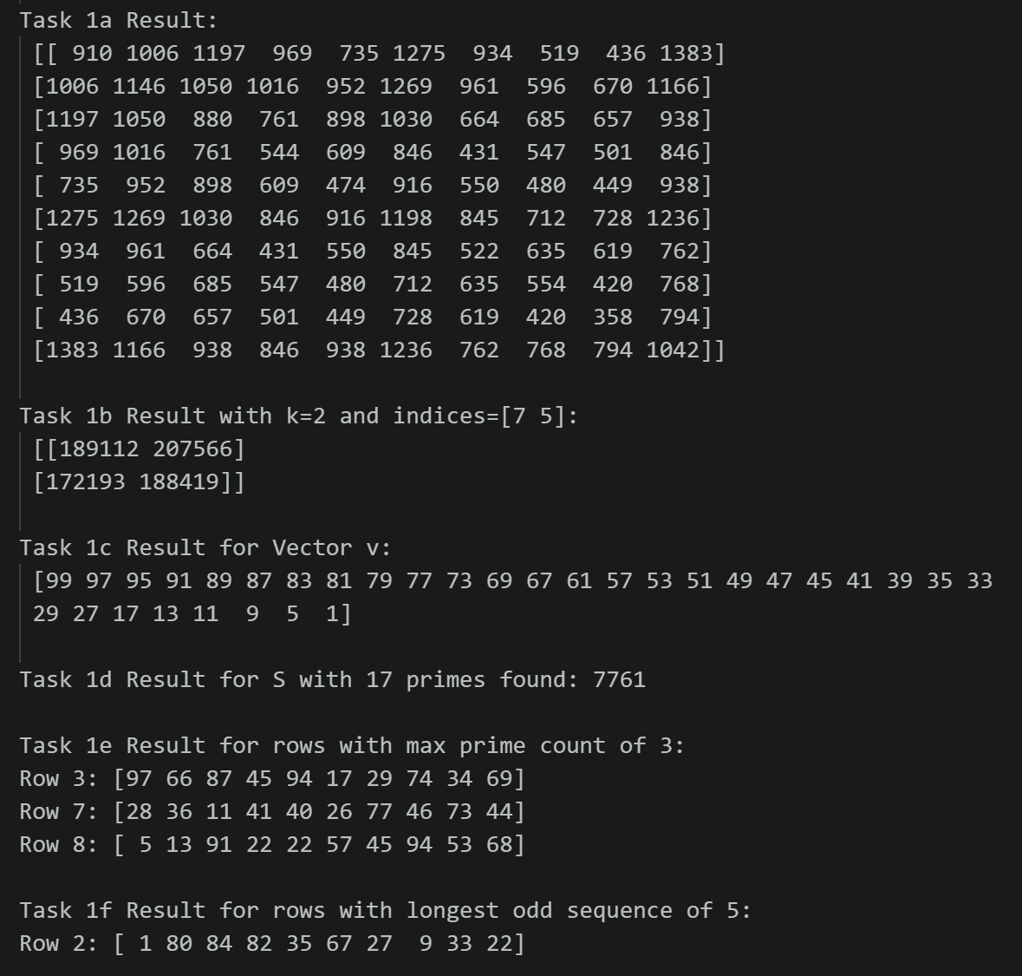
Figure 2.3 Terminal output for Trial 3: Matrix initialization and Tasks 1a-1f

Trial 4 Results
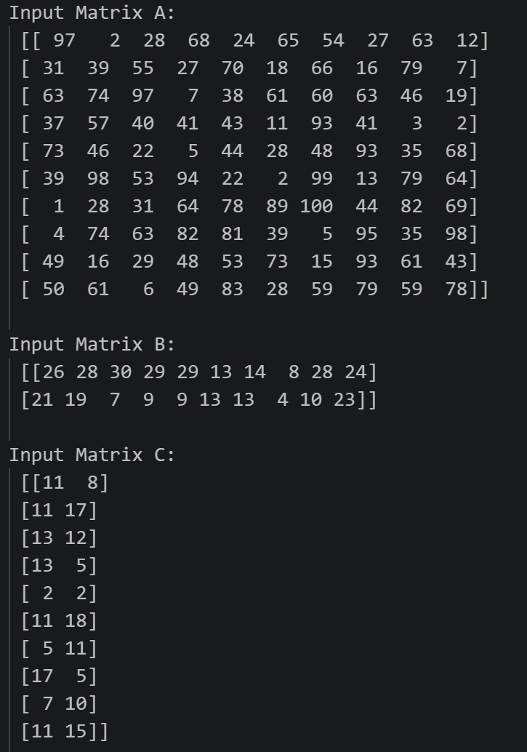
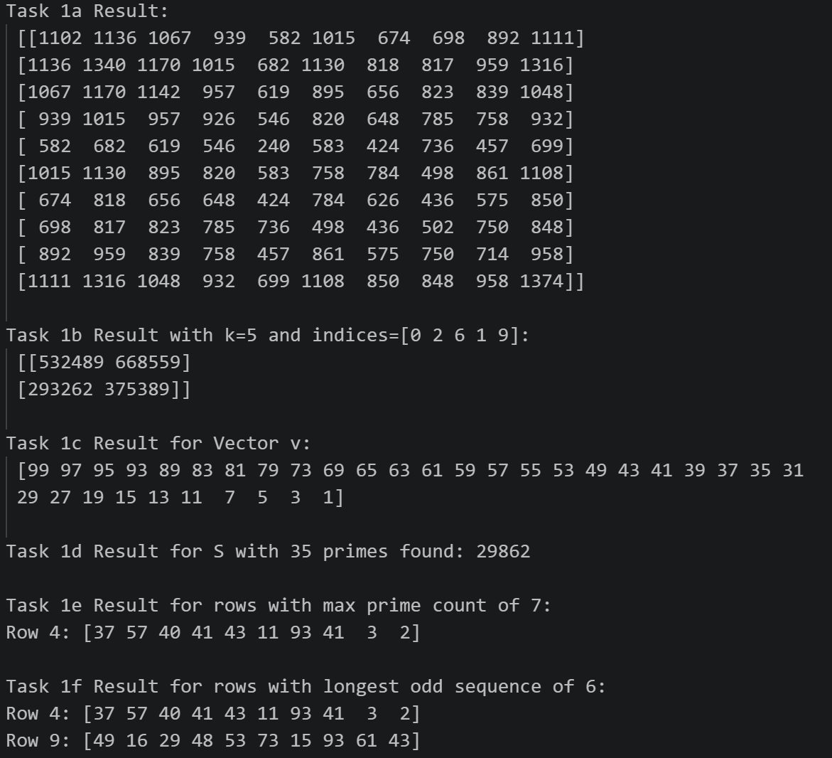
Figure 2.4 Terminal output for Trial 4: Matrix initialization and Tasks 1a-1f

Trial 5 Results
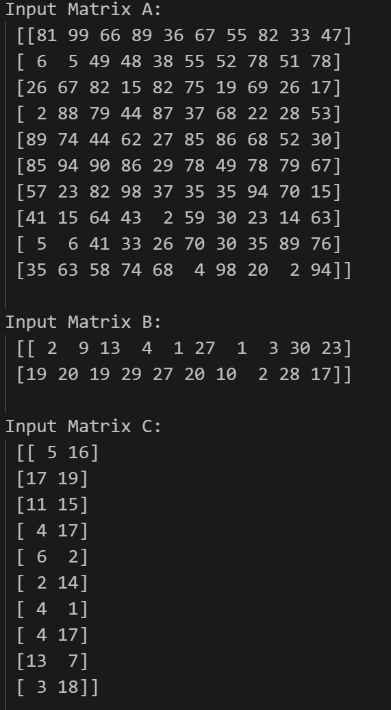

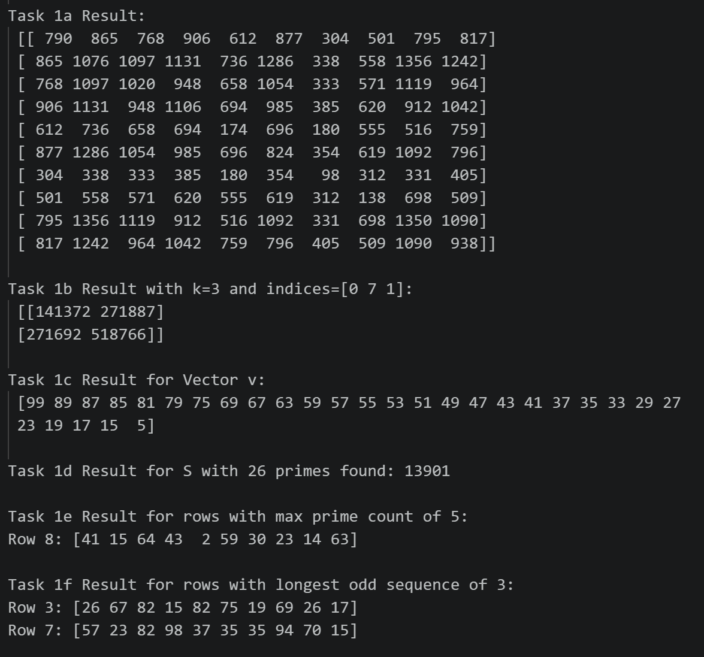
Figure 2.5 Terminal output for Trial 5: Matrix initialization and Tasks 1a-1f

REFERENCES
[1] Pham Quoc Duy. (2026). Applied Linear Algebra for IT: Midterm Essay Instructions. Ton Duc Thang University, Faculty of Information Technology.
[2] Harris, C. R., Millman, K. J., van der Walt, S. J., et al. (2020). Array programming with NumPy. Nature, 585(7825), 357-362.
[3] NumPy Documentation. (2026). NumPy v2.0 Manual. Retrieved from https://www.google.com/search?q=https://numpy.org/doc/
[4] Python Software Foundation. (2026). The Python Standard Library: Math Module. Retrieved from https://www.google.com/search?q=https://docs.python.org/3/library/math.html

